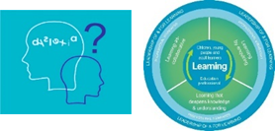
Developing Inclusive school Community Improvement Exemplar
- What are we trying to accomplish? (Aim)
- How will we know that a change is an improvement? (outcome)
- What change can we make that will result in an improvement?
What is the area we want to explore?
Are our school policies and plans equitable and inclusive?
Aim | Ensure that our school policies and plans are inclusive and reflect the needs of our learners with neurodevelopmental differences, ASN and protected characteristics.
Projected Outcome | Inclusive school policies and planning developed through empowerment, engagement and participation
Who is leading this activity? |  | Impact /improvement measures |  | Time Scale
For example
- School management Team
- Staff group
- Learners’ Dyslexia group
- Dyslexia working group
- Equalities working group
Chosen reflective questions |  |  | Evidence of change | Outcome
Are all our school policies and planning methods inclusive – do they fulfil the statutory and professional duties?
Next Steps

