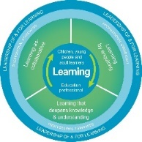
Dyslexia and Inclusive Practice Professional Reflection and Planning Tool:
Inclusive Practice - The Scottish Context and Inclusion within the School Community
This professional reflection and planning tool support opportunities to reflect on your knowledge and understanding of dyslexia and Inclusive practice and help you plan the next steps in your professional learning.
Name |  |  | Establishment |  |  | Date
Inclusive School Focus Areas |  | Developing an Inclusive School Community
Reflective questions |  | Response |  |  | Evidence
Have we successfully established an inclusive school community? How do we know
Are all our school policies and planning methods inclusive – do they fulfil the statutory and professional duties? |  |  |  |  | )
Next steps for improvement
Personal Reflective Prompts |  |  |  | Next Steps and Priorities for my Professional Learning.
How inclusive do I feel my practice is and how do I know?

