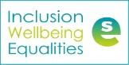
Inclusion, Wellbeing and Equalities Professional Learning Framework Overview animations transcript.
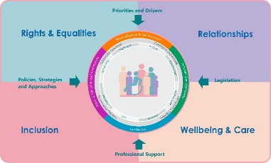

Welcome to the inclusion wellbeing and equalities professional learning framework that aims to support all educators.

Set within the Scottish inclusive context, of our national drivers and priorities, legislation , professional support and policies.

The framework places children and young people at its centre supported by the Wellbeing Indicators, the Four Capacities, and the totality of the curriculum.

Explore the ‘Essential for All’ activities and the four interconnected and interdependent themes.

Inclusion. Explore: Inclusive practice and Scottish context, Additional Support Needs – including complex needs, The Additional Support for Learning process and entitlements.

Rights and Equalities. Explore: Entitlements, United Nations Convention on the Rights of the Child (UNCRC), participation, bias and diversity in the curriculum.

Relationships. Explore: Understanding around expectations and consequences and skills around co-regulation, de-escalation, attunement and active listening.

Wellbeing and Care. Explore: The Getting it right for every child approach (GIRFEC), mental health and wellbeing, nurture, trauma, safeguarding & Child Protection.

Keep exploring the Inclusion, Wellbeing and Equalities Professional Learning Framework as new activities will continue to be added.

