Enhancing Professional Learning in STEM
Grants Programme Round Two (2019 – 2020)

Leadership and Collegiate Professional Learning Fund
Guidance document

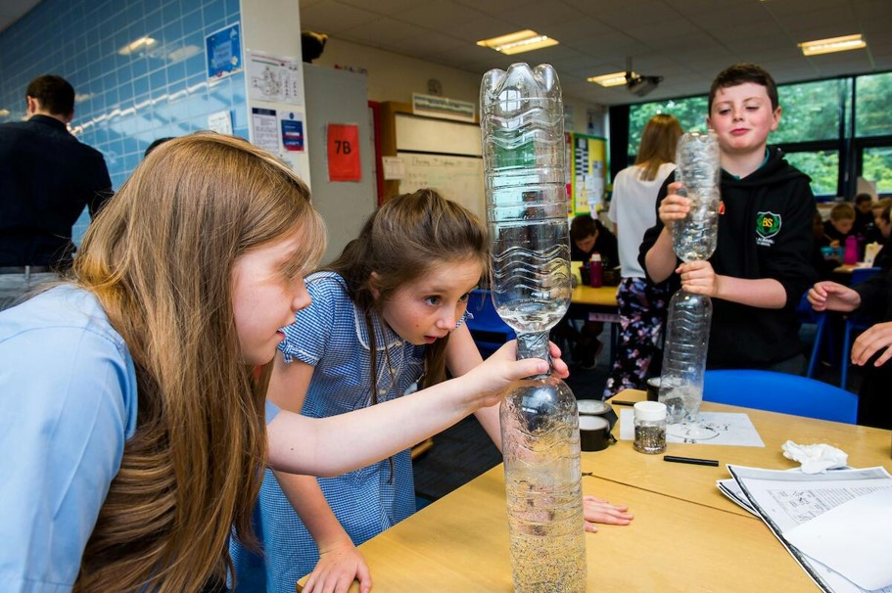
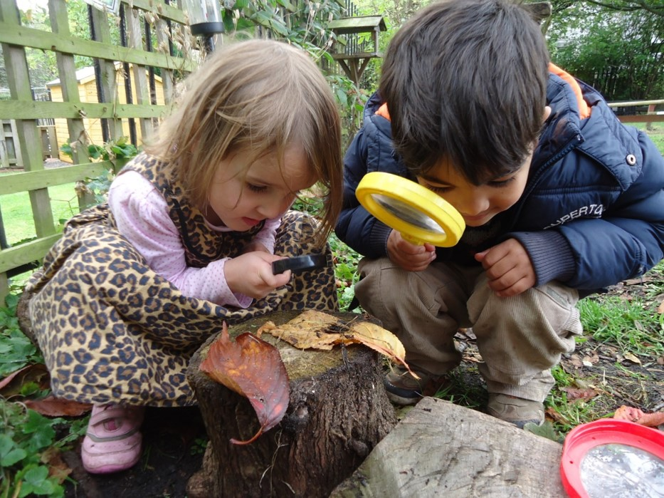

For Scotland's learners, with Scotland's educators

The Leadership and Collegiate Learning Fund ̶ Who is it for?
The Enhancing Professional Learning in STEM (sciences, technologies, engineering and mathematics) Grants Programme will have two different funding streams in financial year 2019/20:
- Leadership and collegiate professional learning fund
- Regional and national partner fund.
This guidance document provides important information for practitioners considering applying for funding through the Leadership and Collegiate Learning Fund. This fund aims to provide professional learning support to practitioners in the following sectors:
- Early learning and childcare
- Additional support needs
- Primary
- Secondary
- Community learning and development
- School-based technical support staff.

Programmes will only be considered for funding if they are primarily targeted at practitioners in publically-funded settings, including local authority partner providers in the early learning and childcare sector.
The second funding stream, the Regional and National Partner Fund, is in its second round in financial year 2019/20. This funding stream has been designed to support proposals from organisations at a regional and national level including: regional improvement collaboratives, local authorities, colleges, universities, Third Sector organisations and a wide range of STEM providers. A separate guidance document and application form is available for those interested in bidding for this stream. This is available from the following page on Education Scotland’s National Improvement Hub: http://bit.ly/NIHSTEM
The aim of both funding streams will be to support interdisciplinary approaches to STEM and subject-specific support to each of the STEM-related disciplines including:
- Numeracy and mathematics
- Sciences
- Technologies, including digital learning and teaching and engineering.

What are the aims and outcomes?

The aim of the Enhancing Professional Learning in STEM Grants Programme is to stimulate, support and grow programmes that enhance the professional learning available to practitioners who have a responsibility or interest in all aspects of STEM-related learning, teaching and assessment.

The grants programme was established in October 2018 to deliver on the ambitions of the STEM Education and Training Strategy for Scotland (2017), namely, to ensure that educational practitioners are ‘well-equipped with the knowledge, skills and confidence to develop and deliver inspirational, high-quality interdisciplinary STEM (Science, Technology, Engineering and Mathematics) teaching for all learners, across all ages and stages’.

In financial year 2019/20, the grants programme is being extended to further support the delivery of the recommendations and ambitions of the Making Maths Count (2016) Report. The funding previously issued through the National Numeracy and Mathematics Hub, has now been added to the Enhancing Professional Learning in STEM Fund. The Making Maths Count Report seeks to encourage Scotland to become a maths-positive nation. The importance of professional learning is integral to the Report and is outlined in recommendation as follows, ‘All sectors of education should promote access to high-quality career long professional learning (CLPL) to increase staff confidence and enhance professional practices in teaching maths to children, young people and adult learners.’

This next phase of the grants programme, therefore, recognises the importance of mathematics, numeracy and also STEM learning in their own right. As well as creating exciting opportunities to build capacity in the provision of subject-specific support and specialism in STEM-related disciplines, the grants programme offers rich potential in building greater connections between mathematics, numeracy and STEM. STEM, as a context, is ideally placed to promote and support interdisciplinary learning and team approaches, both of which are vital within STEM careers and industries.

A significant focus of the programme is to address the barriers that practitioners face in accessing appropriate high-quality learning and teaching that meets their needs. Education Scotland is keen to ensure that we see a transformation in the provision of professional learning to all the target sectors, which includes some 86,000 practitioners. It is also important that there is an equity of access to professional learning across various sectors, geographical areas, work patterns, developmental stage and within the component STEM disciplines (sciences, technologies, engineering and mathematics).

The grants programme has been developed following extensive consultation with stakeholders and has been informed by the findings from the Annual STEM Practitioner Surveys in 2017 and in 2018 [http://bit.ly/NIHSTEM].

Intended outcomes
Across Scotland, we want learners of all ages and backgrounds to:
- Be highly enthusiastic, confident and engaged in their STEM learning, including in numeracy and mathematics
- Understand the relevance of STEM learning and skills, and interdisciplinary approaches, to their lives, now and in the future
- Be motivated and inspired to develop a life-long interest and passion in STEM and to develop as STEM-literate and numerate citizens
- Demonstrate excellence and high levels of personal achievement in their STEM learning
- Be encouraged to pursue STEM-related pathways and career opportunities, including through college-based and work-based routes and through apprenticeship opportunities
- Have equity and equality of opportunities, support and outcomes; especially for those facing barriers in STEM-related learning due to their gender or disability or as a result of being care-experienced or from a black, Asian and minority ethnic community.

The grants programme aims to provide practitioners with the professional learning support to improve outcomes for our learners as listed above. In particular, our expectation of the programme is that it will:
- Equip practitioners with the skills, knowledge and confidence to continuously improve their STEM learning and teaching in sciences, mathematics and numeracy, technologies, engineering, digital learning and teaching and in STEM learning
- Ensure a greater equity of access to and provision of high-quality STEM professional learning across sectors, specialisms, geographical locations, work patterns and disciplines
- Support the development and testing of effective professional learning models that can be scaled up and replicated in other contexts and locations to further enhance the capacity for STEM learning across Scotland
- Increase the quality, variety and impact of STEM professional learning available to practitioners in Scotland
- Provide access to quality and responsive routes for professional learning in a range of formats from informal, self-directed learning to online learning to different levels of accredited learning
- Increase engagement and capacity for practitioner enquiry, collaboration, and collegiate working through communities of practice and local networks
- Build leadership and specialism capacity for STEM at all levels
- Create opportunities for strong, sustained collaborative partnership working within clusters/ASGs/learning communities and across sectors, including early learning and childcare, schools, colleges, universities, STEM providers and employers
- Enable practitioners to engage effectively with learners, families and communities to help build their STEM capital
- Support the implementation of the Career Education Standard, Work Placement Standard and Guidance on School/Employer Partnerships by ensuring practitioners have exciting opportunities to connect with employers and colleges to learn about STEM learner pathways including apprenticeships
- Build the understanding and skills of practitioners to help them address unconscious bias, tackle stereotypes and to promote equity and equality through learning in all aspects of STEM.

What can we bid for?
Education Scotland recognises that a diverse range of approaches are required to meet the needs of practitioners across such a wide range of sectors and contexts in Scotland. In some cases, applicants may have already consulted their own practitioners and networks and have already developed an effective model of professional learning that is tried and tested, and that they are looking to extend or scale up. In other cases, new approaches may be required to address a particular need that is not currently being met. The grants programme has been designed to accommodate a variety of such scenarios and each will be considered on its merit and suitability for supporting practitioners in the relevant context.

The following examples, although not exhaustive, suggest types of approaches that could be considered.
We are a group of early learning and childcare, ASN, primary and secondary teachers who want to work together to raise attainment in numeracy across our cluster. We need…
- To create opportunities for collaborative professional enquiry, lesson study approaches, communities of practice
- Professional learning on specific STEM aspects
- Opportunity to collaborate across sectors to develop our pedagogy and approaches…

We are early years practitioners who want to develop a programme of STEM through outdoor learning. We need…
- The opportunity to work with outdoor learning specialists to create a programme for our local context
- To come together as an active network to work collegiately, to support one another and learn from each other…

We are a network of practitioners who want to know more about STEM learner pathways and local STEM industries. We need…
- To collaborate with employers and colleges to promote understanding of STEM skills, sectors, workplaces and learner pathways
- Experience of industry visits/placements to develop our knowledge of labour-market information
- To know about Foundation Apprenticeships…
We are a network of community learning and development practitioners who want to build our confidence in relation to STEM. We need…
- Professional learning on how STEM can be used to promote adult literacy and numeracy
- Time to engage with research around science and STEM capital
- The opportunity to collaborate to develop and trial new programmes of professional learning…

We are a group of school clusters who want to support improvements in our technologies curriculum and progression through Early to Fourth Level. We need…
- To release experienced practitioners/ technicians to mentor, coach or support colleagues within the cluster
- Undertake peer learning and collaborative activities involving early learning and childcare, primary and secondary practitioners…
We are a group of primary teachers who would like to explore how to promote equality and tackle inequity through STEM. We need…
- Time to reflect on the current experience of learners
- Collaborative cross-sectoral learning with colleagues in ELC settings and CLD to help us develop a STEM family learning programme…

We are a group of school based technical support staff. We need…
- Time to meet to update each other on new protocols and procedures
- An opportunity to collaborate with others to share our expertise in different areas including ICT, sciences and technologies…

Are there any priority areas?
Improving gender balance, equality and equity are priority areas and all applicants will be expected to demonstrate how they will address these components through their planned activity.
In addition, we also welcome bids which demonstrate links to the following themes as an integral part of their programmes:
- Developing the Young Workforce
- Learning for sustainability
- Creativity.
Progression in learning
We particularly welcome bids that results in effective progression in learning across sectors in relation to STEM, including numeracy and mathematics. This can include groups of early learning and childcare, primary and secondary practitioners taking time to visit each other’s settings to build their understanding of learning teaching, assessment, skills and pedagogy within different contexts. This can also include professional learning resulting from joint curriculum planning activities which help to build on prior learning.
In a similar way, we welcome bids which promote connections, understanding and joint professional learning and regional curriculum planning between schools and colleges to develop effective STEM learning pathways. Bids which promote collaboration and collegiate working between early learning and childcare settings, schools and community learning and development sectors are also welcomed.
Leadership
Education Scotland is very keen to build effective leadership capacity for STEM at school, setting and cluster level. We would welcome bids that provide professional learning support and leadership development for the following groups:

- Senior leadership teams, senior managers, senior technicians
- Secondary faculty heads and principal teachers
- STEM, numeracy and mathematics coordinators at setting, school and cluster level
- Practitioners/technicians looking to mentor, support peer groups, networks or to lead professional learning activities.

Education Scotland’s annual STEM practitioner surveys revealed some areas that are currently under-served by professional learning which we are keen to address. There were also some areas of STEM that were not fully represented in Round One of the grants funding. We would particularly welcome applications for grant funding that seek to provide further professional learning support for the disciplines and sectors listed below.

STEM disciplines
- Mathematics and numeracy
- Technologies, including engineering and digital learning

Sectors
- Additional support needs
- Early learning and childcare
- Community learning and development
- School-based technical support staff
A key strength of STEM is that it provides an ideal context for supporting interdisciplinary learning and approaches, such as project-based learning. This grants programme places equal value on bids which provide professional learning support for specific disciplines on their own and also bids which support interdisciplinary approaches. Both are essential if STEM is to grow and flourish.
Geography
No strong pattern has emerged from the early practitioner survey data to allow us to draw definitive conclusions. However, there are indications, with some exceptions, that practitioners in rural authorities and also in small authorities would benefit from more professional learning support. Education Scotland STEM Provider Survey 2019 provides an early indication of the professional learning support being provided to each local authority by external providers.
Themes
Schools, centres and groups bidding for the Leadership and Collegiate Professional Learning Fund will undoubtedly have a strong idea of the key professional priorities within their contexts. The findings from Education Scotland’s Annual STEM Practitioner Surveys are available on the following page as a helpful reference point as to the priorities highlighted by all those who responded to the surveys. Your bid does not need to align to these priorities.

Sector | Professional learning priorities (based on 2017 and 2018 responses)
Additional support needs | - Awareness about the resources and support available for STEM  - Pedagogies/teaching approaches to deliver STEM learning effectively  - Improving equity and equality in STEM learning
Early learning and childcare | - Pedagogies/teaching approaches to deliver STEM learning effectively  - Understanding the concepts and knowledge that underpin mathematics/numeracy  - Using STEM to raise attainment in literacy and numeracy  - Awareness about the resources and support available for STEM
Primary | - Pedagogies/teaching approaches to deliver STEM learning effectively  - Using STEM as a context to raise attainment in literacy and numeracy  - Skills progression in STEM subjects  - Developing confidence in the teaching of mathematics/numeracy including numeracy across learning  - Awareness about the resources and support available for STEM
Secondary | - Support for National Qualifications in STEM subjects  - Pedagogies/teaching approaches to deliver learning effectively  - Skills progression in STEM subjects  - Awareness of STEM careers and relevance of STEM to the world of work  - How to improve gender balance in STEM subjects
Community learning and development | - Awareness about the resources and professional learning available for STEM  - Understanding how to incorporate STEM-related learning into my current practice  - Using STEM as a context to increase skills in numeracy  - Awareness of how to frame STEM learning to make it relevant in a range of CLD settings  - Understanding of how CLD can engage and inspire disadvantaged young people, adults and families in STEM-related learning
Technicians | 1. Awareness of STEM careers and relevance of STEM to the world of work  2. Understanding of the concepts and knowledge that underpin the sciences and technologies curriculum  3. Support for new content in National Qualifications in STEM subjects  4. Skills progression in STEM subjects  5. Awareness about the resources and professional learning available for STEM

Guidance on funding

What is the maximum level of funding available?
In this grant guidance, we have not specified a maximum level of grant funding that is available. This is for a number of reasons:
- We do not want to set a limit on projects that have the scope to provide high-quality professional learning to practitioners on the scale that is required
- Setting a maximum level of funding can skew all applications towards the amount stated
- The response to each funding round can vary so it is not always easy to judge the demand on the resources available.
Instead, we invite applicants to set out a reasonably costed proposal that is realistic and achievable within the set timeframe. Your proposal will be evaluated against a number of criteria (see page 14) including value for money. If your bid is perceived to be too ambitious, or not representing value for money, then it may affect its overall scoring within the evaluation process.
You should remember that your bid will be judged on a competitive basis with other applications that have been received. We also ask you to consider that if you bid for more than you need then it may deprive other equally-deserving applicants from the funding they need to provide important support in their contexts.
The aim of the Leadership and Collegiate Professional Learning Fund is to provide space, time and capacity for practitioners to collaborate, work collegiately and take on leadership roles. Funding can therefore be provided to free up practitioners to develop, lead and coordinate professional learning for their peers, including through coaching and mentoring. This can be supported through the provision of supply cover for key leaders and coordinators, or also enhancements for those taking on additional responsibilities.
Funding for science or STEM kit-boxes or resources are not eligible costs and should not be included in your bid. See page 16 for more details.
Please include details in your application of any other funding sources or contributions that are supporting your wider ambitions. This may increase your scoring against the value for money criterion.

What period of funding is available?
The application form invites applicants to set out their proposed plans and activities for financial year 2019/20. These plans should be costed and should set out clearly what you will do and hope to achieve by 31 March 2020.
However, Education Scotland recognises that to bring about significant and sustained change often requires a period of support beyond one academic year. We are therefore inviting applicants, where it is useful to do so, to outline possible planned activity for a second phase of funding running from June 2020 to 31 March 2021. This Phase Two section of your application will be evaluated and scored at the same time as your Phase One section. However, Phase Two funding cannot be guaranteed and will depend on confirmation of the Scottish Government budget for 2020/21, the evaluation and impact of your Phase One activities and a number of other factors.

You should outline plans for Phase Two where you believe there is a clear rationale and benefit for doing so. For instance, you may want to scale up or extend successful approaches developed in Phase One of you bid so it can be used to reach a larger number of practitioners. All applicants are asked to bid for the amount that is required to undertake the work you have set out, only where no other resources are available to do this. If you bid for any unnecessary funds then it may deprive another worthy programme or cluster of the support it needs to flourish and develop.

What about partnerships?
As the name suggests, the central purpose of the Leadership and Collegiate Professional Learning Fund is to provide space, time and capacity for practitioners to take on leadership roles in STEM areas and also to work collegiately and collaboratively across sectors, establishments, clusters and areas of interests.
Any bids received must, therefore, involve more than one establishment and seek to build strong and sustainable relationships, partnerships and collaborative models of working. There is no requirement to work with external providers and partners in this regard. Therefore, bids that have been devised, led and directed by learning establishments, or groups of practitioners, are strongly welcomed.
Bids that involve external partners and providers are also welcomed. However, for the Leadership and Collegiate Professional Learning Fund, these partners will be expected to be involved in a supportive capacity with the focus remaining on the collegiate working and collaboration of practitioners.
If, in the course of developing your proposal, you find that the scope increases significantly then you should consider whether your bid is more suited to the Regional and National Partner Fund. This Fund has been developed to support more strategic bids which benefit a significant proportion of establishments or practitioners across an authority or make an impact on a regional or national basis. If in doubt, please refer to the Guidance Document for the Regional and National Partner Fund in the first instance [http://bit.ly/NIHSTEM]. You can also contact Education Scotland’s STEM Team for advice on email: stem@educationscotland.gov.scot
How can I apply?
If you are interested in bidding for the Leadership and Collegiate Professional Learning Fund then you should liaise closely with your potential partner establishments in the first instance to discuss and scope your plans. These discussions should focus on the following areas:
- What are the professional learning needs, in relation to STEM (including numeracy and mathematics) that you are seeking to address?
- What evidence do you have about the professional learning needs of the practitioners to be involved?
- Is there similar provision that already exists that you could tap into or use instead?
- What approaches or models will you use to support this professional learning? How do you know this will work for the practitioners involved?
- To what extent will your approach be consistent with the aims of the Fund and the new National Model of Professional Learning?
- What is your expected legacy from this programme? How will you be building long-term sustainability from the start?
- Do you intend to apply for one phase of funding (until 31 March 2020) or two (until 31 March 2021)?
- How will you measure and evaluate the impact of the programme, including the impact on learners?
- What are your budget needs? Which establishment/programme will act as the lead partner to submit the bid, coordinate the proposed programme of activities and to handle funds?
Once you have scoped your plans and ambitions then you should then discuss them with a relevant contact within your authority, or Regional Improvement Collaborative (RIC). This could be a Quality Improvement Officer, Education Officer, Programme Manager or similar. This is important for a number of reasons:
- Your authority or RIC contact may be able to provide some form of central support or guidance for your work
- They may also be aware of potential overlap with other bids or programmes that are being developed, or already exist
- They may be able to suggest ways in which the scope or impact could be increased
- If your bid is successful then Education Scotland will allocate funding to your local authority for your establishment or network to draw down. It is important therefore, that they are aware of this in advance and have agreed to support your bid.
If you do not know who the appropriate contact is in your local authority then please contact Education Scotland’s STEM Team by email: stem@educationscotland.gov.scot
Once you have confirmed your local authority support for your proposal then you should complete the application form for the Leadership and Collegiate Learning Fund. This is available from Education Scotland’s National Improvement Hub: http://bit.ly/NIHSTEM. You should complete all the relevant sections on the application form and keep a copy of the application form for your own records.

Please send your application form by email to: EdsSTEMGrants@educationscotland.gov.scot by 10:00 on Friday 28 June 2019. The subject line of your email should be: STEM CLPL: Leadership and Collaborative Learning Fund – [your organisation name here].

We will inform you of the outcome of the evaluation process by August 2019.
What further support is available?
Education Scotland will be running engagement events across Scotland in June to provide the necessary face to face support. Information about these events will be promoted through our networks, our STEM blog and social media platforms including:
- STEM blog: http://bit.ly/EdScotSTEMblog
- @EdScotSciences and @mathsscot on Twitter
- STEM ebulletin: http://bit.ly/2hpDK5m

You can also contact the STEM Team on email: stem@educationscotland.gov.scot if you have any questions or would like to discuss your ideas.

How will we evaluate your application?

Criteria for evaluation and decision-making
We will evaluate how well your proposal meets the purpose of this competitive fund based on the criteria below.
Criteria | Score  (0-4) | Weighting (1-5) | Max score  available
How well does the project address the overarching aims and intended outcome of the fund? |  | 5 | 20
How well does the proposal display strategic approaches to ensure impact and legacy? |  | 4 | 16
Value for money – including aspects relating to reach and scale of the programme for a given level of funding. |  | 3 | 12
Additionality – how your proposal would add value to or extend provision including reaching new audiences and delivery of new content and approaches. |  | 3 | 12
Total |  |  | 60

Applications will be scored 0-4 based on the following:
0 | Does not meet the criterion | 3 | Meets the criterion
1 | Does not meet the criterion in one or more significant respects | 4 | Exceeds the criterion in one or more respects
2 | Does not meet the criterion in some minor respects

Scoring
Your application will be evaluated and scored against the above criteria. Your score will determine the amount of funding you are awarded. For example, if your bid receives a score of 85% of the maximum available then you will be awarded 85% of the total amount you bid for in Phase One. This score will also carry over should you be awarded Phase Two funding also in April 2020.
You should therefore follow guidelines closely to ensure your bid provides strong evidence of alignment to each of the listed criteria. Those bids which are aligned closely to the priority areas will score more highly against the criteria.

You should also give consideration to the following:
- Remember to include any evidence of impact or evaluation you have from any pilot activity
- Do not assume that the moderation panel are already familiar with your organisation’s work or programmes
- Be very clear about what you will do and how you will do it – run your bid past someone who has not been involved in writing it to be sure it makes sense and provides the correct information
- Provide the right level of detail – don’t leave any gaps but don’t overload on information either
- Ensure your costings are realistic and in proportion to your plans.

Additional information

1. Eligible costs
Please see below some examples of eligible costs which you might consider in your proposed budget within the application form. Please contact us if you require any additional guidance regarding this.
- Staffing.
- Teacher cover (for practitioners involved in the delivery/facilitation of STEM CLPL activity rather than attendees).
- Reasonable travel and subsistence.
- Training /events ̶ including venue and catering.

2. Ineligible costs include:
- Purchasing of equipment or science/STEM resources.

3. Other sources of funding
There is no requirement to find partnership funding but please let us know of other sources of funding you will be using to develop your activities such as:
- A contribution from your own organisation, either financial or in-kind. If possible, please assign a monetary value to any ‘in-kind’ funding.
- Funding from public organisations, employers and local enterprise companies
- Grants from trusts and foundations.

4. Monitoring and evaluation
- We will need to know what happened as a result of our funding and will ask you to monitor project activities to measure the impact of your project in relation to the intended outcomes of the fund. If your bid is successful, you should complete the monitoring and evaluation activity that you outlined in your original application. This can include informal evaluation and surveys conducted within your setting, cluster or with partners and stakeholders.
- Please note that we will want to report on the outcomes from a national perspective and will send out a tracking template to capture the number of practitioners you have reached.
- Education Scotland is currently preparing a tender to externally evaluate all activity and programmes being supported through the grants programme. Should you be successful in your grant application then we will also ask you to support this process in a proportionate and appropriate way, for example, by promoting surveys to your participants or engaging in focus groups discussions with evaluators. Further information on monitoring, evaluation and reporting requirements will be issued in due course.
- One of Education Scotland’s regional officers will contact you once your funds have been awarded. They will be available to discuss your progress and provide support, particularly prior to the submission of your interim report and your final report. The due dates for these will be given in your grant award letter.

5. Conditions of award
- Your proposal should respond directly to the intended aims and outcomes of this fund as stated in this guidance document.
- Applications can only be considered if they meet the funding criteria.
- All professional learning is to be provided on a non-commercial basis and must be available free of charge to participants.
- The intellectual property developed through your grant-funded programme will reside with the Crown and must continue to be made available free of charge to practitioners beyond the funding period.
- Successful applicants should keep to the grant conditions shown in both our offer letter and any accompanying document. In particular:
  - You should not make changes to the project without notifying us first
  - You should carry out your project in line with the timescales given in your application and within the time limits shown in our offer letter. It is very important that you let us know about any delay or difficulties in keeping to the grant conditions so that we can advise and help you as necessary.
- The conditions of grant award will be included in full in the Grant Award letter issued to successful applicants. Please contact Education Scotland if you would like to request a copy of the grant conditions.

6. Additional important information
Please note that Education Scotland may, by giving at least 7 days written notice, assign any of its rights and obligations under an award, either wholly or in part, to any other person.

7. Publicity
Information on funding awarded may be made public by Education Scotland. If you are successful in your funding bid then we will also ask you to include information of the grant fund in your promotional materials and through your events. This is to ensure practitioners and networks across Scotland are made fully aware of the funding that is being provided by Education Scotland and Scottish Government to support the STEM Education and Training Strategy and the Making Maths Count Report.
Images submitted in support of your application may be stored electronically by us. If we later seek to use these for publicity purposes, we will contact you in order to obtain permission to do so.

8. Openness and accountability
Reports from information you supply within your application and from comments made on your application by external assessors and staff members will be held digitally. The information you supply will be made available to those evaluating your application.
For the purposes of the Freedom of Information (Scotland) Act 2002 (FOISA) Education Scotland is obliged, as a Scottish public authority, to make your information (which will include your application) available by anyone making a Freedom of Information request.
By submitting your application, you waive any right to raise any type of legal proceedings against Education Scotland as a consequence of, or in contemplation of, any disclosure of the contents of your application in response to an information request made under FOISA.

9. Information that we may release
If your application is successful, we will release the following information from your funding application if we receive a FOI request:
- Your name
- The amount of funding requested
- The summary description of your project.

If more detailed information is requested, we will consider this request under FOISA and apply the Act’s exemptions and the public interest test appropriately. If more detail from your funding application is to be disclosed, we will contact you and advise you of this.
For further information on FOISA please see the Scottish Information Commissioners website: www.itspublicknowledge.co.uk

10. Data protection
Information supplied by you in support of your application will be stored on our records system. The data we hold may be used for the following purposes:
- To report statistics
- To evaluate applications
- For accounting purposes
- For contacting you.

Your name, address and contact details will be held on our records system. We will use this information to correspond with you. We will not forward your details on to any other organisations.
The details of your application may become public information (see Openness and Accountability above). However, your personal details will be held by us and only our staff, appointed auditors and those involved in evaluating or monitoring awards will have access to them.
You have a right under the Data Protection Act 2018 to see the information we hold on you. By signing your application form you are agreeing that we can use your information as shown above.

“Data Protection Laws” means any law, statute, subordinate legislation, regulation, order, mandatory guidance or code of practice, judgment of a relevant court of law, or directives or requirements of any regulatory body including the Data Protection Act 1998, the Data Protection Act 2018 and any statutory modification or re-enactment thereof and the General Data Protection Regulation (GDPR). For more information on the Data Protection Act 2018 see https://ico.org.uk/for-organisations/data-protection-act-2018/

Please see Annex A on Page 50 of the STEM Education and Training Strategy for Scotland for a definition of what constitutes ‘STEM’.

