Building the Ambition:
National Practice Guidance on Early Learning and Childcare

What makes the difference for children and families ?

Title of session : The image of the child

Time allocation : 45 minutes

Focus :

- The term “image of the child” is often used by practitioners and a high level of value is placed on taking account of the interests of the child, but what does this actually mean in practice?

Preparation :

- read section 3.1 of Building the Ambition
- copy activity sheets for participants
- flip chart, pens and sticky notes

Leader’s notes :

The purpose of this activity is to focus practitioners on – “ What makes the difference for children and families?”

The European Commission ECEC describes the image of the child as:

“Each child is unique and a competent and active learner whose potential needs to be encouraged and supported. Each child is a curious, capable and intelligent individual. The child is a co-creator of knowledge who needs and wants interaction with other children and adults. As citizens of Europe children have their own rights which include early education and care.”

Activity 1

In pairs look at the following photographs and discuss:

- what it is that shows children are involved in their learning?
- what could the role of an adult be?
- what other possibilities are there that you could help support if you were working with these children in your own setting?

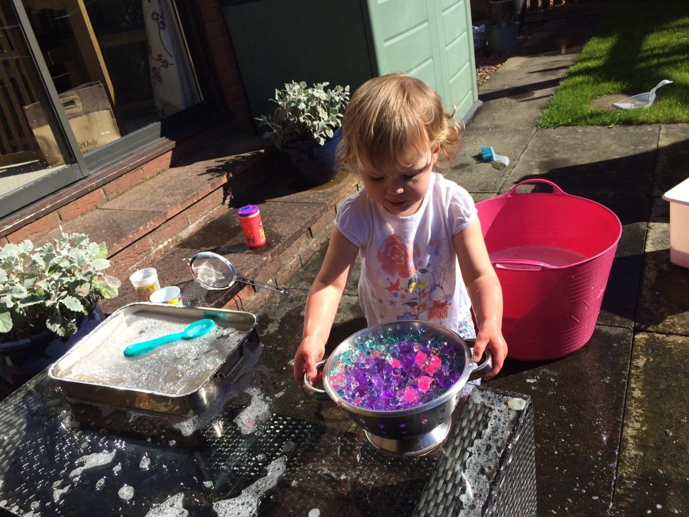

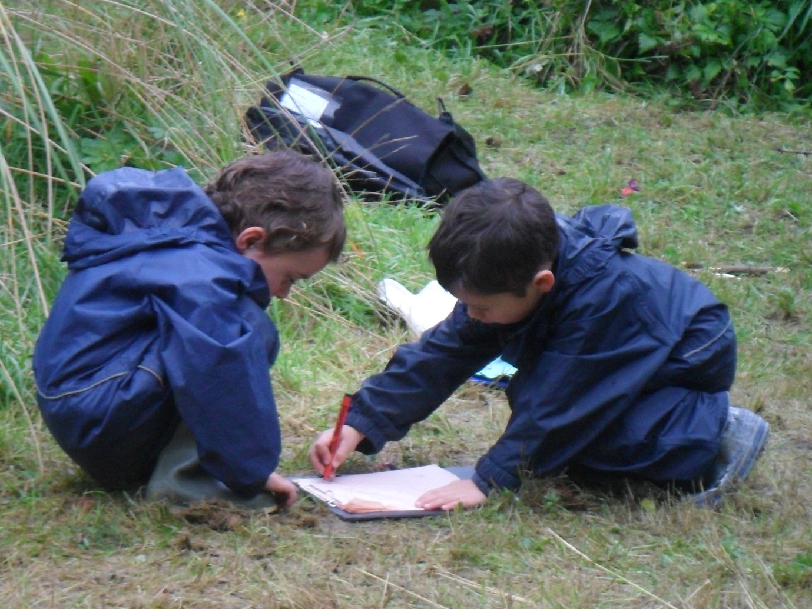

Write down your top three answers, for each question and share these with another pair and then narrow down your six answers to your final top three.

Now think about your own setting and decide on one of the following questions. write down your thoughts .

- What do you see as the characteristics of high quality ELCC in your own particular setting? To what extent does it vary for children 0-3 and children aged 3 to starting school?

- What changes can you make tomorrow, next week and next month to improve the quality of children’s experiences in your setting?

- How well does your setting allow children to make choices and provide them with well thought out experiences and opportunities through play to develop their learning? How could this be improved?
- How will you know that the changes you have made will have had a positive impact?

- Have you been in a situation where children seem disengaged with learning, appear unhappy or are more careless than you would expect? Why do you think this happens?

