Report on the Impact of
the Creative Learning Network (CLN) Fund - 2010-2016
based upon
Online Survey Analysis (carried out in early 2017)

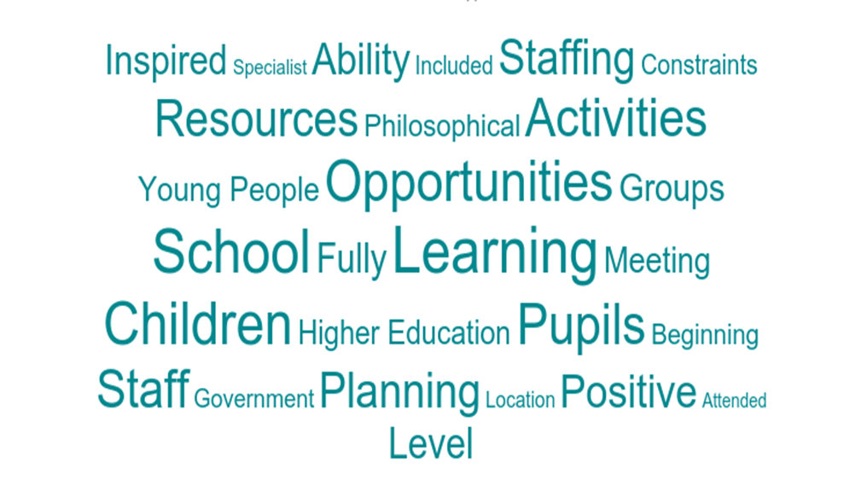

Summary
The survey was circulated to all CLN coordinators, who sought feedback from participants from early years, primary, secondary, CLD, senior managers, third sector organisations, Further and Higher education, culture organisations, arts organisations, employers, parents and carers.
Ninety-two responses were received from sixteen local authorities (Edinburgh includes East/Midlothian and Forth Valley includes Clackmannanshire, Falkirk and Stirling). Nine authorities had no responses. The majority of responses, 62%, came from the primary education sector, 14% from the secondary education sector and 16% from the arts and cultural sectors.
Participants were asked to identify the CLN funded activities undertaken in 2015/16 and which of those had the most impact on their practice. More than 33% of the respondents identified ‘creative’ activities such as creative conversations, creativity days, ‘Let’s Talk Creativity’ and creativity in maths, science and technology. Over 15% of respondents highlighted their very positive experiences of courses in Philosophy with Children, with a further 12% siting the impacts that a variety of good quality CPD experiences have had on their practice. The learning gained from visiting specialists coming into schools was highlighted as important by over 11% of respondents and the involvement with initiatives including the Youth Music Initiative and visits to creative events were also identified as having significant impacts on practice.
In question four, participants were asked to think about creative learning opportunities and their impact on learners. Almost all respondents agreed that learners had increased access to creative learning activities as a direct result of the CLN (90%) and that learners had access to a more diverse range of creative learning activities (83%). 65% strongly agreed/agreed that creative learning took place across all aspects of the curriculum, with 24% neither agreeing or disagreeing and 88% felt that these opportunities contributed to learners achieving their potential.
In question five participants were invited to expand on their answers to question four, and to highlight any obstacles and how these were resolved. Almost 19% of respondents cited a range of creative opportunities and their impacts such as ‘children applying skills in creativity through all areas of the curriculum’ and ‘Using new approaches to teaching maths’. 16% of respondents identified a wide range of direct impacts on learners from specialist inputs, some of which had curriculum wide impacts. ‘Children learning from experienced scientists, writers, performers added depth to the learning.’ A number of participants (9%) highlighted innovative outcomes resulting from their engagement with CLN activity, ‘As a whole school we challenged the children to lead their own learning by creating a futuristic zoo within the space of 1 week. It was a huge success with pupils and parents.’ Of the 10% who identified funding as an important issue, almost all felt that the lack of access to sufficient funding limited their ability to access, promote or develop creativity skills. However, a few highlighted how CLN funding had positive impacts on their work.
Obstacles identified included time to develop practice, resources available and a lack of priority given to the development of creativity skills at local and authority levels. One respondent identified that, ‘Although the impact of creative approaches is well known and frequently witnessed (even reported) by practitioners and participants in creative learning projects it has not been adopted into pedagogical practice to its full potential. "Attainment" is a priority for schools, but what exactly is attained and relevance to employability or progressing to further and higher education in 21st century is something that might be explored, evidenced and developed.’ Reflecting that the majority of respondents came from a school background many identified an overcrowded curriculum and timetabling constraints as key obstacles. Some also identified a fear that the pressures of the attainment agenda will ‘push creativity aside’. Respondents did not offer possible solutions to these obstacles.
In question six, participants were asked to think about specific impacts on their organisation, as a result of CLN funding. 87% agreed that creativity skills are recognised, articulated and valued by participants and 80% strongly agreed/agreed that both learners and practitioners engaged in dialogue about the development of creativity skills. While 69% strongly agreed/agreed that creativity is a practically applied higher order thinking skill, 25% neither agreed nor disagreed with the statement. 73% of participants strongly agreed/agreed that partnerships are used to deliver highly engaging creative learning and 77.53% strongly agreed/agreed that learners and practitioners were transferring creativity skills to new contexts. Only 59% strongly agreed/agreed that learners’ creative endeavours were acknowledged and celebrated, with 34% neither agreeing nor disagreeing.
In question seven, participants were invited to expand on their answers to question six, and to highlight any obstacles and how these were resolved. Example responses included:
‘Creativity is consistently encouraged and celebrated as part of the children's achievement in school and in the wider community…’.
‘Creativity is an integral part of our developing curriculum rationale’.
‘Learners have a greater awareness of what creativity skills are due to their experiences and this has informed their approach to their coursework in school…’.
Question 8 asked respondents to consider a number of statements with regard to their local authority. In reflecting on whether the pool of practitioners supporting the development of creativity/skills had increased over the last two years, 53% strongly agreed/agreed and 40% neither agreed nor disagreed. 67% strongly agreed/agreed that practitioners had improved their practice in supporting learners to develop their creativity skills, while 31% neither agreed nor disagreed. As to whether there were more resources available to support creativity, 48% strongly agreed/agreed, 34% neither agreed nor disagreed and 18% disagreed/strongly disagreed. 65% of participants strongly agreed/agreed that creativity partnerships and networks were stronger, with 30% neither agreeing nor disagreeing.
In question nine participants were invited to expand on their answers to question eight, and to highlight any obstacles and how these were resolved. Examples given include:
‘Staff have developed their understanding of how to encourage creativity in the curriculum’.
‘We have creative champions who share their practice with other teachers and staff showcasing how they evaluate experiences and outcomes using creative approaches to teaching…’.
Of the respondents who commented on resources, almost all felt there were insufficient resources available, with just under 6% of respondents commenting on the lack of funding available.
In relation to partnership, although many participants agreed that partnerships and networks were stronger, only 12% provided examples.
‘We have very good links with creative partners and where possible they support us in the pupils learning. Planning takes place together. I would say in our authority the increase in numbers of teachers who have been involved in creativity had grown, but perhaps only in a limited number of schools and not consistent across the authority’.
‘In the last 2 years, creative networks have really been developing and encouraging people to think and work in this way. I think there could be more collaboration across art forms with practitioners’.
Question ten invited participants to use the space to provide more information on any of the answers given or to add any other comments about the Creative Learning Network or creative learning opportunities in their area. 79% of respondents who chose to comment, identified CLNs as valuable, supportive and effective, providing good quality opportunities that have contributed to improvements and increased the confidence of participants.

Survey Analysis

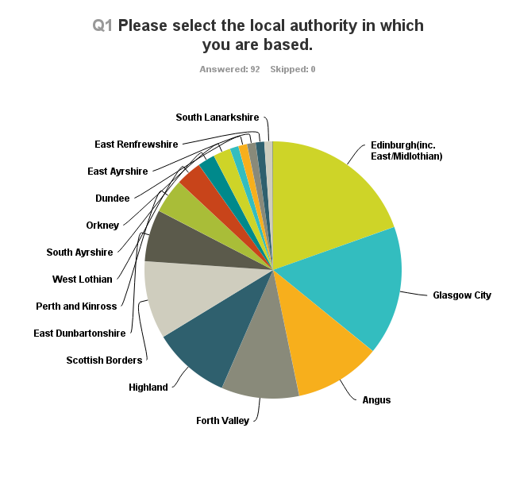

Of these 92 responses:
- 18 (19.57%) responses from Edinburgh
- 15 (16.3%) from Glasgow City
- 10 (10.87%) from Angus
- 9 (9.78%) from Forth Valley, Highland and the Scottish Borders
- 6 (6.52%) from East Dunbartonshire
- 4 (4.35%) from Perth and Kinross
- 3 (3.26%) from West Lothian
- 2 (2.17%) from South Ayrshire and Orkney
- 1 (1.09%) from Aberdeen City, Dundee, East Ayrshire, East Renfrewshire, South Lanarkshire
- No responses were received from Argyle and Bute, Dumfries and Galloway, Inverclyde, Moray, North Ayrshire, North Lanarkshire, Renfrewshire, West Dunbartonshire and the Western Isles.
Of the 92 responses:
- 32 (34.78%) were Primary Teachers
- 25 (27.17%) were Primary Managers
- 12 (13.04%) were local Arts/Cultural
- 9 (9.78%) were Secondary Teachers
- 4 (4.35%) were Secondary Managers
- 3 (3.26%) were national Arts/Cultural
- 2 (2.17%) were CLD Practitioners
- 1 (1.09%) were Early Years Manager, CLD Manager, Further Education Manager, Higher Education Practitioner and a local Heritage Practitioner
In question 3, participants were asked to identify the CLN funded activities undertaken in 2015/16 and which of those had the most impact on their practice. More than 33% of the respondents identified ‘creative’ activities such as creative conversations, creativity days, ‘Let’s Talk Creativity’ and creativity in maths, science and technology.
‘The other significant benefit from being involved in the CLN activities is that I've met many interesting and creative people and now feel I am part of a community rather than isolated just working in one local authority…’
Over 15% of respondents highlighted their very positive experiences of courses in Philosophy with Children, with a further 12% siting the impacts that a variety of good quality CPD experiences have had on their practice. The learning gained from visiting specialists coming into schools was highlighted as important by over 11% of respondents and the involvement with initiatives including the Youth Music Initiative and visits to creative events were also identified as having significant impacts on practice.
‘I have gained an appreciation of how challenging and enjoyable it is to spend time speaking about different questions in life.’

Question 4 asked: As a direct result of your personal engagement in CLN activity

Question 5 asked participants to expand on their answers to question 4, and to highlight any obstacles and how these were resolved. Almost 19% of respondents cited a range of creative opportunities and their impacts:
‘Following on from a Creative Conversation we led a term of creative writing which led to very high level of writing and book publication’. ‘As a result of this course my learners are highly engaged in a new reward system that promotes positive behaviour’ ‘School wide Be Inspired! Week- DYW focus Creativity is recognised not just as art/music/drama etc., but as thinking skills, flexibility of mind and quality interactions’.
16% of respondents identified a wide range of direct impacts on learners from specialist inputs, some of which had curriculum wide impacts.
‘The children and staff have expanded their understanding of what being creative is and taken part in learning experiences both on and off site, all of which have added to their skills set and provided a sense of wonder linked to creativity. This has given us opportunities and ideas for IDL opportunities and enabled us to hold wonderful whole school events sharing our learning with parents, families and the wider community. We are focussing as a staff on identifying how these creative opportunities can foster IDL which complements the learning of core skills and building in links with STEAM projects’.
‘Children learning that creative skills in Science, the Arts, technology, writing etc., are the same skills applied across a range of learning. Children learning from experienced scientists, writers, performers added depth to the learning. Teachers learned many new skills and approaches which increased their confidence. CPD for teachers increased understanding of creative skills in practice and the range of our behaviour, attitudes and practice for children feeling "safe" to be creative’.
‘The projects that we did in school through the CLN used music and art to learn about science and the environment. More pupils should have access to these workshops’.
A number of participants (9%) highlighted innovative outcomes resulting from their engagement with CLN activity.
‘Things I have done as a direct result of the training 1. I built philosophical thinking into a LFS topic about diversity, conflict and resolution where children were able to discuss and reflect on different religious and cultural perspectives in a more meaningful way. 2. I entered a philosophy competition with our P.7s which we won! 3. I found more children participated in discussions using this approach and that even the quieter, less confident pupils felt able to contribute something’.
‘Children are now taking part in Philosophy sessions. The children may not have had this opportunity if the CPD course had not been available. In time believe the children will be able to transfer the creative thinking skills they are developing through Philosophy to other areas of the curriculum. The skills developed through taking part in Philosophy sessions are lifelong skills which will be useful to the learners as they move through different stages of their education and their lives’.
Of the 10% who identified funding as an important issue, almost all felt that the lack of access to sufficient funding limited their ability to access, promote or develop creativity skills. However, a few highlighted how CLN funding had positive impacts on their work.
‘We were able to walk to the activity so there were no expensive travel costs which families can struggle to afford. Instead, many children bought a half price book - great for literacy/reading for enjoyment. This was a very high-quality event, right on our doorstep, which made the children enthusiastic about reading’.
‘Links with CLN have enabled students to experience National Gallery workshops and even contributed to visits from a practising artist’.
The obstacles included time to develop practice, resources available and a lack of priority given to the development of creativity skills at local and authority levels. Reflecting that the majority of respondents came from a school background many identified an overcrowded curriculum and timetabling constraints as key obstacles. A few also identified a fear that the pressures of the attainment agenda will ‘push creativity aside’. No one offered solutions to these obstacles.

Question 6: Thinking about your organisation, as a result of engagement in CLN funded activity:

Examples included in response to question seven included:
‘Learners and practitioners all value and enjoy the opportunity to take part in creative pursuits from art and music classes to thinking creatively in technology, putting on an assembly or taking part in Philosophy. Creativity is consistently encouraged and celebrated as part of the children's achievement in school and in the wider community’.
‘Creativity is an integral part of our developing curriculum rationale’.
‘Learners have a greater awareness of what creativity skills are due to their experiences and this has informed their approach to their coursework in school. Their developing skills are evident in the school context certainly within the department and we are looking at ways of enhancing their transferability, or rather opportunities to demonstrate transferability within the wider school community. One existing example is in students taking a leadership role in enrichment classes, to support lower school students in developing ideas’.
‘Creativity is a school improvement priority and both my schools benefit hugely from these highly motivational and enriching experiences’.
Just under 10% of respondents gave examples of the impacts of partnership:
‘A wide range of partnerships have been developed which support the development of creativity within the school and provide valuable learning opportunities for our children’.
‘The event opened up the discussion of creativity at the heart and we had a varied range of participants from schools, community and partners’.
‘Creativity has become more of a focused priority within school improvement planning. Teachers more aware of providing opportunities for creative development. Teachers actively seeking partnerships with the community to provide learners with a wider variety of creative opportunities’.
With regard to the acknowledging and celebration of creative endeavours, just under 10% detailed specific evidence of this:
‘Children who are entering competitions to make short films’.
‘Certificates, display, sharing ideas with other classes and celebrating success. Refining and modifying designs’.
‘Learners create new contexts for creativity and transfer skills to other area of the curriculum’.
CPD opportunities were seen as an important contributor to providing opportunities for dialogue about all aspects of creativity, to recognising and valuing creativity.
‘Creative Learning is developing CPD for teachers and Artists and has built a strong relationship with the curriculum development team. This provides opportunities to engage in dialogue about the development of creativity skills, but this could be developed further. Within the Creative Learning team, we hold regular meetings to strategise our work across education. Creativity skills are recognised, and valued by practitioners and learners (more so once they have participated in a project)’.
‘Management attend these events and actively encourage engagement and use school CPD sessions to discuss’.
‘Creativity skills are increasingly being recognised as important to learning across all curricular areas. Further work needs to be undertaken to identify how these skills can be exploited and developed in a progressive way’.
Overall, the obstacles are funding, resources and time available to teaching staff. A number of respondents provided more detailed responses:
‘Obstacles limiting developing creative ideas within school are parents, the wider communities' and sometimes fellow teachers’ perceptions of how learning should be i.e. conventional approaches. More specifically how maths is taught, rather than maths being a more rounded subject, which comes into many areas it's seen as something that is better taught in a more conventional and contained way’.
‘I think for some members of staff the creative skills can be difficult to comprehend and therefore apply to their teaching. I feel that those that value the contribution the creative skills can make to children's learning apply these skills as good learning and teaching. We are continually asked to evidence attainment and by the nature of creativity it is challenging to show development in a statistical format’.
‘Recognition of the value of creativity is not universal. This will only be resolved by preaching the message more to the unconverted at every level’.

Question 8: In your local authority:

In response to question 9 - Provide an example(s) supporting your answers to question 8. Are there any obstacles limiting developments? How are these being resolved? Just under 10% of participants provided responses relating to the development of creativity:
‘The Creative Conversations are an excellent way for professionals to get together and hear from a variety of other professionals and then engage in professional dialogue in an inspiring setting other than school’.
‘Staff have developed their understanding of how to encourage creativity in the curriculum’.
‘We have creative champions who share their practice with other teachers and staff showcasing how they evaluate experiences and outcomes using creative approaches to teaching. We also have two teachers who are willing to swap their schools for four half days to explore how others teach, to look at other establishments and see what developments they can take back to their own and look at how they can improve the service they deliver. We will use the findings to look at rolling out this opportunity to other establishments looking at how we can improve creativity within our schools and nurseries’.
‘Although I do not believe that the pool of people influencing creative learning has grown I do believe small but important gains have been made in a general understanding of the importance of creative learning. Teaching staff in particular are keen to explore and find new mechanisms to deliver work and engage learners’.
In relation to partnership, although many participants agreed that partnerships and networks were stronger, only 12% provided examples of this:
‘We have very good links with creative partners and where possible they support us in the pupils learning. Planning takes place together. I would say in our authority the increase in numbers of teachers who have been involved in creativity had grown, but perhaps only in a limited number of schools and not consistent across the authority’.
‘In the last 2 years, creative networks have really been developing and encouraging people to think and work in this way. I think there could be more collaboration across art forms with practitioners’.
‘The Creative team are always in hand to provide links with partners for specific projects as well as supporting schools to develop ideas with resources, staff training and CLPL opportunities’.
Of the 10% of respondents who commented on resources, almost all felt there were insufficient resources available, with just under 6% of respondents commenting on the lack of funding available.
‘In general, Local Authority support for the arts is limited - which is why the CLN funds are vital to supporting activity generated out with formal education but which plays a significant role in providing added value to the curriculum’.
Those who commented on obstacles (11%) identified centrally based staff reductions, workload, limited opportunities, a diminishing pool of expertise and concern that creative opportunities were not reaching those who needed them most.
Question ten invited participants to use the space to provide more information on any of the answers given or to add any other comments about the Creative Learning Network or creative learning opportunities in their area. 79% of respondents who chose to comment identified CLNs as valuable, supportive and effective, providing good quality opportunities that have contributed to improvements and increased the confidence of participants.
‘In my view, the CLN is a vital partnership which both supports staff and provides valuable learning experiences to the children in my school. More opportunities for more children would be wonderful’.
‘Please keep up the rebalancing between tests, measures, compliance, outcomes etc and creativity. We need this for a healthy life, vibrant economy and productive school!’
‘I value the opportunity for staff to be able to engage in conversations/networks with a focus on creativity as it raises the profile and places creativity in a central place within the curriculum.’
‘The local Creative Learning Network opportunities are a hugely valuable resource for sharing knowledge and bringing practitioners together. I would encourage these initiatives to be continued and expanded wherever possible.’
‘The opportunity to take the CLN Philosophy with Children has been a challenging but very positive experience which will have an impact on my creativity in the classroom.’
‘As a P7 class teacher last year I saw the impact that this training had on my class. Their critical thinking skills developed as did their confidence and self-esteem. I believe it also ties in with Rights Education as children find "their voice" and develop the confidence to raise their hand and speak out’.
‘All very important especially as we are expected to be more inclusive. Creativity can support this in our children with additional needs.’
‘The support and support materials from CLN are excellent.’
18% of those who responded chose not to add any additional comments and 8% took the opportunity to thank specific individuals or Networks.
(It should be noted that, throughout this analysis, figures have been rounded up/down to whole numbers, for example: 35.87% = 36%; 2.17% = 2%.)

