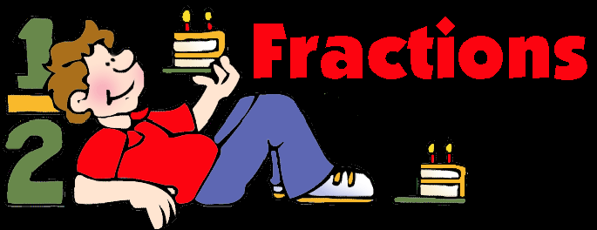

2. Split a whole object into smaller parts.

Assessment Information Block:__________

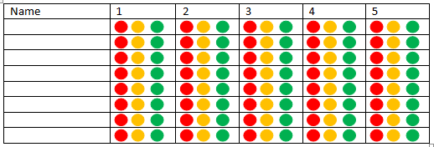

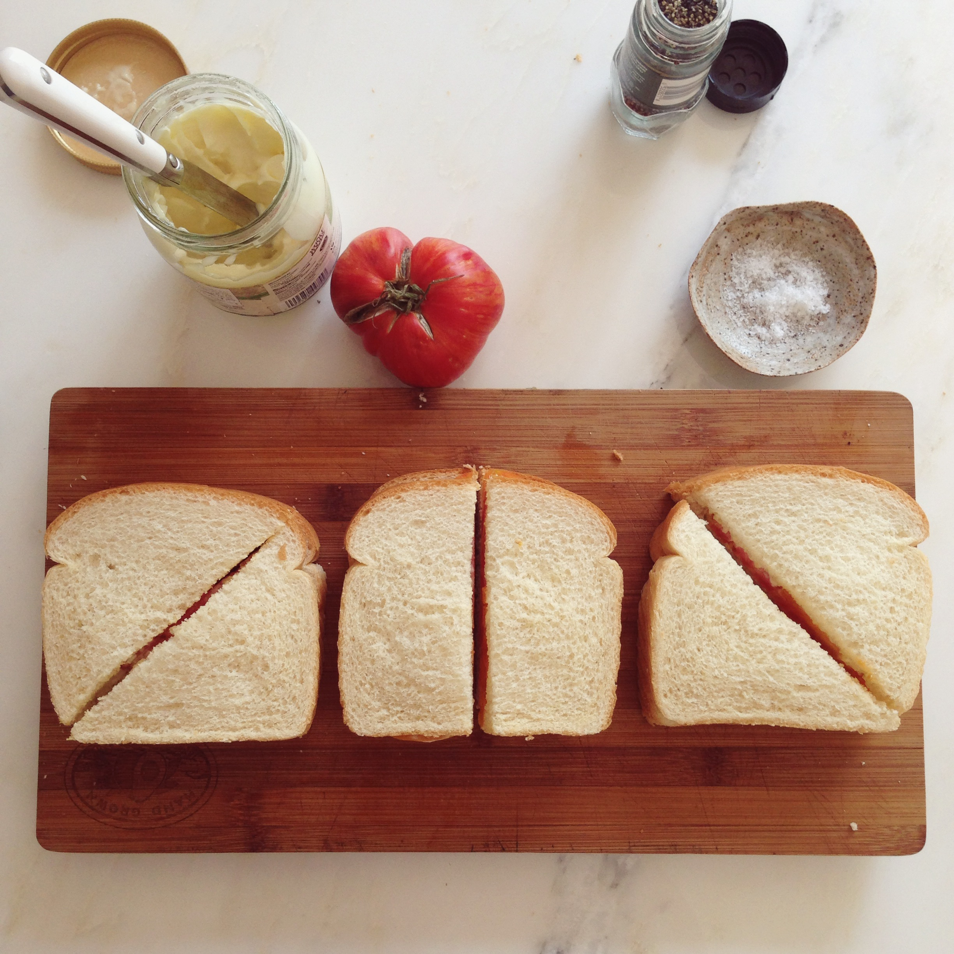

Date(s):

5. Understand the concept of halves and quarters

Date(s):

4. Identify the importance of equal sharing when splitting a whole object into smaller parts.

Date(s):

3. Split a whole object into a specified number of parts.

Date(s):

Date(s):

1. Give out individual items from a set.

**Progression Pathway Early Level - Fractions MNU 0-07a**

**Food and Health Skills Academy – HWB 0-29a / 0-30a / 0-33a**