Links around Global Citizenship, Human Rights, Sustainability and general teacher support for International Engagement

Oxfam
Oxfam for resources.

Amnesty International
Amnesty International - UK - for teaching resources.

British Red Cross
British Red Cross for teaching resources

The Department for International Development (DFID)
Department for International Development (DFID) leads the UK’s work to end extreme poverty.

Bond
BOND is the UK membership body for organisations working in international development or supporting those that do through funding, research, training and other services. Useful links to resources and projects run by their members.

NIDOS
NIDOS is the network in Scotland that unites the international development sector to promote effectiveness and collectively influence the policy agenda. Their aim is to strengthen the contribution of Scottish organisations to reducing inequality and poverty worldwide.

Fairtrade Schools
Visit Fairtrade Schools to find out how to become a Fairtrade School and journey through three awards to embed Fairtrade in your school.

Learning for Sustainability Scotland
Learning for Sustainability Scotland is a network of organisations and individuals working to harness the potential of education to create a flourishing, sustainable world.

Seeds for Learning
Seeds for Learning have a website with over 2,000 global citizenship resources to support educators in their global citizenship work. Resources can be search by themes; ages; course subjects and are linked to the Curriculum for Excellence. Resources are easily adapted for community use.

Take One Action
Do you work with young people in Scotland? Are you looking for ideas and connections to help them explore active citizenship, sustainability and global development. Resources and support for College staff , teachers and youth leaders from Take One Action.

The Wood Foundation (TWF)
The Wood Foundation is a Scottish-based charity which invests in economic, community and enterprise initiatives in Sub-Saharan Africa and the UK.

The Vine Trust
The Vine Trust offers volunteering opportunities for school pupils on sustainable development projects in Peru and Tanzania

IDEAS
The International Development Education Association of Scotland (IDEAS) is a network of 40 organisations and individuals involved in Development Education and Education for Global Citizenship across Scotland.
Scotdec
Scotdec provides resources, training and support to teachers to embed the global dimension into classroom practice and whole school policies. The teaching resources library has a range of resources which support the Scottish school curriculum.

Link Community International
Link Community International - dedicated to improving the quality of education in Africa.

Wosdec
Wosdec Global Education Centre - Professional learning for schools in Glasgow.

One World Centre
One World Centre - Professional learning for schools in Dundee.

Glasgow International Support Service
Glasgow International Support Service gives support to Glasgow schools developing international activities.

Montgomery Development Education Centre
Montgomery Development Education Centre (MDEC) - for schools in Aberdeen.

Highland One World
Highland One World (HOW) - professional learning for schools in the Highland region.

Conforti Institute
Conforti Institute – Professional learning for staff and course for pupils.

Reading International Solidarity Centre
Reading International Solidarity Centre (RISC)
A list of educational resources with a theme of raising global awareness, developing skills, attitudes and values which enable students to take action for change

Scottish European Educational Trust
Scottish European Educational Trust (SEET) - For information about Euroquiz and other learning resources

Global Dimension
Global Dimension brings together resources, case studies and background information to help teachers and other educators bring a global dimension to their work.

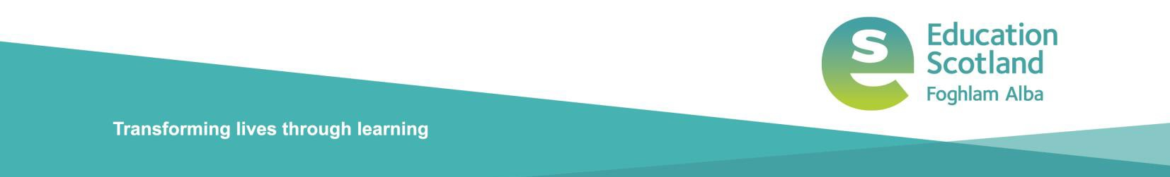

Education Scotland
Denholm House Almondvale Business Park Almondvale Way Livingston EH54 6GA

T +44 (0)131 244 4330
E enquiries@educationscotland.gov.uk

www.educationscotland.gov.uk

