- Confidence before learning  Reading for interest & enjoyment  - Self assessment  - Teacher assessment |  | 1 | 2 | 3
MLAN 3-09a | - I can use a range of reading skills and strategies to read unfamiliar vocabularly.
 | - I can show that I understand extended reading passages/stories/poems.
 | - I can use knowledge of context to help me understand.
 | - I can use knowledge of congnates and grammatical structures to help me understand.
MLAN 3-11a | - I can use a bilingual dictionary to identify cognates.
 | - I can use a bilingual dictionary to identify nouns.
 | - I can use a bilingual dictionary to identify adjectives.
 | - I can use a bilingual dictionary to identify verbs.
 | - I can use a bilingual dictionary to identify adverbs.
 | - I can use a bilingual dictionary to work out the meaning of unknown words.
Moderation: Date: Signature:

Pupil: Teacher: Task:

Overall:

Teacher feedback

Reflections and feedback

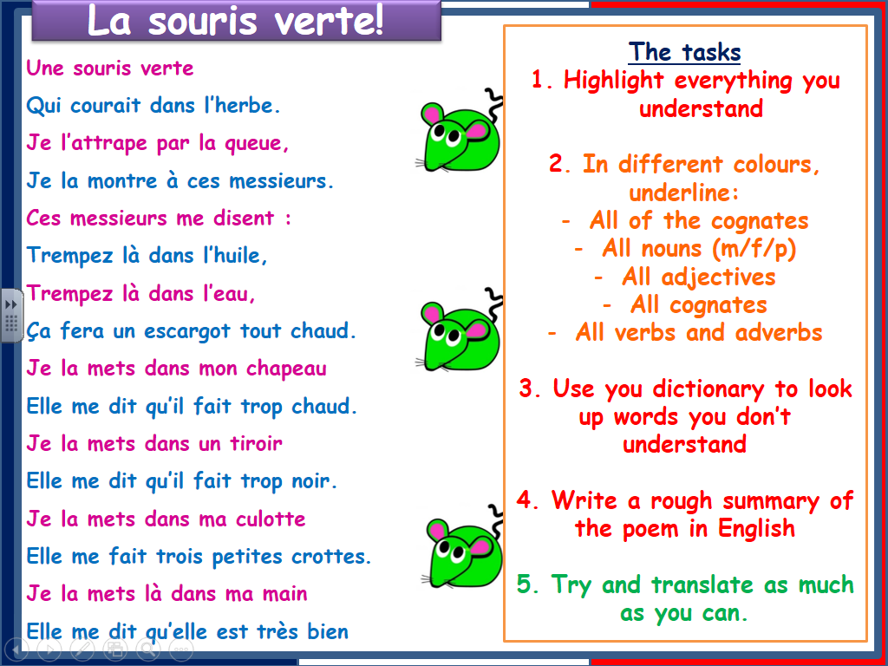
Reading for interest and enjoyment

