Engaging with spelling in Scots language

Lesson Three – Listening

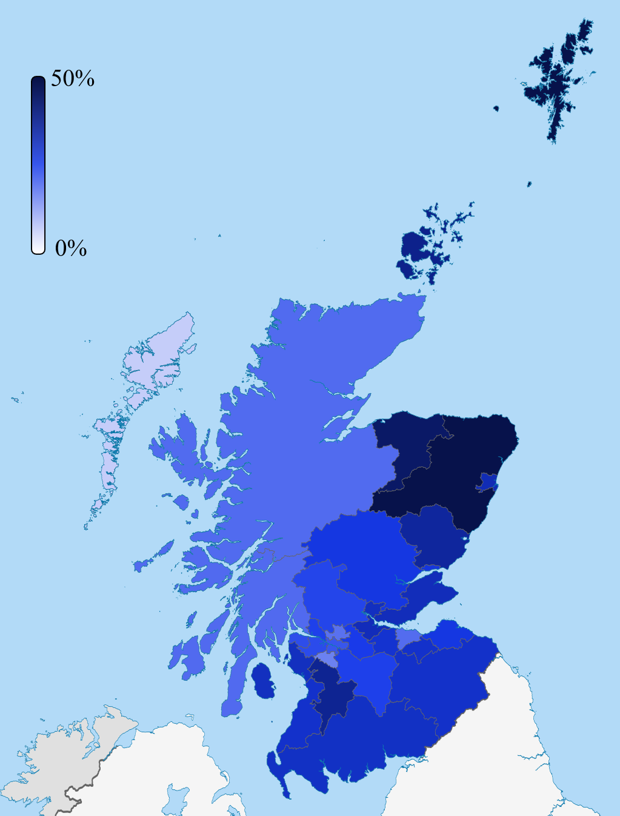
This map shows the percentage of Scots speakers who answered Yes to the question “Can you speak Scots” in the 2011 Census. The dark blue areas are those with the highest percentage of Scots speakers.

As I listen or watch, I can:
- clearly state the purpose and main concerns of a text and make inferences from key statements
- compare and contrast different types of text
- gather, link and use information from different sources and use this for different purposes.
LIT 4-04a
Starter
Watch this clip on YouTube from ‘Outlander’ dialect coach Carol Ann Crawford then answer the following questions: https://www.youtube.com/watch?v=tXpQna8WRB8
- Where in Scotland do people use the back of the mouth a lot?

- Where in Scotland do people stretches their vowels?

- Where in Scotland do people use the tip of the tongue curling back?

- Where in Scotland flattens the ‘i’ sound to ‘eh’? e.g. where a word such as “pie” is pronounced “peh”

- Do you think the way you speak would change the way you spell some words?

‘Mr Tickle’ Text
Using the British Library link below, listen to some of the Banff, Buchan, Dundee, Glasgow, Moray, Skye, West Lothian, Aberdeen, and Edinburgh recordings of ‘Mr Tickle’:
https://sounds.bl.uk/Accents-and-dialects/Evolving-English-VoiceBank
- It was a warm, sunny morning.
- In his small house on the other side of the forest, Mr Tickle was asleep.
- You didn’t know that there was such a thing as a Tickle, did you? Well, there is!
- Tickles are small and round and they have arms that stretch and stretch and stretch. Extraordinary long arms!
- Mr Tickle was fast asleep. He was having a dream. It must have been a very funny dream because it made him laugh out loud, and that woke him up. He sat up in bed, stretched his extraordinary long arms, and yawned an enormous yawn.
- Mr Tickle felt hungry, so do you know what he did? He reached out one of his extraordinary long arms, opened the bedroom door, reached down the stairs, opened the kitchen door, reached into the kitchen cupboard, opened the cookie jar, took out a cookie, brought it back upstairs, in through the bedroom door, and back to his bed.
- As you can see, it’s very useful indeed having arms as long as Mr Tickle’s. Mr Tickle munched his cookie. He looked out of the window. “Today looks very much like a tickling day,” he thought to himself.
Look at the table below. How would you spell these words in the different accents?
Remember, there is no wrong answer here! The first one has been done for you.
Word | Accent | Your spelling
warm | West Lothian | Wohrm
Mr
did you
round
stretch
funny
cupboard
window

Are there any other words you heard in that story which you would spell differently? Write them out below:
Accent | Spelling
Additional Task – Reading and Writing in Scots
The Scots language is a tricky hing tae scrieve in, seein as there’s mair that wan way tae spell almaist ivery wurd. Even as ye read this, some ae it will mak perfect sense and some ae it might no. Some ae it seems tae luik like English and some ae it seems tae luik French, or Scandinavian, even. That might hae something tae dae wi the fact that mony ae oor words come fae these places, if ye trace them back hundreds an hundreds ae years.
Ye might hae found yersel disagreein wi some ae the ways yir seein wurds spelt an that’s braw. Language is an iver-changin hing an it’s only in mere recent times that folk hae decided that there’s only wan way tae spell a wurd. This applies in a lot ae places (the English classroom bein wan ae the maist common places tae get telt ye’re spelling hings wrang) but we often use different spellins when we’re textin or messagin. This creativity wi language is a bonnie hing and shouldna be discouraged.

Would you have spelled anything differently here?
Copy the words out and rewrite them your way below:

Give reason for why you have used a different spelling:
Write a short paragraph – using as much or as little Scots as you feel comfortable with – about who you are and where you are from and your thoughts on learning about Scots language so far:

