Engaging with spelling in Scots language

Lesson Two – Reading

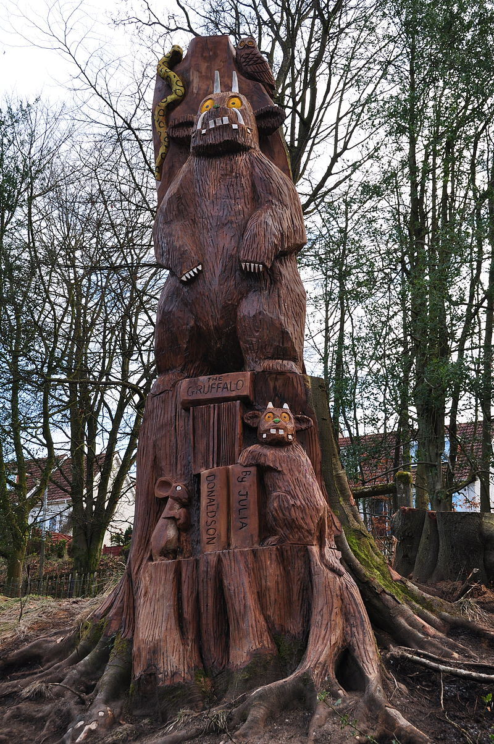
Gruffalo Sculpture, Kilmardinny Loch, Bearsden - Author Julia Donaldson lives nearby

Through developing my knowledge of context clues, punctuation, grammar and layout, I can read unfamiliar texts with increasing fluency, understanding and expression.
ENG 2-12a / ENG 3-12a / ENG 4-12a
“Because Scots does not have a recognized standard spoken form today, many believe that the various dialects spoken in Scotland are dialects of English. They are in fact dialects of Scots and form an unbroken continuum with the language which was the national tongue of the Middle Ages.”
A quote from Scots: The Mither Tongue by Billy Kay, 1986
Reading Task

Julia Donaldson’s ‘The Gruffalo’ has been translated not only into Scots but also into different dialects of Scots language.
Here are 3 short examples:
Glaswegian:
A gallus moose taen a dauner through a scary big wood.
A fox clocked the moose an the moose looked good.
Dundonian:
A moosie taen a daandir throo thi daip, derk waid.
A tod saa that moosie an that moosie looked gaid.
Orcadian:
A moose teuk a dander through the grimly trees.
A fox saw a moose an thowt, You’ll feed me.

Read extracts of ‘The _____ Gruffalo’ and ‘The _____ Gruffalo’.
In the box below, make two lists by writing down any words you see which are spelled differently.
For example, “good” in ‘The Glasgow Gruffalo’ and “gaid” in ‘The Dundee Gruffalo’
‘The _____ Gruffalo’ ‘The _____ Gruffalo’
Why might people in _____ and _____ spell words differently?
* use what you have learned and the notes you made when watching the History of Scots videos to help you

Further explanation:
When groups become distinct, the way they speak becomes distinct too. This happens socially and geographically, but is easiest to illustrate by geographical differences. If a single group splits into two (imagine that one half goes to Island A and one half to Island B), then once they have separated, their way of talking – the way words are pronounced, how they are put together to form phrases and sentences, even the meanings of words – will change over time, but not in the same way.
This is the way different dialects emerge: after just one generation the dialect on Island A might already be different from that of Island B. If the groups stay separated for centuries, the dialects may become so different that we will start wanting to say they are speaking two different languages.
One of the aspects of dialect is accent – the way words are pronounced. No modern English accent is exactly like any accent of the past. All accents change over time.
For more on this, you may wish to read more on the International Linguists Community: https://linguistlist.org/ask-ling/accent.cfm
Additional task: Writing in Scots
Write an idea for your own story or character using Scots language.
Like The Gruffalo, it could be a scary monster for a children’s book.
Or a more sinister creature, perhaps for a comic or graphic novel.
Or you could write about a real person.
You can use the following Scots word bank to help if you are stuck:
English Word | Scots Word
eyes | een
ears | lugs
nose | neb
mouth | mooth
big | muckle
small | peerie
dirty | clarty
scared | feart

The ideas for your story or character can be short bullet points like these:
- His een wir red
- His lugs wir peerie
- She hed a muckle mooth
- Her neb cam doon tae her chin
- They only hed wan lug
- They wir clarty an Ah wis right faert

