Community Resilience Network Day 2 – Denholm House
14th November 2018
Present – Jigsaw Family Learning Centre, Kildrum Family Learning Centre, Crofthill Primary, Brechin High School, Suzanne Ensom from the English Speaking Union.
Cooperative Learning Strategies were used to support the ethos of Community Resilience.
Community Resilience aims “Through partnership working to develop opportunities for learners to participate in and contribute to real-life, relevant community resilience activities locally and nationally.”
Education Scotland and Scottish Government
Agenda
1. Team Formation – Find Someone Who
2. Voice on the Table – Introductions
3. Round Robin – Sharing Outline of Improvement Project Plans based on Resilience Focus
4. Rotating Carousel – Assessment Ideas
5. Introduction of Teams Tile on Microsoft.
6. Introduction to English Speaking Union
7. Corner Activity – Which Road to Take?

Resources

Useful Weblinks
https://education.gov.scot/improvement/learning-resources/The%20Moderation%20Cycle

https://education.gov.scot/improvement/practice-exemplars/Continuous%20profiling%20and%20reporting%20in%20primary%20schools:%20The%20Highland%20Council

https://www.youtube.com/user/TechiMissBrownlee/videos

https://www.youtube.com/watch?v=M3j2ZDMt6Fs

Find Someone Who

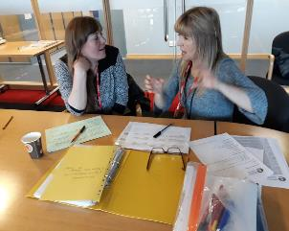
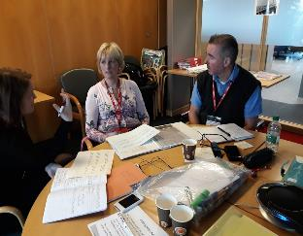

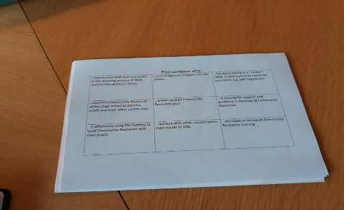

Round Robin – Sharing Plans
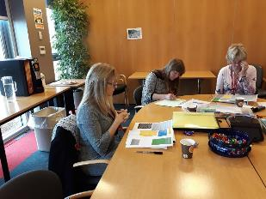
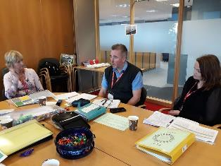
Visual Pathway – First Steps
Rotating Carousel

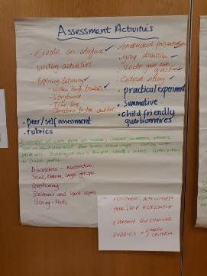
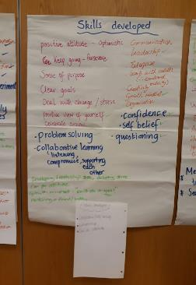

Rotating Carousel contd.

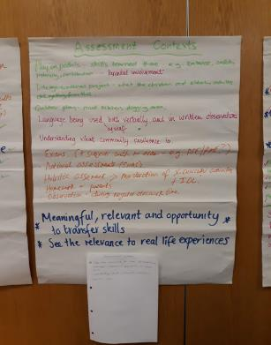
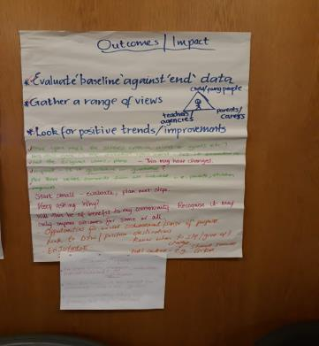
Corners – Next Steps
1. Set up Visual Pathway for own School/Centre Resilience Focus.
2. Plan and carry out an assessment by Network Day 3 – February 2019.
3. Bring Along Assessment examples for Moderation.
4. Collate “Find Someone Who” answers.

If you would like to find out more about embedding Community Resilience within the Curriculum for Excellence Please contact : alison.maclennan@educationscotland.gsi.gov.uk

