May 2024

Community learning and development

Professional Learning in STEM
Findings from the Annual STEM Practitioner Survey 2022/23

Table of contents
List of tables 3
List of figures 3
Introduction 4
Key findings 5
Annual STEM CLD Practitioner Survey 2022/23 8
About the survey 8
About you 10
Your professional learning 14
STEM in your practice 23
Education Scotland response 27
Appendix: Survey questions 29

List of tables
Table 1: Number of responses to the Professional Learning in STEM surveys 10
Table 2: STEM Partner comparison from 2018/19, 2020/21 and 2022/23 surveys 12
Table 3: Comparison of finding a STEM partner (s) from 2018/19, 2020/21 and 2022/23 surveys 13
Table 4. Types of professional learning accessed by practitioners and the impact on learning 16
Table 5. Organisations that provided STEM professional learning 17
Table 6: Comparison of ease of access to STEM professional learning across all survey years 18
Table 7: Main barriers to accessing professional learning in STEM 20
Table 8. Top STEM professional learning priorities in 2018/19 and 2020/21 21
Table 9: STEM professional learning opportunities with greatest anticipated impact from 2017/2018, 2018/2019, 2020/21 and 2022/23 surveys 22
Table 10: Confidence levels in discrete areas of STEM 25
Table 11: Awareness of STEM Nation Award programme and IGBE and equalities toolkit for CLD 26

List of figures
Figure 1: Number of responses by organisation type 10
Figure 2: Number of responses by role 11
Figure 3: Respondents' work pattern 11
Figure 4: STEM partner(s) from private, public or third sector 12
Figure 5: Finding STEM partner organisations 13
Figure 6: Number of hours of STEM professional learning accessed by sector 14
Figure 7: Hours of STEM professional learning accessed in 2020/21 in comparison with the previous year 14
Figure 8: Impact of different types of professional learning 15
Figure 9: Organisations providing STEM professional learning for CLD practitioners 17
Figure 10: Ease of accessing professional learning in STEM 18
Figure 11: Main barriers to accessing STEM CLPL 19
Figure 12: STEM professional learning priorities for academic year 2023/24 21
Figure 13: STEM professional learning opportunities that would deliver greatest impact 22
Figure 14: STEM practice in CLD 23
Figure 15: Practitioner confidence in delivering STEM 24
Figure 16: Practitioner confidence in delivering discrete areas of STEM 24
Figure 17: Awareness of STEM Nation Award for CLD 26
Figure 18: Awareness of IGBE and equalities toolkit for CLD 26

Introduction
This report presents the key findings from Education Scotland’s Annual STEM Community Learning and Development (CLD) Practitioner Survey covering academic year 2022/23.
Education Scotland has continued to gather and analyse this data from the CLD sector since 2017/18 to inform and support the ongoing implementation of the STEM Education and Training Strategy (2017).
The findings from the surveys provide valuable insights into the professional learning needs of practitioners; the challenges they face in accessing professional learning and their professional learning priorities. The survey findings have been used by Education Scotland to help shape the national professional learning offer, including the projects supported through the Enhancing Professional Learning in STEM Grants Programme. A wide range of partner organisations have also used the survey findings to help them align their professional learning programmes and strategies to the needs of practitioners.
These surveys have measured progress against the following STEM Strategy key performance indicator:
II. Increased practitioner confidence in STEM learning in the early years, primary years and in CLD settings and increased practitioner engagement in STEM professional learning opportunities. (Excellence)
- Increase the cumulative hours of STEM professional learning accessed by early years, schools, college and community learning and development (CLD) practitioners annually.
Progress against this key performance indicator, and others, have been reported on annually through the First, Second, Third STEM Strategy Annual Reports and Refresh Annual Report. The 2022/23 surveys will be the last to be issued and so this report marks the end of the data gathering process for the STEM Strategy.
Due to the COVID-19 pandemic, the Annual STEM Practitioner Survey was not issued in 2019/20. In addition, the 2020/21 survey coincided with the COVID Omicron wave, resulting in a significant reduction in the response rate in comparison to previous years. Care should, therefore, be taken when comparing results year on year.

Key findings
Number of responses – The number of survey responses increased by 14.2% from 28 responses in the 2020/21 survey to 30 responses in the 2022/23 survey. It is important to note that the information contained within this report is based on a much small sample size and care should be taken when drawing comparisons or identifying trends.
STEM practice in community learning and development – In the 2022/23 survey asked CLD practitioners what areas of STEM CLD they had been involved in during the 2022/23 academic session. The top three responses were:
- Youth worker practitioner 46.7% (14 responses)
- Adult learning practitioner 40.0% (12 responses)
- Generic CLD practitioner 26.7% (8 responses)
STEM partner or partners – In the 2020/21 survey, 53.3% of respondents confirmed that their service was engaging with a STEM partner(s) from the private, public or third sector. This is a significant increase from previous surveys 37.0% in 2020/21 survey and 35.2% in 20218/19 survey.
Practitioner professional learning hours – The total number of cumulative hours of practitioner professional learning in STEM accessed by the 30 survey respondents between 1 August 2022 and 31 July 2023 was 1,291 hours. This is an average of 43.0 cumulative hours per practitioner per annum. This shows a increase of almost 33.6 hours per practitioner from the previous 2020/21 CLD survey result of 9.4 hours per practitioner per annum.
Approximately a quarter of respondents (26.7%) completed more or a lot more STEM related professional learning than they did in the previous year. In addition approximately half of the 2022/23 respondents said they completed about the same number of hours of STEM professional learning as they did in 2021/2022.
Types of professional learning accessed by practitioners – Responses showed that the most common forms and those with the highest impact (reporting some impact and significant impact) of STEM professional learning for CLD practitioners in 2022/23 were:
- Online learning 63.3% (19 responses)
- Collegiate working within my organisation 56.7% (17 responses)
- Attending local, regional and national events 50.0% (15 responses)
Organisations providing STEM professional learning – When asked which organisation provided the STEM professional learning they had engaged with, the three most popular responses were:
- My employer 60.0% (18 responses)
- Education Scotland 33.3% (10 responses)
- Science centres/festivals 30.0% (9 responses)
Accessing professional learning in STEM – The proportion of respondents reporting that it was ‘easy’ or ‘very easy’ to access STEM professional learning decreased in 2022/23 survey to 26.7% from 37.0% in 2020/21 survey. The ease of access to STEM professional learning in 2022/23 is similar to the pre-pandemic value of 27.0% in 2018/19 survey.
Main barriers to accessing professional learning in STEM - The most common barriers to accessing professional learning in STEM were:
- = Difficulty in attending professional learning 50.0% (15 responses)
due to other commitments
= Lack of funding to pay for professional learning
- Lack of funding to pay for associated travel/ 33.3% (10 responses)
accommodation costs
- Changing workload or role due to Covid-19 23.3% (7 responses)

STEM professional learning priorities for 2023/24 – The top three priorities were:
- = Awareness about resources and support 60.0% (18 responses)
available for STEM
= Learning approaches to delivering STEM 60.0% (18 responses)
through a CLD context
- Understanding and applying digital skills 56.7% (17 responses)
within a CLD context
- How to lead and coordinate STEM within 50.0% (15 responses)
a CLD context

Support for STEM professional learning with the greatest anticipated impact – Practitioners were asked which type(s) of support would have a positive impact on their professional learning in STEM. The most common responses related to online resources, more information from Education Scotland on professional learning and online practitioner networks.

- = More dedicated online professional learning 96.7% (29 responses)
resources for CLD practitioners
= More information from Education Scotland on 96.7% (29 responses)
what professional learning is available
= Access to online network of practitioners 96.7% (29 responses)
to share practice and resources
Practitioner confidence – Practitioners were asked about their confidence in relation to delivering STEM in their practice and also discrete areas of STEM. Of those who answered each question, the proportion of practitioners who responded ‘agree’ or strongly agree’ to the statement “I feel confident in delivering [discrete area of STEM]” were:
- STEM 70.0% (21 responses)
- Sciences 53.0% (16 responses)
- Technologies 46.7% (14 responses)
- Digital learning 50.0% (15 responses)
- Engineering 20.0% (6 responses)
- Mathematics and numeracy 50.0% (15 responses)
- Gender balance, equity and equalities 53.0% (16 responses)
Awareness and relevance of some Education Scotland resources – Practitioners were asked about awareness and relevance of two key STEM for CLD programmes:
STEM Nation Award Programme for CLD settings: Awareness 56.7%, Relevance 80.0%
IGBE and equalities toolkit for CLD practitioners: Awareness 26.7%, Relevance 73.3%

Annual STEM CLD Practitioner Survey 2022/23

About the survey

Background
The aim of the Annual STEM CLD Practitioner Survey is to track enhancements in STEM professional learning undertaken by practitioners in the community learning and development sector.
The survey covers aspects such as:
- Number of hours of STEM professional learning accessed
- Practitioners’ confidence in delivery of STEM learning
- STEM professional learning priorities of practitioners
- Barriers to accessing professional learning.

Two further surveys were issued in 2022/23 to gather data from other sectors including:
- Early learning and childcare and schools, including additional support needs (ASN)
- School-based technical support staff.

The data presented in the 2022/23 survey findings was collected after several years of disruption caused by the COVID-19 pandemic. The response rate to the 2022/23 survey was slightly higher than the 2021/22 survey.

Structure and purpose
The survey was available made available to all practitioners via an online survey. It was promoted widely via Education Scotland and Scottish Government communication channels.
The survey findings have played, and will continue to play, a crucial role in shaping the implementation of the professional learning actions in the STEM Education and Training Strategy (Science, Technology, Engineering and Mathematics: education and training strategy - gov.scot (www.gov.scot)).
The findings from previous surveys have directly influenced the framing of the Enhancing Professional Learning in STEM Grants Programme which has seen over £4.6 million awarded to support professional learning programmes since its inception in 2018. The ambition of the grants programme was to ensure that practitioners in relevant sectors, and in various geographical locations, have access to high-quality professional learning which meets their needs. The survey highlights priority areas for action and gaps that need to be addressed. The evidence provided by the surveys are also directly informing the work of and the professional learning offer from Education Scotland’s regional teams. These teams play a key role in supporting and coordinating professional learning in STEM.
In addition, the survey data allows Education Scotland to track progress against the following key performance indicator in the STEM Education and Training Strategy:
II. Increased practitioner confidence in STEM learning in the early years, primary years and in CLD settings and increased practitioner engagement in STEM professional learning opportunities. (Excellence)
- Increase the cumulative hours of STEM professional learning accessed by early years, schools, college and CLD practitioners annually.

About you

Number of survey responses
2017/18 STEM Practitioner Survey (CLD practitioners) | 139 responses
2018/19 STEM Practitioner Survey (CLD practitioners) | 141 responses
2019/20 STEM Practitioner Survey (CLD practitioners) | Survey not issued
2020/21 STEM Practitioner Survey (CLD practitioners) | 28 responses
2021/22 STEM Practitioner Survey (CLD practitioners) | Survey not issued
2022/23 STEM Practitioner Survey (CLD practitioners) | 32 responses
Table 1: Number of responses to the Professional Learning in STEM surveys
Note. Of the 32 responses to the 2022/23 survey only 30 respondents gave permission for their data to be used in this report. Therefore, the totals in the following tables and figures in this report will sum to 30 unless otherwise stated.

Responding organisations
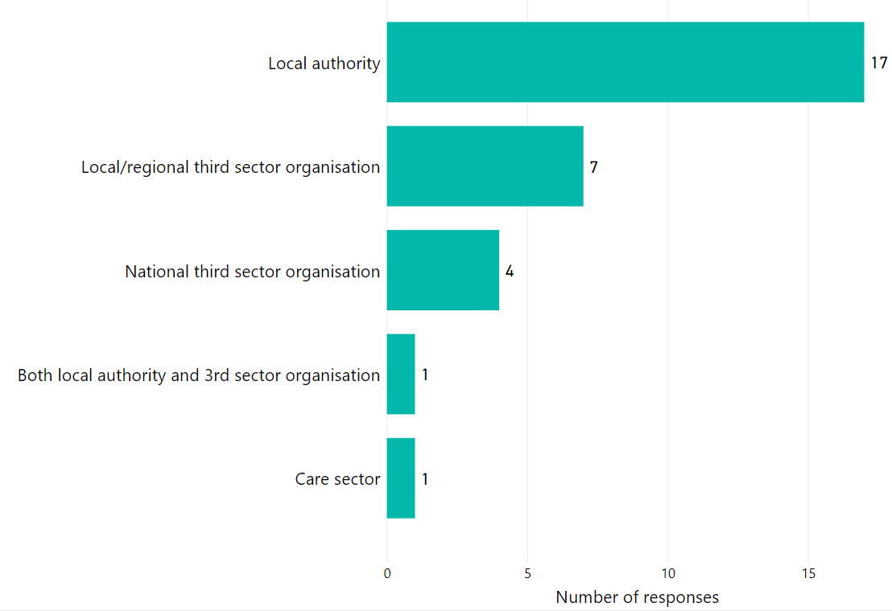
Figure 1: Number of responses by organisation type

Response by role
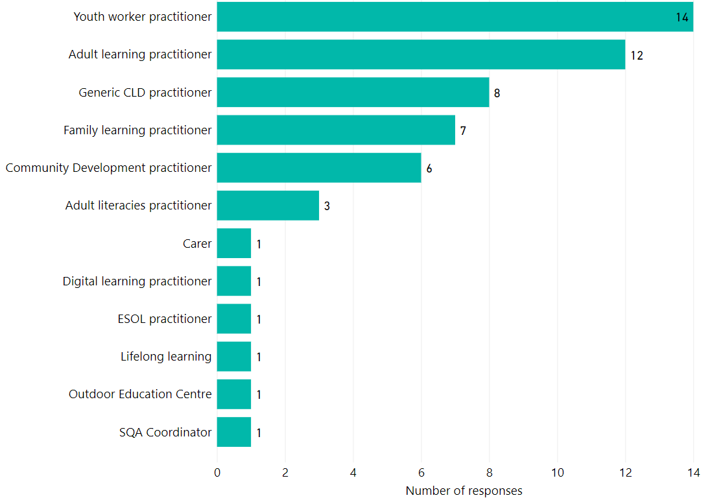
Figure 2: Number of responses by role
Note. The number of practitioner responses in this figure exceeds the total number of responses as multiple selections were possible for this question in the online survey.

Respondents’ work pattern
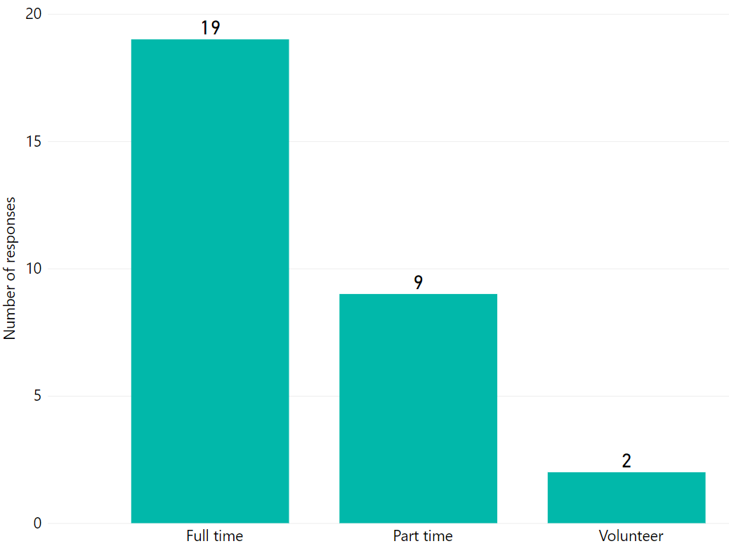
Figure 3: Respondents' work pattern

STEM partners
Practitioners were asked whether they had a STEM partner in the 2022/23 academic session, the responses are shown in Figure 4.
53.3% (16 responses) confirmed that their service had a STEM partner(s) from the private, public or third sector.
A further 3.3% (1 response) stated that their service hoped to have a STEM partner(s) in session 2022/23.

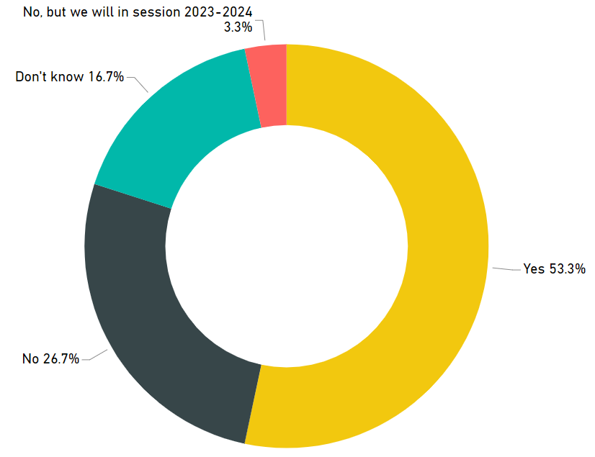

Figure 4: STEM partner(s) from private, public or third sector
Did your service/organisation have a STEM partner(s) from the private, public or third sector during this period? | 2018/19 | 2019/20 | 2020/21 | 2021/22 | 2022/23
Yes | 35.2%  (51 responses) | – | 37.0%  (10 responses) | – | 53.3%  (16 responses)
Table 2: STEM Partner comparison from 2018/19, 2020/21 and 2022/23 surveys
Note: 2019/20 and 2021/22 data is not available as surveys were not issued.

Practitioners were also asked how they found out about STEM partner organisations. The repsonses in 5 show that networking events were the most common approach. However, a significant number of CLD practitioners were unsure how their exisiting STEM partnership had been established.
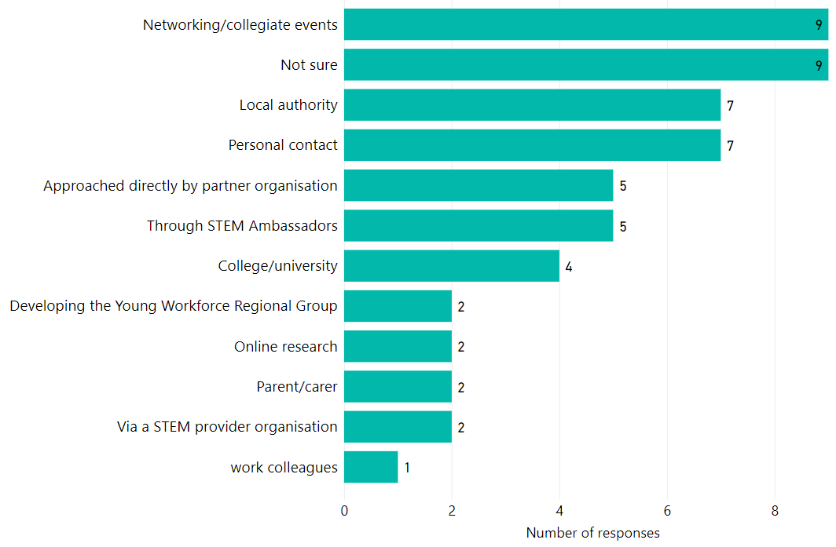
Figure 5: Finding STEM partner organisations
Note. The number of practitioner responses in this figure exceeds the total number of responses as multiple selections were possible for this question in the online survey.
 | 2018/19 | 2019/20 | 2020/21 | 2021/22 | 2022/23
1 | Local authority | – | Networking/collegiate events | – | Networking/collegiate events  Note sure
2 | Networking/collegiate events | – | Not sure  Personal contact | – | Local authority  Personal contact
3 | Not sure | – | Local authority | – | Approached directly by partner organisation  Through STEM Ambassadors
Table 3: Comparison of finding a STEM partner (s) from 2018/19, 2020/21 and 2022/23 surveys
Note: 2019/20 and 2021/22 data is not available as surveys were not issued.

Your professional learning

Total number of hours of professional learning in STEM
The total number of cumulative hours of practitioner professional learning in STEM accessed by the 30 survey respondents between 1 August 2022 and 31 July 2023 was 1,291 hours. This is an average of 43.0 cumulative hours per practitioner per annum. This shows an increase of almost 33.6 per practitioner from the previous 2020/21 CLD survey result of 9.4 hours per practitioner per annum.
Figure 6 shows the distribution of professional learning hours across different sectors of CLD.
Approximately half of the 2022/23 respondents said they completed about the same number of hours of STEM professional learning as they did in 2021/2022. Figure 7 also shows that approximately a quarter of respondents (26.7%) completed more or a lot more STEM related professional learning than they did in the previous year.
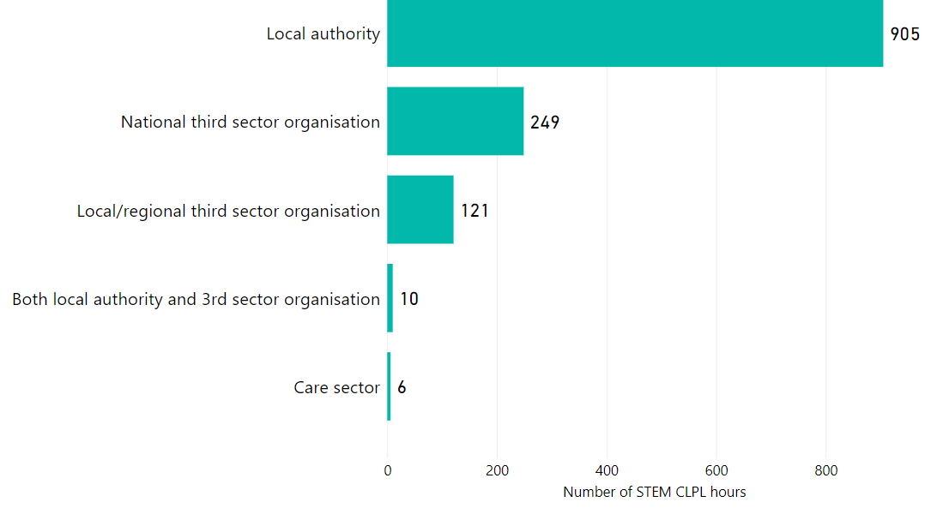
Figure 6: Number of hours of STEM professional learning accessed by sector
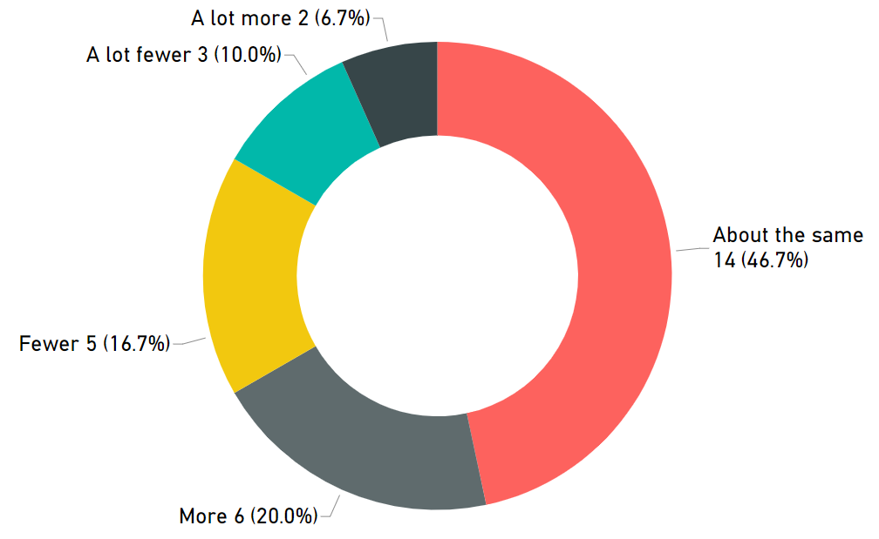
Figure 7: Hours of STEM professional learning accessed in 2020/21 in comparison with the previous year

Types of professional learning accessed and perceived value
Practitioners were surveyed about which types of STEM professional learning they accessed and perceived impact with a rating of ‘some impact’ and ‘significant impact’ during the 2022/23 academic year and were also asked to rate how valuable they found each format. The most common responses remain unchanged from the 2018/19 and 2020/21 survey namely online learning and collegiate working. However the addition of attending local, regional and national events being listed in the top three responses has replaced professional reading and engaging with research. This could be a result of CLD practitioners wanting to share ideas with other colleagues especially after the pandemic. Table 4 highlights that the proportion of practitioners participating in online learning has increased across all survey years.
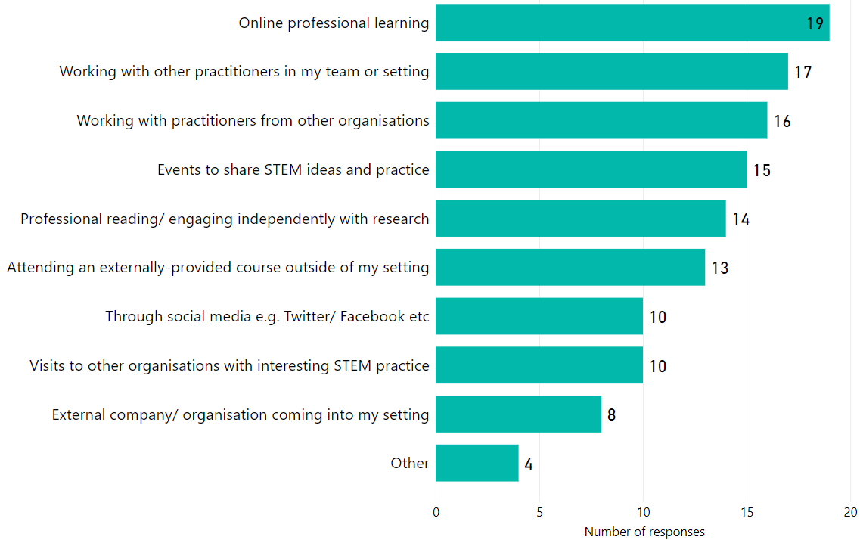
Figure 8: Impact of different types of professional learning

Types of professional learning | 2017/18  Response % (count) | 2018/19  Response % (count) | 2019/20 | 2020/21  Response % (count) | 2020/21  Impact | 2021/22 | 2022/23  Response % (count) | 2022/23  Impact
Online learning | 8.6%  (12) | 42.6%  (60) | – | 60.7%  (17) | 88.2%  (15) | – | 100%  (30) | 63.3%  (19)
Attending an external course | 6.5%  (9) | 30.5%  (43) | – | 21.4%  (6) | 83.3%  (5) | – | 100%  (30) | 43.3%  (13)
External company coming into my organisation | 5.8%  (8) | 29.1%  (41) | – | 17.9%  (5) | 100%  (5) | – | 100%  (30) | 26.6%  (8)
Collegiate working within my organisation | 7.2%  (10) | 41.8%  (59) | – | 64.3%  (18) | 94.4%  (17) | – | 100%  (30) | 56.7%  (17)
Collegiate working with other similar organisations | 2.9%  (4) | 22.7%  (32) | – | 46.4%  (13) | 100%  (13) | – | 100%  (30) | 53.3%  (16)
Through social media | * | 29.8%  (42) | – | 28.6%  (8) | 12.5%  (1) | – | 100%  (30) | 33.3%  (10)
Attending local, regional and national events | * | 34.8%  (49) | – | 46.4%  (13) | 84.6%  (11) | – | 100%  (30) | 50.0%  (15)
Visits to other organisations | * | 21.3%  (30) | – | 42.9%  (12) | 91.7%  (11) | – | 100%  (30) | 33.3%  (10)
Professional reading and engaging with research | * | 53.9%  (76) | – | 60.7%  (17) | 58.8%  (10) | – | 100%  (30) | 46.7%  (14)
Other | * | 14.2%  (20) | – | – | – | – | – | –
Table 4. Types of professional learning accessed by practitioners and the impact on learning
Note: Indicates top 3 responses
* Question not included in the 2017/18 survey
– Data not available as survey was not issued in 2019/20 and 2021/22
Recent surveys show a growing trend in collaborative working relating to STEM professional learning both within and between CLD organisations. The vast majority of practitioners engaging in this type of professional learning report that collaborative work has ‘some impact’ or ‘significant impact’ therefore consideration should be given to developing opportunities for collaboration when designing future professional learning programmes.

Organisations that provided STEM professional learning
Respondents were asked which organisations provided STEM professional learning. Table 5 outlines the top three responses from recent surveys. The top three responses have largely remained unchanged across the last three surveys.
 | 2017/18 | 2018/19 | 2019/20 | 2020/21 | 2021/22 | 2022/23
1 | My employer | My employer | – | My employer | – | My employer
2 | National or local voluntary sector organisation | Education Scotland | – | Education Scotland | – | Education Scotland
3 | Education Scotland | National or local voluntary sector organisation | – | Science centres/ festivals | – | Science centres/ festivals
Table 5. Organisations that provided STEM professional learning
Note: 2019/20 and 2021/22 data is not available as surveys were not issued.
Figure 9 shows the proportion of practitioners accessing STEM professional learning through their employer in 2022/23 survey increased to 60% from 50% in 2020/21. This is similar to the pre-pandemic value of 66.7% in 2018/19 survey.

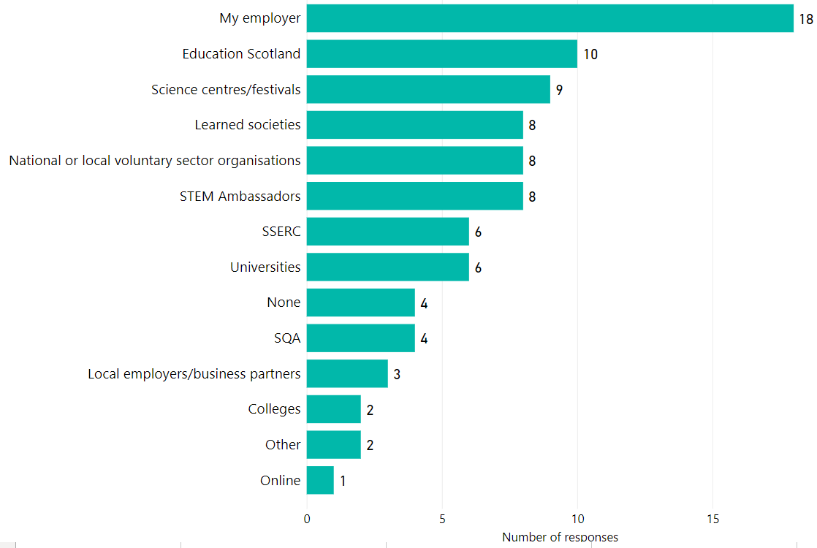
Figure 9: Organisations providing STEM professional learning for CLD practitioners

Note. The number of practitioner responses in figure 9 exceeds the total number of responses as multiple selections were possible for this question in the online survey.

Ease of accessing professional learning in STEM
Figure 10 shows how easy respondents found it to access STEM professional learning. The proportion of respondents reporting that it was ‘easy’ or ‘very easy’ to access STEM professional learning decreased in 2022/23 survey to 26.7% from 37.0% in 2020/21 survey. The ease of access to STEM professional learning in 2022/23 is similar to the pre-pandemic value of 27.0% in 2018/19 survey. Table 6 below shows the comparison of the ease of access confirmed by respondents over all survey years.
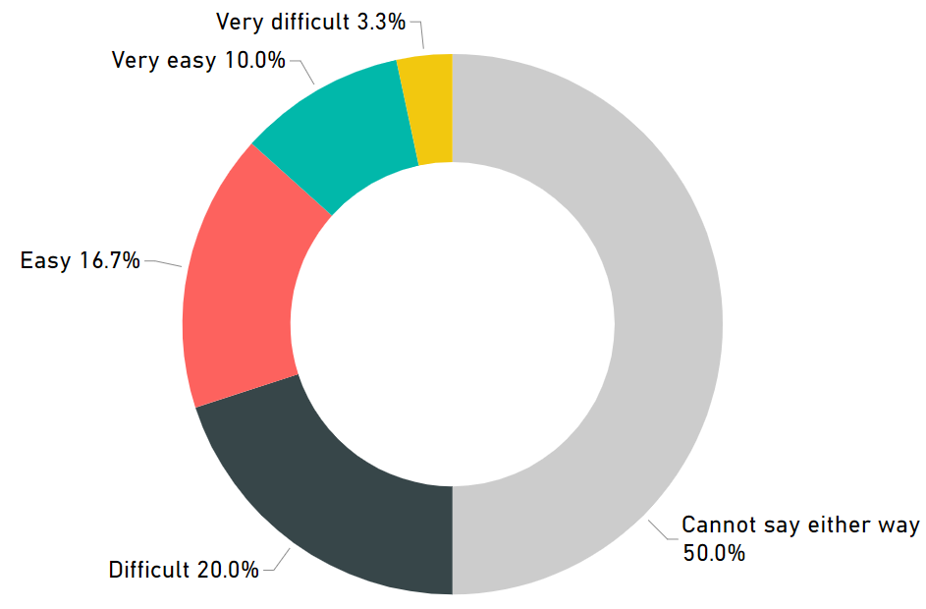
Figure 10: Ease of accessing professional learning in STEM

Ease of accessing professional learning in STEM | 2018/19 | 2019/20 | 2020/21 | 2021/22 | 2022/23
‘Easy’ and ‘Very easy’ | 27.0%  (36 responses) | – | 37.0%  (10 responses) | – | 26.7%  (8 responses)
Table 6: Comparison of ease of access to STEM professional learning across all survey years

Main barriers to accessing professional learning in STEM
The 2022/23 survey highlighted a number of barriers to accessing professional learning in STEM. The responses to this question are shown in Figure 11.
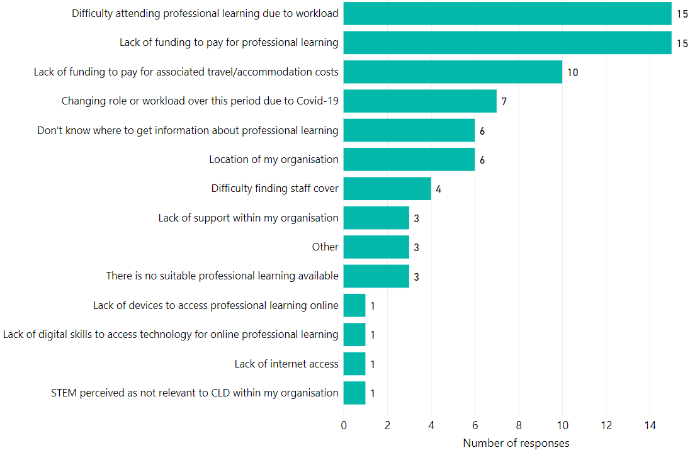
Figure 11: Main barriers to accessing STEM CLPL

Note. The number of practitioner responses in this figure exceeds the total number of responses as multiple selections were possible for this question in the online survey.

Of those who did experience barriers to accessing STEM professional learning, the themes of difficult in attending professional learning due to workload, lack of funding to pay for the professional learning and lack of funding to pay for associated travel/accommodation costs which is similar to previous years surveys.
Table 7 lists the top three barriers to accessing professional learning in STEM over recent surveys.
 | 2017/18 | 2018/19 | 2019/20 | 2020/21 | 2021/22 | 2022/23
1 | Lack of funding to pay for professional learning | Difficulty in attending professional learning due to other commitments | – | Difficulty in attending professional learning due to other commitments | – | Difficulty in attending professional learning due to workload.  Lack of funding to pay for professional learning.
2 | Difficulty in attending professional learning due to other commitments | Lack of funding to pay for professional learning | – | Changing role or workload due to Covid-19 | – | Lack of funding to pay for associated travel/ accommodation costs.
3 | Difficulty in finding staff cover | I don’t know where to get information about professional learning | – | Lack of funding to pay for professional learning | – | Changing role or workload due to Covid-19
Table 7: Main barriers to accessing professional learning in STEM
Note: 2019/20 and 2021/22 data is not available as surveys were not issued.

STEM professional learning priorities for academic year 2023/24
In the 2022/23 STEM professional learning survey practitioners were asked what their professional learning priorities were for the year ahead. Table 5 compares the top three responses from previous years surveys. Awareness about resources and support available for STEM.
 | 2017/18 | 2018/19 | 2019/20 | 2020/21 | 2021/22 | 2022/23
1 | Lack of funding to pay for professional learning | Awareness about resources and support available for STEM. | – | Learning approaches to deliver STEM learning within a CLD context | – | Awareness about resources and support available for STEM.  Learning approaches to deliver STEM learning within a CLD context.
2 | Difficulty in attending professional learning due to other commitments | Learning approaches to deliver STEM learning | – | Understanding of the concepts and knowledge that underpin digital skills within a CLD context | – | Understanding and applying digital skills within a CLD context.
3 | Difficulty in finding staff cover | How to lead and coordinate STEM | – | Support for National Qualifications | – | How to lead and coordinate STEM within a CLD context.
Table 8. Top STEM professional learning priorities in 2018/19 and 2020/21
Note: 2019/20 and 2021/22 data is not available as surveys were not issued.
Figure 12 shows the full range of responses to this question. Only one respondent indicated that STEM professional learning was not a priority for them in the year ahead.
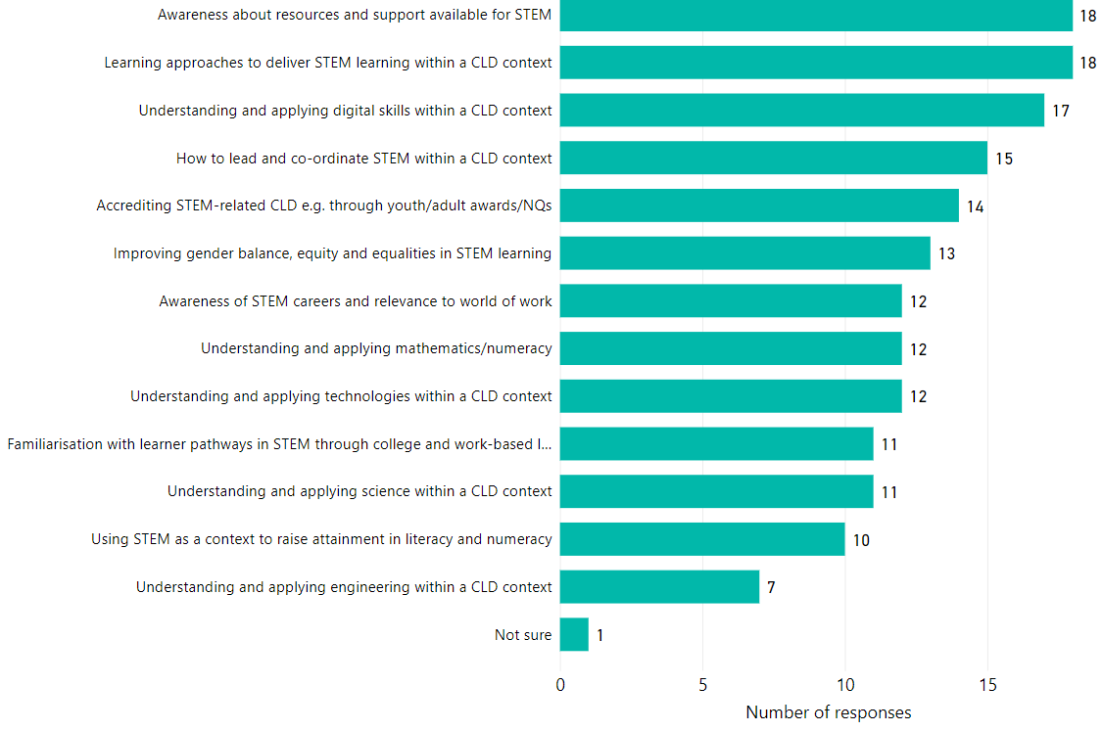
Figure 12: STEM professional learning priorities for academic year 2023/24
Note. The number of practitioner responses in this figure exceeds the total number of responses as multiple selections were possible for this question in the online survey.

Impact of future STEM professional learning opportunities
Respondents were asked which type(s) of STEM professional learning priorities they have for the period 1 August 2023 to 31 July 2024 and this is shown in Figure 13 below.
The most common response was more dedicated online professional learning resources for CLD practitioners. There was also significant support for online, regional and national networks to support professional learning in STEM.
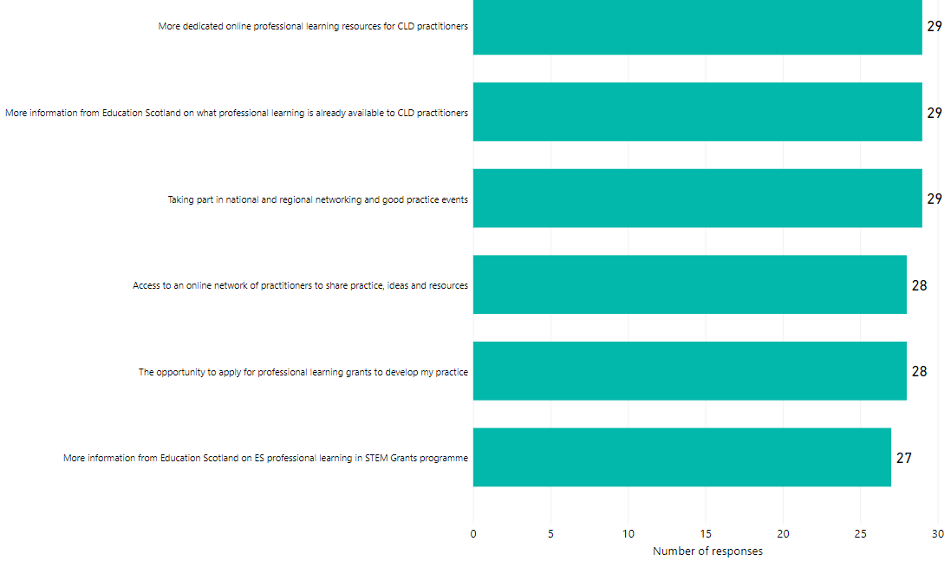
Figure 13: STEM professional learning opportunities that would deliver greatest impact
Note. The number of practitioner responses in this figure exceeds the total number of responses as multiple selections were possible for this question in the online survey.
 | 2017/18 | 2018/19 | 2019/20 | 2020/21 | 2021/22 | 2022/23
1 | Awareness about resources and support available for STEM | More dedicated online professional learning resources for CLD practitioners | – | More dedicated online professional learning resources for CLD practitioners | – | More dedicated online professional learning resources for CLD practitioners
2 | Understanding how to incorporate STEM subjects into my current practice | More information from Education Scotland on what professional learning is already available to CLD and other education practitioners | – | Access to online network of practitioners to share practice and resources | – | More information from Education Scotland on what professional learning is already available to CLD and other education practitioners
3 | Understanding how to incorporate STEM subjects into my current practice | The opportunity to apply for professional learning grants to develop your practice | – | More information from Education Scotland on what professional learning is already available to CLD and other education practitioners | – | Taking part in national and regional networking and good practice events
Table 9: STEM professional learning opportunities with greatest anticipated impact from 2017/2018, 2018/2019, 2020/21 and 2022/23 surveys
Table 9 shows the results from previous STEM professional learning surveys and allows a comparison with the 2020/21 data. CLD practitioners would still like to see more professional learning resources developed to specifically support practitioners delivering STEM in informal CLD settings as opposed to generic cross-sector support.

STEM in your practice

STEM practice in community learning and development
Practitioners were asked what areas of STEM-related community learning and development they had been involved in during the 2022/23 academic session. Reponses, shown in Figure 14, showed a clear focus on youth work with a focus on practical science. This is a shift from 2020/21 survey in which digital learning and numeracy support was the top response.
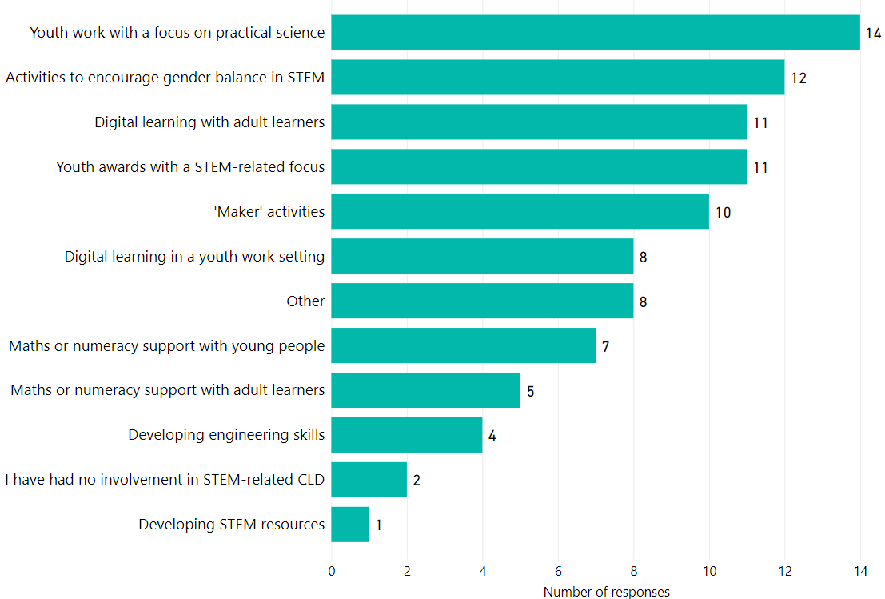
Figure 14: STEM practice in CLD
Note. The number of practitioner responses in this figure exceeds the total number of responses as multiple selections were possible for this question in the online survey.

Practitioner confidence
The 2020/21 survey asked practitioners about their confidence in relation to discrete areas of STEM. The visual below shows the proportion of practitioners who responded ‘agree’ or ‘strongly agree’ with the statement “I feel confident in delivering [discrete area of STEM]”.
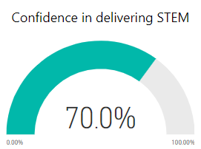
Figure 15: Practitioner confidence in delivering STEM
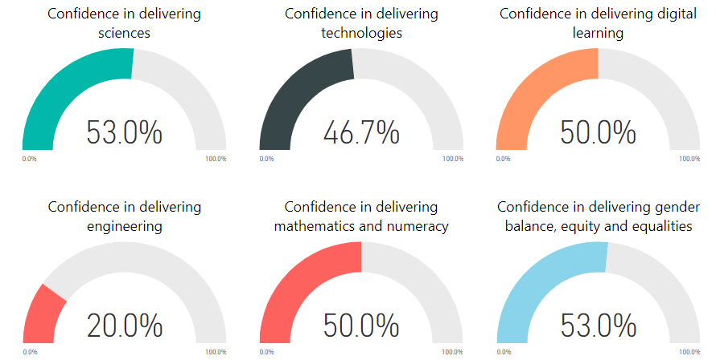
Figure 16: Practitioner confidence in delivering discrete areas of STEM
In comparison, the confidence levels of CLD practitioners for the discrete aspects of STEM in 2018/19 were: Sciences (28.4%), Technologies (32.6%), Digital (49.6%), Engineering (12.8%), Numeracy and Mathematics (63.1%), Gender balance and equalities (48.9%).
CLD practitioner confidence was highest in delivering digital learning and gender balance, equity and equalities. The confidence levels of CLD practitioners in these two areas was similar to the confidence levels of teachers and early learning and childcare practitioners when asked the same question in the 2020/21 practitioner survey. Similarly, confidence levels in delivering engineering received the lowest response rate across all sectors.
CLD practitioners reported a confidence level of 45.8% in relation to the delivery of mathematics and numeracy. This is significantly lower than the 81.0% confidence rate reported by practitioners in the early learning and childcare and school sectors in the 2020/21 practitioner survey.
I felt confident (agree and strongly agree) in delivering STEM (discrete area) | 2018/19 | 2019/20 | 2020/21 | 2021/22 | 2022/23
STEM | Data not collected | – | Data not collected | – | 70.0%
Science | 28.4% | – | 39.1% | – | 53.0%
Technologies | 32.6% | – | 42.9% | – | 46.7%
Digital | 49.6% | – | 60.0% | – | 50.0%
Engineering | 12.8% | – | 27.3% | – | 20.0%
Mathematics and numeracy | 63.1% | – | 45.8% | – | 50.0%
Gender balance, equity and equalities | 48.9% | – | 60.0% | – | 53.0%
Table 10: Confidence levels in discrete areas of STEM

Awareness of Education Scotland resources
The 2022/23 survey introduced two new questions relating to Education Scotland resources for CLD practitioner. The questions asked about the awareness and relevance of the resources and the following details the summary:
STEM Nation Award Programme for CLD settings: Awareness 56.7%, Relevance 80.0%
IGBE and equalities toolkit for CLD practitioners: Awareness 26.7%, Relevance 73.3%
Figure 17 and 18 show the awareness and table 11 details the relevance.

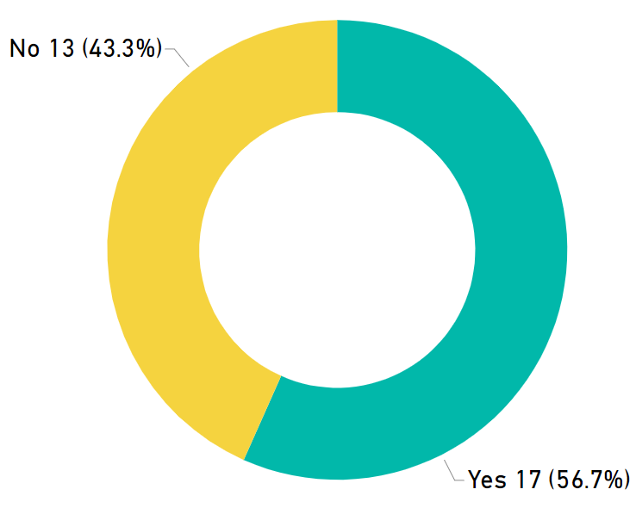
Figure 17: Awareness of STEM Nation Award for CLD

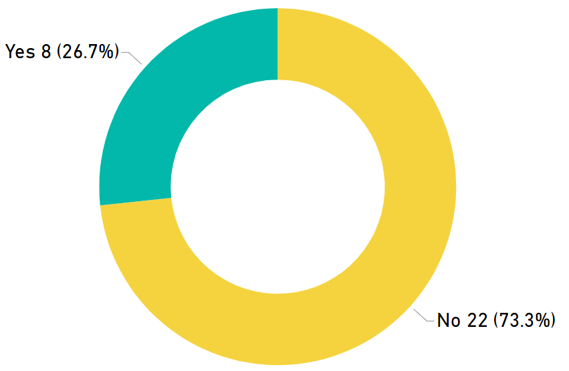
Figure 18: Awareness of IGBE and equalities toolkit for CLD

 | STEM Nation Award programme for CLD providers | IGBE and equalities toolkit for CLD providers
Resource of ‘some relevance’ and ‘very relevant’ | 80.0% | 73.3%
Table 11: Awareness of STEM Nation Award programme and IGBE and equalities toolkit for CLD

Education Scotland response
Education Scotland has continued to provide significant support and resources to address the priorities and needs identified by practitioners in relation to STEM.

CLD Network
ES also co-hosts an online STEM in CLD practitioners network in partnership with YouthLink Scotland, Learning Link Scotland and Glasgow Science Centre. Sessions are open to all CLD practitioners. Find out more about the Network and other resources and information on our CLD and STEM Wakelet. CLD and STEM - Wakelet

Enhancing Professional Learning in STEM Grants Programme
Education Scotland funded a total of £651,888 of STEM professional learning grants in financial year 2022/23, supporting 84 projects in Round 3 and 59 projects in Round 4 of the STEM grants. This funding was aligned to the priorities and findings from the previous STEM annual practitioner surveys. Since the grants programme started in 2018, over £4.6 million has been awarded to 307 projects. An estimated 68,349 practitioners have benefitted from the three funding rounds which have run to date. This includes 1,874 CLD practitioners recorded as having benefitted from the STEM Grants Programme. More information about the grants being supported is available from the STEM summary page on the National Improvement Hub.

Professional learning
Education Scotland’s Community Learning and Development Officers have engaged widely with the CLD sector to support their STEM professional learning needs. This was supported in partnership with Education Scotland’s regional STEM, Numeracy & Mathematics and Digital Skills teams. STEM professional learning opportunities continue in session 2021/22 providing a blend of national and regional webinars across the STEM subjects. For more information please see Education Scotland’s Event page.

STEM Nation Award
From 2022, CLD agencies are invited to apply for the STEM Nation Award in recognition of innovative and inclusive STEM practice. The CLD application guidance was co-developed by Education Scotland and a working group of CLD practitioners from across Scotland. The award programme provides a framework to help evaluate existing practice, identify areas of strength and development needs and create an action plan for continued improvement in STEM. The award contains five elements which can be worked towards over a period of three years: Leadership in STEM, STEM learning in the community, Employability and STEM partnership working, STEM curriculum and learner pathways and Equity and equality in STEM. Education Scotland’s Regional STEM Education Officers will provide ongoing support to CLD agencies interested in working towards and applying for the STEM Nation Award. For more information please STEM Nation online resource STEM Nation Award CLD

STEM Nation Online Resource
Education Scotland has also created a STEM Nation online resource where practitioners can access:

- Resources: Resources – STEM Nation (glowscotland.org.uk)

- Events calendar: Education Scotland has worked with national STEM partner organisations to produce a calendar that lists STEM-related CLPL being offered regionally and nationally. The calendar contains all events categorised by sector, theme and also geographical location: Events – STEM Nation (glowscotland.org.uk)

Appendix: Survey questions
2022/23 survey questions for community learning and development practitioners
Who do you work for?
What is your specific role within CLD? Please select all that apply.
Which of the following closely aligns with your work pattern?
Which local authority area/areas do you work in?
What areas of STEM-related CLD have you been involved in?
Did your service/organisation have a STEM partner(s) from the private, public or third sector during this period?
How did you find out about these partner organisations?
Approximately how many hours of professional learning in STEM did you complete between 01 August 2022 to 31 July 2023?
Was this more or fewer hours than the same period last academic year: i.e. from 01 August 2022 to 31 July 2023?
Please tell us more about the types of professional learning in STEM that you accessed between 01 August 2022 to 31 July 2023.
Please rate each of the options below based on how valuable this professional learning has been for you. If you didn't access the type of professional learning please select N/A.
Please use this field to share any additional If you completed another kind of professional learning please tell us about it in the box below.
Which, if any, of the following organisations provided you with professional learning support between 01 August 2022 to 31 July 2023.
How easy has it been for you to access professional learning in STEM?
What, in your opinion, were the barriers (if any) to you accessing professional learning in STEM?
What are your STEM related professional learning priorities for this academic year (01 August 2023 - 31 July 2024)?
What impact would the following options have on your STEM professional learning in the future?
To what extent do you agree with the following statements regarding your STEM practice between 01 August 2022 – 31 July 2023?
Are you aware of the following Education Scotland resources?
Please rate the options below based on how relevant these resources will be in your practice
What else can you tell us about your experiences or thoughts on STEM-related professional learning for CLD practitioners?

Education Scotland
Denholm House
Almondvale Business Park
Almondvale Way
Livingston EH54 6GA

T +44 (0)131 244 4330
E enquiries@educationscotland.gov.scot

www.education.gov.scot

STEM Education and Training Strategy for Scotland: https://www.gov.scot/publications/science-technology-engineering-mathematics-education-training-strategy-scotland/
A summary of STEM resources: A summary of STEM resources | Resources | Education Scotland
STEM strategy: key performance indicators: STEM Strategy: key performance indicators - gov.scot (www.gov.scot)
STEM Strategy for Education and Training in Scotland - First Annual Report: STEM strategy for education and training: first annual report - gov.scot (www.gov.scot)
STEM Strategy for Education and Training in Scotland - Second Annual Report: STEM strategy for education and training: second annual report - gov.scot (www.gov.scot)
STEM Strategy for Education and Training in Scotland - Third Annual Report: STEM strategy for education and training: third annual report - gov.scot (www.gov.scot) 7 STEM Strategy for Education and Training in Scotland - Refresh: STEM education and training strategy - refresh: annual report - gov.scot (www.gov.scot)

