CLD Standards Council Competent Practitioner Framework

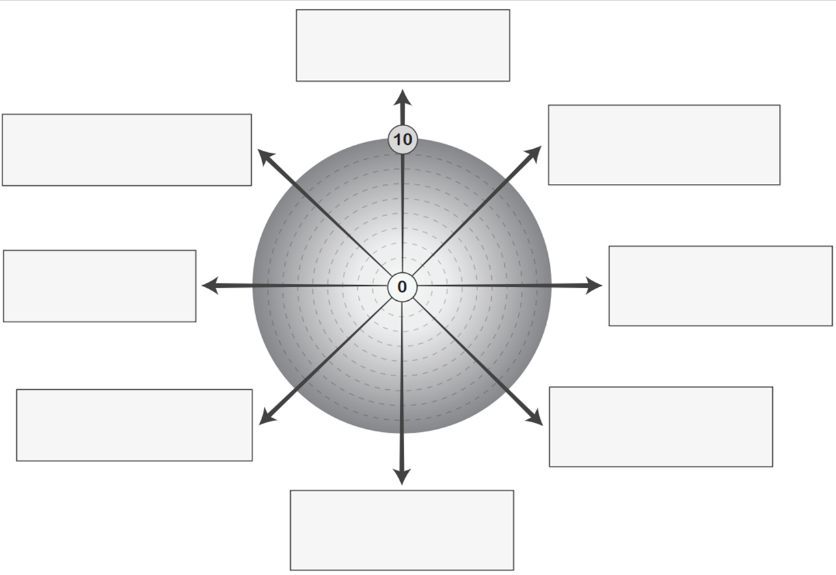
Competence C: Provide learning and development opportunities in a range of contexts, so that people can identify and achieve their individual and collective goals.
Values of CLD: Self-determination, Inclusion, Empowerment, Working collaboratively, Promotion of learning as a lifelong activity
Competence G: Evaluate and inform practice, so that robust evidence can sustain, inform, influence and change policy and practice.
Competence F: Develop and support collaborative working, so that people can enhance decision making and collaborative activities that impact on the quality of life of individuals and communities.
Competence E: Organise and manage resources, so that individuals, communities and organisations can achieve effective management of community assets and resources, services and organisations.
Competence D: Facilitate and promote community empowerment, so that people can take individual and collective action to bring about change.
Competence B: Build and maintain relationships with individuals and groups so that people’s ability and opportunities to work together are enhanced.
Competence A: Know and understand the community in which we work, so that practitioners can work with individuals and communities to identify and plan action based on knowledge of some of the internal and external influences at work.

