Standard for Full Registration (August 2021)

The self-evaluation wheel covers the standards under the following headings:

- Professional Knowledge and Understanding including

- Curriculum and Pedagogy
- Professional Responsibilities

- Professional Skills and Abilities including

- Curriculum and Pedagogy
- The Learning Context
- Professional Learning

These Standards have been selected as having the most relevance to the Equity programme.
It will be helpful to visit the Standards for Registration and read over each section as you consider each area of each wheel.

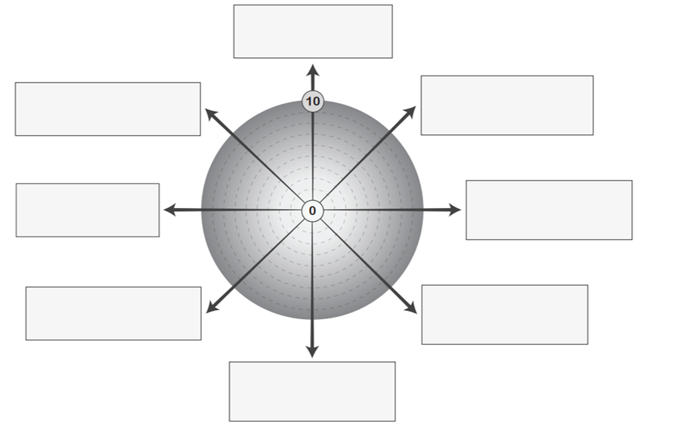
3.2.2 I recognise that childhood experiences impact on learning and well-being of children and young people and actively respond in appropriate ways, seeking advice and collaborating as required.
3.1.3 I create and sustain effective working relationships with colleagues, parents / carers, families, wider school community and partner agencies to support learning and well-being across the school and taking a lead role when appropriate.
2.1.1 I take account of the gender, social, cultural, ethnic, religious and economic context of learners and how to adapt accordingly.
3.3.1 I engage critically with research to challenge and inform professional practice and critically question and challenge educational assumptions, beliefs and values of self and system.
3.2.3 I recognise where learners with additional support needs require alternative approaches and seek support as necessary.
3.1.2 I employ appropriate teaching strategies and resources including digital approaches to meet the needs and abilities of every learner.
2.2.1 I have a depth of knowledge and understanding of biases and their impact on people and challenge them.
2.1.4 I have a depth of knowledge and understanding of how to adapt planning approaches to ensure that the needs of every learner are effectively addressed.

