****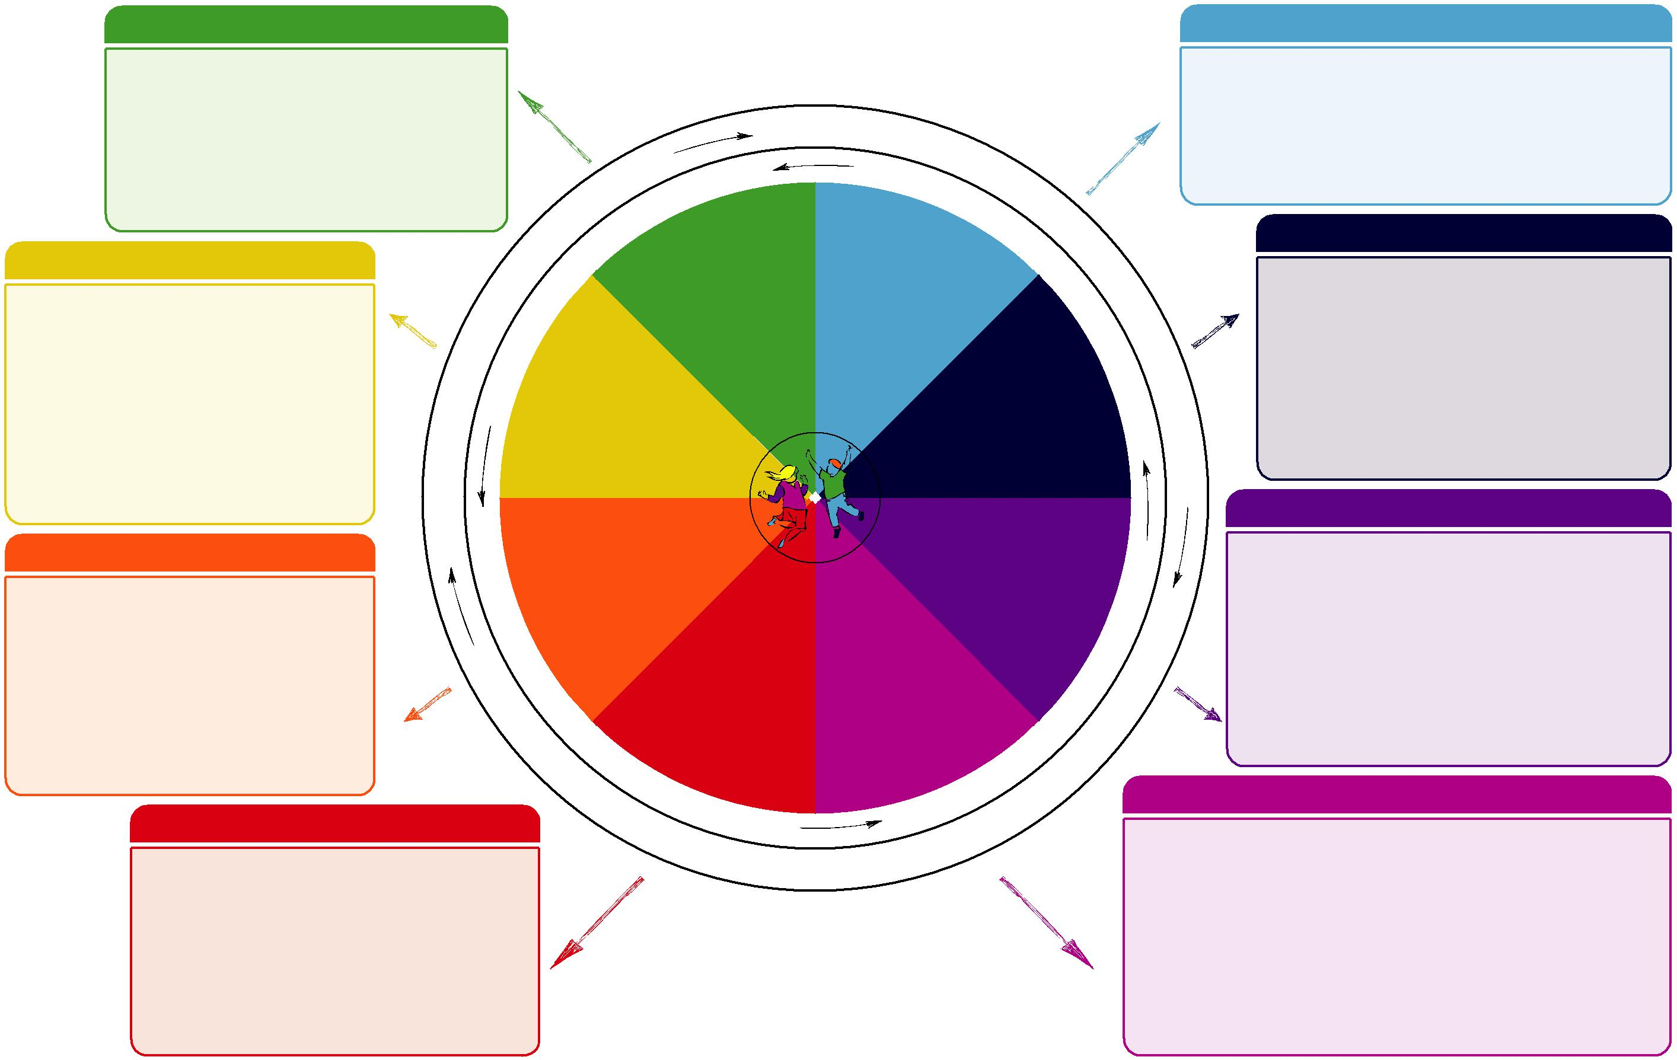

**Do luchd-ionnsachaidh na h-Alba, le luchd-foghlaim Alba**

For Scotland's learners, with Scotland's educators

**Slàinte agus Sunnd Dleastanas na h-uile**