Standard for Headship (August 2021)

The self-evaluation wheel covers the standards under the following headings:

- Professional Knowledge and Understanding including

- Curriculum, Pedagogy, Leadership and Strategic Vision
- Professional Responsibilities

- Professional Skills and Abilities including

- Curriculum, Pedagogy, Leadership and Strategic Vision
- The Learning Context
- Self-Evaluation

These Standards have been selected as having the most relevance to the Equity programme.
It will be helpful to visit the Standards for Headship and read over each section as you consider each area of each wheel.

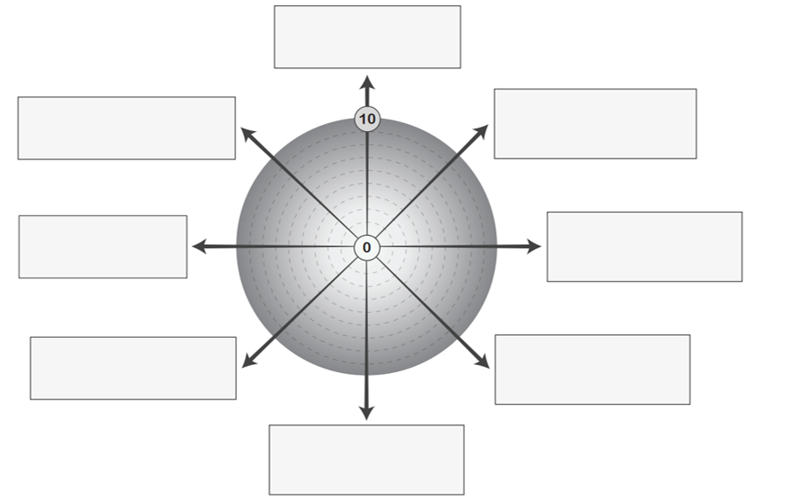
2.1.3 I ensure effective learning experiences for learners with additional support needs.

3.2.1 I promote and enable a learning culture where additional support needs are integral to the learning community ethos.
2.2.4 I regularly display and communicate my deep commitment to the education, well-being and inclusion of every learner through your everyday thinking and practice.
2.2.4 I communicate effectively and actively to build positive working relationships with colleagues, parents / carers/ families and partners.
3.1.1 I ensure curriculum design and planning processes are well informed to ensure learners with additional support needs experience a curriculum that meets their needs.
3.2.4 I understand my own and others responsibilities in supporting the well-being needs of every child or young person to inform practices in the school and the wider learning community.
3.4.2 I enable and support colleagues in using a wide range of information to plan curriculum (pedagogy, assessment and reporting) with a focus on improving outcomes for learners.
3.1.3 I model and develop a culture of mutual trust, respect and accountability through the development and enactment of the curriculum.

