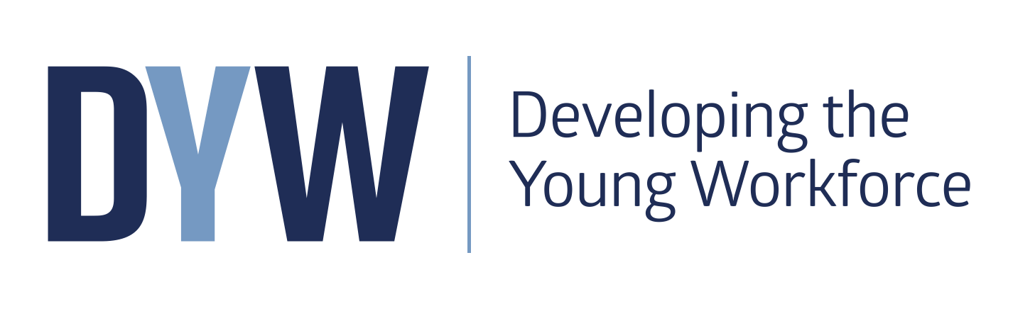

Information update

January 2020

Headline Target – to reduce youth unemployment by 40% from 2014 levels by 2021

Our vision: To develop Scotland’s young workforce by providing young people with learning which is directly relevant to getting a job, benefiting individuals and improving the economy through increased youth employment.

Resources and information

How to keep up with the latest information and engage with Education Scotland and others?

Subscribe Developing the Young Workforce (DYW) monthly e-bulletin:
- Sign up here: http://edscot.org.uk/p/LQE-39I/subscribe
- Access all previous e-bulletins here: https://blogs.glowscotland.org.uk/glowblogs/eslb/2016/05/06/the-first-5-dyw-e-bulletins-for-2016-so-far/

Education Scotland’s learning blog – Keep up to date with news and updates across the organisation.
https://blogs.glowscotland.org.uk/glowblogs/eslb/category/skills/

Follow us on Twitter to get snippets of information @ESskills and use the hashtag #youngworkforce

Join the professional conversations on Yammer? :
https://www.yammer.com/glowschools.org.uk/#/threads/inGroup?type=in_group&feedId=8228932&view=all

Email us at edsskills@educationscotland.gsi.gov.uk

DYW Website
The website contains key information including the suite of standards and guidance documents, resource and weblinks as well as news from our blogs and twitter feed.

https://education.gov.scot/education-scotland/scottish-education-system/policy-for-scottish-education/policy-drivers/developing-the-young-workforce-dyw/

More details on the DYW programme and its key components can be found on the Developing Employability, Creativity and Skills web page

https://education.gov.scot/education-scotland/what-we-do/developing-employability-and-skills

A summary of all DYW related resources and information can be accessed on the National Improvement Hub here:
https://education.gov.scot/improvement/learning-resources/a-summary-of-developing-the-young-workforce-dyw-resources/

Standards and Guidance documents

Career Education Standard (3-18)
This document contains the entitlements and expectations as well as examples of ‘I can’ statements to support practitioners in developing career education from 3-18.
https://www.education.gov.scot/Documents/dyw2-career-education-standard-0915.pdf

A review of the Career Education Standard, Work Placements Standard and School/Employer Partnership guidance has been undertaken and the report has now been published on the Education Scotland website

Work Placements Standard
The standard sets out the expectations for young people, employers, parents, schools and local authorities in advance, during and after a placement. Resources and benchmarking/self-evaluation tools have been developed to support schools and Local authorities achieve the ambitions of the standard which are available on the National Improvement Hub.

School/Employer Partnership Guidance - for schools, employers and local authorities
These three documents support the aim of creating meaningful and productive partnerships in all secondary schools, highlighting the benefits and suggest practical steps.
https://www.education.gov.scot/Documents/DYW_GuidanceforSchoolEmployerPartnerships0915.pdf

Interesting practice exemplars
The following interesting practice examples are available on the National Improvement Hub:

Early Years/Primary
- St Mary’s Primary School: Work-based learning through community partnerships
- Maisondieu Primary School: Opening horizons and challenging stereotypes through career education
- Dalgety Bay Primary School: CES 3-18 and the heart of school planning
- Busby Primary School: Skills development at the core of the curriculum
- Ferguslie – Pre-Five Centre: Skills Development in Early Years
- Bonhill Primary School: A whole school approach to enterprise and employability education
- Career education in the primary sector – Caskieberran Primary School
- Developing Career Management Skills – Millburn Area School Group

Secondary
- Kingussie High School: Profiling employability skills and wider achievement
- A partnership approach at Ardrossan Academy
- Currie Community High School: Shared Vision
- Castlebrae Community High School: Junior Adventure Leader – developing employability skills in the BGE
- Larbert High School: Skills Framework
- Calderglen High School: Inspirational learning delivered in partnership
- Craigroyston Community High School: Developing skills to realise aspirations
- Dalziel High School: Skills development through STEM
- Scottish Food and Drink Federation and Bathgate Academy – an industry partnership project
- ‘Teen Takeover’ and Community Café, Sandwick Junior High School, Shetlands
- Pre-Apprenticeship Programme at Govan High School (Glasgow)
- Skills Academy programme at St Matthew’s Academy (North Ayrshire)
- Woodfarm High School: A whole school approach to career education

Further Education
- SCOTS Programme at Forth Valley College
- Kibble Education and Care Centre

Local Authorities
- Moray Skills Pathways
- Clyde Gateway
- Angus Works – Extended work placements for senior phase pupils
- ‘Workout’ programme at South Ayrshire Council
- Work-based learning initiatives in Dumfries and Galloway
- Flexible Pathways Initiative​
- Guide to work-based learning in Dumfries and Galloway

Equalities
- Parkhill Secondary School: Enterprise Academy – flexible pathways for young people with additional needs
- ​Sanderson High School: Tailored learning pathways to meet the needs of all
- Flexible Learning Pathways Case Study – Sanderson High School​
- ​Improving gender balance from 3-18

Capacity building
- The National DYW Leads Network was established in February 2017. It brings together colleagues with a lead role for DYW implementation and delivery from authorities and colleges. More recently this group has now been joined by the DYW Regional Employer Groups who now form a collaborative network.

- Regional Curriculum Planning
In order to support curriculum planning at regional level providing access to a wide range of diverse pathways for learners particularly in the senior phase a number of resources are now available on the NIH. These include:
- Learning pathways: Senior Phase design
- Senior phase benchmarking tool
- Partnership Self-evaluation Guide for School/College Partnership
- Preparing young people for the Future: Senior phase in Scotland’s Colleges
- Thematic Review in the Moray Area (senior phase focus)

A number of interesting practice exemplars have also been published such as:
- St Andrew’s Secondary School – weaving employability into the senior phase curriculum
- Craigroyston Community High School – learning pathways tailored to meet individual needs and aspirations
- Govan High School – pre-apprenticeship training programme
- Dalziel High School – partnership working supporting vocational qualifications and pathways to engineering
- Kibble Education and Care Centre – work-based learning programmes.

- Curriculum Narrative Refresh
The Refreshed Narrative for Scotland’s curriculum, was launched at the Scottish Learning Festival by DFM and was a product of collaboration between education practitioners, academics, local government, Education Scotland and key educational bodies. It has been widely endorsed across the leadership of Scottish education. Education Scotland is developing a range of different opportunities to engage schools and practitioners with the refreshed narrative and to continue to support schools and settings in relation to their curriculum design and development. This will include more focused work on the wider curriculum offers particularly in the secondary schools to enhance the provision learning pathways for all learners

- The National STEM Network was launched on 2017 in Glasgow. The event brought together members from the former sciences, technologies and mathematics networks for the first time to share existing practice in STEM and consider a number of STEM priorities. Over 80 local authority STEM coordinators and officers from most local authorities attended. Education Scotland plan to host further events in 2017. In the aftermath the Scottish Government published the STEM Education and Training Strategy for Scotland. This sets out a vision of Scotland as a STEM nation: with a highly-educated and skilled population equipped with the STEM skills, knowledge and capability required to adapt and thrive in the fast-paced, changing world and economy around us. https://education.gov.scot/improvement/learning-resources/a-summary-of-stem-resources/

Contact: Ian Menzies ian.menzies@educationscotland.gov.scot

Career Education 3-18

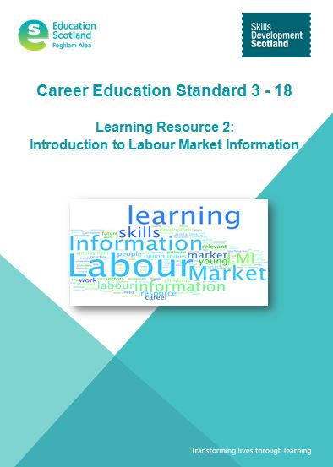
- Professional learning resources available on the National Improvement Hub:
- Learning Resource 1: Introduction to the Career Education Standard (3-18)
- Learning Resource 2: Introduction to the Labour Market Information
- Learning Resource 3: Introduction to the Career Management Skills
- Learning Resource 4: Introduction to My World of Work (to be released March ’17)
- Learning Resource 5: Introduction to Creativity Skills
- Learning resource 6: Profiling skills and achievements in the context of DYW/career education
- Learning Resource 7: Ensuring equality of opportunities

This suite of emerging resources are designed to support the expectations for teachers/practitioners set out on page 10 of the Career Education Standard (3-18). We anticipate that these resources.
Contact: Klaus.Mayer@educationscotland.gov.scot

- Profiling Skills and achievements – guidance
This resource has been develop alongside the associated learning resource (see above) in order to support the realisation of the relevant CES 3-18 entitlements and expectations and help learners to articulate and record their career education journey and skills development. A number of video guides have also been released to support teachers in their conversations with learners in this area.

- A suite of teaching resources designed with and for teaching staff to use with students is available at https://www.myworldofwork.co.uk/partners . These resources guide teaching staff on how to get the best out of My World of Work including within their subject area. Each activity is designed to meet a range of experiences and outcomes and support teachers to deliver the entitlements / ‘I can’ statements defined by the Career Education Standard .

- Primary school career education resources – My World of Work/I can.
A suite of tools designed for use by teachers with children in P5 to P7. Mapped to CfE and the Career Education Standard, the three fun and engaging tools help introduce children to the concept of careers and how it relates to them.
More information and how to get started at: https://www.myworldofwork.co.uk/primary

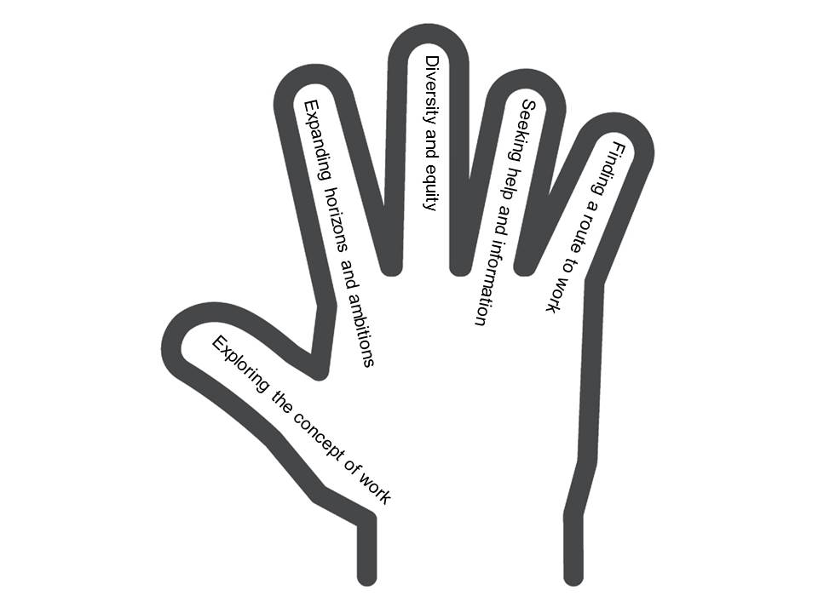
- Career Education Standard – Exemplification tool:
Based on the ‘I can’ statements this tool supports organisations and practitioners in planning, delivery and reflection on the implementation of the standard . https://blogs.glowscotland.org.uk/glowblogs/eslb/2016/12/01/career-education-standard-3-18-exemplification-tool-offers-a-helping-hand/

- CES 3-18 Self-evaluation Wheel and Reflection Tool
These materials have been specifically designed to help teachers and practitioners reflect on their expectations and entitlements for children and young people outlined within the Career Education Standard.

- Parent resources:

- Career Education: A World of Possibilities http://www.npfs.org.uk/wp-content/uploads/2015/09/NPFS_world_of_possibilities_1509_E.pdf

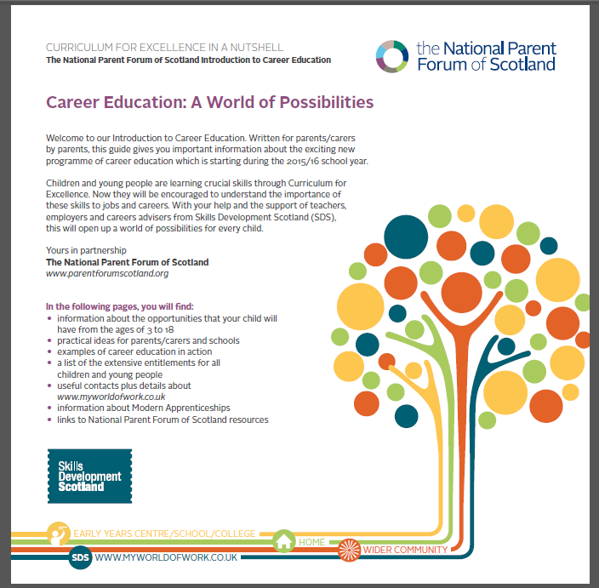
- Skills in a Nutshell http://www.npfs.org.uk/skills-in-a-nutshell/

- Learning Pathways in the Senior Phase and beyond. http://www.npfs.org.uk/wp-content/uploads/2015/06/nutshells_pathway_E.pdf

- Career Conversations in a Nutshell
http://www.npfs.org.uk/downloads/career-conversations-in-a-nutshell/

- Digital Skills in a Nutshell
https://www.npfs.org.uk/downloads/digital-skills-in-a-nutshell/

- Creativity, Enterprise and Employability: Skills for Learning Life and Work
http://www.npfs.org.uk/wp-content/uploads/2017/05/creativity_E.pdf

- Apprenticeships in a Nutshell

Help and information for parents and carers on how to support their child with career decisions at https://blogs.glowscotland.org.uk/glowblogs/eslb/files/2016/11/Apprenticeships-in-a-Nutshell.pdf

- My World of Work
Skills Development Scotland’s (SDS) award-winning careers web service, complements the Career Management Skills Framework and supports the SDS’s work of Careers Advisers in schools, colleges and local centres. Used extensively in secondary schools, the website offers customers careers information and advice on:
  - My Career Options
  - Learn and train
  - Getting a job

Latest tools: https://www.myworldofwork.co.uk/

- My World of Work Ambassadors
The programme is free, easy-to-run, with ready-made resources providing career education benefits for pupils, teachers, parents, carers and the wider school community. The ambition is for every school in Scotland to recruit volunteer Ambassadors who have the aim of spreading the word about the advice, information and resources available on My World of Work and the help it can offer to pupils and their parents, carers and teachers.
Ambassadors gain valuable experience working on promotional activities in school, while building employability and career management skills that can be used in their future education and working lives. Staff will also benefit from experience gained in leadership and project management. A full suite of project resources for pupils and teachers have been designed in a logical, easy to follow format.
More at https://www.myworldofwork.co.uk/partners

- My World of Work Live!

A set of interactive exhibits and activities designed to inspire young people’s interest in careers in science, technology, engineering and maths (STEM). Every free, fun My World of Work Live! experience is about hands-on learning – building, making, designing – and makes the best use of the latest technology to engage and inspire. The My World of Work Live! Digital Studio and Careers Lab at the SDS Inverness careers centre has recently been nominated for a UK Career Development Award for Best Use of Technology in Career Development.
Go to https://www.myworldofwork.co.uk/live to find out more.
NB.: A new profiling and skills tool for learners will be available in the new academic session 2018/19.

- Skills Investment plans
Working with employers and industry leadership groups, Skills Development Scotland has produced Skills Investment Plans. The plans focus on key issues for Scotland’s growth industries and provides information about what is being done to help.
https://www.skillsdevelopmentscotland.co.uk/what-we-do/partnerships/skills-investment-plans/

Most recently SDS has published Regional Skills Assessment data. The aim of Regional Skills Assessments (RSAs) is to provide a coherent evidence base to inform future investment in skills, built up from existing datasets and forecasts.
This helps to inform learning about future career prospects and pathways.
https://www.skillsdevelopmentscotland.co.uk/what-we-do/skills-planning/regional-skills-assessments/#data-matrix

STEM
- Raising Aspirations in Science and STEM education (RAISE) Programme
A thirty-three months pilot programme has been launched to raise aspirations in science and STEM education in Scotland’s schools. The £1 million programme is being funded by The Wood Foundation and Scottish Government and led by Education Scotland in partnership with the Scottish Schools Education Research Centre. The RAISE programme, previously entitled the Improving Primary Science Education Programme, will enable ten local authorities to recruit development officers to build the capacity of practitioners in all their schools in relation to learning, teaching and assessment in science and STEM. The programme will have a strong focus on science and STEM in the broad general education and will seek to ensure effective progression in learning across sectors.

From the outset, the programme will seek to make strong connections locally and nationally with other priorities including Developing Scotland’s Young Workforce, the Digital Strategy, he Strategy for STEM Education and Training and Improving Gender Balance in STEM. Also key to the programme will be how it links with our national ambitions to promote excellence and equity within the context of the National Improvement Framework and Scottish Attainment Challenge. Education Scotland and authorities will also be liaising with STEM organisations and providers throughout to promote effective partnership working and explore new models of engagement.

Authorities involved in year 1 (FY 16/17) include: Highland, Moray, East Ayrshire, West Dunbartonshire and Edinburgh. From August 2017, a further five authorities will join the programme including: Fife, Glasgow, Angus, Dumfries and Galloway and Aberdeenshire. All of the authorities involved have an existing commitment to science and STEM and have been involved in the Primary Cluster Programme supported by the Scottish Schools Education Research Centre (SSERC).

Following an externally evaluation there may be the opportunity for the RAISE Programme to be extended to all 32 local authorities over a total of an eight-year period. We would encourage all DYW leads within the pilot authorities to contact their authority leads for the RAISE programme if they haven’t already done so.

Contact: gayle.duffus@educationscotland.gsi.gov.uk . National Education Officer.

- National STEM Network – see note 3.

Learner Journey 15-24
- The Learner Journey Review (15-14) has now been published .
The report includes 17 recommendations aimed at improving the education and skills system by providing a more coherent and consistent education journey that allows all young people to better plan and progress their future pathways.
The key objective of the Learner Journey Review is to ensure “all learners are on the right route to the right job, through the right course via the right information”. To achieve this learners will require effective support and guidance in profiling their achievements and skills.
The review makes direct reference to eg. embedding DYW within the curriculum (Rec 9), creating diverse curriculum pathways including college courses (Rec 5+11), CIAG delivery (Rec2) etc.
- The new Arrangements for assuring and improving the quality of provision in Scotland’s colleges implemented in December 2016 require colleges to engage local authorities, schools, employers and community partners in evaluating the quality provision and planning for improvement.

Curriculum development work in ES for 2017/18 will build on these arrangements. to support and enable post-compulsory education and training providers to jointly evaluate the regional curriculum offer and plan for improvement. This includes supporting meaningful ‘bridging’ from schools to other post-compulsory education providers and strengthening understanding amongst teachers of the role of individual subject areas within industry sectors. 2 pilots have been identified in Forth Valley and Fife. Work has started to engage DYW leads in schools/authorities and colleges in joint evaluative activities.

18. Senior Phase Benchmarking Tool
This tool has been developed to help organisations evaluate current approaches to planning the senior phase of the curriculum and to consider any necessary improvements/actions.
https://education.gov.scot/improvement/self-evaluation/senior-phase-benchmarking-tool/

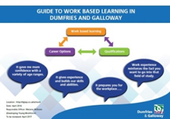
19. Work Placements Standard Tool kits:

- Work Placements Standard Benchmarking tool
https://education.gov.scot/improvement/learning-resources/work-placements-standard-benchmarking-exercise

- Kibble Education and Care Centre
https://education.gov.scot/improvement/learning-resources/work-placements-standard-toolkit-kibble-education-and-care-centre/

- Guide to work-based learning in Dumfries and Galloway
https://education.gov.scot/improvement/learning-resources/work-placements-standard-toolkit-kibble-education-and-care-centre/

- Work Placements Toolkit (West Lothian Council)

20. Self-evaluation guide for school/college partnerships
This self-evaluation guide has been created for school and college senior managers, practitioners, guidance and support staff to assist quality enhancement as part of the ongoing analysis of partnerships between schools and colleges.
https://education.gov.scot/improvement/self-evaluation/a-self-evaluation-guide-for-school-college-partnerships/

Apprenticeships

21. Foundation Apprenticeships allow young people to complete elements of an apprenticeship while still at school. Available in 2017-18 across 12 subject areas:
- Accountancy
- Business skills
- Civil engineering
- Creative and Digital Media
- Engineering
- Financial Services
- Food & Drink Operations
- Hardware and System support
- Scientific Technologies
- Social Services – Children and Young People
- Social services and Healthcare
- Software Development

You can visit apprenticeships.scot/foundation for details of what’s available to students locally and how to register.

22. Modern Apprenticeships
There are over 80 Modern Apprenticeship frameworks – from healthcare and financial services to construction and IT. These have been developed by sector skills councils, in consultation with their industry to provide learners with work-based learning pathways accredited at SCQF level 5 - 7.
Modern Apprenticeships help employers to develop their workforce by training new staff, and up-skilling existing employees. For individuals, an MA is a job which lets them earn a wage while gaining an industry-recognised qualification. At the same time it provides valuable work experience with the potential if a direct route into employment.

22. Graduate Level Apprenticeships provide work-based learning opportunities for employees up to Masters level. Visit apprenticeships.scot for more information.

23. Aspiring apprentices can search for vacancies at apprenticeships.scot. There’s also information for employers on how to get involved as well as a vacancy upload service.

Find more information on Foundation Apprenticeships the National Improvement Hub here: https://education.gov.scot/improvement/learning-resources/foundation-apprenticeships/

Creativity
25. What Are Creativity Skills?
Infographic outlining the four creativity skills.
http://bit.ly/whatarecreativityskills - format

26. Find your local Creative Learning Network
Local authority contacts leading funded programmes of activity to build capacity for creativity through partnership working.
http://bit.ly/creativitycontacts

27. Creativity Infographics
A suite of eight infographics which explain why creativity is integral to Curriculum for Excellence and improves outcomes for all learners. The largest will soon be available as pull up banners in each local authority; all are either printable or look great on a smart phone.
http://bit.ly/creativitybanners

28. Planning For And Evaluating Creativity
Tools to support planning and that allow evaluation of the development of creativity skills, many of which are used extensively in the field by the Creative Learning Networks
http://bit.ly/planforcreativity
29. Creativity portal
All DYW related items can be found under the following oink:
http://creativityportal.org.uk/?q=&t=,developing-the-young-workforce

Contact: Julia Fenby julia.fenby@educationscotland.gsi.gov.uk
Stephen Bullock stephen.bullock@educationscotland.gsi.gov.uk

Equalities
30.
The Improving Gender Balance (IGB) project has completed its successful three year pilot and a full evaluation is available here. Project ownership will now move to Education Scotland with a team of 6 Gender Balance officers working with the newly established Regional Improvement Collaboratives to roll out the learning to every Early Year, Primary and Secondary centre in Scotland. The project officers will also continue to work with other STEM, equalities and national partners to ensure gender balance principles are embedded in all areas of a young person’s journey.

The suite of resources available on the National Improvement Hub has expanded to include action guides for early years, primary and secondary, posters and postcards, lesson plans, videos and case studies of learning from the pilot.

Contact: Heather Earnshaw heather.earnshaw@educationscotland.gov.scot

DYW Regional Groups

31. DYW Regional Groups have been established in 21 regions: Glasgow; North East; Fife; Ayrshire; North Highland; the West Region; Edinburgh, Midlothian and East Lothian; Dumfries and Galloway; Dundee and Angus; West Lothian; Inverness and Central Highland; West Highland; Forth Valley; Moray; Perth & Kinross; Lanarkshire and East Dunbartonshire; Argyll and Bute; and the Borders.
Western Isles, Orkney and Shetland Islands groups have no also been established.
A ‘Formative Evaluation of the DYW Regional Groups’ has been undertaken by SQW which will include 13 recommendations. Publication date: September 2018
32. DYW Marketplace System is a digital matching platform that will allow employers to post offers of careers, skills and inspiration sessions to schools. The system has been developed as a partnership between Edinburgh, East and Mid Lothian DYW group and Skills Development Scotland, providing the digital expertise to build and host the platform.

- The Marketplace system builds on and is accessed through existing SDS digital platforms Teachers access the system through My World of Work and employers access the system through the Our Skills Force website using existing log-ins.
- A pilot has been successfully completed by the Edinburgh, East and Mid Lothian Developing the Young Workforce group. Marketplace is currently being rolled out to other DYW groups across Scotland . Currently DYW Glasgow, DYW North East and DYW Ayrshire are piloting the system.
- For teachers: Teachers can search for opportunities listed by employers or use Founders 4 Schools to find and invite business leaders to an event at https://www.myworldofwork.co.uk/marketplace
- For employers: Employers can share the opportunity they’d like to offer through https://www.ourskillsforce.co.uk/marketplace

Contact: Steven.Turnbull@gov.scot

Inspection and review

33. Focus on DYW and implementation of CES 3-18 and the WPS in early years, primary and secondary general inspections from August 2016. There is a specific focus on the Learning pathways theme from 2.2 Curriculum in secondary inspections.
- The new full establishment inspection model has a focus on the theme of Learning Pathways from quality indicator 2.2 Curriculum in How Good is Our School (fourth edition). https://education.gov.scot/improvement/Documents/Frameworks_SelfEvaluation/FRWK2_NIHeditHGIOS/FRWK2_HGIOS4.pdf
- This is providing evidence of the progress schools are making in providing flexible learning pathways for young people to meet a range of different needs and aspirations. It also evaluates the breadth of opportunities on offer including work-based learning and vocational qualifications.
- Within Leadership of Change (quality indicator 1.3), inspectors gather evidence on how well schools work with partners such as colleges, employers and third sector organisations to plan learning pathways and how well the Career Education Standard (3-18) and the Work Placements Standard are being implemented.

34. New College arrangements in place from January 2017 - see item 14.

- How good is our College?
https://education.gov.scot/improvement/self-evaluation/how-good-is-our-college/

https://education.gov.scot/improvement/self-evaluation/how-good-is-our-college/

- Arrangements for assuring and improving the quality of provision and services in Scotland’s colleges December 2016
https://education.gov.scot/improvement/practice-exemplars/arrangements-for-assuring-and-improving-the-quality-of-provision-and-services-in-scotland-s-colleges/
https://education.gov.scot/media/ssdlusgv/frwk18-arrangements-scotlands-colleges161216.pdf

35. Career Information and Guidance reviews :
Since April 2014, external review of Scotland's careers information, advice and guidance services will be conducted by Education Scotland.
Reports will be published based on local authority geographical areas, with some additional Aspect Reports being provided on themes of national interest.

All others reviews can be access here: https://education.gov.scot/education-scotland/what-we-do/inspection-and-review/inspection-and-review-sector-specific-guidance/careers-service-reviews/

36. The Review of the Career Education and Work Placements Standards and the Guidance on School/Employer Partnerships. This review looked at the pace of implementation and whether the expectations set out in the standards were ambitious enough. Evidence was gathered from ongoing CIAG and general inspection activity and from: visits to 27 secondary schools and 3 ASN schools across 13 authorities; 72 HT responses via the annual SDS survey; just under 500 responses to an Education Scotland survey and responses from 46 employers via the FSB and CBI. The report has been published in May 2017.

Contact: Peter.connelly@educationscotland.gsi.gov.uk

Scottish Attainment Challenge
37. The Scottish Attainment Challenge (SAC)is about achieving equity in educational outcomes, with a particular focus on closing the poverty-related attainment gap. In order to achieve this goal a team of Attainment Advisors support schools and local authorities to focus on and accelerate targeted improvement activity particularly in literacy, numeracy and health and wellbeing.
More information is available on Education Scotland’s website: https://education.gov.scot/education-scotland/what-we-do/delivering-the-scottish-attainment-challenge/

38. In support of the SAC The Interventions for Equity Framework is now available. This initial framework is based on a range of interventions and approaches that are currently being used in schools across Scotland and will continue to be updated and developed. These are neither exhaustive or definitive but can provide a helpful stimulus for discussions around planning. Decisions schools make about the most appropriate interventions and approaches should be based on effective self-evaluation and improvement planning, including robust measures of impact and progress.
The framework can be accessed on the National Improvement Hub (http://www.gov.scot/Publications/2016/12/8072 )

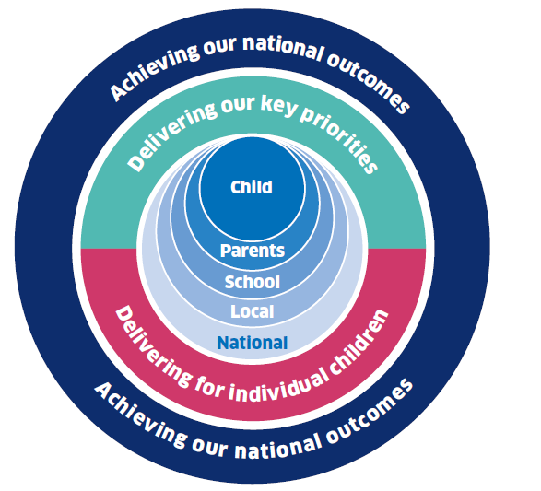
National Improvement Framework
39. The National Improvement Framework (NIF)is one of the key policy initiatives in Scottish Education designed to accelerate progress in improving outcomes for young people in four key priority areas.:
•Improvement in attainment, particularly in literacy and numeracy;
• Closing the attainment gap between the most and least disadvantaged children;
• Improvement in children and young people’s health and wellbeing; and
• Improvement in employability skills and sustained, positive school leaver destinations for all young people;

The actions set out in the National Improvement Framework for Scottish Education (January 2016) have all been developed to support high-quality learning, teaching and assessment, the core principle of Curriculum for Excellence. It identifies 6 key drivers of improvement:
•School leadership
•Teacher professionalism
•Parental engagement
•Assessment of children’s progress
•School improvement
•Performance information

Over time, the Framework will provide a level of robust, consistent and transparent data across Scotland that we have never had before, to extend our understanding of what works and to drive improvements across all parts of the system.
More information can be accessed on the National Improvement Hub: https://education.gov.scot/education-scotland/what-we-do/implementing-the-national-improvement-framework/

Other useful resources and websites
Reports and reviews

SFC Early Adopter Programme Evaluation Report
Evaluation report on Scottish Funding Council’s Early Adopter Programme to guide regional partnerships in the development of senior phase vocational pathways.
http://www.sfc.ac.uk/web/FILES/Corporate_publications_Evaluation_report_for_the_SFC_Early_Adopter_Programme_SFC/SFCCP042016_Evaluation_report_for_the_SFC_Early_Adopter_Programme.pdf

DYW and Insight
An article outlining how the Insight benchmarking tool supports DYW.

https://blogs.glowscotland.org.uk/glowblogs/eslb/2016/09/06/in-focus-how-insight-supports-dyw/

Colleges Scotland Learner Journey Think Piece

http://collegesscotland.ac.uk/briefings-and-publications/851-think-piece-the-learning-and-skills-journey/file

DYW Annual Report
The Developing the Young Workforce annual reports are published by Scottish Government setting out progress of implementing of the seven year programme.

http://www.gov.scot/Publications/2016/12/2989

Review of Youth Awards in Scotland
The review considered how well youth awards in Scotland collectively contribute to:
• improved life chances for young people
• stronger, more resilient, supportive, influential and inclusive communities
• and the implementation of Curriculum for Excellence

https://www.education.gov.scot/Documents/youth-awards-review-2015.pdf

Youth Awards Scotland has published ‘Amazing Things’, packed with information that will help young people, educators and employers learn more about youth awards and how they contribute to young people’s learning, life and work skills development: https://www.youthscotland.org.uk/resources/amazing-things-4th-edition/

Looking at Gender Balance in STEM Subjects
Find useful resources to promote gender equality in STEM as well as key research findings and influencing factors.

https://education.gov.scot/improvement/research/gender-balance-in-stem-2015/

Preparing Young People for the Future – Senior phase in Scotland’s colleges
The report seeks to provide direction and support to colleges and their partners involved in delivering the senior phase of CfE, and implementation of the recommendations of Developing the Young Workforce (DYW).
https://education.gov.scot/Documents/PreparingYoungPeopleAspectReportFinal2.pdf

Scotland Skills 2030: The Future of Work and the Skills System in Scotland
This report identifies the gaps and overlaps in Scotland's skills provision, and proposes how they can be remedied to ensure that Scotland enjoys inclusive economic growth in future.

Websites
SQA
http://www.sqa.org.uk/sqa/71723.html

Investors in Young People
https://www.investorsinpeople.com/

Foundation Apprenticeships
https://www.apprenticeships.scot/foundation-apprenticeships/

Scottish Credit and Qualifications Framework
http://scqf.org.uk/

Equate Scotland
http://www.equatescotland.org.uk/

Princes Trust
https://www.princes-trust.org.uk/

Young Enterprise Scotland
http://www.yes.org.uk/

Scotland’s Enterprising Schools
http://enterprisingschools.scot/

Springboard:
http://springboard.uk.net

Founders 4 Schools
https://www.founders4schools.org.uk/#/

Primary Futures
http://www.inspiringthefuture.org/schools-and-colleges/primary-futures/

