Bloom’s Fans – a Brief Overview
The main purpose behind using Bloom’s fans is for learners to develop an understanding of the thinking processes they use when answering questions and for staff to assess reasoning skills.
Bloom’s fans, to develop thinking skills, can be used in a variety of ways:
Planning
- Staff can adapt the activities as appropriate and incorporate these into their planning.

- Fans can be made available to learners – e.g. wallets on wall, box per group table.
Groups can work through the thinking stages as a Think, Pair, Share activity, or use them as a starter activity, determining where they will begin.
Assessment
- Used to assess progress – the level activity achieved will determine learners’ progress.

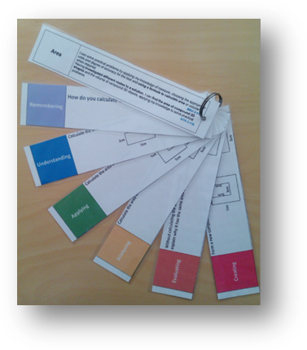
- Used to assess pupil confidence - pupils choose which activity they want to explore, determined by their level of confidence.

Homework
- Plenary Fan questions could be issued one at a time as homework to reflect on learning in class.

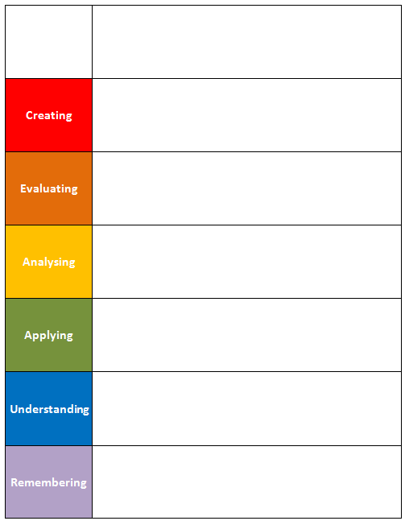
In all of these methods, learners’ working, through say, write, make and do, should demonstrate the thinking stages they have gone through to determine their answers.
How to use the fans:
The Bloom’s blank grid can be used as a tool for staff to develop their own HOT questions or as a staff development task for the department.

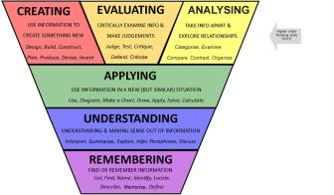
The Bloom’s Revised Taxonomy Planning Tool
can be used to phrase questions to promote higher order thinking in numeracy and mathematics classroom.

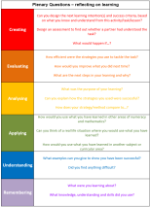

The Bloom’s Plenary Questions Fan can be used to encourage learners to reflect on their learning in a meaningful way, extending their thinking skills.

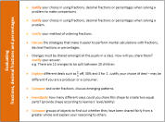
The Bloom’s Activities Fans provide learning and teaching ideas for learners to develop their higher order thinking skills in numeracy and mathematics. These include activities relating to number and number processes, fractions, decimal fractions and percentages and measurement.

