Think – Pair - Share

Think-Pair –Share is a powerful way to promote thinking and listening skills in learners and aid the staff in making each learner accountable for their learning and to get a quick and concise idea of who in the class understands the problem being discussed.
The problem can be anything; it is the timed sections of the activity and what is going on in the class that is the important part of this technique.
‘1 for me, 2 for you’
First of all the staff should present the problem and using a countdown clock give the learners a minute to read, think and try and solve the problem all on their own (this minutes silence can also be a good settler for a class at beginning of a lesson). When the buzzer signals that the minute is up, another minute is given for the learners to discuss the problem in pairs. It is a good idea here to tell the learners that the minute will be split equally, one partner alone speaks for 30 seconds, and the other must listen intently.
“I may ask you to explain what your partners views were and you must use their words not your own”
Once both have had a fair and equal chance to explain their thinking and present their solution to the other, the staff can decide, after listening into the pairs as they walk round the classroom, if a third minute is needed for the pairs to form groups of four to further discuss or if the problem has been tackled well enough in pairs.
The staff can now get a feel of the class’ understanding of the problem using traffic lights or thumbs or take a quick vote on possible answers from the pairs. The staff can then explore further and ask individuals to explain what their pair thinks or indeed what their partner thinks ensuring everyone in the class is accountable and has been taking part in the task. Here the staff can explore the wrong answers, the alternative solutions and check learner understanding.

Example - Block of butter
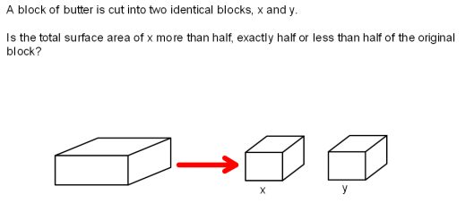

The staff then adds boxes to take a class vote
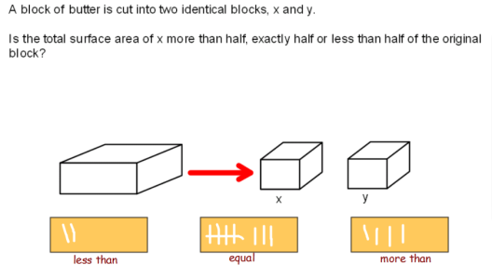

The staff can now continue to question the class
- “Why did your pair vote more than?”
- “Can you explain why Sophie said she thought it was equal?”
- “Is there another way we can think about the way to solve this problem?”

The lower order thinking for the learners is the remembering what surface area means and understanding how the surface area is calculated.
The chance learners have to think and to talk about the problem gives them the chance to move into the higher order thinking skills needed to solve the problem. Analysing what happens to the surface area as the block is cut in half, how the shape has changed and then evaluating the increase in surface area as this a new surface on each half block that weren’t there before.

