School-based technical support staff
Professional Learning in STEM
Findings from the Annual STEM Survey 2022/23

May 2022

Table of contents
List of tables 3
List of figures 3
Introduction 4
Key findings 5
Annual STEM Survey 2022/23 7
About the survey 7
About you 8
Your professional learning 10
Education Scotland response 17
Appendix: Survey questions 18

List of tables
Table 1 Number of responses to the school-based technical support staff surveys 8
Table 2: Professional learning formats recording the biggest impact 11
Table 3: Top three organisations that provided STEM professional learning 12
Table 4: Top three barriers to accessing professional learning in STEM 14
Table 5: Top STEM professional learning priorities in 2018/19, 2020/21 and 2022/23 16

List of figures
Figure 1: Number of responses per type of technical support delivered 8
Figure 2: Respondents' work pattern 9
Figure 3: Hours of STEM professional learning accessed in 2022/23 compared with 2021/22 10
Figure 4: Professional learning accessed which had ‘some impact’ or ‘significant impact’ 11
Figure 5: Organisations providing STEM professional learning to technical support staff 12
Figure 6: Accessing professional learning in STEM 13
Figure 7: Main barriers to accessing professional learning in STEM 14
Figure 8: STEM professional learning priorities for academic year 2023/24 16

Introduction
This report presents the key findings from Education Scotland’s Annual STEM Survey for school-based technical support staff covering academic year 2022/23.
Education Scotland has continued to gather and analyse annual STEM surveys since 2016/17 to inform and support the ongoing implementation of the STEM Education and Training Strategy (2017). A dedicated survey for school-based technical support staff was introduced in 2018/19.
The findings from the surveys provide valuable insights into the professional learning needs of practitioners and technical support staff; the challenges they face in accessing professional learning and their professional learning priorities. The survey findings have been used by Education Scotland to help shape the national professional learning offer, including the projects supported through the Enhancing Professional Learning in STEM Grants Programme. A wide range of partner organisations have also used the survey findings to help them align their professional learning programmes and strategies to the needs of practitioners and technical support staff.
Education Scotland will continue to measure progress against the following STEM Strategy key performance indicator:
II. Increased practitioner confidence in STEM learning in the early years, primary years and in CLD settings and increased practitioner engagement in STEM professional learning opportunities. (Excellence)
- Increase the cumulative hours of STEM professional learning accessed by early years, schools, college and CLD practitioners annually.
Progress against this key performance indicator, and others, have been reported on annually through the First, Second, Third STEM Strategy Annual Reports and Refresh Annual Report. The 2022/23 surveys will be the last to be issued and so this report marks the end of the data gathering process for the STEM Strategy.
Due to the COVID-19 pandemic, the Annual STEM Practitioner Survey was not issued in 2019/20. In addition, the 2020/21 survey coincided with the COVID Omicron wave, resulting in a significant reduction in the response rate in comparison to previous years. Care should, therefore, be taken when comparing results year on year.

Key findings
Number of responses – There were 76 responses to the 2022/23 survey for school-based technical support staff. This is an increase of 72.7% compared to the 2020/21 survey which had a response count of 44. In the 2022/23 survey, 73 (96.1% of responses) were submitted by technical support staff working in the secondary sector, and one each from the early learning and childcare, primary and all-through school sectors.

Type of technical support provided – Respondents were asked to identify which type of technical support they provided. More than fourth fifths (86.8%) of respondents said they provided technical support across sciences. The distribution of the remaining responses reflects a smaller number providing support for technical, digital/ICT and AV/ICT.

Cumulative hours of professional learning – The total number of cumulative hours of STEM professional learning accessed between 1 August 2022 and 31 July 2023 by the 76 school-based technical support staff who responded to the survey was 1,459 hours. This equates to a mean average of 19.2 cumulative hours per person per annum in 2022/23 survey compared to 14.7 cumulative hours per person per annum in 2020/21 survey.

Types of professional learning accessed – Respondents were asked about the types of professional learning they accessed and how valuable each format was. The top three types of professional learning that were identified as having ‘some impact’ or ‘significant impact’ were:

1st Attending an externally provided course 48.7% (37 responses)
outside of my school or setting

2nd Online professional learning 44.7% (34 responses)

3rd Collegiate working within my school/setting 39.5% (30 responses)

Organisations providing STEM professional learning – When asked which organisations provided the STEM professional learning they had engaged with, the three most popular responses from school-based technical support staff were:
1st SSERC 52.6% (40 responses)
2nd Local authority 42.1% (32 responses)
3rd Technician Service Centre 17.1% (13 responses)

Accessing professional learning in STEM – In the 2022/23 survey, 39.5% of respondents reported that it was ‘easy’ or ‘very easy’ to access STEM professional learning. This is the highest value over the three surveys and represents a significant increase compared to both the figure for the 2020/21 survey (4.9%) and the 2018/19 survey (14.9%).

Main barriers to accessing professional learning in STEM – The most common barriers to accessing professional learning in STEM were:
1st Difficulty in finding staff cover 42.1% (32 responses)
= Lack of funding to pay for professional learning 42.1% (32 responses)

2nd Lack of funding to pay for associated travel/ 25.0% (19 responses)
accommodation costs
3rd Difficulty attending professional learning due 21.1% (16 responses)
To other commitments

STEM professional learning priorities for 2023/24 – The top three responses for STEM professional learning priorities for school-based technical support staff in the year ahead were:
1st Health and safety update 47.4% (36 responses)
2nd Sciences 44.7% (34 responses)
3rd Skills progression in STEM subjects 39.5% (30 responses)

Annual STEM Survey 2022/23

About the survey

Background
The aim of the Annual STEM Survey for school-based technical support staff is to track enhancements in STEM professional learning undertaken.
The survey covers aspects such as:
- Number of hours of STEM professional learning accessed
- STEM professional learning priorities of school-based technical support staff
- Barriers to accessing professional learning.

Two further surveys were issued in 2022/23 to gather data from other sectors including:
- Early learning and childcare, primary, secondary and ASN practitioners
- Community and learning development (CLD) practitioners.

The data presented in the 2022/23 survey findings was collected after several years of disruption caused by the COVID-19 pandemic. Care should be taken when comparing data from the 2022/23 survey with previous years as the results provide a limited snapshot of STEM professional learning within the wider context of education recovery.

Structure and purpose
The survey was made available to all school-based technical support staff via an online survey. It was promoted widely via Education Scotland and Scottish Government communication channels.
The survey findings have played a crucial role in shaping the implementation of the professional learning actions in the STEM Education and Training Strategy (Science, Technology, Engineering and Mathematics: education and training strategy - gov.scot (www.gov.scot)).
The findings from previous surveys have directly influenced the framing of the Enhancing Professional Learning in STEM Grants Programme which has seen over £4.6 million awarded to support professional learning programmes since its inception in 2018. The ambition of the grants programme was to ensure that practitioners in relevant sectors, and in various geographical locations, had access to high-quality professional learning which meets their needs. The survey highlights priority areas for action and gaps that need to be addressed.
In addition, the survey data allows Education Scotland to track progress against the following key performance indicator in the STEM Education and Training Strategy:
II. Increased practitioner confidence in STEM learning in the early years, primary years and in CLD settings and increased practitioner engagement in STEM professional learning opportunities. (Excellence)
- Increase the cumulative hours of STEM professional learning accessed by early years, schools, college and CLD practitioners annually

About you

Number of survey responses
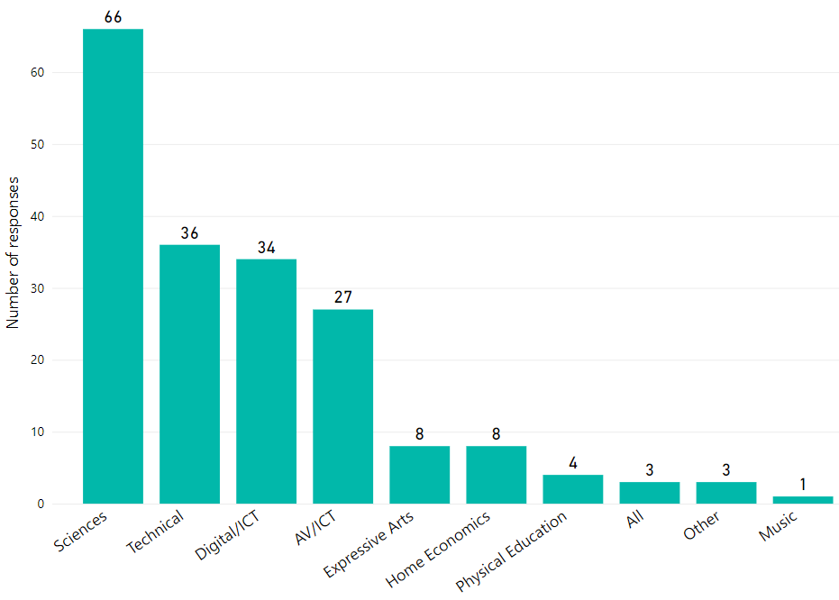
Figure 1: Number of responses per type of technical support delivered
Note 1: The number of responses in this figure exceeds the total number of responses as multiple selections were possible for this question in the online survey.
Note 2: Of the 78 responses to the 2022/23 survey, only 76 respondents gave permission for their data to be used in this report. Therefore, the totals in the following tables and figures in this report will sum to 76, unless otherwise stated.
STEM Professional Learning Survey 2018/19 Findings (School-based Technical Support Staff) | 215 responses
STEM Professional Learning Survey 2019/20 Findings (School-based Technical Support Staff) | Survey not issued
STEM Professional Learning Survey 2020/21 Findings (School-based Technical Support Staff) | 44 responses
STEM Professional Learning Survey 2021/22 Findings (School-based Technical Support Staff) | Survey not issued
STEM Professional Learning Survey 2022/23 Findings (School-based Technical Support Staff) | 76 responses
Table 1 Number of responses to the school-based technical support staff surveys
Note. Data is not available for 2019/20 and 2022/23 as surveys were not issued.

Respondents’ work pattern
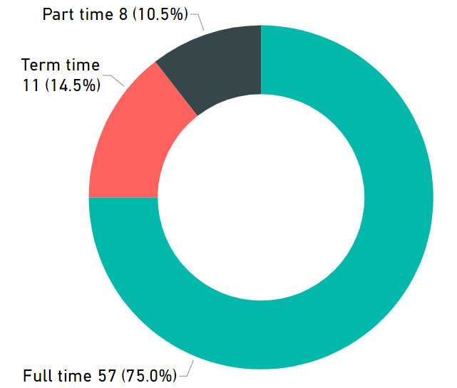
Figure 2: Respondents' work pattern
The overall number of responses increased by 72.7% from 44 responses in the 2020/21 survey to 76 responses in the 2022/23 survey. In the 2022/23 survey, 73 (96.1%) of responses were submitted by technical support staff working in the secondary sector. A further three responses were received – one each from the early learning and childcare, primary and all-through school sectors.
Respondents were asked to identify which type of technical support they provided. More than fourth fifths (86.8%) of respondents said they provided technical support across sciences. The distribution of the remaining responses reflects a smaller number providing support for technical, digital/ICT and AV/ICT.
The majority of respondents 57 (75.0%) stated that they worked on a full-time basis. Eight (10.5%) respondents worked part-time and the remaining eleven (14.5%) respondents worked term-time only.

Your professional learning

Total number of hours of professional learning in STEM
The total number of cumulative hours of STEM professional learning accessed by the 76 survey respondents between 1 August 2022 and 31 July 2023 was 1,459 hours. This compares to 647 cumulative hours recorded by the 44 survey respondents in 2020/21. This equates to a mean average of 19.2 cumulative hours per person per annum in the 2022/23 survey compared to 14.7 cumulative hours per person per annum in the 2020/21 survey.

In the 2022/23 survey, 28 (36.8%) respondents stated that they did not participate in any STEM professional learning in the given time period.
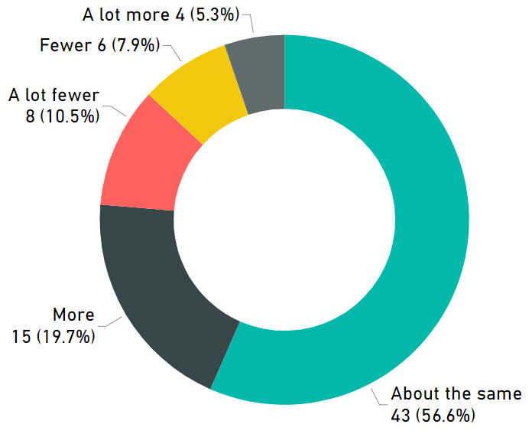
Figure 3: Hours of STEM professional learning accessed in 2022/23 compared with 2021/22
Respondents were asked if they accessed more or fewer hours of STEM professional learning than in the previous year. The majority of respondents said the number of hours of professional learning they accessed in 2022/23 was about the same as hours accessed in 2021/22.

Types of professional learning accessed and perceived value
Technical support staff were surveyed about which types of STEM professional learning they accessed during the 2022/23 academic year and were also asked to rate how the impact they found each format. When compared to the 2020/21 survey results, the proportion of respondents engaging in professional learning outwith their setting increased.
The 2022/23 survey identified that the top three types of professional learning that were recognised as ‘some impact’ or ‘significant impact’ with regards to impact were:
- Attending an externally provided course outside of my school or setting
- Online professional learning
- Collegiate working within my school/setting

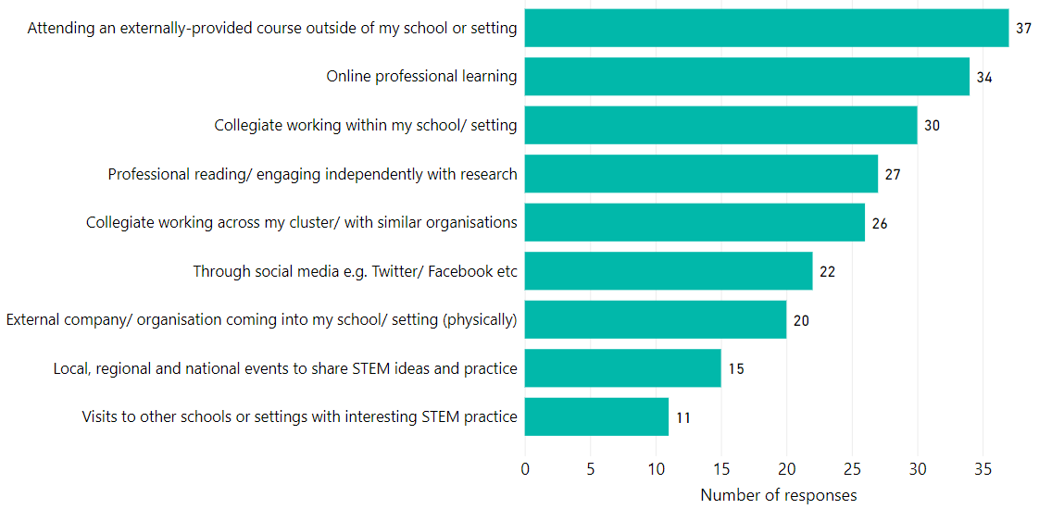
Figure 4: Professional learning accessed which had ‘some impact’ or ‘significant impact’
Note. The number of responses in this figure exceeds the total number of responses as multiple selections were possible for this question in the online survey.
The responses for 2022/23 survey indicate that after the COVID, school-based technicians confirm that the type of professional learning that has ‘some impact’ and ‘significant impact’ is attending an externally provided course outside of school or setting.
 | 2018/19 | 2019/20 | 2020/21 | 2021/22 | 2022/23
1 | Attending an externally provided course outside of my school/setting | – | Online professional learning | – | Attending an externally provided course outside of my school/setting
2 | Professional reading/engaging independently with research | – | Professional reading/engaging independently with research | – | Online professional learning
3 | Online professional learning | – | Collegiate working within my school/setting | – | Collegiate working within my school/setting
Table 2: Professional learning formats recording the biggest impact
Note. Data is not available for 2019/20 and 2021/22 as surveys were not issued

Organisations that provided STEM professional learning
Respondents were asked which organisations provided their STEM professional learning. Table 3 outlines the top three responses from recent surveys and Figure 6 shows the full range of responses in the 2022/23 survey. In all three surveys, SSERC and the relevant local authority and technician service centre featured in the top three responses.
 | 2018/19 | 2019/20 | 2020/21 | 2021/22 | 2022/23
1 | SSERC | – | SSERC | – | SSERC
2 | Local authority | – | Technician Service Centre | – | Local authority
3 | Scottish Technicians Advisory Council (STAC) | – | Local authority | – | Technician Service Centre
Table 3: Top three organisations that provided STEM professional learning
Note. 2019/20 and 2022/23 data is not available as surveys were not issued.

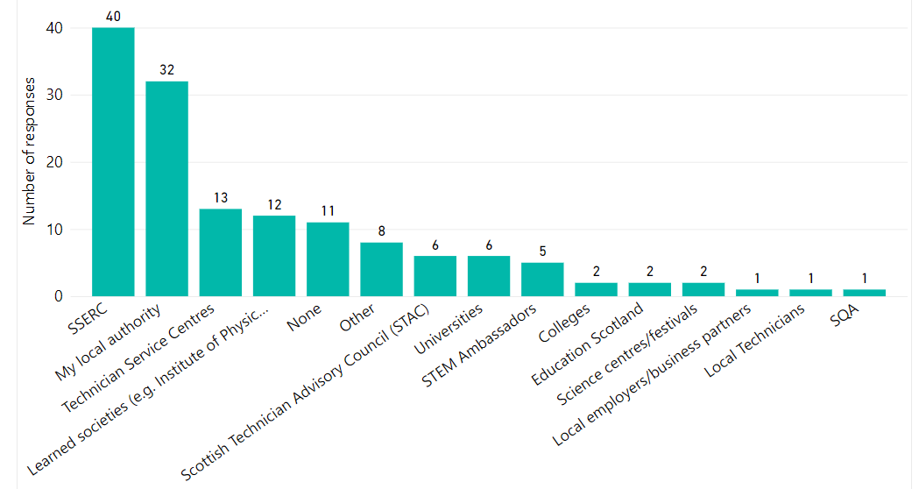
Figure 5: Organisations providing STEM professional learning to technical support staff
Note. The number of responses in this figure exceeds the total number of responses as multiple selections were possible for this question in the online survey.

Ease of accessing professional learning in STEM
Figure 6 shows how easy respondents found it to access STEM professional learning. The proportion of respondents reporting that it was ‘easy’ or ‘very easy’ to access STEM professional learning was 39.5% in the 2022/23 survey. This is the highest reported value across all three surveys and represents a significant increase from the responses in the 2020/21 survey (4.9%) and the 2018/19 survey (14.9%).
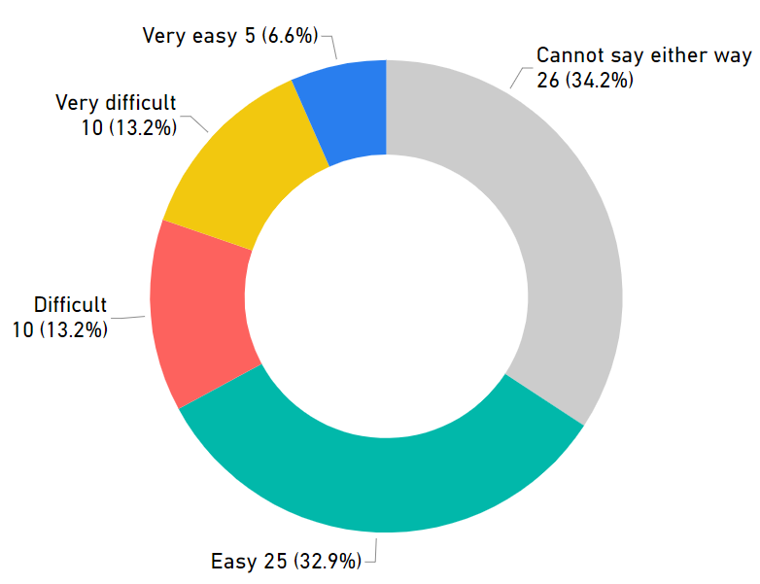

Figure 6: Accessing professional learning in STEM

Main barriers to accessing professional learning in STEM
The 2022/23 survey highlighted a number of barriers to accessing professional learning in STEM. The responses to this question are shown in Figure 7.
Table 4 outlines the top three responses from recent surveys and Figure 7 shows the full range of responses in the 2020/21 survey.
 | 2018/19 | 2019/20 | 2020/21 | 2021/22 | 2022/23
1 | Lack of funding to pay for professional learning | – | Changing role/workload due to the COVID-19 pandemic | – | Difficulty in finding staff cover
2 | Lack of funding to pay for associated travel/accommodation | – | Lack of funding to pay for professional learning | – | Lack of funding to pay for professional learning
3 | Lack of support in my organisation | – | - Difficulty in finding staff cover  - Don’t know where to get information about professional learning  - Lack of funding to pay for associated travel/accommodation costs | – | Lack of funding to pay for associated travel/accommodation
Table 4: Top three barriers to accessing professional learning in STEM
Note. 2019/20 and 2021/22 data is not available as surveys were not issued.
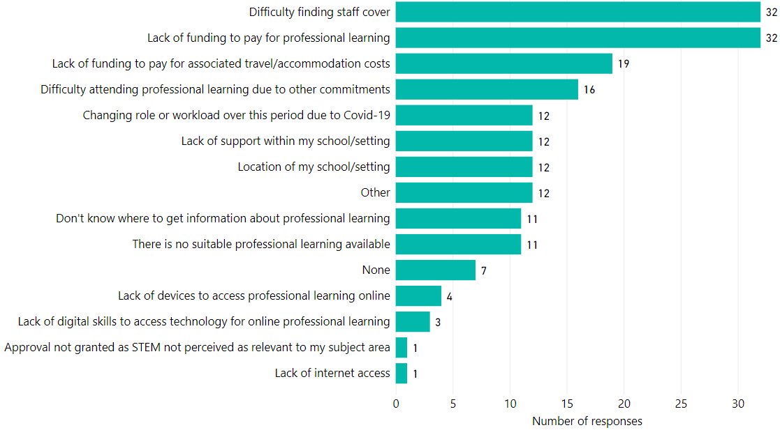
Figure 7: Main barriers to accessing professional learning in STEM
Note. The number of responses in this figure exceeds the total number of responses as multiple selections were possible for this question in the online survey.

STEM professional learning priorities for the academic year 2022/23
In the 2022/23 STEM professional learning survey, school-based technical support staff were asked what their professional learning priorities were for the year ahead. Table 5 compares the top three responses from the surveys in 2018/19, 2020/21 and 2022/23. Support with health and safety updates and sciences remain key priorities across all surveys.
It is important to note that in 2022/23, survey respondents listed ‘skills progression in STEM subjects’ for the first time. Figure 8 shows all the responses.
 | 2018/19 | 2019/20 | 2020/21 | 2021/22 | 2022/23
1 | Sciences | – | Sciences | – | Health and safety update
2 | Health and safety update | – | Support with new equipment | – | Sciences
3 | Supporting advanced higher projects | – | Health and safety update | – | Skills progression in STEM subjects
Table 5: Top STEM professional learning priorities in 2018/19, 2020/21 and 2022/23
Note. Data for 2019/20 and 2021/22 is not available as surveys were not issued.
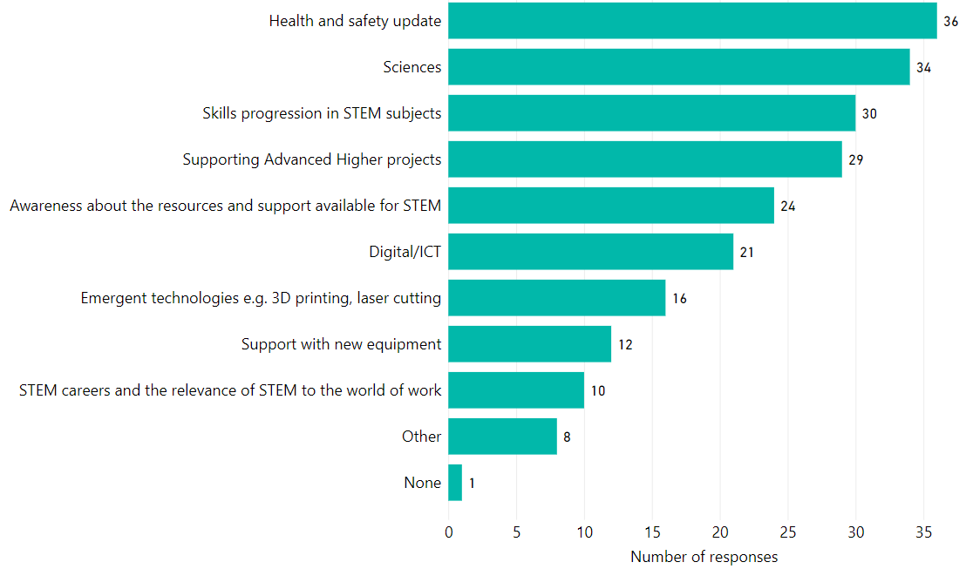
Figure 8: STEM professional learning priorities for academic year 2023/24
Note: The number of responses in this figure exceeds the total number of responses as multiple selections were possible for this question in the online survey.

Education Scotland response
Education Scotland has continued to address the priorities and needs identified by school-based technical support staff in relation to STEM professional learning.

Enhancing Professional Learning in STEM Grants Programme
Education Scotland funded a total of £651,888 of STEM professional learning grants in financial year 2022/23, supporting 84 projects in Round 3 and 59 projects in Round 4 of the STEM grants. This funding was aligned to the priorities and findings from the previous STEM annual practitioner surveys, with support for school-based technical support staff highlighted as a priority area.
Since the grants programme started in 2018, over £4.6 million has been awarded to 307 projects including support for the Scottish Technicians Advisory Council. An estimated 68,349 practitioners have benefitted from the three funding rounds which have run to date. This includes 384 school-based technicians recorded as having benefitted from the STEM Grants Programme.
More information about the grants being supported is available from the STEM summary page on the National Improvement Hub.

Sharing of the data and advocacy
In addition to the STEM Grants, Education Scotland has shared the findings from the Annual STEM Professional Learning Surveys with a wide range of STEM partner organisations and with officers leading on STEM within local authorities. This has been supported by a number of data workshops that have been offered to further support engagement with the findings.
Education Scotland made use of previous survey data to show that school-based technical support staff had proportionately less access to STEM professional learning than other sectors. Our aim was to encourage further support to be provided to meet the needs of school-based technical support staff. The significant increase in technical support staff reporting in the 2022/23 survey that it is ‘easy’ or ‘very easy’ to access STEM professional learning is, therefore, welcome. However, more still needs to be done to support technicians at a time when their services are facing a number of pressures.

Appendix: Survey questions
2022/23 survey questions for school-based technical support staff
Which sector do you work in?
Which of the following most closely aligns with your work?
Which local authority do you work in?
Please provide the full postcode of your school/setting.
The postcode provides important information about rurality and SIMD. If you don’t know the postcode please input street/setting name.
Which subjects do you provide technical support for in your setting?
Approximately how many hours of professional learning in STEM did you complete between 01 August 2022 to 31 July 2023?
Was this more or fewer hours than the same period last academic year (i.e. from 01 August 2021 to 31 July 2022)?
Please tell us more about the types of professional learning in STEM that you accessed between 01 August 2022 to 31 July 2023.
If you completed another kind of professional learning please tell us in the box below.
Which, if any, of the following organisations provided you with professional learning support between 01 August 2022 and 31 July 2023?
How easy has it been for you to access professional learning in STEM?
What, in your opinion, were the barriers (if any) to you accessing professional learning in STEM?
What are your STEM professional learning priorities for this academic year (01 August 2023 - 31 July 2024)?

Education Scotland
Denholm House
Almondvale Business Park
Almondvale Way
Livingston EH54 6GA

T +44 (0)131 244 4330
E enquiries@educationscotland.gov.scot

www.education.gov.scot

STEM Education and Training Strategy for Scotland: https://www.gov.scot/publications/science-technology-engineering-mathematics-education-training-strategy-scotland/
A summary of STEM resources: https://education.gov.scot/improvement/learning-resources/a-summary-of-stem-resources/
STEM strategy: key performance indicators: https://www.gov.scot/publications/stem-strategy-key-performance-indicators/
STEM Strategy for Education and Training in Scotland - First Annual Report: STEM strategy for education and training: first annual report - gov.scot (www.gov.scot)
STEM Strategy for Education and Training in Scotland - Second Annual Report: STEM strategy for education and training: second annual report - gov.scot (www.gov.scot)
STEM Strategy for Education and Training in Scotland - Third Annual Report: STEM strategy for education and training: third annual report - gov.scot (www.gov.scot) 7 STEM Strategy for Education and Training in Scotland - Refresh: STEM education and training strategy - refresh: annual report - gov.scot (www.gov.scot)

