May 2024

Early learning and childcare, primary, secondary and ASN

Professional Learning in STEM
Findings from the Annual STEM Practitioner Survey 2022/23

Table of contents
List of tables 3
List of figures 3
Introduction 4
Key findings 5
Annual STEM Practitioner Survey 2022/23 9
About the survey 9
About you 11
STEM in your setting 15
Your professional learning 20
STEM in your practice 30
Education Scotland response 34
Appendix: Survey questions 37

List of tables
Table 1. Number of responses to the STEM practitioner surveys 11
Table 2. Number of completed survey responses by sector 12
Table 3. Number of STEM professional learning hours per sector 20
Table 4. Comparison of number of STEM professional learning hours with previous years 21
Table 5. Types of professional learning accessed by practitioners and the impact on learning 23
Table 6. Top three organisations providing STEM professional learning (2016/17 to 2022/23) 25
Table 7. Ease of accessing STEM professional learning 26
Table 8. Main barriers to accessing professional learning in STEM 27
Table 9. STEM professional learning priorities for academic year 2022/23 29
Table 10. Practitioner confidence levels in each aspect of STEM by sector 33

List of figures
Figure 1. Number of responses by sector to the 2022/23 survey 11
Figure 2. Breakdown of survey responses by role 13
Figure 3. Respondents’ work pattern 13
Figure 4. Breakdown of survey responses by respondents’ main curriculum area 14
Figure 5. Overview of when STEM featured on respondents’ setting improvement plan 15
Figure 6. Does STEM feature on respondents’ cluster improvement plan? 16
Figure 7. School and setting engagement with the STEM self-evaluation framework 17
Figure 8. Do settings have an identified STEM coordinator? 18
Figure 9. Overview of STEM partners in schools and ELC settings 18
Figure 10. Approaches to connecting with STEM partner organisations 19
Figure 11. Total number of hours of STEM professional learning accessed by sector 20
Figure 12. Number of STEM professional learning hours compared to the previous year 21
Figure 13. Engagement with professional learning as part of the Enhancing Professional Learning in STEM Grants Programme 22
Figure 14. Types of STEM professional learning accessed by practitioners and rated as ‘some impact’ or ‘significant impact’ 24
Figure 15. Organisations providing STEM professional learning 25
Figure 16. Ease of accessing professional learning in STEM 26
Figure 17. Main barriers to accessing professional learning in STEM 27
Figure 18. STEM professional learning priorities for academic year 2022/23 29
Figure 19. Overall practitioner confidence delivering STEM 30
Figure 20. Practitioner confidence delivering STEM broken down by sector 31
Figure 21. Overall practitioner confidence in delivering discrete aspects of STEM 32
Figure 22. Practitioner confidence in delivering each aspect of STEM by sector 32

Introduction
This report presents the key findings from Education Scotland’s Annual STEM Practitioner Survey for early learning and childcare (ELC), primary, secondary and additional support needs (ASN) covering academic year 2022/23.
Education Scotland has continued to gather and analyse this data since 2016/17 to inform and support the ongoing implementation of the STEM Education and Training Strategy (2017).
The findings from the surveys provide valuable insights into the professional learning needs of practitioners; the challenges they face in accessing professional learning and their professional learning priorities. The survey findings have been used by Education Scotland to help shape the national professional learning offer, including the projects supported through the Enhancing Professional Learning in STEM Grants Programme. A wide range of partner organisations have also used the survey findings to help them align their professional learning programmes and strategies to the needs of practitioners.
These surveys have measured progress against the following STEM Strategy key performance indicator:
II. Increased practitioner confidence in STEM learning in the early years, primary years and in CLD settings and increased practitioner engagement in STEM professional learning opportunities. (Excellence)
- Increase the cumulative hours of STEM professional learning accessed by early years, schools, college and community learning and development (CLD) practitioners annually.
Progress against this key performance indicator, and others, have been reported on annually through the First, Second, Third STEM Strategy Annual Reports and Refresh Annual Report. The 2022/23 surveys will be the last to be issued and so this report marks the end of the data gathering process for the STEM Strategy.
Due to the COVID-19 pandemic, the Annual STEM Practitioner Survey was not issued in 2019/20. In addition, the 2020/21 survey coincided with the COVID Omicron wave, resulting in a significant reduction in the response rate in comparison to previous years. Care should, therefore, be taken when comparing results year on year.

Key findings
Number of responses – The number of survey responses increased by 26.6% from 312 responses in the 2020/21 survey to 395 responses in the 2022/23 survey. The proportion of responses from each sector are listed below. The number of responses per sector for the 2022/23 survey are similar to those from previous surveys. It is important to note that the information contained within this report is based on a much smaller sample size than previous surveys and care should be taken when drawing comparisons or identifying trends.

    - Primary 37.0% (142 responses)
    - Secondary 32.6% (125 responses)
    - Early learning and childcare 25.0% (96 responses)
    - Additional support needs 5.5% (21 responses)
Note: From a total of 395 respondents only 384 respondents confirmed that the data collected can be used in this survey.
More than two-thirds of the responses in the 2020/21 survey came from class teachers and ELC practitioners with a smaller proportion coming from classroom assistants, probationer teachers and practitioners in middle or senior leadership roles.
STEM in your setting – Practitioners were asked a range of questions about STEM improvement planning, leadership and partnership working in their setting.
- STEM featured in setting 2022/23 improvement plan: Yes 45.6%
- STEM featured on their cluster improvement plan: Yes 25.5%
- Settings working with a STEM partner: Yes 37.8% (The proportion of settings working with a STEM partner increased from 23.1% in the 2020/21 survey to 37.8% in the 2022/23 survey which is close to the pre-COVID-19 figure from 2018/19 survey of 42.1%. This is a significant increase from the previous survey and could be possibly due to emerging from the COVID-19 years regarding advice on social distancing and restrictions on visitors in schools and ELC settings).
- Engagement with STEM self-evaluation framework: Yes 20.3%
- STEM co-ordinator within setting: Yes 55.2%
Level of engagement with professional learning in STEM – The total number of hours of professional learning accessed by the 384 survey respondents between 1 August 2022 and 31 July 2023 was 5,791 hours. This is slightly higher than 5,405 hours reported in the 2020/21 survey. This equates to a mean average of 15.9 hours per practitioner per annum. This is a slight decrease in the average figure of 17.4 hours reported in the 2020/21 survey. Note in the 2022/23 survey that approximately 20 respondents did not quantify the amount of hours of STEM CLPL during that survey year. They confirmed it was in “a lot” and in the “hundreds”. Therefore the amount of hours reported for 2022/23 is a conservative figure.
In the 2022/23 survey, 14.8% of respondents stated that they had undertaken zero hours of STEM professional learning – this measure has decreased by 3.6% from the 2020/21 survey and 2018/19 survey where this measure was consistently 18.4%. The number of STEM professional learning hours per practitioner per annum is broken down by sector below:
    - Additional support needs 28.9 hours
    - Secondary 18.9 hours
    - Primary 8.9 hours
    - Early learning and childcare 6.3 hours
Across all sectors, approximately three quarters of respondents stated that they engaged with either the same or more hours of STEM professional learning in 2022/23. In the 2020/21 survey, this measure was lower, with approximately two thirds of respondents giving this response.
Engagement in professional learning as part of STEM grants – 13.4% of respondents stated that their setting had received funding from Education Scotland’s Enhancing Professional Learning in STEM Grants Programme.
Types of professional learning accessed – Practitioners were also asked to describe how valuable they found each professional learning format. The 2022/23 survey responses indicate that the most valuable formats with the highest perceived impact were:
- Online learning 70.8% (292 out of 384 responses)
- Collegiate working within my setting 67.4% (259 out of 384 responses)
outside of my setting
- Professional reading and engaging with 66.4% (255 out of 384 responses)
research

The format practitioners reported as least valuable was ‘accessing STEM professional learning through visits to other settings’. Only a third of the respondents who engaged with this type of professional learning reported that it had ‘some impact’ or ‘significant impact’.
Organisations providing STEM professional learning – When asked which organisation provided the STEM professional learning they had engaged with, the top three responses were:
- Local authority 49.4% (190 responses)
- SSERC 33.6% (129 responses)
- Education Scotland 33.3% (128 responses)
Accessing professional learning in STEM – In the 2022/23 survey, 41.2% of respondents reported that they found it ‘easy’ or ‘very easy’ to access STEM professional learning. This is similar to the value of 41.7% from the 2020/21 survey. The consistent figure of over 41% is higher than the pre-pandemic figure from 2018/19 survey of 30.1%. This may be attributed to the increased availability of online STEM professional learning.
Main barriers to accessing STEM professional learning in STEM – In the 2022/23 survey, the top three responses identifying the main barriers to accessing STEM professional learning are:
- Difficulty in finding staff cover 52.8% (201 responses)
- Difficulty in attending professional learning due to
other commitments 39.1% (149 responses)
- Lack of funding to pay for professional learning 38.3% (146 responses)
STEM professional learning priorities for 2023/24 – The top three responses across ELC, primary, secondary and ASN sectors for STEM professional learning priorities for in the year ahead were:
- Pedagogies and teaching approaches to deliver
STEM learning effectively 55.5% (213 responses)
- Skills progression in STEM subjects 36.2% (139 responses)

- Developing the curriculum for STEM 30.5% (117 responses)
When broken down to sector level the top priority for practitioners in each sector was:
- ASN: Pedagogies/teaching approaches to deliver STEM effectively (9 responses)
- ELC: Pedagogies/teaching approaches to deliver STEM effectively (60 responses)
- Primary: Pedagogies/teaching approaches to deliver STEM effectively (82 responses)
- Secondary: Pedagogies/teaching approaches to deliver STEM effectively (62 responses)
Practitioner confidence – In the 2022/23 survey, 72.7% of practitioners stated that they were ‘confident’ or ‘very confident’ delivering STEM learning. This an increase of 9.7% compared to the 2020/21 survey. Confidence levels were highest in secondary (83.6%) followed by primary (77.5%), and ASN (71.4%) and lowest in ELC (47.0%).
Practitioners were also asked about their confidence in relation to discrete areas of STEM. Of those who answered each question, the proportion of practitioners who responded ‘agree’ or strongly agree’ to the statement “I feel confident in delivering [discrete area of STEM]” were:
- Sciences 73.0% (255 out of 348 responses)
- Technologies 62.0% (212 out of 343 responses)
- Gender balance, equity and equalities 61.0% (218 out of 359 responses)
- Digital learning 59.0% (214 out of 360 responses)
- Engineering 46.0% (136 out of 294 responses)
On reviewing the data per sector the key points relating to practitioner confidence were:
- Confidence levels in each of the discrete STEM areas were highest in primary followed by secondary, ELC and then ASN.
- Confidence levels for engineering, although being consistently low across all sectors, has increased from 35.7% in the 2020/21 survey to 46.0% in the 2022/23 survey.
- ASN practitioners reported the lowest level of confidence in technologies, digital and engineering.
- Primary practitioners reported high confidence levels in science, technologies, digital and engineering. This may be due to the support provided by the RAiSE programme that has involved 27 out of 32 local authorities. The RAiSE Primary Science Development Officers (PSDOs) have provided comprehensive professional learning and support including development of science and technologies planning resources that support practitioners with the delivery of the curriculum.

Note: In the 2022/23 survey, data for the confidence level in numeracy and mathematics was not collected due to an error in the survey.

Annual STEM Practitioner Survey 2022/23

About the survey

Background
The aim of the Annual STEM Practitioner Survey is to track enhancements in STEM professional learning undertaken by practitioners in early learning and childcare, primary, secondary and additional support needs sectors.
The survey covers aspects such as:
- Number of hours of STEM professional learning accessed
- Practitioners’ confidence in delivery of STEM learning
- STEM professional learning priorities of practitioners
- Barriers to accessing STEM professional learning.

The 2022/23 survey gathered the views of a wide range of practitioners involved in delivering aspects of STEM learning including classroom assistants, senior leaders and teachers of curriculum areas not traditionally associated with STEM.
Two further surveys were issued in 2022/23 to gather data from other sectors including:
- Community and learning development (CLD) practitioners
- School-based technical support staff.

The data presented in the 2022/23 survey findings was collected after several years of disruption caused by the COVID-19 pandemic. The response rate to the 2022/23 survey was slightly higher than the 2021/22 survey. Care should be taken when comparing data from the 2022/23 survey with previous years as the results provide a limited snapshot of STEM professional learning within the wider context of education recovery.

Structure and purpose
The survey was made available to all practitioners via an online survey. It was promoted widely via Education Scotland and Scottish Government communication channels.
The survey findings have played, and will continue to play, a crucial role in shaping the implementation of the professional learning actions in the STEM Education and Training Strategy (Science, Technology, Engineering and Mathematics: education and training strategy - gov.scot (www.gov.scot)).
The findings from previous surveys have directly influenced the framing of the Enhancing Professional Learning in STEM Grants Programme which has seen over £4.6 million awarded to support professional learning programmes since its inception in 2018. The ambition of the grants programme was to ensure that practitioners in relevant sectors, and in various geographical locations, have access to high-quality professional learning which meets their needs. The survey highlights priority areas for action and gaps that need to be addressed. The evidence provided by the surveys are also directly informing the work of and the professional learning offer from Education Scotland’s regional teams. These teams play a key role in supporting and coordinating professional learning in STEM.
In addition, the survey data allows Education Scotland to track progress against the following key performance indicator in the STEM Education and Training Strategy:
II. Increased practitioner confidence in STEM learning in the early years, primary years and in CLD settings and increased practitioner engagement in STEM professional learning opportunities. (Excellence)
- Increase the cumulative hours of STEM professional learning accessed by early years, schools, college and CLD practitioners annually.

Detailed survey findings: About you

Number of survey responses
2016/17 Annual STEM Practitioner Survey | 788 responses
2017/18 Annual STEM Practitioner Survey  (ELC, primary, secondary and ASN practitioners) | 876 responses
2018/19 Annual STEM Practitioner Survey  (ELC, primary, secondary and ASN practitioners) | 1187 responses
2019/20 Annual STEM Practitioner Survey  (ELC, primary, secondary and ASN practitioners) | Survey not issued
2020/21 Annual STEM Practitioner Survey  (ELC, primary, secondary and ASN practitioners) | 312 responses
2021/22 Annual STEM Practitioner Survey  (ELC, primary, secondary and ASN practitioners) | Survey not issued
2022/23 Annual STEM Practitioner Survey  (ELC, primary, secondary and ASN practitioners) | 395 responses
Table 1. Number of responses to the STEM practitioner surveys
Note. Of the 395 responses to the 2022/23 survey only 384 respondents gave permission for their data to be used in this report. Therefore the totals in the following tables and figures in this report will sum to 384 unless otherwise stated.
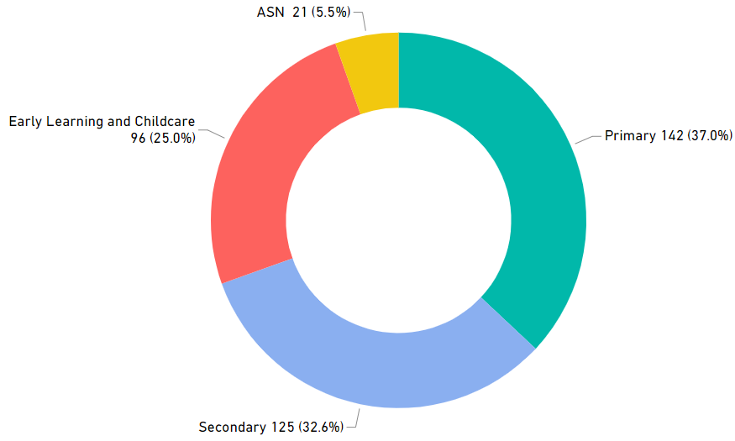
Figure 1. Number of responses by sector to the 2022/23 survey (n=384)

Sector | 2016/17 | 2017/18 | 2018/19 | 2019/20 | 2020/21 | 2021/22 | 2022/23
ASN | 1.1% (9) | 1.7% (15) | 5.1% (61) | – | 4.2% (13) | – | 5.5% (21)
ELC | 3.5% (28) | 16.6% (145) | 17.4% (206) | – | 32.9% (102) | – | 25.0% (96)
Primary | 34.8% (274) | 43.6% (382) | 40.9% (485) | – | 25.8% (80) | – | 37.0% (142)
Secondary | 58.5% (461) | 38.1% (334) | 36.6% (435) | – | 37.1% (115) | – | 32.6% (125)
Total number of responses | 788 | 876 | 1187 | – | 310 | – | 384
Table 2. Number of completed survey responses by sector

The overall number of responses increased by 23.9% from 310 responses in the 2020/21 survey to 384 responses in the 2022/23 survey. The proportion of responses from the primary sector increased by 7.9% in comparison with the previous survey. The proportion of responses from the ASN and secondary sectors remained broadly similar to the distribution of responses in the 2020/21 survey. However, the proportion of responses from the ELC sector decreased by 7.9% in comparison with the previous survey.

Response by role
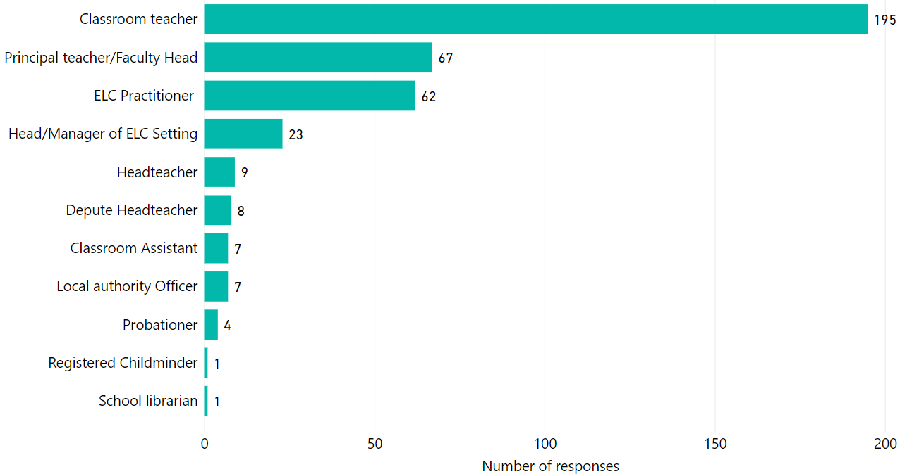
Figure 2. Breakdown of survey responses by role (n=384)
Note. The principal teacher/faculty head category gives an overview of respondents in middle leadership roles across schools and ELC settings. This includes ELC practitioners who described their role as “Team Leader” or “Equity and Excellence Lead”.
More than two-thirds of the responses in the 2022/23 survey came from class teachers and ELC practitioners with a smaller proportion coming from classroom assistants, probationer teachers and practitioners in middle or senior leadership roles.

Respondents’ work pattern
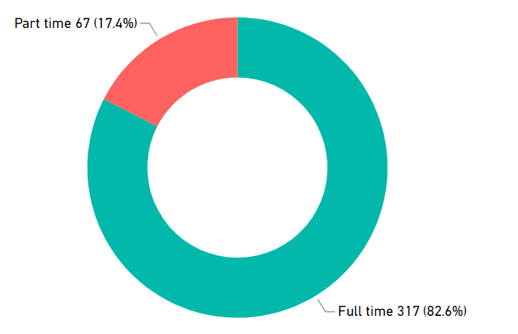
Figure 3. Respondents’ work pattern (n=384)

Response by curriculum area
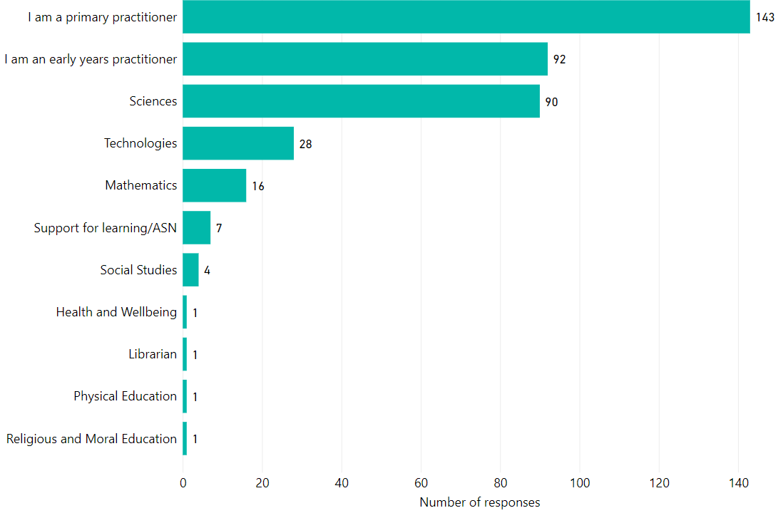
Figure 4. Breakdown of survey responses by respondents’ main curriculum area (n=384)

Figure 3 shows that more than four-fifths of the respondents reported that they worked on a full-time basis.
As shown in Figure 2 and Figure 4, most survey responses came from classroom teachers and ELC practitioners. Of the secondary teachers who responded, most responses came from teachers in the sciences or technologies specialisms. Only seven respondents described themselves as a support for learning/ASN teacher.

Detailed survey findings: STEM in your setting

STEM featured in setting improvement plan
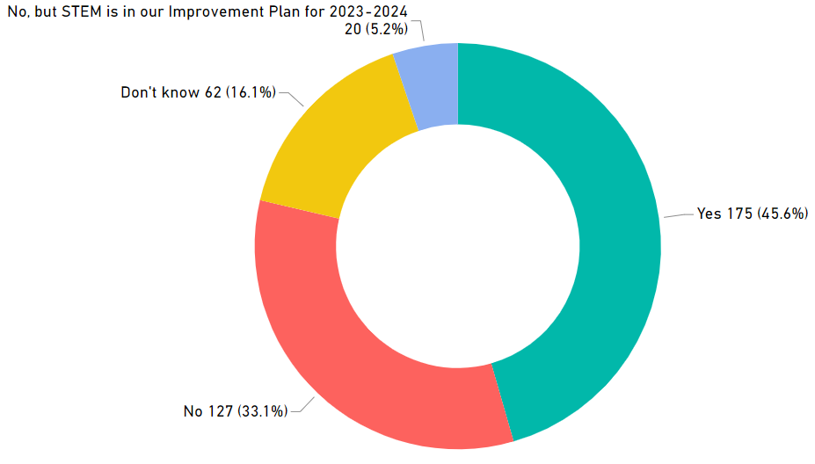
Figure 5. Overview of when STEM featured on respondents’ setting improvement plan (n=384)

Figure 5 shows 45.6% confirmed that STEM featured on their improvement plan in academic year 2022/23. This is an increase of 8.7% when compared with the responses in the 2020/21 survey.
There was an increase in the proportion of respondents stating that STEM would feature on their improvement plan in the following 2023/24 academic year. This measure had increased over the previous three surveys; 8.8% in the 2017/18 survey, 11.3% in the 2018/19 survey, 18.8% in the 2020/21 survey but has now decreased to 5.2% in the 2022/23 survey.

STEM featured in cluster improvement plan
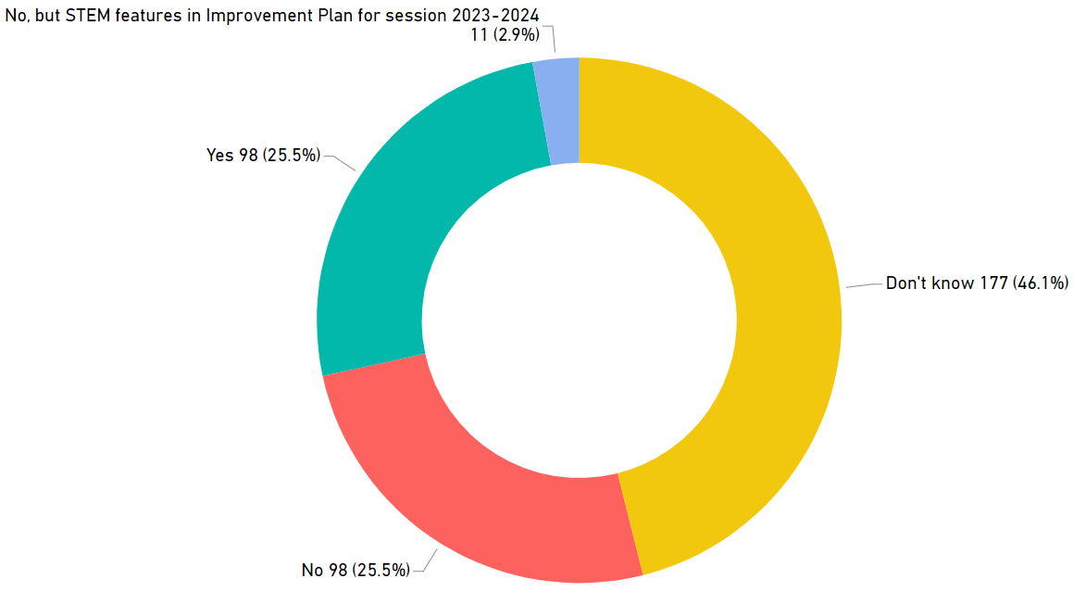
Figure 6. Does STEM feature on respondents’ cluster improvement plan? (n=384)

Figure 6 shows that 25.5% of respondents confirmed that STEM featured on their cluster improvement plan in academic year 2022/23. This is an increase of 2.5% from the 2020/21 survey.
A further 2.9% of respondents stated that STEM would feature on their cluster improvement plan in the following 2023/24 academic year. This is a decrease from the 7.1% of respondents in the 2020/21 survey who anticipated that STEM would feature on their improvement plan in the following academic year.
Again, the reduction in this measure may be linked to an increased focus on literacy, numeracy and health and wellbeing as part of education recovery. However, it is important to note that almost half (46.1%) of respondents were unfamiliar with their cluster improvement plan and were unable to say whether STEM featured on this plan. Of those who identified themselves as a senior leader (i.e. headteacher, depute headteacher, head of centre of centre manager), only four respondents (less than 1% of the total number of respondents) replied “Don’t know” when asked if STEM featured on their cluster improvement plan. It is worth considering whether all staff are included in discussions regarding their cluster improvement plan or are sufficiently aware of cluster priorities.

Engagement with the STEM self-evaluation framework
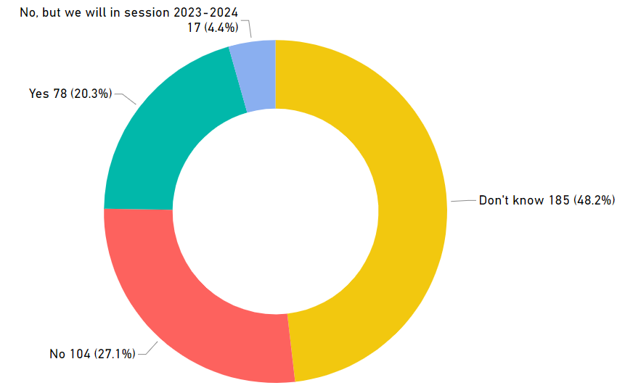
Figure 7. School and setting engagement with the STEM self-evaluation framework (n=384)

From the completed responses 20.3% of respondents confirmed that their setting had engaged with Education Scotland’s STEM self-evaluation framework in academic year 2022/23. A further 4.4% of respondents stated that their setting planned to engage with the framework in session 2023/24. This is slightly lower than 9.9% of respondents in the 2020/21 survey who anticipated that they would engage with the framework in 2019/20.

STEM coordinator in setting
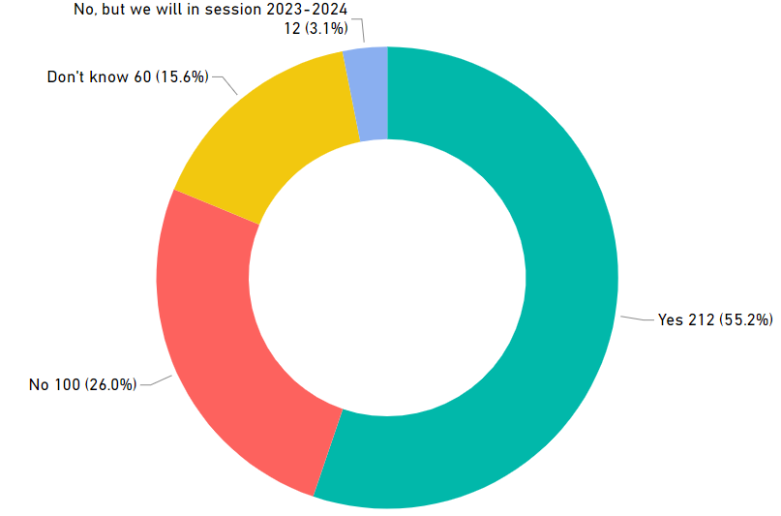
Figure 8. Do settings have an identified STEM coordinator? (n=384)
From the completed responses, 55.2% of respondents confirmed that their setting had a STEM coordinator in 2022/23. This is a significant increase from the figure (42.0%) reported in the 2020/21 survey. A further 3.1% of respondents stated that their setting intended to have a STEM coordinator in place for the 2023/24 academic year.

STEM partners
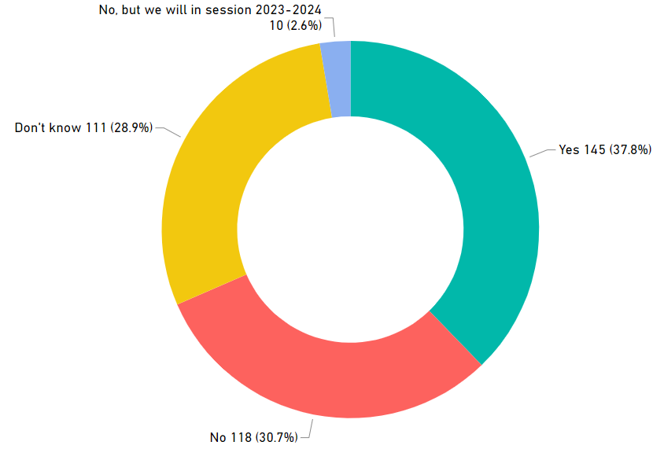
Figure 9. Overview of STEM partners in schools and ELC settings (n=384)

More than one third (37.8%) of respondents stated that their setting had a STEM partner from the private, public or third sector in 2022/23. This is a significant increase from the 2020/21 survey figure (23.1%). A further 2.6% of settings are planning to establish a STEM partnership in 2023/24. The survey findings in 2018/19 showed that 42.1% of settings had worked with one or more STEM partners. Therefore, the 2022/23 findings show that engagement with partners is starting to recover to pre-COVID levels.
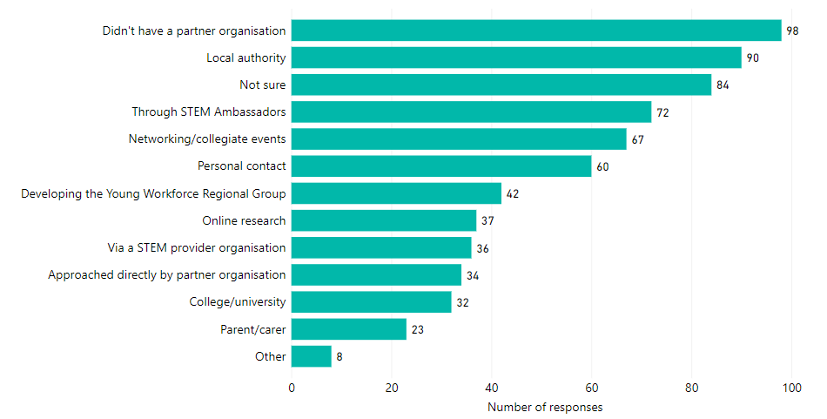
Figure 10. Approaches to connecting with STEM partner organisations (n=384)
Note. The number of practitioner responses in this figure exceeds the total number of responses as multiple selections were possible for this question in the online survey.
The top three ways (excluding the responses ‘not sure’ and ‘don’t have a partner organisation’) in which practitioners found out about partner organisations were through:
- Local authority contacts
- STEM Ambassadors
- Networking/collegiate events

In the 2022/23 survey, the prominence of local authorities in helping settings identify STEM partners is similar to the findings in 2020/21 survey. This could signify an increase focus and capacity for STEM at local authority level. Regional working, support from Education Scotland’s Regional Teams and an increase in the number of authorities participating in the Raising Aspirations in Science Education (RAiSE) Programme may also be factors.

Detailed survey findings: Your professional learning

Total number of hours of professional learning in STEM
The total number of cumulative hours of practitioner professional learning in STEM accessed by the 384 survey respondents between 1 August 2022 and 31 July 2023 was 5,791 hours. This is slightly higher than the 5,405 hours reported in the 2020/21 survey. This equates to a mean average of 15.9 hours per practitioner per annum. This is a slight decrease in the average figure of 17.4 hours reported in the 2020/21 survey. Note: in the 2022/23 survey, approximately 20 respondents did not quantify the number of hours of STEM CLPL during that survey year. They confirmed it was in “a lot” and in the “hundreds”. Therefore the amount of hours reported for 2022/23 is a conservative number.
In line with the 2018/19 survey, 13.8% of respondents (53 responses) stated that they did not participate in any STEM professional learning in the given time period.
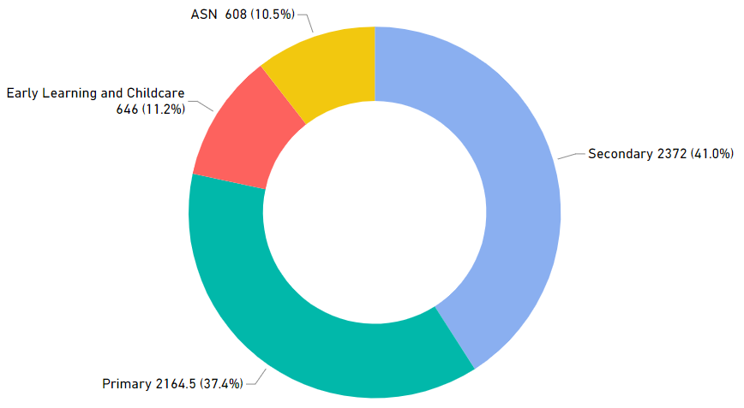
Figure 11. Total number of hours of STEM professional learning accessed by sector (n=384)
Sector | 2017/18 |  | 2018/19 |  | 2019/20 | 2020/21 |  | 2021/22 | 2022/23
 | Total hours of STEM PL | Hours of STEM PL per practitioner | Total hours of STEM PL | Hours of STEM PL per practitioner |  | Total hours of STEM PL | Hours of STEM PL per practitioner |  | Total hours of STEM PL | Hours of STEM PL per practitioner
ASN | 135 | 9.0 | 583 | 9.6 | – | 180 | 13.8 | – | 608 | 28.9
ELC | 2,799 | 19.3 | 1,368 | 6.6 | – | 883 | 8.7 | – | 646 | 6.3
Primary | 5,186 | 13.6 | 5,865 | 12.1 | – | 919 | 11.5 | – | 2,164 | 8.9
Secondary | 10,556 | 31.6 | 11,250 | 25.9 | – | 3,423 | 29.8 | – | 2,372 | 18.9
Total | 18,675 | – | 19,066 | – | – | 5,405 | – | – | 5,791 | –
Table 3. Number of STEM professional learning hours per sector
Note: Data not available for 2019/20 and 2021/22 as survey was not issued.
ASN practitioners reported the highest number of STEM professional learning hours per practitioner. ASN practitioners reported the largest increase of STEM professional learning hours per practitioner from 9.6 hours in the 2018/19 survey to 28.9 hours of STEM professional learning per practitioner in the 2022/23 survey. This is encouraging as Education Scotland has encouraged support for the ASN sector since earlier survey findings showed it was amongst the least supported in terms of STEM professional learning. However, the findings show a drop in hours of STEM professional learning in ELC, primary and secondary sectors. A likely cause could be financial and staffing constraints being experienced widely across the system at present, making it difficult for practitioners to be released from classroom commitments.

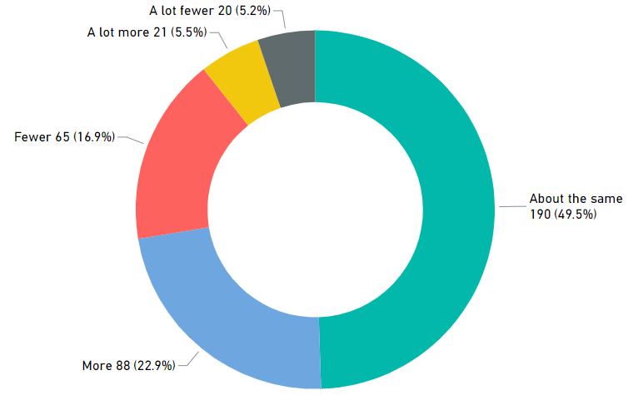
Figure 12. Number of STEM professional learning hours compared to the previous year (n=384)

Hours of STEM professional compared  to the previous academic year | 2017/18 | 2018/19 | 2019/20 | 2020/21 | 2021/22 | 2022/23
‘More’ or ‘A lot more’ | 30.4% | 28.4% | – | 24.2% | – | 28.4%
‘About the same’ | 47.7% | 51.5% | – | 42.3% | – | 49.5%
‘Fewer’ or ‘A lot fewer’ | 21.9% | 14.3% | – | 22.3% | – | 22.1%
Table 4. Comparison of number of STEM professional learning hours with previous years
Note: 2019/20 and 2021/22 data is not available as surveys were not issued.
More than one quarter of respondents said the number of hours of STEM professional learning they accessed in 2022/23 was ‘more’ or ‘a lot more’ than the previous year. Furthermore, 49.5% of respondents said the number of hours of STEM professional learning they accessed in 2022/23 was ‘about the same’ as the previous year. In contrast to the significant reduction in overall response rate to the Professional Learning in STEM Annual Practitioner Survey, the figures relating to engagement with STEM professional learning from those who did complete the survey remained broadly similar to previous years.

Engagement in professional learning as part of STEM grants
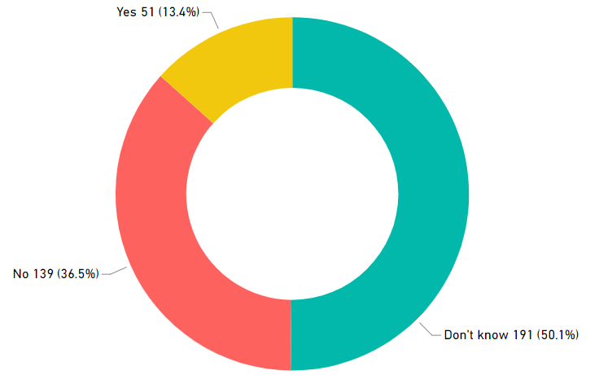
Figure 13. Engagement with professional learning as part of the Enhancing Professional Learning in STEM Grants Programme (n=381)
Note. 381 respondents provided a reply to this question.
In the 2022/23 survey, 191 respondents (50.1%) did not know whether their professional learning was supported with funding from Education Scotland’s Enhancing Professional Learning in STEM Grants Programme compared with 71 respondents (21.0%) in the 2020/21 survey. Although 191 respondents did not know whether their professional learning has been supported with grant funding, 51 respondents (13.4%) reported that they had benefitted from the grants programme.

Types of professional learning accessed and perceived value
In the 2022/23 survey, practitioners were asked about the types of STEM professional learning they accessed and the relative value of each format. The most common responses remain unchanged from the 2018/19 survey, namely, online learning, collegiate working within a setting, and professional reading and engaging with research. Table 5 shows that the proportion of practitioners participating in online learning has continued to increased year on year. The reduction in face-to-face professional learning opportunities because of COVID-19 is evidenced by a decrease in the number of practitioners accessing external courses, external companies delivering professional learning in settings and open day visits and collegiate working between settings.

The final column in Table 5 shows the perceived impact of different professional learning formats. Of the respondents who participated in each type of professional learning, only those who rated the experience as ‘some impact’ and ‘significant impact’ were included in this analysis.
Types of professional learning | 2016/17  Response % | 2017/18  Response % (count) | 2018/19  Response % (count) | 2019/20  Response % (count) | 2020/21  Response % (count) | 2021/22  Response % (count) | 2020/21  Impact | 2022/23 Impact
Attending an external course | 49.4% | 53.5%  (469) | 45.3%  (538) | – | 23.2%  (82) | – | 87.8%  (72) | 52.3%  (201)
External company coming into my setting | 17.1% | 37.9%  (332) | 36.6%  (435) | – | 16.1%  (61) | – | 82.0%  (50) | 37.2%  (143)
Collegiate working within my setting | 43.1% | 74.5%  (653) | 64.0%  (760) | – | 55.2%  (213) | – | 80.3%  (171) | 67.4%  (259)
Collegiate working across my cluster | 28.4% | 53.9%  (472) | 41.4%  (491) | – | 31.6%  (128) | – | 76.6%  (98) | 46.9%  (180)
Attending visits to other settings | * | 33%  (289) | 27.9%  (332) | – | 19.0%  (67) | – | 88.1%  (59) | 33.3%  (128)
Attending local, regional and national events to share practice | * | 45.8%  (402) | 39.3%  (467) | – | 36.5%  (145) | – | 77.9%  (113) | 49.2%  (189)
Online learning | 25.8%† | 37.9%†  (332) | 56.5%  (671) | – | 62.6%  (248) | – | 78.2%  (194) | 70.8%  (272)
Through social media | 17.3% | 45.8%  (401) | 48.0%  (570) | – | 28.4%  (166) | – | 53.0%  (88) | 51.0%  (196)
Professional reading and engaging with research | 40.1% | 78.5%  (688) | 68.8%  (817) | – | 60.0%  (236) | – | 78.8%  (186) | 66.4%  (255)
Other | 12.8% | 15.9%  (139) | 9.6%  (114) | – | <1%  (3) | – | NA | 8.6%  (33)
Table 5. Types of professional learning accessed by practitioners and the impact on learning
Note: Indicates top 3 responses per survey year.
* Question not included in survey.
† In the 2016/17 and 2017/18 surveys, online learning was one of several digital
approaches to professional learning including webinars and online networks. From
2018/19 onwards, these subcategories were collectively listed under online learning.
– Data not available as survey was not issued in 2019/20 and 2021/22.
All respondents (384) completed this question for 2022/23 survey.

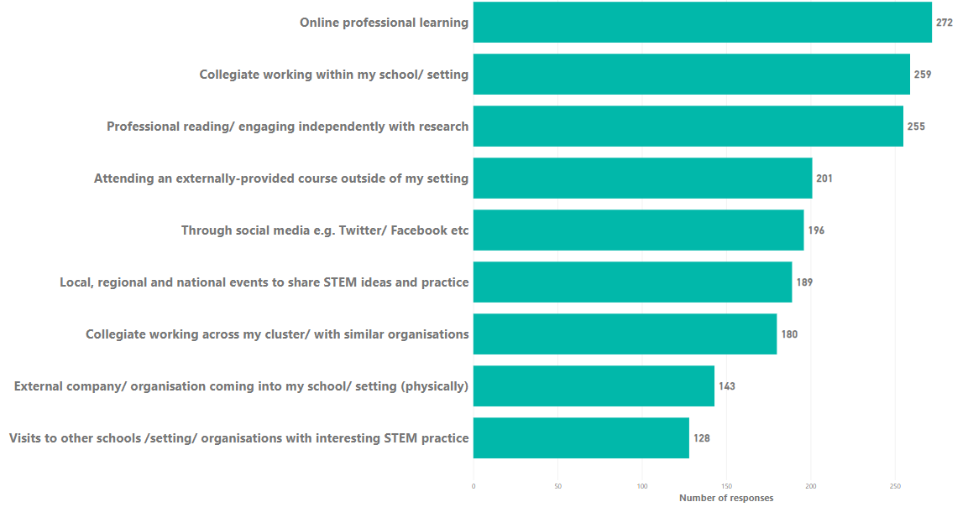
Figure 14. Types of STEM professional learning accessed by practitioners and rated as ‘some impact’ and ‘significant impact’ (n=384)
Note. The number of practitioner responses in this figure exceeds the total number of responses as multiple selections were possible for this question in the online survey.
Of those who participated in each type of professional learning, the 2022/23 survey responses indicate that the most valuable formats with the highest perceived impact were:
1st Online learning 70.8% (292 out of 384 responses)
2nd Collegiate working within my setting 67.4% (259 out of 384 responses)
outside of my setting
3rd Professional reading and engaging with 66.4% (255 out of 384 responses)
research

The format practitioners reported as least valuable was accessing STEM professional learning through visits to other settings. Only a third of the respondents who engaged with this type of professional learning reported that it had ‘some impact’ or ‘significant impact’.

Organisations that provided STEM professional learning
Respondents were asked to identify the main organisations providing them with STEM professional learning. Table 6 outlines the top three responses from recent surveys.
 | 2016/17 | 2017/18 | 2018/19 | 2019/20 | 2020/21 | 2021/22 | 2022/23
1 | SSERC | Local authority | Local authority | – | Local authority | – | Local authority
2 | Local authority | SSERC | SSERC | – | Education Scotland | – | SSERC
3 | STEM Ambassadors | STEM Ambassadors | Education Scotland | – | SSERC | – | Education Scotland
Table 6. Top three organisations providing STEM professional learning (2016/17 to 2022/23)
Note. 2019/20 and 2021/22 data is not available as surveys were not issued.
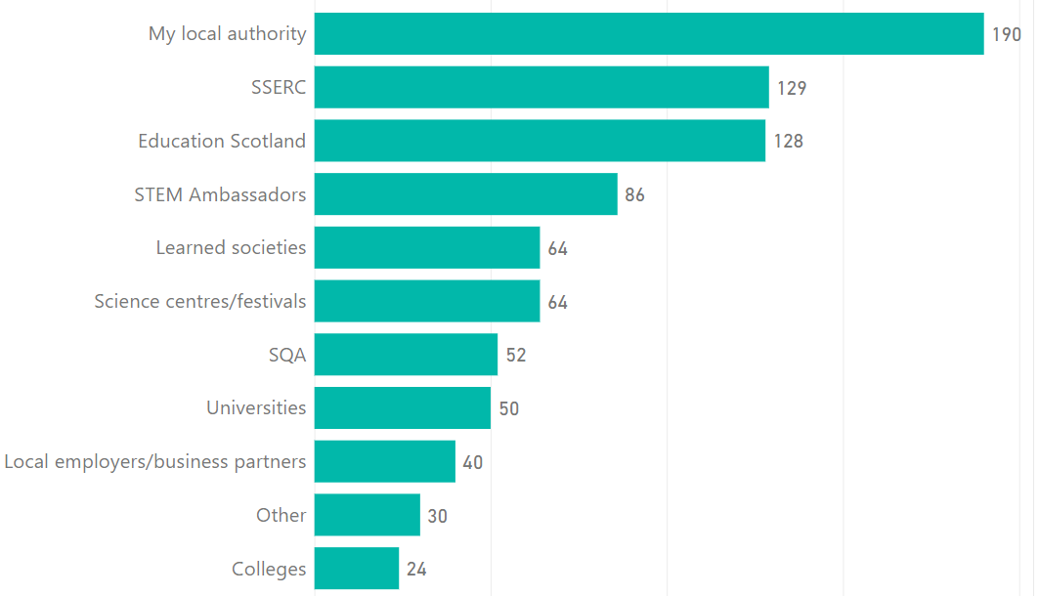
Figure 15. Organisations providing STEM professional learning (n=384)
Note. The number of practitioner responses in this figure exceeds the total number of responses as multiple selections were possible for this question in the online survey.
Figure 15 shows the remaining responses to this question. The proportion of practitioners accessing STEM professional learning through their local authority increased from 40.0% in the 2020/21 survey to 49.5% in 2022/23.
Several other professional learning providers were included in respondents free text comments including:

- NatureScot
- RHET
- SmartSTEM
- Let’s do engineering
- Dresscode
- Clickview
- IET
- YouTube
- Makey Makey
- FOLA
- STACS
- ETRUST
- Internet
- Colleagues

Ease of accessing professional learning in STEM
In the 2022/23 survey, 41.2% of respondents reported that they found it ‘easy’ or ‘very easy’ to access STEM professional learning. This is similar to the value of 41.7% from the 2020/21 survey and a significant increase from the 2018/19 figure (30.1%). This may be attributed to the increased availability of online STEM professional learning. However the data may be skewed by the low response rate to the 2022/23 survey.
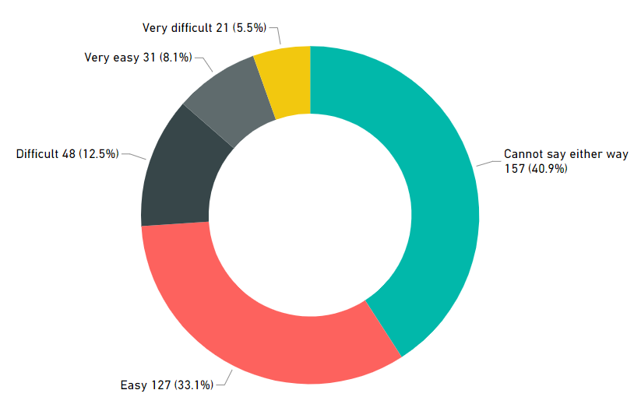
Figure 16. Ease of accessing professional learning in STEM (n=384)

Ease of accessing STEM professional learning | 2018/19 | 2019/20 | 2020/21 | 2021/22 | 2022/23
‘Easy’ or ‘very easy’ | 30.1% | – | 41.7% | – | 41.2%

Table 7. Ease of accessing STEM professional learning

Main barriers to accessing professional learning in STEM
The 2022/23 survey highlighted several barriers to accessing professional learning in STEM. The responses to this question are shown in Figure 17.
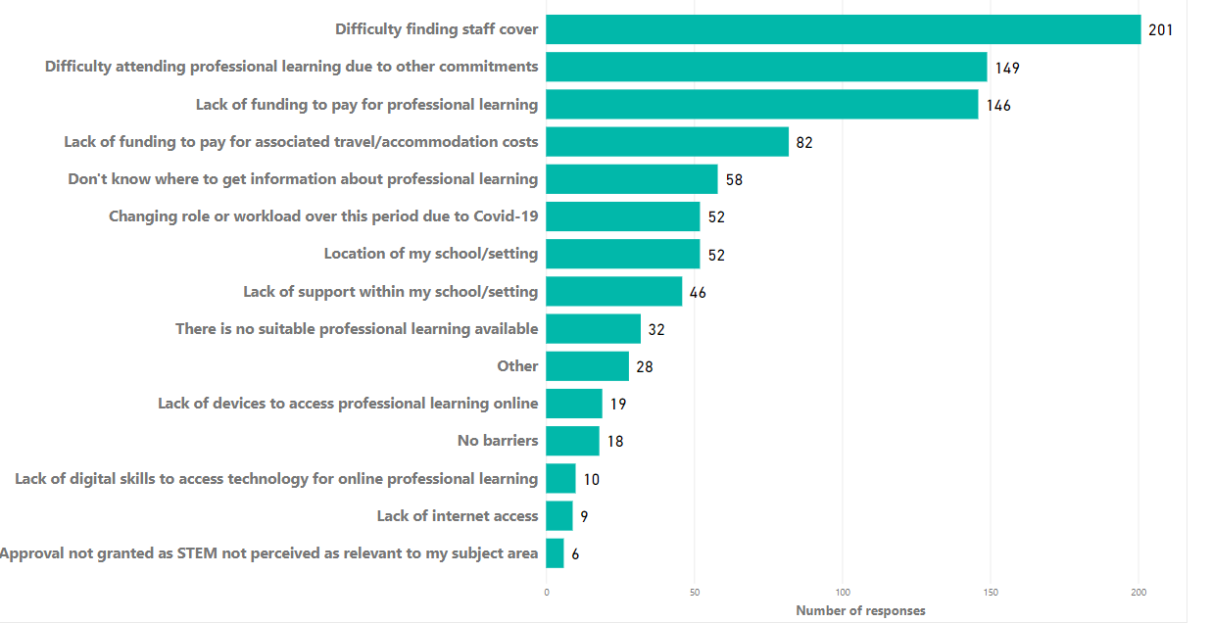
Figure 17. Main barriers to accessing professional learning in STEM (n=381)
Note 1: In the 2022/23 survey there were 381 responses to this question.
Note 2. The number of practitioner responses in this figure exceeds the total number of responses as multiple selections were possible for this question in the online survey.
Table 7 lists the top three barriers to accessing professional learning in STEM over the last five surveys.
 | 2016/17 | 2017/18 | 2018/19 | 2019/20 | 2020/21 | 2021/22 | 2022/23
1 | Too many demands on staff time | Difficulty finding staff cover | Difficulty finding staff cover | – | Difficulty in attending PL due to other commitments | – | Difficulty in finding staff cover
2 | Lack of funding to pay for professional learning | Difficulty in attending PL due to other commitments | Difficulty in attending PL due to other commitments | – | Difficulty in finding staff cover | – | Difficulty in attending PL due to other commitments
3 | Difficulty finding staff cover | Lack of funding to pay for professional learning | Lack of funding to pay for professional learning | – | Lack of funding to pay for professional learning | – | Lack of funding to pay for professional learning
Table 8. Main barriers to accessing professional learning in STEM
Note: 2019/20 and 2021/22 data is not available as surveys were not issued.
Over the last five surveys the top three responses have been consistent.
28 (7%) of respondents provided further suggestions of barriers within the “Other” section. The comments below give a flavour of these responses:
“Impact due to 1140 hours” (ELC practitioner)
“Relevance to Early Years is limited” (ELC practitioner)
“I work within an ASN secondary school where the young people work at early/first level never any targeted training provided have to slot into Primary” (ASN practitioner)
“Having other roles and CPD to do.” (Primary practitioner)
“Lack of free time after school.” (Primary practitioner)
“Area cover are not treated in same manner as class teachers” (Secondary practitioner)

Conversely, 18 (5%) of respondents reported that they did not experience any barriers to accessing STEM professional learning. As the comments below show, this could be attributed to the increased availability of online STEM professional learning because of the COVID-19 pandemic.
“I have found that there is a wealth of free/funded resources in STEM and that it is usually highly relevant and worthwhile having a direct impact on my teaching.”
“Access has been great and I feel well supported by colleagues and partners

STEM professional learning priorities for the academic year 2023/24
In the 2022/23, STEM professional learning survey practitioners were asked what their professional learning priorities were for the year ahead. The top three responses in the 2022/23 survey mirrored the 2018/19 survey showing a clear focus on STEM pedagogy, skills progression in STEM and STEM curriculum development.
The top response from practitioners across all sectors was in relation to STEM pedagogy and effective learning and teaching approaches to delivering STEM. However, the remaining responses differed by sector as show in Table 8.
The responses show that practitioners in the ASN and ELC sectors require further information on the resources and support available for STEM. Using STEM as a context to raise attainment in literacy and numeracy is a key priority for practitioners in the ASN and primary sectors. Similarly, ELC practitioners focused in on the need to develop further understanding of the concepts and knowledge that underpin mathematics as a priority for their sector. Given the priority placed on STEM skills progression and curriculum development in the primary and secondary sectors this may be useful to consider across the Broad General Education rather than discrete support for separate sectors. Finally, secondary practitioners highlighted a desire to increase their awareness of STEM careers and the relevance of STEM to the world of work.
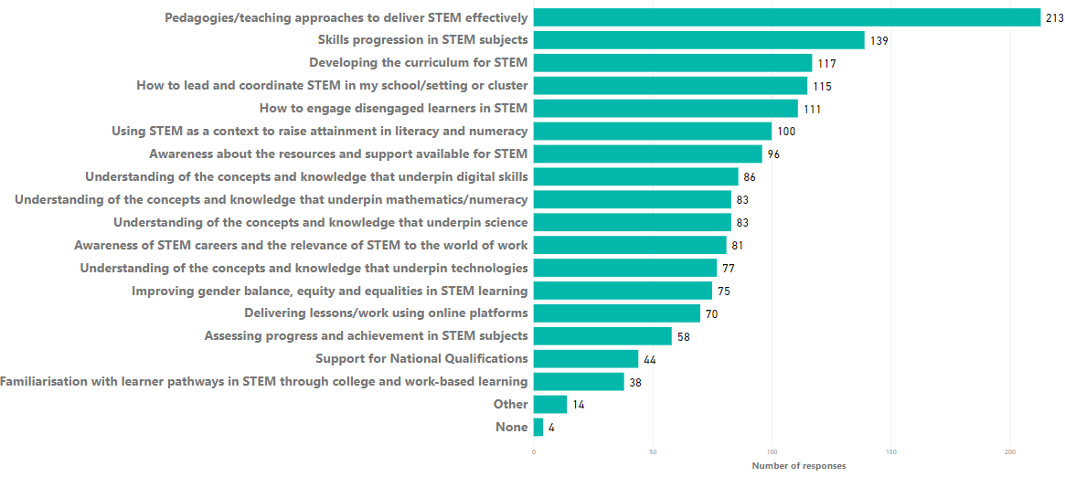
Figure 18. STEM professional learning priorities for academic year 2023/24 (n=384)
Note. The number of practitioner responses in this figure exceeds the total number of responses as multiple selections were possible for this question in the online survey.
 | ASN (21 responses)  (no. of responses) | ELC (96 responses)  (no. of responses) | Primary (142 responses)  (no. of responses) | Secondary (125 responses)  (no. of responses)
1 | Pedagogies/teaching approaches to deliver STEM effectively (9)  Developing the curriculum for STEM (9) | Pedagogies/teaching approaches to deliver STEM effectively (60) | Pedagogies/teaching approaches to deliver STEM effectively (82) | Pedagogies/teaching approaches to deliver STEM effectively (62)
2 | How to engage disengaged learners in STEM (7)  Skills progression in STEM subjects (7)  Understanding of the concepts and knowledge that underpin digital skills (7)  Understanding of the concepts and knowledge that underpin mathematics (7) | Using STEM as a context to raise attainment in literacy and numeracy (32) | Skills progression in STEM subjects (62) | Skills progression in STEM subjects (53)
3 | How to lead and coordinate STEM In my school/setting or cluster (6) | Understanding of the concepts and knowledge that underpin mathematics (31) | How to lead and coordinate STEM In my school/setting or cluster (53) | How to engage disengaged learners in STEM (50)
Table 9. STEM professional learning priorities for academic year 2023/24

Detailed survey findings: STEM in your practice

Practitioner confidence
Practitioners were asked about their confidence in delivering STEM learning during academic year 2022/23. Figure 19 shows the responses across all sectors. Approximately three quarters (72.7%) of respondents stated that they were ‘confident’ or ‘very confident’ delivering STEM which is an increase of 9.7% compared to 2020/21 survey.
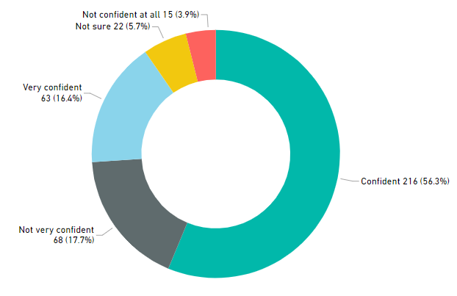
Figure 19. Overall practitioner confidence delivering STEM (n=384)
Note. Education Scotland promoted the STEM professional learning survey through a variety of channels to ensure a representative response from practitioners. However, as with all surveys, it is likely that respondents have higher levels of engagement or interest in the subject matter. Subsequently, the levels of confidence expressed are prone to reflect this and may be higher than that of the general practitioner population.
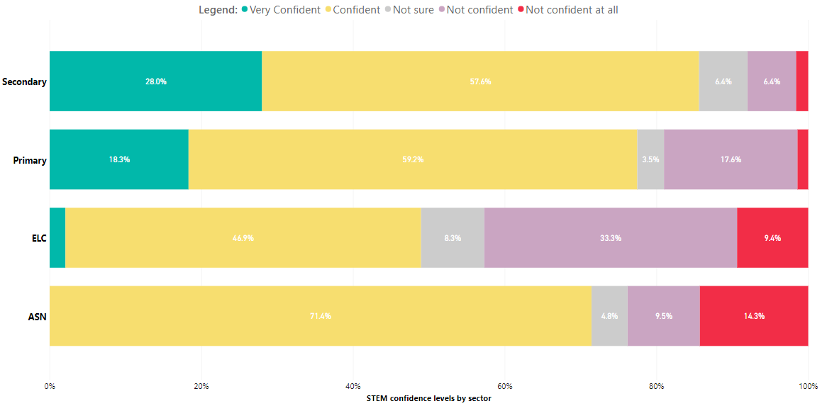
Figure 20. Practitioner confidence delivering STEM broken down by sector (n=384)

Figure 20 shows that confidence delivering STEM was highest amongst secondary teachers with 85.6% of respondents stating they were ‘confident’ or ‘very confident’ followed by primary practitioners with 77.5%. Confidence delivering STEM was lowest in the ELC sector with approximately one half of respondents stating they were ‘not sure’, ‘not very confident’ or ‘not confident at all’.
In the 2022/23 survey, practitioners were also asked about their confidence in delivering learning in discrete aspects of STEM. Practitioners reported the highest level of confidence in the delivery of science with more than three-quarters of respondents reported being ‘confident’ and ‘very confident’ in delivering science-based learning in my practice. The aspect of STEM with the lowest overall confidence rating from practitioners was engineering with only 46.0% of respondents ‘confident’ or ‘very confident’ with the statement “I felt confident in delivering engineering based learning in my practice.” Although this is the lowest overall confidence rating for 2022/23 survey, it represents a significant increase from confidence levels for engineering recorded in the 2018/19 survey (31.0%). This could be a result of the significant focus on engineering professional learning provided through the RAiSE Programme and increased awareness of other partners of the need for support in this area as a result of previous survey findings.
The confidence levels for the remaining aspects are shown in Figure 21.

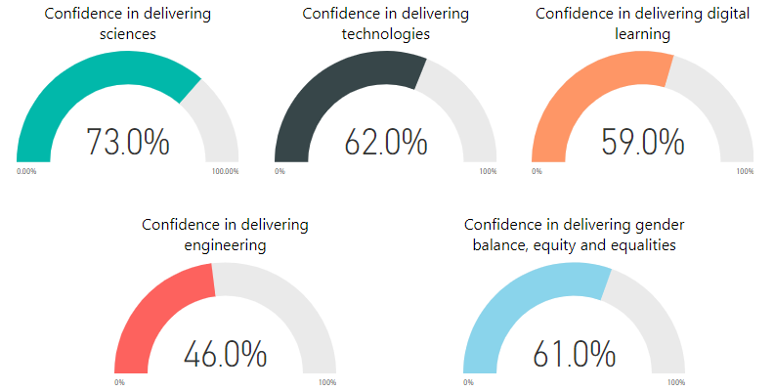
Figure 21. Overall practitioner confidence in delivering discrete aspects of STEM (n=384)
In comparison, the confidence levels for the discrete aspects of STEM in 2018/19 were: Sciences (60.2%), Technologies (54.6%), Digital (53.7%), Engineering (31.0%), Numeracy and Mathematics (77.8%), Gender balance and equalities (60.2%).
The practitioner responses are further broken down by sector in Figure 22. This shows the number of respondents who are ‘confident’ or ‘very confident’ in delivering STEM learning in their practice
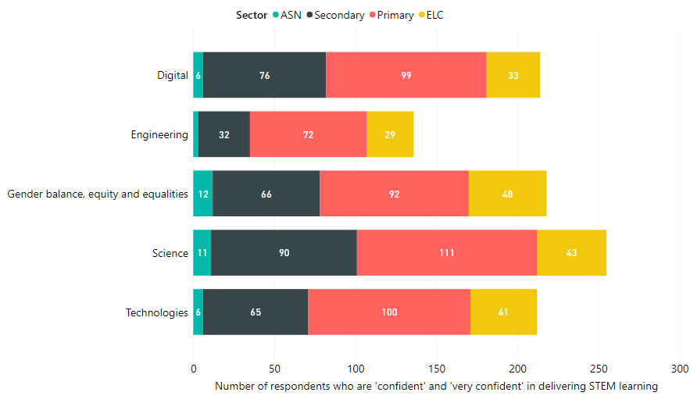
Figure 22. Practitioner confidence in delivering each aspect of STEM by sector (n=384)

Practitioner confidence statements  . | Percentage who responded ‘agree’ or ‘strongly agree’ (Number/Total responses)
 | ELC | Primary | Secondary | ASN
I felt confident in delivering science based learning in my practice. | 48.3%  (43 / 89) | 81.6%  (111 / 136) | 85.7%  (90 / 105) | 61.1%  (11 / 18)
I felt confident in delivering technologies based learning in my practice. | 46.1%  (41 / 89) | 73.5%  (100 / 136) | 65.7%  (65 / 99) | 31.6%  (6 / 19)
I felt confident in delivering digital based learning in my practice. | 37.9%  (33 / 87) | 72.3%  (99 / 137) | 65.5%  (76 / 116) | 30.0%  (6 / 20)
I felt confident in delivering engineering based learning in my practice. | 33.3%  (29 / 87) | 52.9%  (72 / 136) | 34.0%  (32 / 94) | 17.6%  (3 / 17)
I felt confident in addressing gender balance, equity and equalities in my practice. | 50.7%  (48 / 96) | 64.8%  (92 / 142) | 52.8%  (66 / 125) | 57.1%  (12 / 21)
Overall number of survey responses | 96 | 142 | 125 | 21
Table 10. Practitioner confidence levels in each aspect of STEM by sector
Note1: The respondents from the secondary sector were from a range of different subject specialisms. This should be considered when reviewing the responses in Table 9. For example, a secondary mathematics teacher may express a high level of confidence delivering mathematics and numeracy but a lower level of confidence delivering other curriculum areas. Some practitioners chose not to respond to every statement therefore the totals for each aspect are inconsistent. Care should be taken when drawing comparisons between the responses from the ASN sector and other sectors due to the relatively lower number of responses from that sector.
Note 2: In 2022/23 survey data for the confidence level in numeracy and mathematics was not collected due to an error with the survey question.
Key points when considering the responses by sector:
- Confidence levels in engineering were consistently low across all sectors.
- Primary practitioners reported the highest level of confidence in addressing gender balance, equity and equalities.

Education Scotland response
Education Scotland has continued to provide significant support and resources to address the priorities and needs identified by practitioners in relation to STEM.

Enhancing Professional Learning in STEM Grants Programme
Education Scotland funded a total of £651,888 of STEM professional learning grants in financial year 2022/23, supporting 84 projects in Round 3 and 59 projects in Round 4 of the STEM grants. This funding was aligned to the priorities and findings from the previous STEM annual practitioner surveys. Since the grants programme started in 2018, over £4.6 million has been awarded to 307 projects. An estimated 68,349 practitioners have benefitted from the three funding rounds which have run to date. More information about the grants being supported is available from the STEM summary page on the National Improvement Hub.

Education Scotland Regional Teams
Throughout this period, Education Scotland’s STEM, Numeracy & Mathematics, Digital/Technologies and Community Learning and Development teams contributed to the provision of STEM professional learning on a local, regional and national basis.
Education Scotland’s Regional STEM Officers have engaged widely with Regional Improvement Collaboratives and local authorities to identify and support the STEM professional learning needs of practitioners. Between 1 August 2022 and 31 July 2023 the Education Scotland STEM team undertook 411 direct engagements reaching 176 distinct establishments. In total this amounted to over 1,085 hours spent on engagements. This activity represented a wide range of engagements including delivering professional learning, providing professional advice and supporting policy and strategy developments.

RAiSE Programme
The Raising Aspirations in Science Education (RAiSE) programme was established in 2016 to build the capacity of practitioners, particularly in primary school settings, to deliver inspiring and engaging learning in science and STEM. The programme is led by Education Scotland and funded by The Wood Foundation, Scottish Government and participating local authorities. To date (2023/4), 27 out of 32 local authorities are participating, or have participated, in the programme including:
- Aberdeenshire Council
- Angus Council
- City of Edinburgh Council
- Clackmannanshire Council
- Comhairle Nan Eilean Siar
- Dundee City Council
- Dumfries and Galloway Council
- East Ayrshire Council
- East Dunbartonshire Council
- East Renfrewshire Council
- Falkirk Council
- Fife Council
- Glasgow City Council
- Inverclyde Council
- Moray Council
- Midlothian Council
- North Ayrshire Council
- North Lanarkshire Council
- Orkney Islands Council
- Renfrewshire Council
- Scottish Borders Council
- South Ayrshire Council
- South Lanarkshire Council
- The Highland Council
- West Dunbartonshire Council
- West Lothian Council

Local authorities participating in the RAiSE Programme, are provided with co-funding to support the recruitment of a Primary Science Development Officer (PSDO). These officers coordinate and lead professional learning in science and STEM across authority establishments. Since it was established in 2016, the RAiSE Programme has reached 32,000 practitioners through 3,107 professional learning sessions. This has resulted in over 73,538 cumulative hours of professional learning being provided.
RAiSE Officers also collaborated to produce a variety of comprehensive resources such as:
- Science planning resource: Science Planning Resource – STEM Nation (glowscotland.org.uk)
- Technologies planner: Technologies Planning Resource – STEM Nation (glowscotland.org.uk)
- STEM Through stories: STEM through Stories – STEM Nation (glowscotland.org.uk)

More information about the RAiSE programme can be found on the Education Scotland website.

STEM Nation Online Resource
Education Scotland has also created a STEM Nation online resource where practitioners can access:

- Resources: Resources – STEM Nation (glowscotland.org.uk)

- Events calendar: Education Scotland has worked with national STEM partner organisations to produce a calendar that lists STEM-related CLPL being offered regionally and nationally. The calendar contains all events categorised by sector, theme and also geographical location. Events – STEM Nation (glowscotland.org.uk)

National e-Learning Offer
Education Scotland’s STEM Officers provided critical support for the development of all three aspects of the National e-Learning Offer (NeLO) including collaborating with West Online School to support the development of recorded lessons and direct delivery of e-Sgoil live lessons. STEM Officers also led developments on the supported resources within NeLO, drawing inspiration from its sciences network to grow it into an extensive bank of online resources to support the STEM curriculum.
In response to requests from practitioners, Education Scotland’s STEM team worked with a wide range of partners to film videos of practical science experiments. Since the start of COVID lockdown, over 240 videos have now been produced. See our STEM Nation Online Resource to access all these videos: https://blogs.glowscotland.org.uk/glowblogs/stemnation/stem-resources/

STEM Networks
Education Scotland has continued to lead and support a number of local, regional and national STEM networks. These provide practitioners with opportunities to share practice, collaborate and learn together.
National practitioner networks in Glow are as follows:
- Secondary sciences network: Over 1,100 members. Joining code is uh9sf32
- STEM Network (ELC, primary): Over 800 members. Joining code is kz41xx4

Education Scotland has runs a STEM Lead Officer Network for those leading STEM strategically at local authority level. A STEM Partners Network is also supported to help coordinate efforts of national partners and to ensure they have the opportunity to connect, share practice, collaborate and inform national developments.

STEM Nation Award
From 2022, ELC, ASN, school and community learning and development (CLD) settings have been invited to apply for the STEM Nation Award in recognition of innovative and inclusive STEM practice. The award programme provides a framework to help evaluate existing practice, identify areas of strength and development needs and create an action plan for continued improvement in STEM.
The award contains five elements which can be worked towards over a period of three years: Leadership in STEM; STEM family learning; Employability and STEM partnership working; STEM curriculum and learner pathways; and Equity and equality in STEM. Education Scotland’s Regional STEM Education Officers will provide ongoing support to those settings interested in working towards and applying for the STEM Nation Award.
Visit our STEM Nation Online Resource to find out more about the award programme: https://blogs.glowscotland.org.uk/glowblogs/stemnation/stem-nation-award/

Appendix: Survey questions
2022/23 survey questions for ELC, primary, secondary and ASN practitioners
Which sector do you work in?
What is your current role?
Which of the following best describes your work pattern?
In which local authority area do you work?
Please tell us the full postcode of your school/setting.
Which subject do you teach? If you teach more than one curricular area then please select main curricular area.
Did STEM feature in your school or setting Improvement Plan in academic year 2022-23?
Did STEM feature in your associated school group/cluster Improvement Plan in academic year 2022-2023?
Did your school or setting engage with Education Scotland's STEM Self-evaluation and Improvement Framework in academic year 2022-2023?
Did your school or setting have a STEM co-ordinator(s) in academic year 2022-2023?
Did your school or setting have a STEM partner or partners from the private, public or third sector in academic year 2022-2023?
How did you find out about these STEM partner organisations?
Approximately how many hours of professional learning in STEM did you complete between 01 August 2022 and 31 July 2023?
Was this more or fewer hours than the same period previous academic year? (01 August 2021 to 31 July 2022)
Has your school or setting received any Education Scotland STEM grant funding between 2018 and 2023?
Has your setting/organisation taken part in Education Scotland STEM Nation Award Programme?
Please tell us more about the types of professional learning in STEM that you accessed between 01 August 2022 and 31 July 2023.
Which, if any, of the following organisations provided you with professional learning between 01 August 2022 and 31 July 2023?
How easy was it for you to access professional learning in STEM in academic year 2022-2023?
What, in your opinion, were the barriers (if any) to you accessing professional learning in STEM in academic year 2022-2023?
What are your STEM professional learning priorities for the academic year 1st August 2023 to 31st July 2024?
Overall, how confident did you feel in delivering STEM in academic year 2022-2023?
To what extent do you agree with the following statements with regard to your STEM practice between 01 August 2022 to 31 July 2023?

Education Scotland
Denholm House
Almondvale Business Park
Almondvale Way
Livingston EH54 6GA

T +44 (0)131 244 4330
E enquiries@educationscotland.gov.scot

www.education.gov.scot

STEM Education and Training Strategy for Scotland: Science, Technology, Engineering and Mathematics: education and training strategy - gov.scot (www.gov.scot)
A summary of STEM resources: A summary of STEM resources | Resources | Education Scotland
STEM strategy: key performance indicators: STEM Strategy: key performance indicators - gov.scot (www.gov.scot)
STEM Strategy for Education and Training in Scotland - First Annual Report: STEM strategy for education and training: first annual report - gov.scot (www.gov.scot)
STEM Strategy for Education and Training in Scotland - Second Annual Report: STEM strategy for education and training: second annual report - gov.scot (www.gov.scot)
STEM Strategy for Education and Training in Scotland - Third Annual Report: STEM strategy for education and training: third annual report - gov.scot (www.gov.scot) 7 STEM Strategy for Education and Training in Scotland - Refresh: STEM education and training strategy - refresh: annual report - gov.scot (www.gov.scot)

