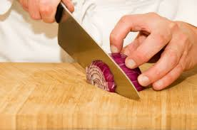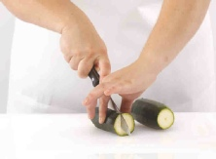

**The Claw Grip**

Place the celery onto the chopping board. Make a claw with your hand by partly curling your fingers together. Decide how thick you want the slices before you begin. Then, pick up the knife with your other hand and check that the blade is facing downwards. Tilt the knife and slice through the celery, using your fingers as a guide. Slide your fingers back, keeping your grip on the celery, and continue slicing carefully. This method of slicing is safe, and can be used for lots of different ingredients, such as peppers or cucumber.

**The Bridge Hold**

First, twist the stalk from the tomato. Place the tomato onto the chopping board. Make a bridge over the tomato with your hand. Your fingers should be on one side and your thumb should be on the other. Pick up the knife with your other hand and check that the blade is facing downwards. Then, guide the knife under the bridge and over the tomato. Cut into the tomato by pressing the knife down and pulling it out of the bridge.  You might like to think of the knife as a train which goes under the bridge. Now, take one half at a time and place it flat side down. Make a bridge over the tomato, and use the knife just like before to cut it into quarters.

This method of cutting is safe and can be used for lots of different ingredients, such as potatoes or strawberries.