Partnership Planning Afternoon – Thursday 4 May 2017
Using the Senior Phase Design Workshop Tools for 11-18 curriculum planning

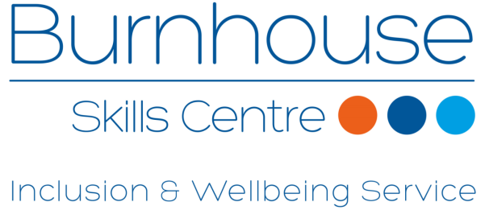

SUMMARY OF WORKSHOP
We were looking for a format to run a partnership planning session as part of our Service Improvement Day on Thursday 4 May 2017. The first half of the day focused on us discussing our progress against our Improvement Plan for 16/17 and traffic lighting progress as a team. This led into a session we ran together with the Improvement Service where we reflected on our rated school improvement plan (SIP) and looked ahead to areas of focus for 17/18. Both sessions were attended by Inclusion and Wellbeing Service staff only and by the end of the morning we had a good shape of the key actions for 17/18.
We were keen to build a fully collaborative session into the afternoon and did not want to merely consult and run our SIP past key partners. Instead, we were looking for a format that would significantly enhance our relationships with all our key partners. The session had 4 key aims:
- To inform all partners about our new model and approach for working with young people with social, emotional and/or behavioural barriers to learning.

- To create a space for our team to network with all key partners and build relationships.

- To work together to consider real case studies of young people to ensure each young person has the best possible chance of success regardless of any barriers they may have.

- To identify specific activities and actions which will be taken forward as part of the Improvement Plan for 2017/18.
Using the senior phase design workshop process, we built an agenda for the afternoon which would foster a multi-agency collaborative. The focus was not on S4-S6, instead we used the resource to help us plan for all our young people in 2017/18.
Instead of using the Education Scotland personas, we used Pupil Passports, based on 8 young people we work with. This ensured that we were very focused on designing a curriculum to meet the needs of our young people. We anonymised the Pupil Passports which show: strengths and interests, medical issues, concerns, rated wellbeing indicators and targets. In addition, each had a central area for collaboration entitled ‘How might we make a difference?’ (appendix 2).
The Pupil Passports are wholly owned by the young person and are something we have tested and developed over the course of this session. Each one is developed between an Inclusion and Wellbeing Service staff member and a young person and is written from the point of view of the young person. We support 216 young people across all 11 West Lothian mainstream secondary schools. Schools were keen to learn more about the strategies to engage young people that we were using in our work with partners so that they could extend this to when the young people were attending timetabled classes in their own school and the Pupil Passports provide this information.
We used the passports of 8 young people identified by the Inclusion and Wellbeing Service staff as those who would benefit most from collaborative working.
Each table debated and interrogated one Pupil Passport case study at a time. Inclusion and Wellbeing Service staff were positioned at every table to ensure they could support the discussions as they know the young people best, without naming the child. Each table was focused on how collectively we could make a difference. (Step 2 in the senior phase design workshop process: ‘How might we...?’ Figure 1.)
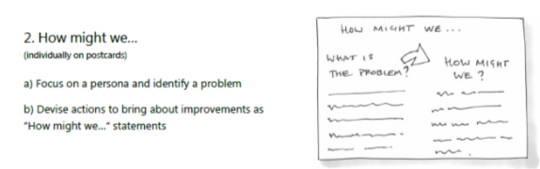
Figure 1
The suggested actions were recorded on post-its and attached to the blown up Pupil Passports on the walls. All the groups shared their feedback at the end of each case study discussion. At the plenary, The Head of Service, Jim Cameron, provided a summary of the key items which required further action – there were common themes emerging across the groups. (Step 3 of the senior phase design workshop process: Emerging themes. Figure 2.)
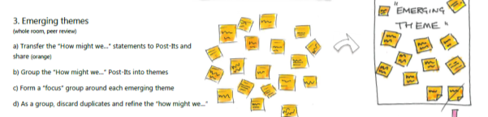
Figure 2
Each Pupil Passport with suggested actions was then to be taken forward by the Inclusion and Wellbeing Service, via the Child’s Planning Process, in partnership with the relevant partner agencies. Each one was written up as an action plan with key aspects across all 8 case studies being included in the School Improvement Plan also (appendix 3). (Step 8: Action plan.)
The event concluded with a pledge and a commitment by everyone to attend a follow-up session during the 2017/18 session. (Step 9: Pledge.)
Next steps for us are to factor all the actions into our curricular planning for next session. We have already moved on recruiting a counselling service into our programme of interventions following on from this session. We are also looking at expanding our industry-related programmes of learning based on feedback – we are in the process of being approved for a range of SQA Skills for Work programmes which will be in place for August 2017 including Rural Skills, Construction Craft, Retail and Hairdressing. We are also already thinking about when to revisit this workshop with the likely follow up to take place before the end of 2017.
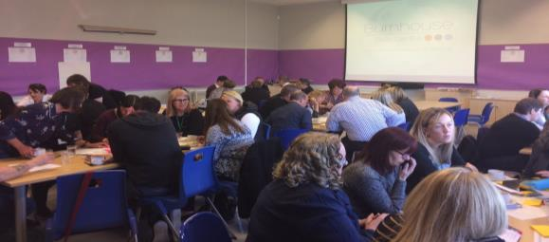

Andrew Millar
Depute Head Teacher
Inclusion and Wellbeing Service
West Lothian Council

June 2017

APPENDIX 1 - AGENDA
Inclusion and Wellbeing Service (Secondary)
Partnership Planning Agenda
1.30pm – 4.00pm
Burnhouse Skills Centre, Whitburn
4 May 2017

1.15 – 1.30 | Tea and Coffee
1.30 – 1.45 | Welcome, scene setting and context | Jim Cameron  Head of Education (Learning, Policy and Resources)
1.45 – 1.50 | Outline of key tasks | Andrew Millar  Depute Head Teacher IWS
1.50 – 2.20 | Task 1 | Discussion around young person 1 – using Pupil Passport
2.20 – 2.40 |  | Team feedback – highlight possible solutions
2.40 – 3.10 | Task 2 | Discussion around young person 2 – using Pupil Passport
3.10 – 3.30 |  | Team feedback – highlight possible solutions
3.30 – 3.45 | Task 3 | All delegates to consider all 8 Pupil Passports – “How can we improve the life chances of this young person?”
3.45 – 4.00 | Conclusions, next steps and close | Jim Cameron  Head of Education (Learning, Policy and Resources)

APPENDIX 2 – PUPIL PASSPORT – PUPIL 8
These are my concerns-
- I stay at a residential house
- I like to have authority over others
- I am a smoker
- I can be abusive to staff
- I have been violent in the minibus
- I find it difficult to control my swearing in any social situation
- I try to lead others in my behaviours
- I am a LAAC child
- I have been involved with Youth Justice
- I miss having time with my family
- I need space to handle situations but provide reassurance that I can get help if I need it.
- I want to know what I am learning and why.
- I like task followed by rewards
- I don’t like raised voices
- I don’t like to write

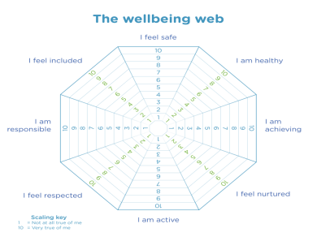
These are my strengths and interests-
- I am pleasant
- I am well mannered
- I have attended the ‘Larder’
- I am really good at Mathematics
- I enjoy SITFIT and football
- I am confident with my cooking skills

How might we make a difference?

These are my medical issues-
N/A

These are my targets-
To achieve Silver Personal Achievement award in SITFIT
To pass National 3 Lifeskills Mathematics
Set on 03/05/2017
To be reviewed 6 weeks later

INCLUSION & WELLBEING SERVICE – BURNHOUSE- CHARTER
Staff
- Plan and teach lessons that are interesting and structured
- Encourage young people to do their absolute best
- Be organised and prepared with resources to help learning
- Work with staff from other services and agencies to make sure support is available when required
- Support all young people to achieve qualifications
- Explore work placement options, college options and future career
- Support all our young people to progress successfully onto a post-school positive destination
- Student –
- Signed_____________________Date 20.02.2017
- School –
- Signed_____________________Date 20.02.2017

INCLUSION & WELLBEING SERVICE – BURNHOUSE
CHARTER
Young People
- Arrive ready to learn with an open mind
- Arrive on time for learning
- Always wear school dress
- Follow instructions
- No mobile phones in learning environment
- Do your absolute best
Everyone
- Respect ourselves
- Respect other people
- Respect our learning environment
- Work together to learn and share ideas
- Question and challenge
- Regularly review our progress together along with parents/carers
- Always aim for our absolute best

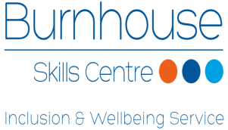
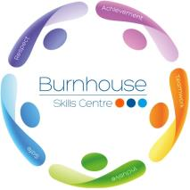
Name – Pupil 8
Schoo School – S2

APPENDIX 3 – ACTION PLAN
Pupil 8 - S2

Actions | By Whom | By When
Autism Strategies
More Choices, More Chances type work
Encourage more time doing physical activities (linked to learning)
Work with family to arrange more access to siblings
Check for any diagnosis of dyslexia, handwriting
Family support re connection to some part of his family. Connection to dad’s side
Test for ASD (raised voices, instructions, what I’m hearing and why)
Restorative behaviour work (rebuilding relationships)
Cyrenians, Amber Project
Smoking Cessation
Mental Health Referral, CAHMS, Therapeutic Counselling

APPENDIX 4 – DELEGATE ATTENDANCE REGISTER
First Name | Surname | Organisation
Colin | Gegan | Police Scotland
Claire | Stobie | Skills Development Scotland
Dawn | Roden | CLD Youth Services (WLC)
Stuart | McKay | DYW Lead (WLC)
Linda | Jenkins | NHS Lothian
Linda | Sanders | Social Policy (WLC)
Sarah | Summers | Social Policy (WLC)
Wendy | Milne | Social Policy (WLC)
Donna | Stephen | Education Services (WLC)
Evelyn | Russell | Broxburn Academy
Robin | Thomson | Broxburn Academy
Caroline | Evans | West Lothian College
Angela | Boyd | The Larder
Lesley | Williams | Education Services (WLC)
Alison | Raeburn | Education Services (WLC)
Jennyfer | McNiven | Education Services (WLC)
Heather | Allan | Youth Justice (WLC)
Kate | Ashcroft | Business Gateway Team (WLC)
Elaine | Hardie-Cameron | Youth Inclusion Project
Helen | Davies | Youth Action Project
Emma | Sowerby | Scottish Borders Council
Catriona | Grant | Inclusion and Wellbeing Service (WLC)
Morag | Higgins | Ross Dhu Equestrian
Martin | Berginis | Education Services (WLC)
Ian | McIntosh | CLD Youth Services (WLC)
Jim | Cameron | Education Services (WLC)
Greg | McDowall | St Margaret's Academy
Christine | McLure | Children and Young People's Team
Paul | Corner | Police Scotland
Robert | Cochrane | Police Scotland
David | Thomson | Police Scotland
Gillian | Amos | Health Improvement Team
Plus all Inclusion and Wellbeing Service (Secondary) Staff

