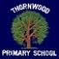**Lesson Study in Numeracy**

**Planning for Cluster Peer Visits**

 Session 2016 – 2017**



**14th October 2016**



**Planning** 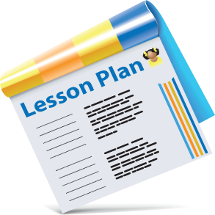

*Identify specific lesson goals (these goals often come from examination of*

*assessment data or identifying a common issue/ problem)*

*• Select or revise research lesson*

*• Anticipate student responses*

*• Plan data collection and lesson*

**Do Research Lesson** 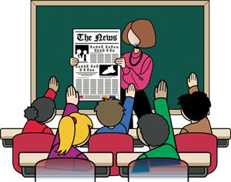

*• One person teaches the lesson*

*• Observers note pupil actions and responses*

*• Collect evidence of pupil thinking*

*• Purpose is to gather data on effectiveness of the lesson not to evaluate the teacher*

**Reflect (later revise and re-teach) **

*• Discuss the lesson and observations and share evidence of student learning*

*• Based on the evidence collected and discussed the team makes changes to the lesson*

*• Changes are designed to address issues and student misunderstandings within the lesson*

*• This may involve several meetings and reiterations*

*• Lesson then re-taught to a new group of pupils*

*• Disseminate the findings of the study*

*• Use the knowledge generated to inform practice in other areas*