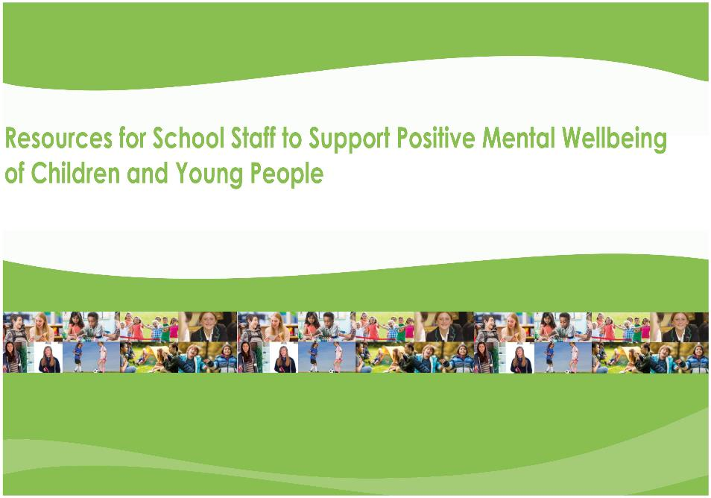

Supporting learners at risk of, or
who are in conflict with the law

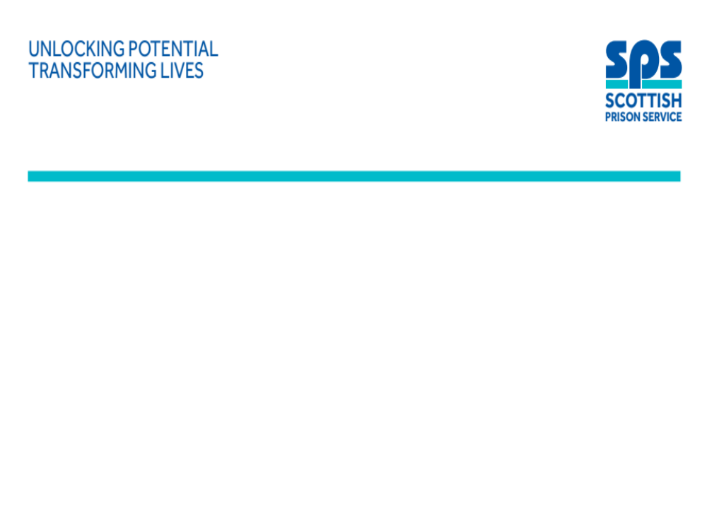

‘Early school exclusion was one of the strongest predictors of making the transition from the Children’s Hearing System to the adult criminal justice system and of ending up in custody, even taking other factors such as offending behaviour into account. School exclusion before age 12 increased the odds of imprisonment by age 22 by a factor of four.’ (McAra and McVie, 2010).

Resources for educational practitioners to support:
learners at risk of or who are in conflict with the law

Introduction
Children and young people who present a risk of being, or who are, in conflict with the law, are often highly vulnerable, with complex needs. In many cases these young people have themselves been victims of crime, neglect and abuse, and a number are care experienced.
Preventing children coming into conflict with the law is integral to Scottish Government’s vision of Scotland as the best place to grow up and to ‘Getting it Right for Every Child’. It is imperative that children are diverted away from the Criminal Justice System, wherever possible and appropriate, in order to avoid the criminalisation of their behaviour and the potential negative impact this could have on their future life chances. Education is a key partner in this preventative work; school attendance and staying engaged with learning can reduce risk and improve life chances. A learning environment underpinned by stable positive relationships is a crucial factor in supporting all children and young people. Approaches to inclusion and well planned support strategies to meet learners’ additional support needs can also play a significant role in minimising children coming into conflict with the law. For the small minority who will go through the Criminal Justice System then it is important that they are meaningfully supported to participate and understand the system and processes.
This resource provides information, resources, research-based evidence and a range of approaches which could help schools create inclusive, calm, learning environments which promote positive behaviour, identify and address learning needs, and support social and emotional wellbeing.
Raising the age of criminal responsibility
Scottish Government are committed to:
- protecting and promoting the rights and interests of children and young people, and
- preventing and addressing offending behaviour by children and young people.

Legislation and guidance.

What have we learned about children and young people who come into conflict with the law?

RESOURCE: What we can learn from young people in custody and how can we use this for supporting the vulnerable children in our schools right now?
A presentation by Dr Gill Robinson (Scottish Prison Service and Chair of the Improving Life Chances Implementation Group)

From research we know:
- Of 100 under 12 years olds referred to the Children’s Reporter on offence grounds, the offence was part of a pattern of behaviour for 37 of these children. Of these 37, 30 had parents who presented risks to them, 26 had educational problems, 16 had mental health difficulties and 11 had been the victims of physical or sexual abuse (Henderson et al, 2016).
- Of 327 young men under 21 in HMYOI Polmont, 33% reported being in care as a child and 25% were in care at the age of 16 (Broderick and Carnie, 2016).
- In a further study of 103 young offenders in HMYOI Polmont who had experienced care and removal from their family home more than 75% had experienced traumatic bereavement.
- Early school exclusion was one of the strongest predictors of making the transition from the Children’s Hearing System to the adult criminal justice system and of ending up in custody, even taking other factors such as offending behaviour into account. School exclusion before age 12 increased the odds of imprisonment by age 22 by a factor of four (McAra and McVie, 2010).
- 60-70% of children and young people who enter the Criminal Justice System have speech and language difficulties (CYCJ, 2020)
The experiences of care experienced children and young people were comprehensively collated in The Promise as a result of the Independent Care Review. In relation to children in conflict with the law the review identified that:
- care experienced children are disproportionately criminalised
- many children attending a Children’s Hearing on the grounds of offending have a known speech, language or communication issue and there is an over representation of children with additional support needs at Children’s hearings.
- the impact of early criminalisation is life long and can make it profoundly difficult for young people to access future opportunities (Disclosure)
The Promise makes a commitment to care experienced children and young people that:
- first and foremost children must be listened to and be meaningfully and appropriately involved in decision making
- the principles that ‘children who engage in offending need care and protection rather than punishment’ needs to be re-stated and understood across all services.
- a progressive rights based youth justice approach based on Kilbrandon principles must be developed to prevent criminalisation of children.

The following three tables outline what educational practitioners can do for these learners and their families in terms of prevention and support.

What educational practitioners can do:

to help to prevent children coming into conflict with the law
Justice Delivery Plan (2018)  Preventing offending: Getting it right for children and young people (2015)  A new vision and action plan will be published in the summer 2021. |  | The plan and strategy present a vision of us living “in communities that are inclusive, empowered, resilient and safe” (National Performance Framework outcome, 2018). Ultimately the aim is for learners who are at risk of being, or who are, in conflict with the law to engage, or re-engage, with the learning opportunities available to them, and to prevent a future cycle of offending.
Practitioners should:
- develop a shared understanding of nurture, resilience, the impact of adversity, trauma and bereavement in childhood, and how to effectively use relational approaches including using restorative language and how to respond restoratively;
- focus on inclusive practice to ensure all CYP have opportunities to access activities and learning experiences
- plan to meet all additional support needs, including speech, language and communication needs and address any barriers to learning
- proactively promote attendance and when required explore alternatives to exclusion
- support and improve the health and wellbeing of children and young people (CYP) who are putting themselves or others at risk
- plan all transitions early and thoroughly
- ensure that children and young people have a say in all discussions and decisions about them and their future
- communicate safety messages to learners through universal supports such as effective pastoral care systems and PSE programmes,
- develop responses, in collaboration with key partners, to support learners at risk of offending such as targeted support programmes
- sensitively provide children and families with information about the justice system including the possible implications of going down this path
Resources | The Children’s Hearing: What Educational Practitioners should know  Educational exclusion and inclusion - Common themes from the Improving Life Chances Group  Applying nurture as a whole school approach  Compassionate and Connected Classroom  Disclosure: What educational practitioners should know  Mentors in Violence Prevention - Promotes attitudinal change and better understanding of violence/bullying.  What works to Prevent Youth Violence: A summary of Evidence  No Knives Better Lives  Reducing exclusion and improving wellbeing through inclusions – Perth Academy case study.  The Children and Young People’s Centre for Justice - Youth and criminal justice information.
Professional Learning | The Slide – Teacher’s Pack – Preventing young people becoming involved in serious and organised crime.  Compassionate and Connected Communities (GLOW login required)  Recognising and Realising Children Rights  Timeline: An anti-sectarian professional learning resource

What educational practitioners can do:

when children and young people are in conflict with the law
Improving the life chances of children who offend: A summary of common factors (2020) |  | The research based report highlight some of the key factors which contribute to improved life chances for these learners.
Practitioners should:
- develop a shared understanding of nurture, resilience, the impact of adversity in childhood and trauma, and how to effectively use relational and restorative approaches (see some Restorative Case Studies);
- respond to deeds in the context of needs (i.e. identify any underlying unmet ‘needs’ and consider these when responding)
- understand and respond to behaviour in an child friendly, integrated, and holistic way considering the young person, their family and their community context (this should be captured in a Relationship and Behaviour Policy that has been co-developed by all stakeholders)
- show unconditional positive regard (you don’t like what they have done but you still like and care for them).
- help them to understand the impact of their actions and behaviours
- gain a better understanding of Children’s Hearings and how to prepare reports for Hearings;
- focus on the following six themes to improve outcomes for learners who are in conflict with the law (see article above for more detail):
- School inclusion
- Strengthening relationships and engagement
- Supporting victims and build community confidence (reduce the risk of victims of crime becoming involved in offending themselves)
- Improving health and wellbeing
- Provide ‘Opportunities for all’ (support post 16 learning, training and work)
- Transitions
Resources | Developing a positive whole school ethos and culture: relationships, learning and behaviour  Disclosure: What educational practitioners should know  Inclusion in Practice: The Circle Framework - Secondary  Inclusion as Prevention: CYCJ Case Study in South Lanarkshire  Information to support victims of youth crime and Young Victims of Crime  Positive Mental Wellbeing  Beyond Youth Custody  Secure Care Standards (2020) Youth Justice Standards (currently under consultation)
Professional Learning | Introduction to inclusive education – Free online professional learning  Introduction to inclusive education for pupil support staff (GLOW login required)  Supporting children and young people through grief and loss (GLOW login required)

What educational practitioners can do:

to support parents and families
Learning Together: Scotland National Action Plan (2018-2021) |  | The Plan recognises the importance of parents and families in helping a child or young person stay engaged in learning at school.
Practitioners should:
- proactively engage with parents of children and young people who are at risk of coming into conflict with the law, without judgement
- encourage parents to be involved in their child’s education. For these learners the two-way communication between home and school is particularly vital. For this to happen schools need to proactively develop trusting relationships with parents of children who present a risk of being, or who are, in conflict with the law.
- support parents to engage or interact with their child’s learning. The quality of a parent’s engagement can significantly and positively affect how a child engages with learning and school life. It can also impact on attendance, self-exclusions and truanting.
- support parents to participate in family learning where they can learn how to support their children’s learning. For many of these learners this may help to break a cycle of disengagement from education, or involvement in crime which can often be inter-generational.
- raise awareness of the negative impact of having an imprisoned parent and the importance of maintaining and improving communication with parents in prison about their child’s progress
Resources | Engaging parents and families - A toolkit for practitioners – Resource designed to support self-evaluation and improvement.  Engaging with Families - Resource designed to support parents, schools and communities.
Professional Learning | Family Matters – Solihull Approach Parenting Programme

Reflective and Improvement questions
These reflective questions invite you to consider the impact of your own practice, and your school’s approaches, to improving the life chances and outcomes of learners who are at risk of being, or who are, in conflict with the law.
- How effectively do I build relationships with learners who are at risk of being, or who are, in conflict with the law?
- Do I look beyond their behaviour to their needs?
- How well do we as a school recognise and plan for transitions for these vulnerable learners?
- How effective are we at recognising and planning to meet the additional support needs of our learners who find it very difficult to engage with traditional school provision?
- How effectively do we adopt a holistic approach when working with the child/young person and their family?
- How effectively do we identify challenges and possible barriers to success through a multidisciplinary approach?
- How well do we create shared professional learning opportunities with key partners?

Guidance, Legislation and Support Back
Guidance | A guide to Youth Justice in Scotland: policy, practice and legislation  Children Missing from Education  Included, Engaged and Involved Part 1  Included, engaged and involved part 2 | Practice guidance with links to topics such as managing risk of serious harm, reintegration and transition, SLCN in Youth Justice etc.  Guidance for promoting and managing school attendance  Guidance preventing and managing school exclusions.
Legislation | The Age of Criminal Responsibility (Scotland) Act 2019  Children and Young People (Scotland) Act 2014  Education (Additional Support for Learning) (Scotland) Act 2004 and Code of Practice 2017 | Once commenced in 2021 this Act raises the age of criminal responsibility in Scotland from 8 to 12. It includes appropriate safeguards in relation to issues such as police powers in exceptional cases to investigate harmful behaviours by under 12 year olds, to take and retain forensic samples, disclosure and the impact on victims.  This legislation strengthened the rights of children and young people in Scotland and created new systems for earlier identification of issues rather waiting for crises to occur.  Legislation for educational provision for any learner considered to have additional support needs. This group of learners are more likely to require additional support.

Supporting Agencies | - Scottish Government Corporate Parenting  - Skills Development Scotland  - Children and Young People’s Centre for Justice  - Scottish Prison Service  - Children’s Hearings Scotland  - Disclosure Scotland  - Police Scotland  - Children’s Reporter (SCRA)  - Criminal Justice Voluntary Sector Forum

References | Broderick, R. and Carnie, J. (2016) Young People in Custody 2015, http://www.sps.gov.uk/Corporate/Publications/Publication-3908.aspx  CYCJ (2020) A Guide to Youth Justice in Scotland: policy, practice and legislation Section 9: Speech, Language and Communication Needs in Youth Justice, http://www.cycj.org.uk/wp-content/uploads/2020/09/Section-9-2020.pdf  McAra, L. and McVie, S. (2010) Youth crime and Justice: Key Messages from the Edinburgh Study of Youth Transitions and Crime, www.research.ed.ac.uk/portal/files/8195355/Youth_crime_and_justice_Key_messages_from_the_Edinburgh_Study_of_Youth_Transitions_and_Crime_Criminology_and_Criminal_Justice.pdf  Scottish Government (2003) The Kilbrandon Report

Education Scotland
Denholm House
Almondvale Business Park
Almondvale Way
Livingston EH54 6GA

T +44 (0)131 244 4330
E enquiries@educationscotland.gsi.gov.uk

www.education.gov.scot

© Crown Copyright, Choose an item.

You may re-use this information (excluding images and logos) free of charge in any format or medium, under the terms of the Open Government Licence providing that it is reproduced accurately and not in a misleading context. The material must be acknowledged as Education Scotland copyright and the document title specified.

To view this licence, visit http://nationalarchives.gov.uk/doc/open-government-licence or e-mail: psi@nationalarchives.gsi.gov.uk

Where we have identified any third party copyright information you will need to obtain permission from the copyright holders concerned.

Extracts from Children and Young People in Custody in Scotland: Looking Behind the Data (Revised June 2018)

