**MVP logo-a black- M, a red V and a black P with Scotland underneath in red. Below this are the words Mentors in Violence Prevention and on the final line
Challenging Gender-based Violence, Everyone's Responsibility**

**Annual Report**

**MVP**

**April 2023-March 2024**

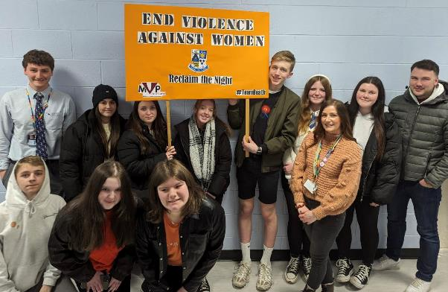



# MVP is funded by Scottish Government ‘Safer Communities Grant Funding’. The programme is supported and developed by Education Scotland and delivered in schools and communities by multi-agency staff and young people.Contents

04 | Context

05 | What is Mentors in Violence Prevention?

06 | The reach of MVP

07 | New resources

08 | Campaign: 16 Days of Activism

10 I Impact of MVP

Impact of professional learning

Impact on Mentors (senior pupils)

Impact on Mentees (younger pupils receiving the peer education)

16 I Breaking News

18 I Conclusions

# Context

Mentors in Violence Prevention is a gender-based violence prevention programme. Gender-based violence is a violation of women’s human rights. The [World Health Organisation](https://www.who.int/news-room/fact-sheets/detail/violence-against-women) (WHO) estimates that about 1 in 3 women worldwide have been subjected to physical and/or sexual violence in their lifetime.

The [United Nations Convention on the Rights of the Child](https://www.unicef.org.uk/wp-content/uploads/2010/05/UNCRC_summary-1.pdf) enshrines the right to protection from all forms of violence. The United Nations sustainable development goals include [Goal 5 Gender Equality](https://www.unwomen.org/en/news-stories/explainer/2022/09/explainer-sustainable-development-goal-five), with gender equality woven through most of the other Goals.

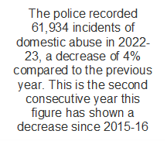While recorded incidents of domestic abuse from [Police Scotland 2022-23](https://www.gov.scot/publications/domestic-abuse-statistics-recorded-police-scotland-2022-23/) highlight a 4% decrease from the previous year, this is in the context of an increase in recorded incidents every year from 2015 until 2020.

The WHO states that children who grow up in families where there is violence may suffer a range of behavioural and emotional disturbances.

Sexual crimes account for 5% of [all crimes recorded in Scotland 2022-23](https://www.gov.scot/publications/recorded-crime-scotland-2022-23/pages/6/). The number of sexual crimes recorded decreased by 3% compared to the previous year, however this is in the context of a long-term upward trend since 1974. In 2022-2023,14,602 sexual crimes were recorded in Scotland and 3830 of these were online sexual crimes.

Abuse carried out by boys and young men against girls and young women is often in school environments although it can also be in the context of intimate relationships. [Thirty-seven percent of girls and young women](https://neu.org.uk/sites/default/files/2023-03/sexism-survey-feminista-2017.pdf) report experiencing sexual harassment in school. Furthermore, The [Rise Report 2022](https://womensaid.scot/wp-content/uploads/2022/07/The-Rise-Report-Final.pdf) found that in Scotland over a third (36%) of young women respondents had been in an intimate relationship with someone who was abusive or harmed them physically or emotionally and nearly three quarters knew someone who had been in such a relationship.

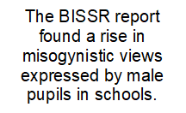The [Behaviour in Scottish Schools Research Report](https://www.gov.scot/binaries/content/documents/govscot/publications/research-and-analysis/2023/11/behaviour-scottish-schools-research-report-2023/documents/behaviour-scottish-schools-2023/behaviour-scottish-schools-2023/govscot%3Adocument/behaviour-scottish-schools-2023.pdf) found that there has been an increase since 2016 in levels of misogyny and gender-based abuse from male pupils, potentially related to the use of social media and the impact of influencers. [The Man Box](https://jss.org.au/programs/research/the-man-box/) research, updated in 2024, found that almost four in ten men feel pressure to conform to the Man Box rules (a rigid set of rules about how to think, feel or act a certain way because of their gender). Those who most strongly agreed with the Man Box rules were more likely to have perpetrated violence, hold violence-supportive attitudes, and consume violent pornography. They were 35 times more likely to have frequently perpetrated verbal sexual harassment against a woman or girl in a public place.

# What is Mentors in Violence Prevention?

In March 2024, the Scottish Government launched ‘[Preventing and responding to gender based violence: a whole school framework’](https://www.gov.scot/publications/preventing-responding-gender-based-violence-whole-school-framework/), a framework which aims to help every child and young person feel safe and respected in schools and to contribute to the prevention and eradication of gender-based violence. Mentors in Violence Prevention supports a whole school approach to gender-based violence prevention and contributes to [Equally Safe](https://www.gov.scot/publications/equally-safe-scotlands-strategy-preventing-eradicating-violence-against-women-girls/), Scotland’s strategy for preventing and eradicating violence against women and girls, and to Scotland’s [Violence Prevention Framework](https://www.gov.scot/publications/violence-prevention-framework-scotland/).

Mentors in Violence Prevention (MVP) is a peer education leadership programme in which senior pupils are trained and supported to deliver lessons to their younger peers. Developed in the United States by US Educator Dr Jackson Katz PhD, it was introduced to Scotland in 2012 and adapted for the culture and context of Scottish learners. It is now delivered in 210 secondary schools in Scotland. In this short [video](https://youtu.be/Jc7DwTNGrLI), the headteacher from Balwearie High School considers why the peer education aspect of MVP is impactful.

MVP lessons explore and challenge the attitudes, beliefs and cultural norms that underpin gender-based violence and give learners a language and framework to explore the issues. These lessons cover a range of topics including sexual harassment, consent, image-based abuse, misogyny and coercive control. Supporting young people to develop healthy relationships and recognise harm is at the heart of the [MVP programme](https://blogs.glowscotland.org.uk/glowblogs/mvpscotland/).

The programme uses a bystander approach which allows learners to explore sensitive topics from the stand point of a neutral observer, rather than as victim or perpetrator, and allows options for safe interventions to be explored within a supportive environment.

In this [video](https://youtu.be/unlyc4xgsiU), two mentors from Balwearie High School explain why they became involved in the programme. Young people from Graeme High School discuss what they do [here](https://twitter.com/i/status/1666123653258395651):

# 

# The reach of MVP

This year, 210 schools have been confirmed to be delivering MVP as part of their curriculum. This is an increase from 173 confirmed schools in 2022-2023. Thirty-two schools delivered MVP for the first time.

Based on an average of 29.5 mentors per school, this means this year 6,195 mentors (senior phase pupils) have delivered a minimum of 8,400 MVP lessons to younger pupils. In 55% of schools, staff are delivering additional lessons.



32

schools

delivering MVP for first time

210

schools

6,195

mentors

**Staff Professional Development**

This year, 738 staff were trained to deliver MVP. This involved learning about gender-based violence, exploring the MVP programme and its rationale, and planning how to implement the programme. Some of these staff were trained by Local Authority training teams. Professional learning was delivered to teaching and education staff, and a wide range of partner agency staff from organisations such as Rape Crisis Scotland, Police Scotland and Community Learning & Development teams.

Following two Train the Trainer professional learning programmes run this session, there are now 12 Local Authorities with MVP Trainers.





12

Local Authorities with MVP Trainers

738

staff trained

# New resources

To keep MVP relevant to young people, new scenarios are developed in collaboration with young people and topic experts. Topics are chosen based on information from young people and staff. Partners included [Shakti Women’s Aid](https://www.bing.com/ck/a?!&&p=d12be68113e9f1efJmltdHM9MTcyMjkwMjQwMCZpZ3VpZD0zNmY1MDkzNy03MzE1LTY0NjYtM2EyMC0xOWY3NzcxNTZmMWImaW5zaWQ9NTIyMg&ptn=3&ver=2&hsh=3&fclid=36f50937-7315-6466-3a20-19f777156f1b&psq=Shakti%e2%80%99s+Women%e2%80%99s+Aid&u=a1aHR0cHM6Ly9zaGFrdGllZGluYnVyZ2guY28udWsv&ntb=1), and [Dr Kaitlyn Regehr](https://profiles.ucl.ac.uk/88177-kaitlyn-regehr), University College London.

This year, three topic resources were finalised: honor-based violence, body image and misogyny.

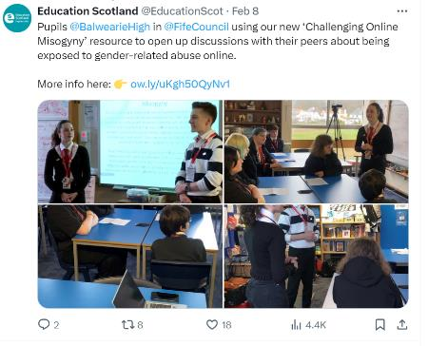

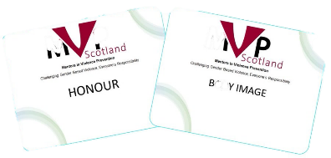

Following the launch of the [Challenging Online Misogyny resource](https://education.gov.scot/news/new-mentors-in-violence-prevention-mvp-resource/), an Education Scotland [podcast](https://educationscotland.podbean.com/e/mvp-social-media/) episode was created on the topic. In the episode, the interim Chief Executive of Education Scotland, Gillian Hamilton interviewed Angela MacDonald from the Mentors in Violence Prevention (MVP) programme, and researcher Dr Kaitlyn Regehr from University College London who collaborated on the resource. They discussed how social media algorithms amplify extreme content and normalise harmful ideologies, and they considered the role of education.

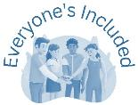

Materials to teach about the role of the bystander and anti-bullying scenarios that had previously been used in MVP are now available to all through [Everyone’s Included](https://education.gov.scot/resources/everyone-s-included/). There were 1292 views in the first 8 months.

# Campaign: 16 Days of Activism

**What are the 16 Days of Activism to end Gender-based Violence?**

The 16 Days of Activism are an important opportunity to raise awareness and call for changes at an international, national and local level to end violence against women and girls. The campaign was from 25th November (UN Day For the Elimination of Violence against Women) to 10th December (Human Rights Day) 2023.

This year we worked with Equally Safe in Schools to create a call to action to encourage schools to take part in the 16 days of activism.

**What was our call?**

We wanted to encourage as many young people as possible to take part this year in the 16 Days of Activism. To this end, we invited all secondary schools to create a campaign to raise awareness and call for change to end violence against women and girls.

**What did schools need to do?**

* Gather a group of interested young people
* Create an action plan for a campaign/series of activities to take place during the 16 Days of Activism
  + Collaborate with relevant groups across the school (where they existed), such as Equally Safe at School, MVP mentors, Equality Group and with partner agencies.
  + Submit a pro-forma to the MVP team

**What happened?**

We received 17 action plans: 3 Local Authority Plans and 14 individual plans spanning 9 Local Authorities. Plans ranged from lessons to younger pupils, signing of pledges, input from relevant agencies, exhibitions and stalls, quizzes to bake sales and a lip sync competition to raise awareness of gender-based violence. Visits or online meetings were arranged with 11 schools and school groups to support and publicise their work. A highlight [video](https://x.com/MVPScot/status/1734245900170432671) of the school visits and events was circulated on social media.

Feedback from each event was positive, with pupils happy to take part and engaged in at least some parts of the planning and organisation of the events.

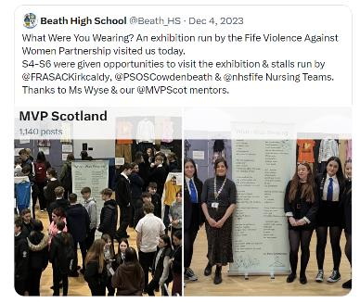

A social media screenshot saying thanks to Glenrothes High MVP mentors for inviting us yesterday to watch their awareness raising session with S6. Great to see pupils pledge their suport to challenge GBV. Hastag Scotschools16 days
Within post is photo of seven mentors standing in front of a stage with a screen showing' Every girl has the right to learn without fear'.

A screenshot of a social media post by MVP Scotland on 11th December 2023. It says 'Thanks to Fife council schools who welcomed us last week at Beath HS, Balwearie HS and IHS to showcase their hashtag scots schools events.A privilege to meet your inspiring mentors and hear all about your gender-based violence prevention work. Bak sale goodies were great.
Phot of bake sale.

# 

# Impact

1. **Impact of Professional Learning**

Leadership is key to the success of preventing gender-based violence in schools: knowledgeable and confident staff are therefore crucial. Surveys for pre- and post-learning were received from professional learning participants. These staff comprised mainly teachers but included Community Learning & Development, Police Scotland and other partners. 589 surveys were completed before the professional learning and 490 afterwards. The graph below outlines the changes in responses to the following statement.

As can be seen in the above graph, there is an enormous increase in confidence in terms of skills related to educating others about GBV.

The graph below summarises responses to a number of statements related to the professional learning:

The majority of participants strongly agreed that the information presented was important to know, raised their awareness of gender-based violence and help them feel prepared to intervene in difficult situations involving friends, colleagues and peers. The responses suggest the training is highly valued.

Examples of what staff found useful included:





“Practically carrying out the scenarios

made me feel a lot more confident to

deliver it in school”

*Edinburgh City Council*

“Active learning, non-judgemental,

supportive, interesting, empowering.”

*Glasgow City Council*

“I found all aspects extremely useful,

gave me an incredible amount to think

about and has changed my perspective

on many aspects.” *Highland Council*

“Learning how to approach the teaching

of this often contentious area to the

young people in my school”

*East Renfrewshire Council*

“I found the most valuable part to be

how to approach this topic and its

information related materials with young

people - how to make this a normalised

conversation in youth based community

work and hopefully by doing that, more

young people can identify abuse and

know who to turn to for help and

support.” *North Ayrshire Council*

1. **Impact on Mentors (senior pupils)**

The staff survey of impact received 60 responses from 21 Local Authorities. The following responses were received in relation to impact on mentors.

A screenshot of responses to a range of statements:
MVP has helped mentors increase their understanding of healthy and unhealthy relationships-nearly all mentors agreed or strongly agreed
MVP has helped mentors to better understand gender-based violence.-most strongly agreed, slightly less agreed and a very few were neutral or diasagreed
Mentros leadership skills have improved through involvement in MVP
Most strongly agreed, a smaller group agreed and a very small number were neutral or disagreed.
Following training and delivery MVP mentors are more likely to take action when they are aware of abuse. A small number disagreed or were neutral, most agreed and about a third strongly agreed.

Most felt mentor understanding of healthy and unhealthy relationships had increased as had their understanding of gender-based violence. Most felt mentor leadership skills had improved. Many were able to give examples of impact including:

“A mentor noticed behaviours in their own partner which had been highlighted through the programme and felt able to end the relationship and deal with the fallout with support from others.” *East Lothian Council*

“I have seen mentors come into their own and independently improve their leadership skills and safely disclose information that has prevented incidents from occurring.” *Inverclyde*

“One of our mentors was able to support a friend out of a coercively controlling relationship” *Argyll and Bute*

“Mentors were able to understand what a healthy relationship was like and review this in their own circumstances and make changes to their current relationships and friend groups with positive outcomes.” *Glasgow City Council*

“On several occasions, MVP mentors have approached Pastoral Care regarding the wellbeing of younger peers.” *Glasgow City Council*

“Some pupils have particularly responded well to the MVP programme and this has led to discussions specifically around misogyny – *influencer named*. Pupils were really keen to apply what they have seen on the news to what they've learned through the MVP Programme. Also there are pupils who have not previously been involved in leadership programmes and they have really taken to the role of MVP Ambassador and the feedback from staff was overwhelming on how great they did.” *Perth and Kinross Council*

“

A mentor survey was also held which received responses from 80 young people from 9 secondary schools (4% of schools delivering MVP). While it is not representative it can still give us insight into impact and areas for improvement. Here are their responses to a series of statements:

As can be seen, mentors who responded highly valued their MVP experience. They felt MVP had helped them to recognize healthy and unhealthy relationships and how to help if they witnessed abuse. They felt it supported good relationships with younger peers and helped them recognize their responsibility to keep other learners safe.



“Being a mentor shaped me to become the best possible version of myself. It has allowed me to pay more attention to situations at parties and challenge poor behaviour. I have gained so much respect from the S2 pupils and high 5 the boys who think I am cool. I hope it will let them grow up to treat girls properly.”

*Male Mentor Feedback*

*East Dunbartonshire Council*

1. **Impact on Mentees (younger pupils receiving the peer education)**

Staff were asked in the survey to respond to a series of statements related to the impact of the MVP programme on the younger pupils (60 responded from 21 Local Authorities). Here are the responses:

This graph shows a visual depiction of responses to a number of statements by staff in relation to the impact on mentees. The results are analysed in text below the graph
Impact of MVP on mentees

Staff agreed or strongly agreed that mentees had increased their knowledge of healthy and unhealthy relationships and ways to intervene if they witnessed harm. They felt mentees had an increased understanding that gender stereotyping can be harmful to health and wellbeing. MVP helped widen their concept of violence. Only about half of the staff, however, agreed or strongly agreed that help seeking behaviours increased in mentees following the programme. Most of the other respondents were unsure about this statement.

Mentees were also asked their views after the input they received from senior pupils. 480 pupils from 11 schools (5% of schools delivering MVP) submitted a response. While it is not representative it can still give us insight into impact and areas for improvement.

Some mentees gave some insight into what they had found most helpful about the lessons:

* “We were in the head of a bystander for the train of thought and the discussion”
* “Being able to understand what a good relationship looks like”
* “Realising how much goes on under people’s noses”
* “they included our opinions in the subjects”
* “The train of thoughts and the situations were relatable to me and others and brought a personal aspect to the lessons”
* “The fact that they had realistic situations and they gave us options to choose and it was interactive.”
* “That sometimes people get forced to do things (e.g.) females being forced to do sexual things”
* “They made people realise the harm they can cause.”
* “How to help people when they are struggling”
* “They have given me more confidence to speak up and talk when things are wrong.”

Here are their responses to a range of statements:

The majority felt MVP helped them to recognise that gender stereotypes can be harmful to health and wellbeing and that there are different ways to help if they witness bullying or abusive. The majority of respondents also felt that MVP helped them to recognise what a bystander can do and to realise that they had a responsibility to help pupils in their school to feel safe. More than 70% agreed that it made them realise that violence is not just physical. About half of the respondents felt that following MVP they were more likely to take action if they witnessed a pupil being bullied or abused. Only a small percentage of mentees felt the programme had helped to build good relationships with the mentors with most choosing ‘Neither agree nor disagree’ to this statement. Some mentees, however, didn’t feel their mentors were prepared and did not enjoy their lessons. This underlines the need for whole school planning so that both staff and mentors are given the time required to deliver the programme in an engaging and effective way.

# Breaking News

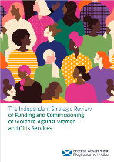MVP was recognised as contributing to gender-based violence prevention by [‘The Independent Review of Funding and Commissioning of Violence Against Women and Girls Services’](https://www.gov.scot/publications/violence-against-women-girls-independent-strategic-review-funding-commissioning-services-report/documents/) which recommended ‘at pace’ national roll out of MVP (p.87 2023).

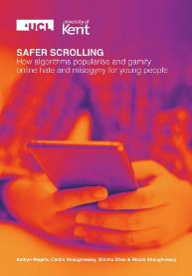

In Dr Kaitlin Regehr’s [research](https://www.ascl.org.uk/ASCL/media/ASCL/Help%20and%20advice/Inclusion/Safer-scrolling.pdf) on online misogyny, she notes ‘There is some admirable work being done in this area...such as Education Scotland’s Mentors in Violence Prevention (MVP) programme’ (p.31 2024).

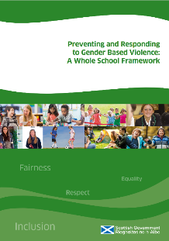

MVP is cited in Page 42 of the [Scottish](https://www.gov.scot/binaries/content/documents/govscot/publications/advice-and-guidance/2024/03/preventing-responding-gender-based-violence-whole-school-framework/documents/preventing-responding-gender-based-violence-whole-school-framework/preventing-responding-gender-based-violence-whole-school-framework/govscot%3Adocument/preventing-responding-gender-based-violence-whole-school-framework.pdf)

[Government (2024) ‘Preventing and](https://www.gov.scot/binaries/content/documents/govscot/publications/advice-and-guidance/2024/03/preventing-responding-gender-based-violence-whole-school-framework/documents/preventing-responding-gender-based-violence-whole-school-framework/preventing-responding-gender-based-violence-whole-school-framework/govscot%3Adocument/preventing-responding-gender-based-violence-whole-school-framework.pdf)

[Responding to Gender Based Violence:](https://www.gov.scot/binaries/content/documents/govscot/publications/advice-and-guidance/2024/03/preventing-responding-gender-based-violence-whole-school-framework/documents/preventing-responding-gender-based-violence-whole-school-framework/preventing-responding-gender-based-violence-whole-school-framework/govscot%3Adocument/preventing-responding-gender-based-violence-whole-school-framework.pdf)

[A Whole School framework’](https://www.gov.scot/binaries/content/documents/govscot/publications/advice-and-guidance/2024/03/preventing-responding-gender-based-violence-whole-school-framework/documents/preventing-responding-gender-based-violence-whole-school-framework/preventing-responding-gender-based-violence-whole-school-framework/govscot%3Adocument/preventing-responding-gender-based-violence-whole-school-framework.pdf) as an example of a school programme to prevent and respond to GBV.

Peer education programmes to prevent gender-based violence were also cited as useful by secondary school staff in the [Behaviour in Scottish Schools Research Report](https://www.gov.scot/binaries/content/documents/govscot/publications/research-and-analysis/2023/11/behaviour-scottish-schools-research-report-2023/documents/behaviour-scottish-schools-2023/behaviour-scottish-schools-2023/govscot%3Adocument/behaviour-scottish-schools-2023.pdf).

A graphic logo in pink and black saying 'Stop it Now'

MVP worked with the [Lucy Faithfull Foundation Scotland](https://www.stopitnow.org.uk/scotland/) to adapt materials for professional learning on ‘Children and young people who engage in technology-assisted harmful sexual behaviour’.

Twenty-six local authority representatives attended the event in November with the aim that they will deliver this professional learning in their own local authority.

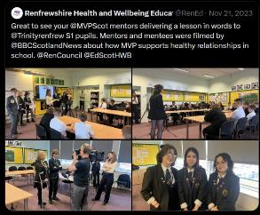

BBC News highlighted MVP as one way that schools were supporting understanding of healthy relationships.



A pilot of professional learning for Early Learning and Childcare staff and Primary Staff on Gender based Violence will be delivered in September to October 2024.

There has been a growing recognition that children can be impacted by gender-based violence from a young age. Some children will have experienced domestic abuse or sexual abuse. It has also been [reported](https://news.npcc.police.uk/resources/external-totality-2) that an increasing proportion of child sexual abuse is committed by children and young people (National Police Chief's Council England and Wales 2024).

Many children have access to potentially harmful material online with recent [Ofcom research](https://www.ofcom.org.uk/media-use-and-attitudes/media-habits-children/children-and-parents-media-use-and-attitudes-report-2024/) suggesting nearly a quarter of UK five-to-seven-year-olds now have their own smartphone. As access to online material is often not carefully controlled by parents the opportunities to witness upsetting material or become drawn into unsafe interactions is high (for example, [20% of girls and 14% of boys](https://www.ofcom.org.uk/media-use-and-attitudes/media-habits-children/children-and-parents-media-use-and-attitudes-report-2024/) have experienced ‘nasty or hurtful interactions online).

There is therefore a strong case to ensure that practitioners in the Early Years and in primary school settings understand the nature of gender-based violence, recognise how social attitudes can contribute and know how they can act to help prevent and respond to gender-based violence. To this end, a professional learning day has been designed by Education Scotland in collaboration with staff working with children in the early years and primary.

# Conclusion

A key success this year has been the ongoing engagement of schools to deliver the MVP programme despite competing priorities and timetabling challenges. Without the dedication of staff in over 200 schools, young people would not have the opportunities to deliver or receive peer education on gender-based violence.

The growing concerns from primary staff in relation to gender-based violence suggests that the development of professional learning for primary staff this session has been timely.

Going forward we need to support school staff to build in quality assurance ensuring MVP is delivered to a high standard wherever it is adopted.

Finally, it will be important going forward to create materials to reflect current concerns, for example the rise in ‘sextortion’.

vvv

**For more information contact** [**iwe@educationscotland.gov.scot**](mailto:iwe@educationscotland.gov.scot)