How the Parliament Works |  | The 129 members choose one MSP to be the First Minister.  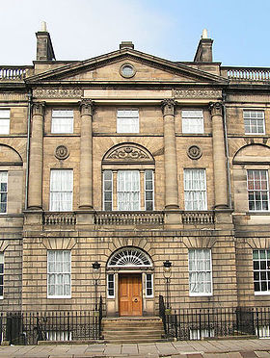
 |  | Bute House residence of FM
 | 
The First Minister then asks a small group of MSPs and Law Officers to be the Government.  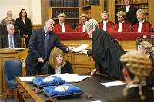  They suggest ideas for laws and set these out in a Bill. |  |  | In the Parliament MSPs and members of the Government discuss, change and vote on new laws for Scotland.  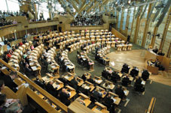
Members of the public sometimes take part in the work of Committees, by giving evidence.  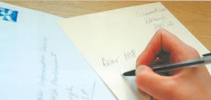  They also put their point of view across by sending petitions to the Parliament, writing to their MSP, etc. |  |  | MSPs might be members of one or more Committees of the Parliament.  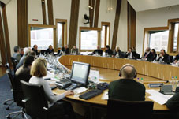  In the Committees and in the Parliament, MSPs keep an eye on what the Government is doing. They help plan the laws that affect all of our lives.

