Hinge Questions?
Using questioning to determine how a lesson will progress is something that good teachers do instinctively. So what is different about a hinge question?
A hinge question is planned within a lesson to gauge the level of understanding, the depth of thinking and hence to determine the next stage of the lesson.
- The planning of the question prior to the lesson is essential
- The question should be asked about midway in the lesson to allow time to address the issues
- Everyone in the class MUST respond to the question within two minutes
- The teacher must be able to assess the results within less than a minute
The benefits?
- It develops thinking skills
- Improves reasoning skills
- Encourages discussion, debate and explanation
- Reveals misconceptions
Possible ways to conduct the technique?
- Question is put to the class – on board, orally, or using SMART response
- The question may be put in the form of a multiple choice but need not be. The important point to ensure is that the likely responses are thought out by the teacher prior to the lesson allowing immediate feedback to take place
- Pupils could respond by using ‘show me boards’ or by the handset if using SMART
- The emphasis must be on the quick response by the pupils
- Where opinion is divided, pupils construct their case to persuade others of their point of view
… and feedback could be?
- Identification of those needing further support – this MUST be acted upon there and then
- All on track – lesson continues as planned
- Most of class not achieving desired result – lesson then redirected to address misconceptions
How can this strategy be implemented in the classroom?
The attached sheets give examples that could be used as CPD for staff to introduce them to this strategy.
Furthermore the same examples could be used by the pupils themselves to assist them in an understanding of the strategy.

Hinge Questions: example 1

The gradient of the line joining the points (2,3) and (5,-7) is?  A ³/₋₁₀ B ⁻¹⁰/₃ C ⁻⁴/₇ D ⁷/₋₄ |  |  | I have discussed ways to describe the slope of a line, can interpret the definition of gradient and can use it to make relevant calculations, interpreting my answer for the context of the problem.  MTH 4-13b
Correct Answer | B: m = y₂ – y₁  X₂ – x₁
Thinking for wrong answers | A: x’s on top and y’s on bottom | C: added instead of subtracting | D: added x’s on top and y’s on bottom
How do you deal with the incorrect answers? | Go back to diagram and look at definition of gradient

Hinge Questions: example 2
The distance between the two points (3, 5) and (8, 7) is?  A √29 B √21 C √265 D 7 |  |  |  | I have explored the relationships that exist between the sides, or sides and angles, in right-angled triangles and can select and use an appropriate strategy to solve related problems, interpreting my answer for the context.  MTH 4-16a
Correct Answer | A: distance² = (8 – 3)² + (7 – 5)²  = 5² + 2²  = 25 + 4  = 29  distance = √29
Thinking for wrong answers | B: subtracting the squares | C: adding the coordinates then squaring | D: distance = (8 – 3) + (7 – 5)  = 5 + 2  = 7  Not squaring anything
How do you deal with the incorrect answers? | Explanation ????

Hinge Questions: example 3
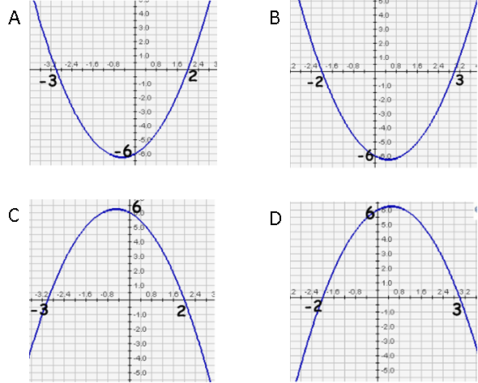  f(x) = (x - 3)(x + 2).  Which diagram shows  the graph of this function? |  |  | Reference to CfE
Correct Answer | B: Working for correct solution
Thinking for wrong answers | A: Explanation | C: explanation | D: explanation
How do you deal with the incorrect answers? | Explanation

Hinge Questions: blank

Insert question |  |  | Reference to CfE
Correct Answer | Working for correct solution
Thinking for wrong answers | Explanation | explanation | explanation
How do you deal with the incorrect answers? | Explanation

