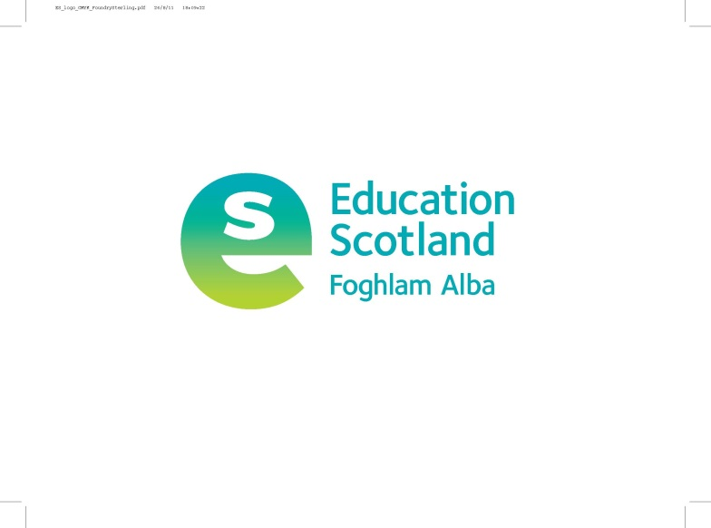

Education Scotland

The Optima, 58 Robertson Street, Glasgow, G2 8DU.

*t 0131 244 3000*

*e* [*enquiries@educationscotland.gov.*](mailto:enquiries@educationscotland.gov.)*scot*

*w https://education.gov.scot/*

**Permissions Form (Under-16s)**

**To the parents, guardians and carers**

Education Scotland produces websites, publications and resources for Scottish education, sometimes in partnership with other organisations. Education Scotland also promotes news, events and resources on our websites, social media channels, newsletters and in the media.

We would like to use images (photographs or film) or recordings (video or audio) of you or your quotations in the materials and resources that we produce for Scottish education.

Education Scotland may use the images, footage, or quotations in a number of different ways, for example:

1. Our printed publications such as reports and magazines.
2. Our websites and on the National Improvement Hub.
3. Glow Service – Scotland’s nationally available online digital environment to allow communication and collaboration amongst Scottish educators and learners.
4. Our digital resources such as videos, DVDs and presentations.
5. Scottish, UK or international media relations activity, reports or adverts.
6. Social media channels used by Education Scotland such as Twitter, Facebook, Instagram, Linkedin and YouTube.
7. Our podcast platforms.

Please note this list is not exhaustive.

Education Scotland will not pass on the images, recordings, or quotations to be used by any other organisation (apart from our partner organisations) except to illustrate features promoting our materials. All images, recordings, written quotations or case studies will be held according to our privacy policy, details of which can be found here: <https://education.gov.scot/privacy-and-cookies>

**I agree to allow images or recordings (video or audio) of my child to be used in printed and/or digital resources produced by Education Scotland.**

**I agree they may be quoted in printed and/or digital resources produced by Education Scotland**

|  |
| --- |
|  |
| Name of child |
| Name and address of establishment |
| Name of parent, guardian or carer |
| Signature Date |

If you have any questions, please contact us at the details above. This form has been issued under the terms of the General Data Protection Regulation and Data Protection Act 2018.

To withdraw your permission, access your data or if you have any further questions before completing this form please contact: [EDSFCPEI@educationscotland.gov.](mailto:EDSFCPEI@educationscotland.gov.)scot

Please return this completed form to the **Project Officer (named below), Education Scotland, The Optima, 58 Robertson Street, Glasgow G2 8DU**

|  |  |  |
| --- | --- | --- |
| **Education Scotland use only (to be completed prior to issuing)** | | |
| Name of project | Name of officer | Date Issued |
|  |  |  |