Standard for Middle Leadership (August 2021)

The self-evaluation wheel covers the standards under the following headings:

- Professional Knowledge and Understanding including

- Professional Responsibilities

- Professional Skills and Abilities including

- Curriculum, Pedagogy, Leadership and Strategic Vision
- The Learning Context
- Professional Learning

These Standards have been selected as having the most relevance to the Equity programme.
It will be helpful to visit the Standards for Middle Leaders and read over each section as you consider each area of each wheel.

2.2.2 I use cultural and emotional intelligence to explore bias through questioning my own assumptions and identify how these influence my work and relationships.
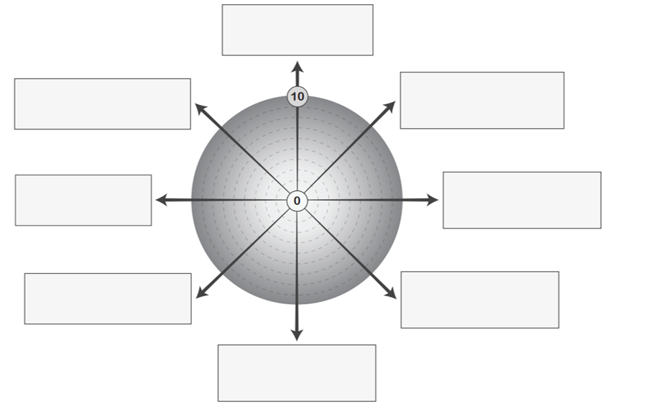
3.5.2 Take due account of the legislative framework related to equality and social inclusion to promote an inclusive community which values diversity and challenges discrimination.
3.2.1 I create and sustain a learning culture where additional support needs are integral to the learning community ethos.
3.2.3 I help build and sustain a culture to enable all parents / carers and families to have a range of opportunities to engage in partnership activities and processes related to learning, the life of the school and the wider learning community.
3.2.4 I ensure planning and provision for learning is underpinned by the principles of equality and social justice.
3.1.2 I model and support high expectations of curriculum in order to provide all learners with creative and consistently high learning experiences and pathways and opportunities for learning to be transformative in terms of challenging assumptions and expanding world views.
2.2.4 I communicate effectively and actively build positive working relationships and inclusive practices within the school, learning community, with colleagues, parents, carers, families and partners.
2.2.4 I regularly display and communicate my deep commitment to the education, well-being and inclusion of every learner through my everyday thinking and practice.

