- Purpose of tracking and monitoring
This resource can be used to support professional dialogue within your establishment.
The benefits of tracking and monitoring can be classified into the following five main themes:
- Identify gaps in learning and achievement
- Evaluate learning, teaching and assessment
- Communicate achievement, progress and attainment
- Set personal learner goals
- Identify trends and patterns
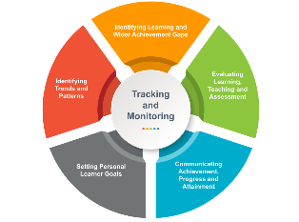
The benefits for all stakeholders are outlined below, aligned to each of these five main themes.
Learners

Tracking and monitoring can help you:
- Identify areas in your learning that you find challenging
- Ensure you have opportunities for wider achievement
- Take part in discussions about your learning experiences
- Become involved in planning and evaluating your learning
- Know how well you are doing in different areas of the curriculum
- Set realistic and achievable targets for yourself
- See the progress you are making
- Understand your areas of strength areas for development and those that require improvement

Parents and Carers
Tracking and monitoring supports informed communication with parents and carers. It can provide information about how you can support your child and:
- Reflect on your child's learning experience
- Be involved in planning and evaluating your child's learning
- Engage and support your child on their learner journey
- Understand your child's next steps, goals and targets
- Identify trends and patterns in your child’s learning and progress over time
Practitioners
Tracking and monitoring can help you to:
- Identify areas of challenge, areas for targeted support and timeous interventions
- Evaluate the effectiveness of the learning, teaching and assessment approaches and resources being used
- target learner conversations that celebrate success and identify manageable, achievable next steps, goals and targets
- Reflect on current progress
- Set improvement goals and targets and plan for the systematic measuring of progress against these
- Identify trends and patterns and consider strengths and areas for improvement

Senior Leadership Teams

Tracking and monitoring can help:

- Have an overview of learner progress- whole school, groups and cohorts and individuals
- Identify the need for support or intervention.
- Inform professional dialogue and reflection on effective pedagogy
- Plan for improvement in learning, teaching and assessment to better support needs
- Provide high level reporting on progress
- Reflect on current progress, set improvement steps/goals/targets and plan for the systematic measuring of progress against these
- Analyse trends and patterns for a ‘closer look’

Local Authority

Tracking and monitoring can help:
- Analyse attainment and achievement data, informing areas of strength and development
- Analyse areas of strength and development in learning, teaching and assessment, enabling strategic improvement planning
- High level reporting at key points throughout the year
- Setting high level targets e.g. stretch aims
- Evaluation of data at school, LA and national level, to support high level reporting and enable planning for improvement

