Snawflakes
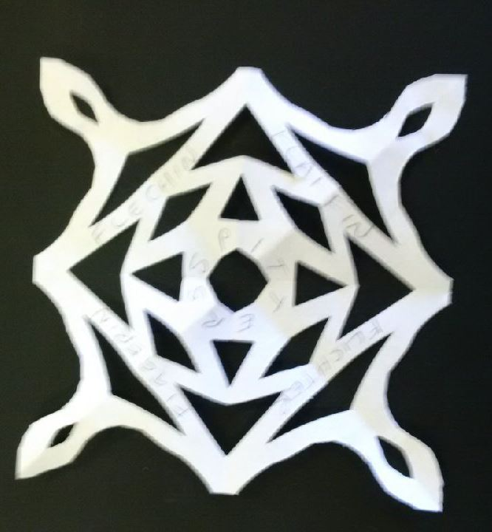

Mak yer ain snawflake oot o paper

Ye need:
A square or a circle o paper the size ye wint yer snowflake
A pair o scissors – tak tent gin they’re shairp

Ye hiv tae:
Faul yer paper in hauf, canny-like, top tae boddom.
Turn it throwe 90°.
Faul it in hauf again, top tae boddom.
Turn it throwe 45°.
Faul it in hauf eence mair, top tae boddom.
Noo, cut intae yer paper, be-in affa canny nae tae cut aw the wye across, apairt fae at the pynt and at the tap-maist edge. Mine an catch the wee bitties an pit them in the bucket!

Faan ye hiv a bonnie pattren, open it oot flat.

Pit some o these wirds fir snowflake ono yer finisht snawflake:

Flaffin(g) | Fleuk | Snaw-flauchen | Flag
Flauchin | Flicht | Figgerin | Flagin
Flaucht | Flechin | Spitters | Skelf
Flauchter | Flok | Flitcher | Skovin
Blett | Flukra

Ye can find mair wirds on the Historical Scots Thesaurus at http://scotsthesaurus.org/ gin ye wint.

Ye can yaise different sizes, kines and thicknesses o paper tae mak a wheen o snawflakes like thon.

Ye could pit them on the windaes: affa bonnie faan it’s dark ootby!
Snowflakes

Make your own paper snowflake

You need:
A square or a circle of paper the same size as the snowflake you want to make
A pair of scissors – be careful if they are sharp

You should:
Fold your paper in half, carefully, top to bottom.
Turn it round through 90°.
Fold it in half again, top to bottom.
Turn it round through 45°.
Fold it in half once again, top to bottom.
Now, cut into the paper, taking care not to cut all the way across, apart from at the point and the top edge. Remember to catch the scraps and put them in the bin!

When you have a beautiful pattern, open the paper out flat.

Put some of these Scots words for snowflake onto your finished snowflake:

Flaffin(g) | Fleuk | Snaw-flauchen | Flag
Flauchin | Flicht | Figgerin | Flagin
Flaucht | Flechin | Spitters | Skelf
Flauchter | Flok | Flitcher | Skovin
Blett | Flukra

You can find more words on the Historical Scots Thesaurus at http://scotsthesaurus.org/ if you would like.

You can use different sizes, types and thicknesses of paper to make an assortment of snowflakes in that way.

You could put them on the windows: beautiful when it’s dark outside!
Ye need a square or a circle o paper the size ye wint yer snowflake:
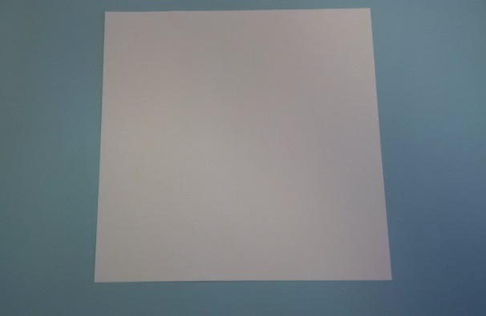

Faul yer paper in hauf, canny-like, top tae boddom:
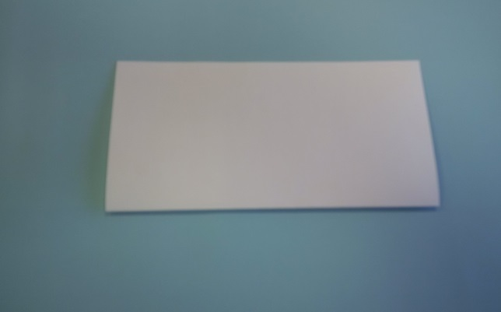

Turn it throwe 90°:
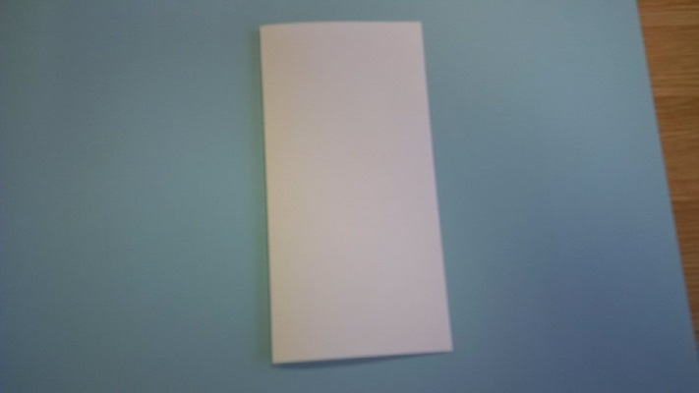

Faul it in hauf again, top tae boddom:
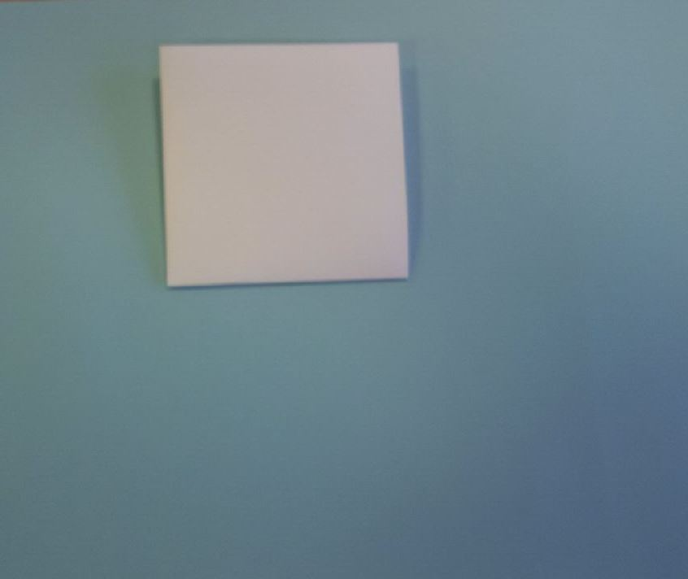

Turn it throwe 45°:
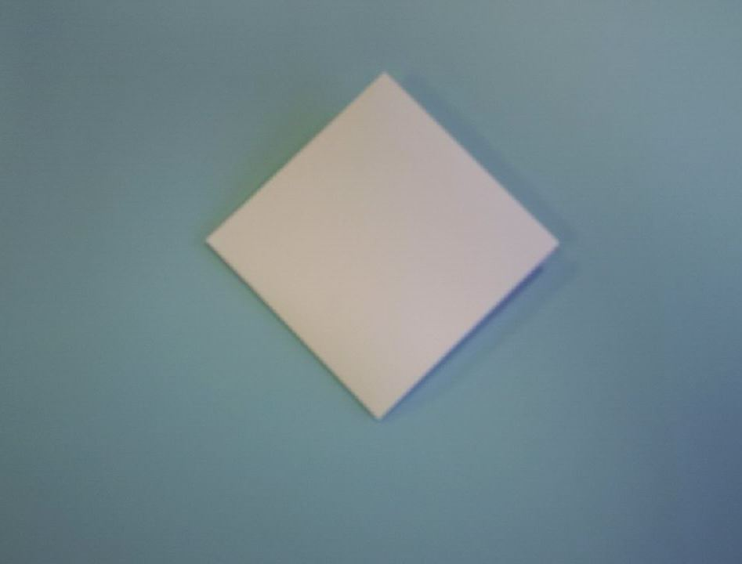

Faul it in hauf eence mair, top tae boddom:
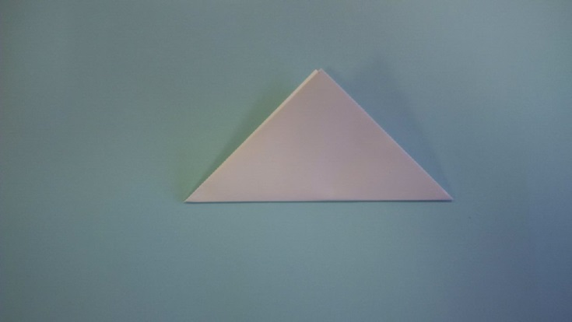

Noo, cut intae yer paper, be-in affa canny nae tae cut aw the wye across, apairt fae at the pynt and at the tap-maist edge:
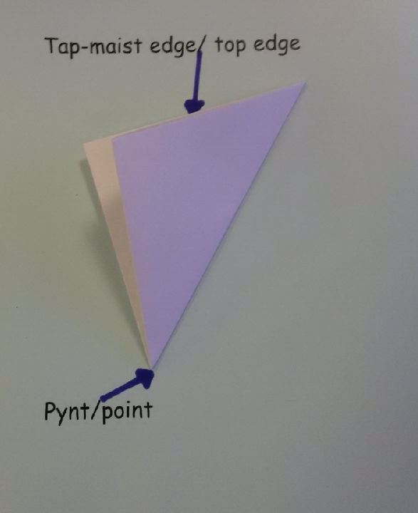

You need a square or a circle of paper the same size as the snowflake you want to make:

Fold your paper in half, carefully, top to bottom:

Turn it round through 90°:

Fold it in half again, top to bottom:

Turn it round through 45°:

Fold it in half once again, top to bottom:

Now, cut into the paper, taking care not to cut all the way across, apart from at the point and the top edge:

Further Research

Once you have made a number of snowflakes, using different types of paper, decide which work best and why. What advice would you pass on to others?

Challenge 1:

Pass on your knowledge to another pupil who has not yet tried to make a snowflake. You could give the instructions verbally and give advice as the snowflake is being made. Use Scots or English.

Or

Write a blog giving advice on snowflake making. Write in Scots or in English.

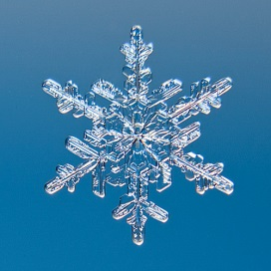

Did you know that real snowflakes have six points, not eight?
Why do you think most people make them with eight or four points, as these instructions ask you to do?
What can you find out about snowflakes and how they are formed?

Challenge 2:

Can you work out how to make six-pointed snowflakes using a similar method?

Can you write instructions so that other people can use your technique? Can you write these instructions in Scots?
Speir Oot Mair

Eence ye’v made a wheen o snawflakes, yaisin different kines o paper, decide whit wirks best an how. Whit advice wid ye gie ither fowk?

Henner 1:

Gie whit ye ken tae anither bairn/wean wha hisnae hid a go at makkin a snowflake afore. Ye cuid gie the intstructions bi mooth an gie advice whiles the snowflake is in the makkin. Yaise Scots or Inglis.

Or

Scrieve a blog geein advice oan makkin a snowflake. Scrieve in Scots or in Inglis.

Did ye ken that real snawflakes hiv sax pynts, nae eicht?
How dae ye think maist fowk mak them wi eicht or fower pynts, like this instructions hiv ye daein?
Whit can ye find oot aboot snawflakes an whit wye they are makkit?

Henner 2:

Can ye devise a wye tae mak a sax-pyntit snowflake sic-like they anes?

Can ye scrieve instructions for ither fowk tae follae? Can ye scrieve they instructions in Scots?

