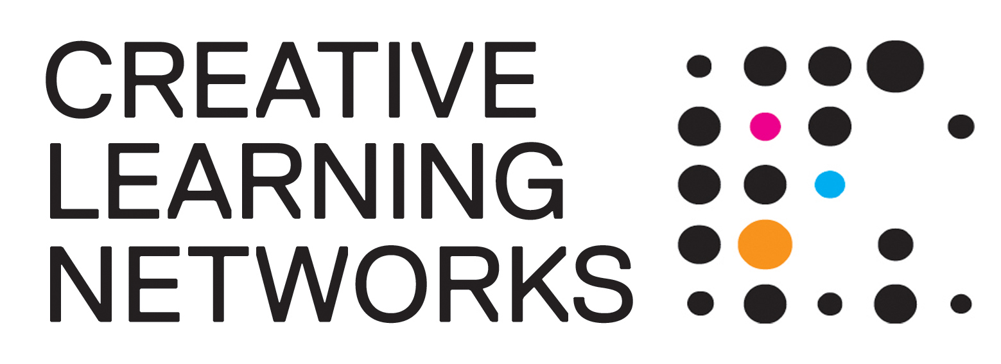
Unlocking Creativity Skills in Learners

Evaluation Checklist

Points for observation | Rating 1-5 (1=weak and 5=strong) | Notes
Engagement with the task

Are learners…..

- asking effective questions

- making connections and noticing patterns and anomalies

- defining problems and identifying where intervention would solve them

- exploring, combining and refining multiple ideas, options and viewpoints

- using imagination purposefully to explore ideas

- able to see a range of possible outcomes

- managing uncertainty and responding positively to the unexpected

Managing their learning

Are learners….

- taking responsibility for their own creative approaches (alone or in groups)

- developing initial ideas well and following through on those with the most potential

- crafting and presenting appropriate solutions

- overcoming obstacles to progress

Evaluating their learning

Are learners…….

- continuously interrogating their ideas and checking them against the brief?

- responding positively to mistakes and failures?

- identifying clearly whether their solution is appropriate and if not, what would have worked better?

- recognising and articulating how they have used their creativity skills?

Evaluating the wider impact of creative activities

Are you……

- tracking individual learner progress against specific criteria?

- analysing the impact of creative activity on other areas of learning or development

- identifying how the lessons of a creative experience could be applied in other areas?

