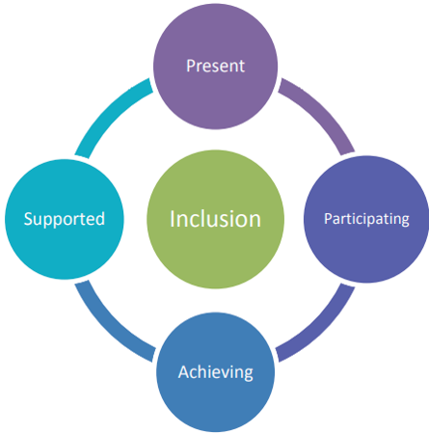
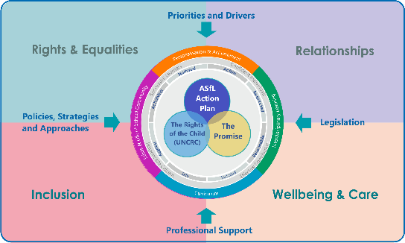

Rights Reviews and Promises.

The table below provides an example of how the four interconnected inclusion themes can be mapped across each
of the three policies using a time efficient approach to support self-evaluation for continuous improvement.

The Planning Tool template on the next page can be used in an educational setting as a reflective tool using the four interconnected inclusion themes to identify work already underway and to plan future improvements to implement children’s rights and the recommendations from the ASL Implementation Review and The Promise.
Rights, Reviews and The Promise | Self-evaluation | National Improvement Hub (education.gov.scot)

Interconnecting  Inclusion Themes | UNCRC Articles |  |  |  |  |  |  |  |  |  |  | The Morgan Review Themes |  |  |  |  |  |  |  |  | The Promise Priorities
 | 2 | 3 | 4 | 5 | 15 | 20 | 23 | 28 | 29 | 31 | 42 | Vision and Visibility | Mainstreaming and Inclusion | Maintaining focus, but overcoming fragmentation | Resources | Workforce development and support | Relationships between schools and parents | Relationships and behaviour | Understanding Rights | Assurance Mechanism | Voice | Family | People | Care | Scaffolding
Rights and Equalities
Relationships
Wellbeing and Care
Inclusion

Summary UNCRC Articles UNCRC  Article 2 - You have the right to protection against discrimination.  Article 3 - Adults should do what’s best for you.  Article 4 - You have the right to have your rights made a reality by government.  Article 5 - You have the right to be given guidance by your parents and family.  Article 12 - You have the right to an opinion and for it to be listened to and taken seriously.  Article 15 - You have the right to be with friends and join or set up clubs, unless this breaks the rights of other  Article 23 - If you are disabled, either mentally or physically, you have the right to special care and education.  Article 28 - You have the right to education.  Article 29 - You have the right to education which develops your personality, respect for other’s rights and the environment.  Article 31 - You have the right to play and relax by doing things like sport, music and drama.  Article 42 - All adults and children should know about this convention. |  |  |  |  |  |  |  |  |  |  |  | The Morgan Review Themes – overview Full report  - Vision & Visibility – Understanding and recognition of learners who require additional support, meaningful learner participation and voice. Recognising and Measuring Achievement of all learners who require additional support.  - Mainstreaming & Inclusion – Embedding and implementing the 4 principals of inclusion . Values and beliefs, culture and mind-set. Values driven leadership at all levels for inclusion.  - Maintaining focus, but overcoming fragmentation - Leadership, strategic planning & policy integration need to improve. Effective implementation of ASL duties and key processes.  - Resources – Holistic and partnership approach to early intervention and prevention. Values driven leadership, processes and equitable access to good practice, processes and materials to support implementation of ASL legislation.  - Workforce development and support – Understanding of additional support needs, professional learning for all, including support staff.  - Relationships between schools and parents – Recognising, supporting Prioritise promoting positive relationships, communication & cooperation. Relationships first , processes second.  - Relationships and behaviour - Permeates across all themes. Develop priorities to improve understanding & practice around additional support for learning and relationships & behaviour.  - Understanding Rights – Understanding and implementing legislative entitlements and duties, effective identification, support and stage level of intervention planning processes  - Assurance Mechanism- assurance and scrutiny mechanisms to implement policy intention and practice. |  |  |  |  |  |  |  |  | The Promise Foundations - Key messages for education Full report  Voice - Listen to children and families and promote participation in decision making at every level.  Family - Whole family support from multiple services needed, overarching impact of poverty, & universal supports combat stigma.  People - Prioritise relationships and workforce culture, development and support.  Care - Relationships are prioritised, mentoring is provided, ASNs recognised and addressed & we have a better understanding of risk.  Scaffolding - Workforce can recognise and realise children’s rights, shared language and values, and work to improve data and information sharing.
.

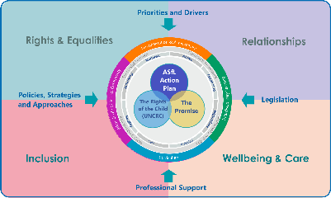
Reflective Planning Tool: ‘Rights Reviews, Promises and Inclusion for All.

National Priorities: UNCRC, The ASL Implementation Review and The Promise.
Establishment/Service |  | Date
Reflective question | How do we know we are implementing the 3 national priorities within our practice and establishment?
Interconnecting Themes | Evidence |  | Impact |  | Next Steps
Rights and Equalities

Relationships

Wellbeing and Care

Inclusion

