Scoping and Scanning

Complete the scoping and scanning cycle, responding to the six prompts to understand the past, present and potential future in your learning environment.

Use this knowledge to consider what the top priorities are to be developed in order to be responsive to the future needs of all learners.

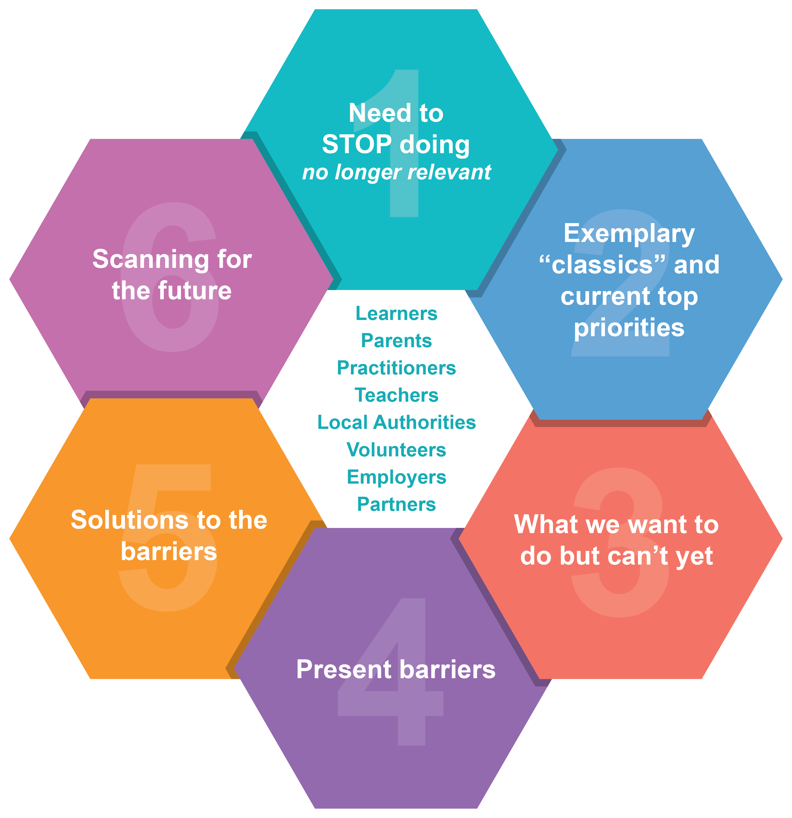

1. Need to STOP doing (no longer relevant):

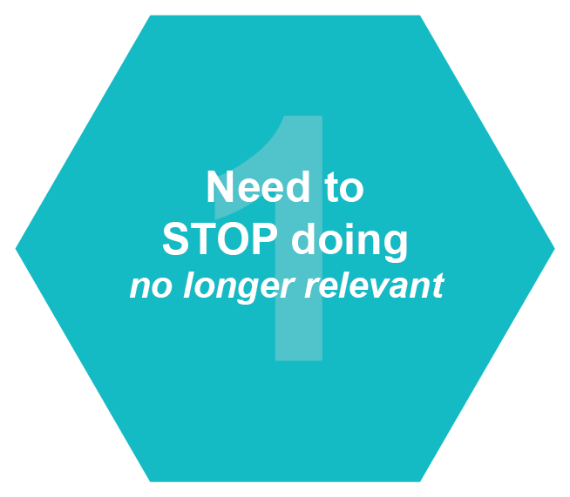

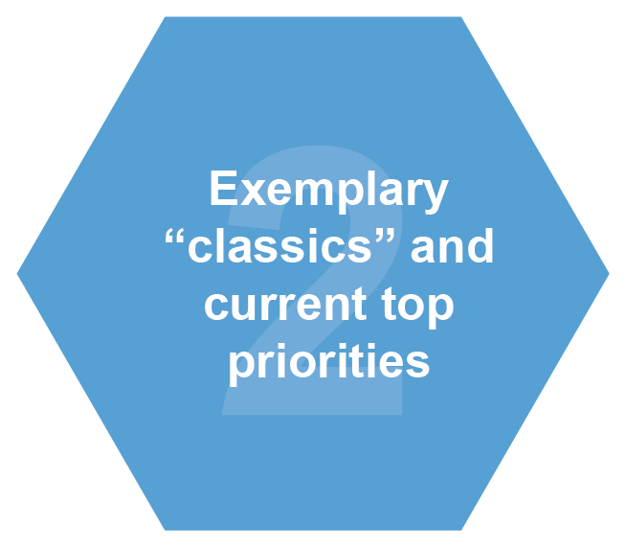
2. Exemplary “classics” and current top priorities:

3. What we want to do but can’t:
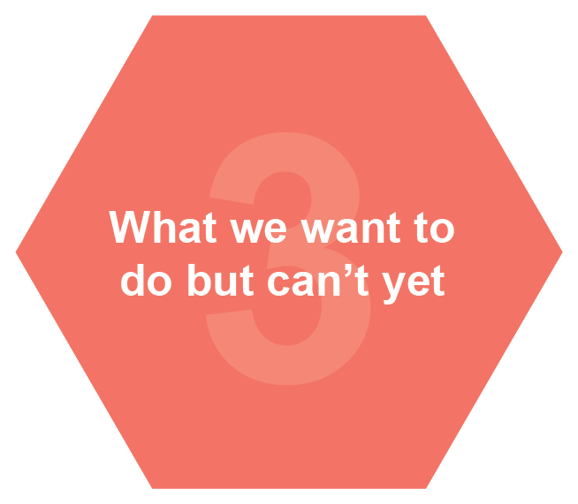

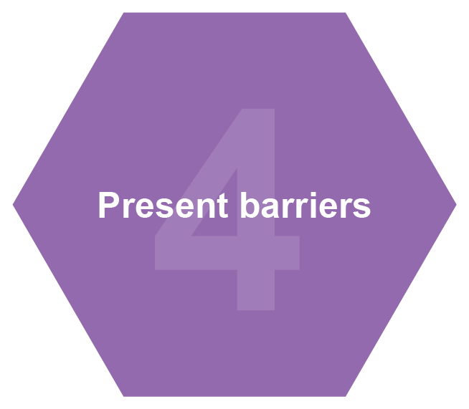
4. Present barriers:

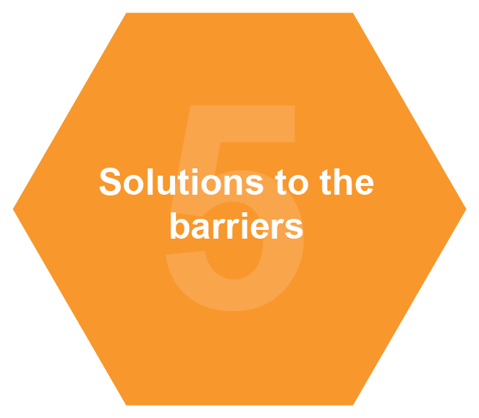
5. Solutions to the barriers:

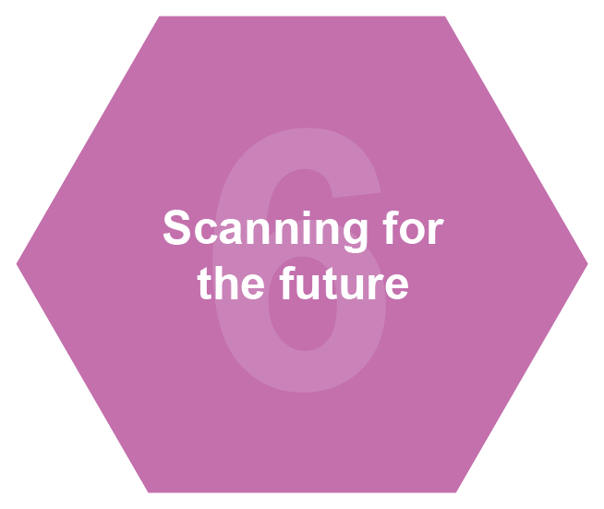
6. Scanning for the future:

