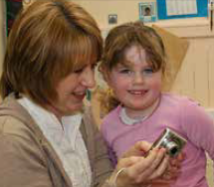
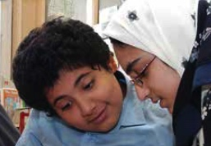
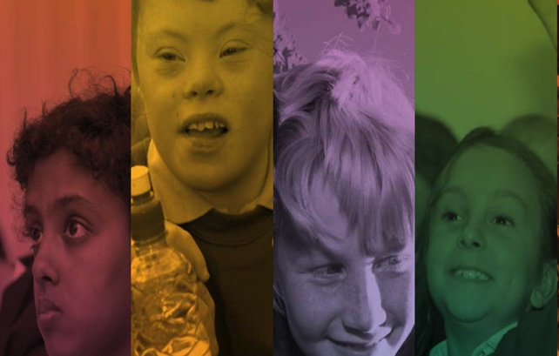
Empowering transformational change at all levels.
Transforming Learning

Scoping and Scanning

Complete the scoping and scanning cycle, responding to the six prompts to understand the past, present and potential future in your learning environment.

Use this knowledge to consider what the top priorities are to be developed in order to be responsive to the future needs of all learners.

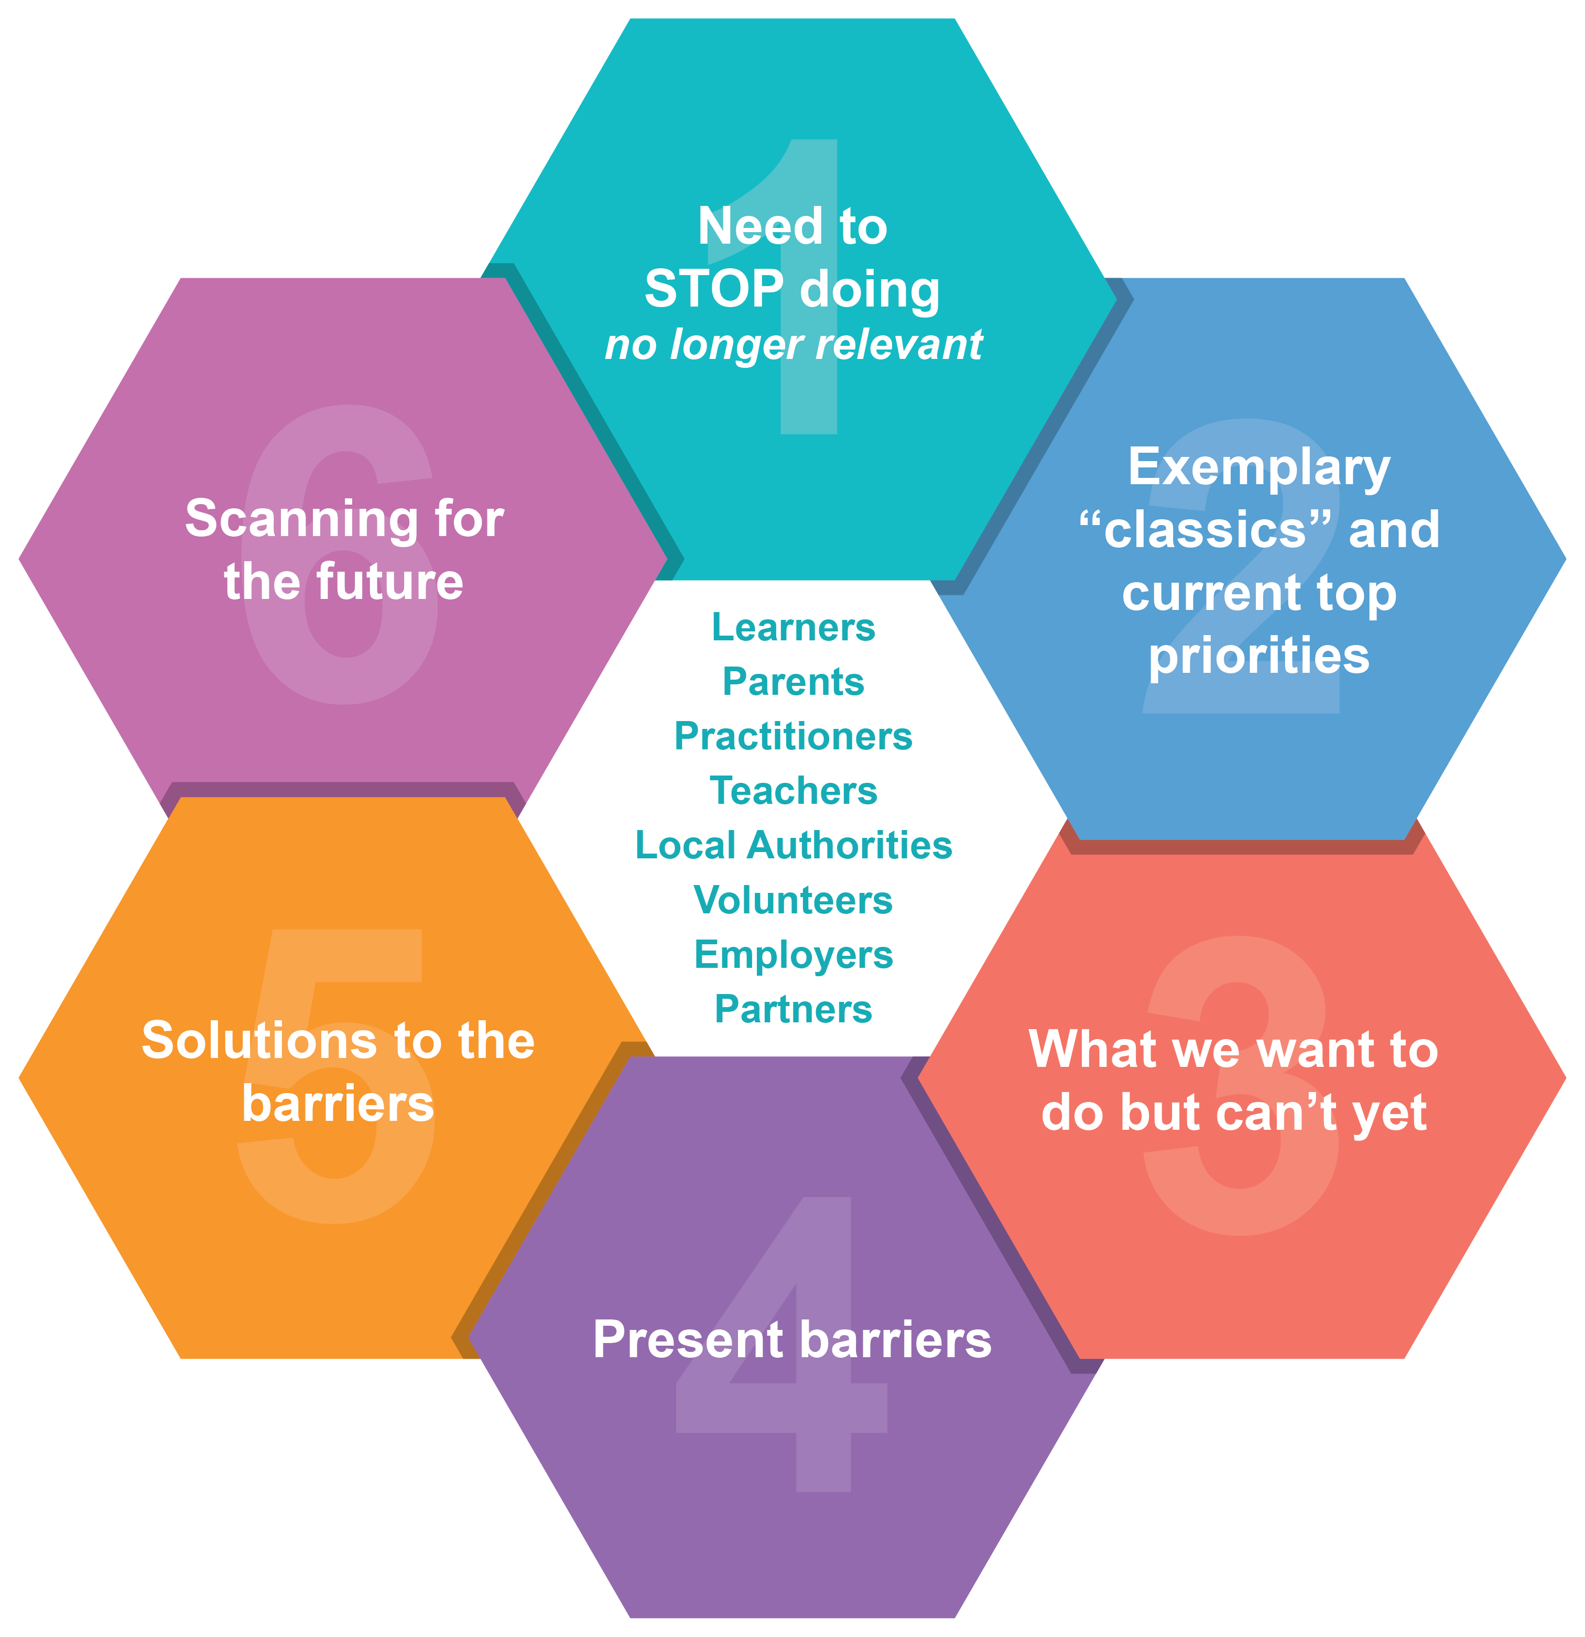

1. Need to STOP doing (no longer relevant):
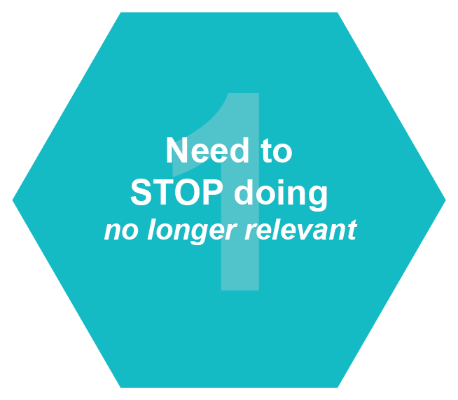

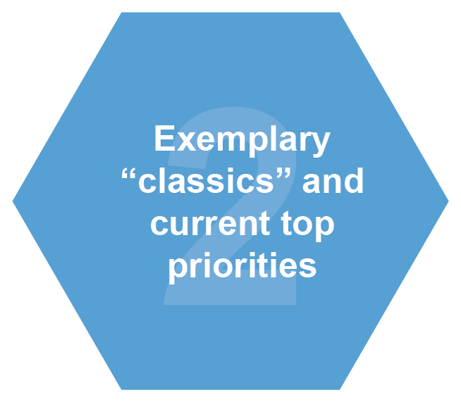
2. Exemplary “classics” and current top priorities:

3. What we want to do but can’t:
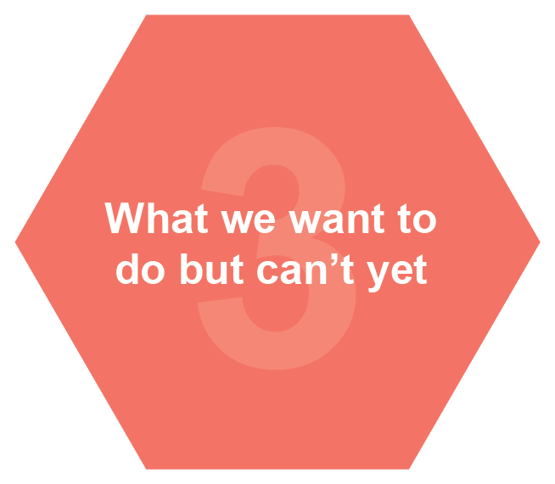

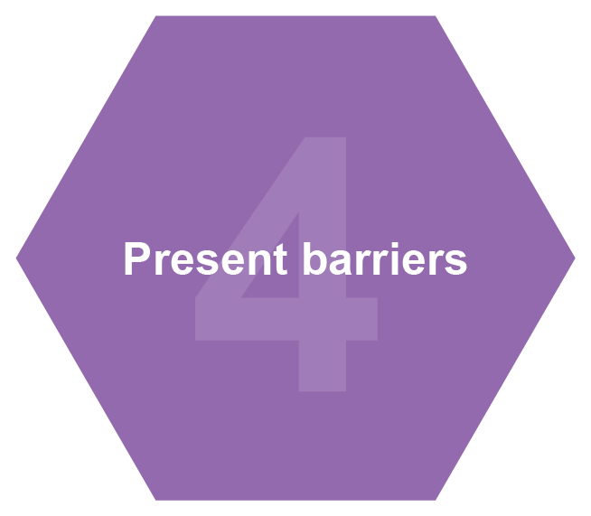
4. Present barriers:

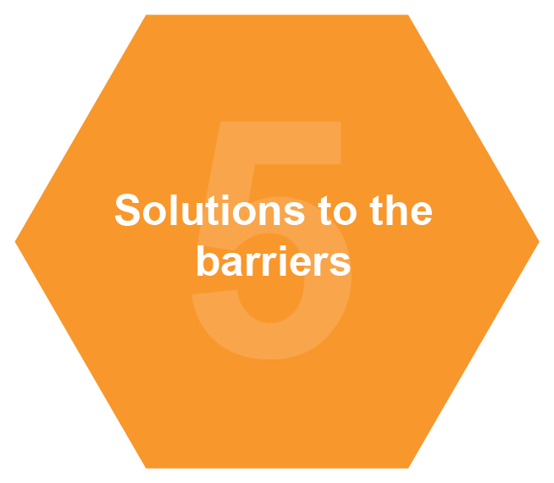
5. Solutions to the barriers:

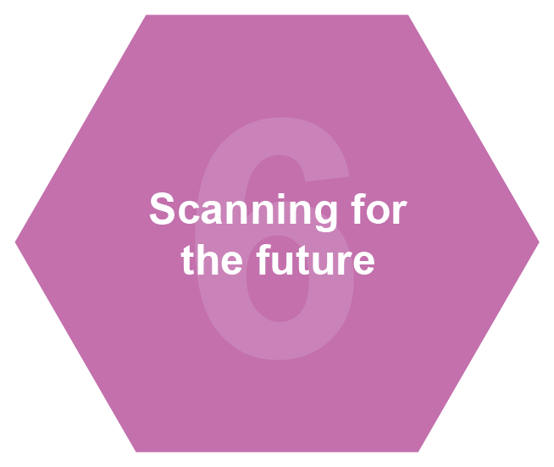
6. Scanning for the future:

Looking Inwards, Outwards and Forwards

Record the evidence, evaluation frameworks, research information, systems management and resources from your area of expertise to demonstrate your inwards, outwards, forwards strategy suggested by Education Scotland.

Looking inwards: to evaluate performance at every level and use the information gathered to decide on what needs to be done to improve.
Looking outwards: to learn from research, others and best practice and use this to facilitate innovation and creativity and inform improvement actions.
Looking forwards: to explore what the future might bring and use this information to anticipate what change is required to ensure the education system is responsive to the future needs of all learners.

Drag the images on the right and add text areas into each section below:
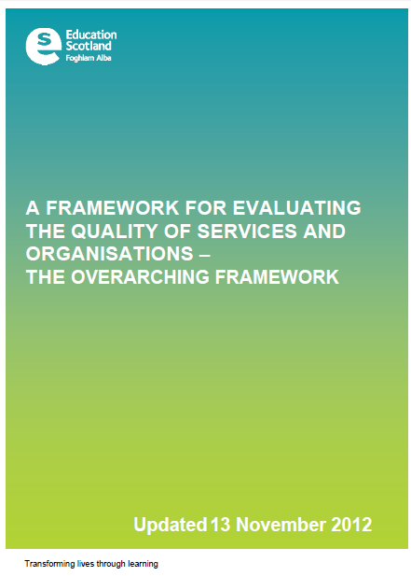
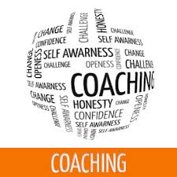
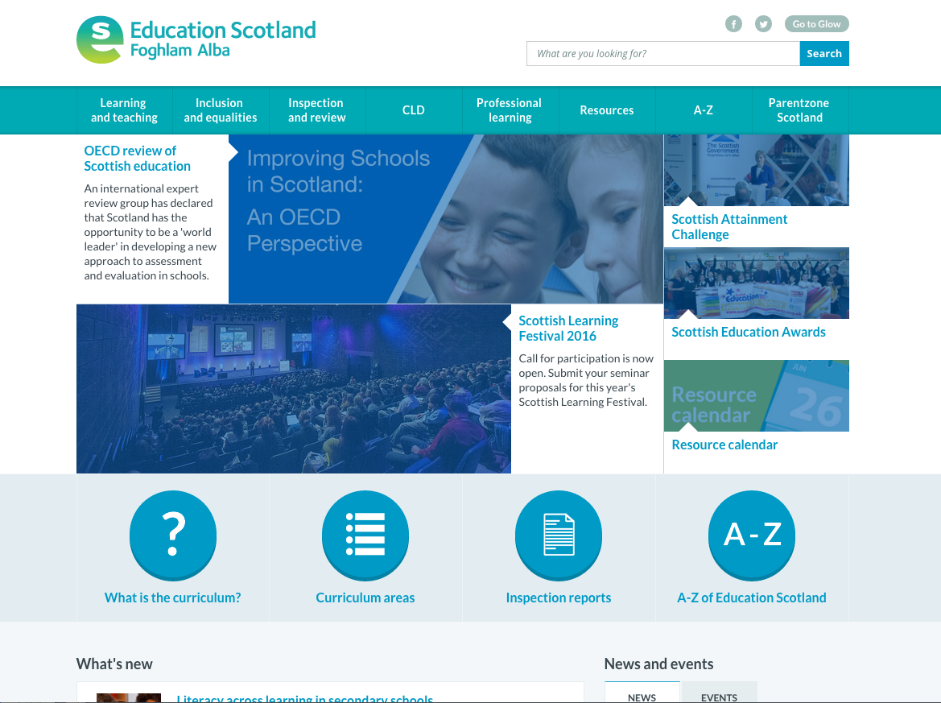
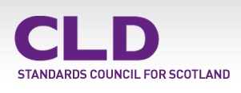
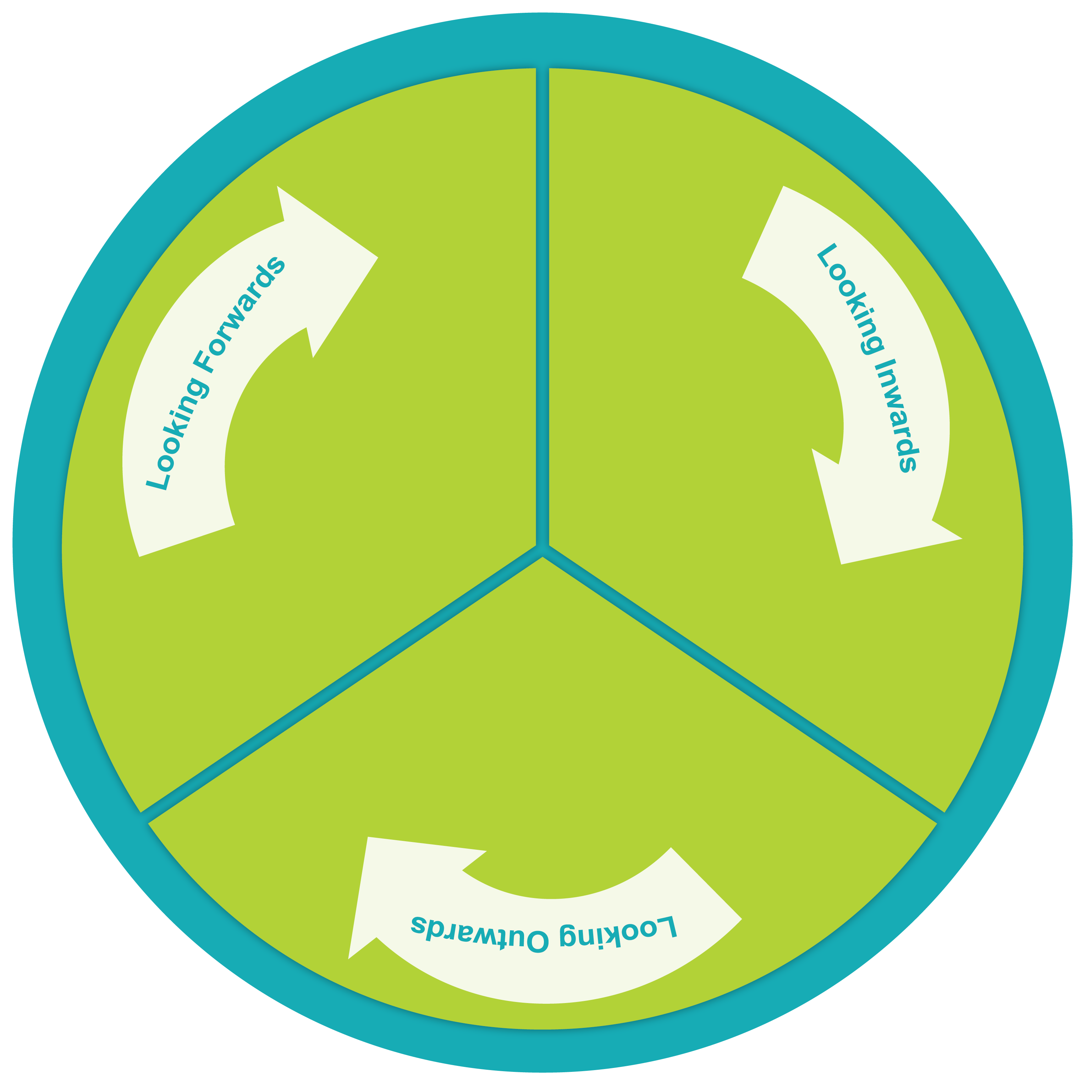

Action Points
Define your chosen actions and link them to your improvement plan.

Your chosen action:

Link to improvement plan:

What are we going to achieve? | High level outcomes for your actions:

Summary and Planning
Define your why, what, how and then calibrate* your responses from these questions to support your chosen actions.

*The team must go back round the Why? What? How? for a second time to ‘calibrate’ (check, adjust, adapt, benchmark, explore further) their responses now they have a full cycle in place.

Why? | What?
How? | Calibrate

Aspirational actions
List the finalised aspirational action points from your previous analysis?

1 Year Plan “for an aspirational standard”

Your chosen action:

Task | Resources | Personnel | Timescale | Risks | Progress Checks

Evidence
Impact

Risks and Hazards Analysis

Low Risks | Medium Risks | High Risks
Best practice to avoid any of these risks

Evidence of impact

Explain your progress and impact.
How will we know there has been an impact on outcomes for learners from this work?

Possible Measures used | Impact
Stakeholders surveys
Leaners’ views
User evaluations
Use of data
Impact reviews

Site visits
Others please specify

Impact Analysis

Demonstrate the impact achieved from actions completed.
Remember the Education Scotland “tackling bureaucracy” advice when completing this section.

Possible Measures used
Learner and other stakeholder’s response:
Leadership team response:

