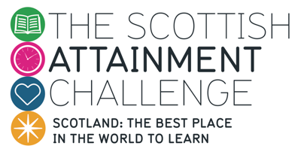
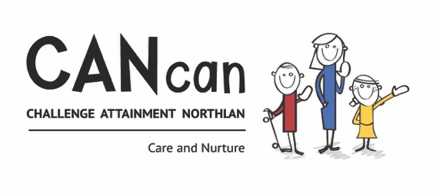

Family Group Meetings 2016/17

As outlined in the CANcan project plan for 2016/17, the North Lanarkshire self-improving school system established in Year 1 will be further embedded this session, with a specific focus on tackling issues around raising attainment and closing the poverty-related gap. This will include the collegiate analysis of data.

Family groups have the freedom to develop their own approaches to exploring the above areas. However, these materials provide family groups with ready-made starting points and a suggested focus/structure for each meeting during the course of the session.

No matter the approach they agree on, it is important that all family groups make a definite start this session on sharing, analysing and responding to data. Comparative schools have much to learn from one another and it is hoped that the relationships built between Head Teachers last session will have been successful in creating safe spaces in which schools will have the confidence and trust to share and explore data around attainment and to learn from each other’s improvement journeys and effective practice.

In its commitment to the pursuit of excellence, North Lanarkshire is equally committed to avoiding ‘islands of excellence’. It is absolutely vital that successful schools become the keys to success in helping other establishments bring about transformational change in themselves. For this to happen, effective practice and success need to be shared and knowledge needs to be continually moved around. It is vital this session, therefore, that we fully utilise and embed simple, effective ways of sharing effective practice between family groups.

Meeting 1 (September/October 2016)

- Use the following questions, based on HGIOS?4 3.2 (Raising Attainment and Achievement), to sketch out a plan for the 2016/17 session:

- How confident and effective are we in using a range of data to measure pupils’ progress and attainment in literacy and numeracy?
- How robust are our tracking systems in accurately predicting and measuring the attainment of pupils over time?
- How effective are our approaches to literacy and numeracy in raising attainment for all pupils?
- In what ways are we removing barriers to learning and ensuring equity for all?

- Set the dates for six further meetings during the course of the year (two per term).

- Agree on common data to bring to the next meeting (e.g. the number of pupils who have achieved a particular CfE level; recent CEM data)

Meeting 2 (October/November 2016)

- Look at and compare the data from each school within your family. Select two or three questions from the data analysis resource, ‘Mind the Gap’, to help interrogate and analyse the data.

- Based on differences in attainment between your comparative schools, identify examples of effective practice which appear to be making a difference. Agree on how your group will explore these further (e.g. a resource being emailed to each member; observation of an approach within an establishment).

Meeting 3 (November/December 2016)

- Take time to explore and discuss those examples of effective practice identified at your previous meeting. This may include direct observation of a particular approach/resource within an establishment.
- Discuss how your family group might begin to identity and utilise ‘change radicals’ (advocates taking on leadership roles) within each school to facilitate collegiate working around raising attainment and ensuring equity for all across the family group.

Meeting 4 (January/February 2017)

- Update on use and impact of ‘change radicals’; next steps.
- It is suggested that you use the remainder of this meeting to focus on how you are using the new benchmarks to monitor progress and support overall professional judgement of when a learner has achieved a curriculum level. Support resources for this work will be provided to family groups in time for this meeting.

Meeting 5 (March/April)

- Agree on examples of effective practice you have identified or developed during the course of the session which you feel would be worth sharing with a wider audience. Submit these electronically to Graeme Young for inclusion on the Self-Improving Schools GLOW site. A selection of these examples will be shared as part of a CANcan presentation at the North Lanarkshire Learning Festival.

Meeting 6 (May)

- Attendance at the North Lanarkshire Learning Festival (this is an Inservice day)

Meeting 7 (May/June 2017)

- Share and discuss ideas, learning and questions generated by NL Learning Festival.
- Share and begin analysis of your most recent CEM data (support materials will be issued in time for this meeting).
- Think ahead to your shared priorities/next steps for the 2017/18 session; nominate a new lead for your family group.

