Developing the Young Workforce - Interesting Practice in Skills (3-18) exemplar:
Teen Takeover and the Community Café at Sandwick Junior High School

The following document provides a brief summary of the key elements of this project.
For more information please access this exemplar on the National Improvement Hub here: https://education.gov.scot/improvement/searchresults?k=DYW

1. Introduction
Establishment | Sandwick Junior High School
Contact name and details | Stuart Clubb (Headmaster)  Margaret Ramsay (HE Teacher)  Sandwick JHS, Sandwick, Shetland, ZE2 9HH  Tel No: 01  margaretramsay@shetland.gov.uk  stuartclubb@shetland.gov.uk
About the establishment: | Junior High School based in the south mainland of Shetland. Includes nursery to S4.  Has a school role of 250.  Key influence in the centre of the South mainland community of Shetland
Main tags (please add or delete as appropriate) | Secondary,  Employability  Employer engagement  Parents  Skills development Scotland

2. Porject information:
Overview | Teens Takeover Project  S3 Health & Food Technology pupils working with Haysdock Cafe Restaurant in Lerwick to plan, prepare, cook and serve a 3 course meal over 2 nights to over 100 paying guests including school staff, parents and friends  Community Cafe  Monthly cafe run by S1-S3 pupils on a Thursday afternoon and open to the local community.
How was this done? | Teens Takeover Project  Making onctact and working alongside a local restaurant with S3 pupils. Chef and head of rfestaurant trained the pupils during and after school. Teacher worked closely with manager on skills and CfE SALS and what should be covered.  Community Cafe  Every term the HE and other staff member were given a group of pupils from S1-S3 who wanted to be part of the community cafe. They were trained up by community members who had experience in this field. They budget, shop, market and cook for the cafe as well as run it monthly. Have made local links with NHS Shetland & Alheimerzers Scotland who work alongside the group noe educating and supporting those coming to the cafe
Impact | Learning from school to real life enhances knowledge, understanding and interests and develops skills for the course the pupils are studying. Raises achievement.  Pupils gain so much confidence in both these activities.  Better links witht the community
Best piece of advice | Persevere! Difficult at first to get a restaurant/hotel (busy with oil workers in Shetland) on board but took time to build up relationships with staff. Do not rush into it but plan well. Take risks – invite people from the community to see what the pupils are dolng and get hem involved too.  Is time consuming building up to event BUT worth it!  Same with cafe – persevere. Difficult to juggle teaching and learning and also run cafe BUT make sure other staff are involved. Look out for links with local groups – NHS, Alzeimhers group,
Curriculum links | Technology  Health & Well Being  SALS – Food Expereince, keeping safe and hygienic developing healthy choices
Partnerships | Haysdock Cafe Restaurant, Lerwick  Shetland Museum  Shetland Island’s Amenity Trust  Media – Shetland Times  Cafe – NHS Shetland, Alzeimhers Scotland
Next steps | Teens Takeover is confirmed for November 2016 and over the year work with the chef and NEW manager and continue to build up relationships. Trying to develop up event to include other departments, e.g. business studies, music, etc  Due to funding from Education Scotland new equipment has been purchased for the cafe and more money available to buy healthy ingredients so more options for healthy choices.  Encourgaing ALL pupils in S1-S3 to have experience in the cafe over their first 3 years in secondary. Getting more staff involved.
Quotations | “Encapsulates all that is good about learning in the classroom and workplace. High light of school year”  Headmaster Mr S Clubb  “I learnt a lot in a very short space of time and I did not get nervous serving people because I had been told everything I needed to know and I did it!!”  Rebekah Tregonning (S3 Pupil at Sandwick JHS)  CAFE  “I just love running our own cafe.” Liam (S1)  “Visitng your cafe today as a retired Educational Officer on Shetland” filled me with sheer excitement and hope for education in the furutre, Seeing this whole school activity reach out to such a wide area of the community was a breath of fresh air.” Letter sent after cafe in June 2016  “I can’t believe my daughter is so confident and able and can serve others” Proud parent
Standards and guidance materials | Did you use any of the following documents in preparation or alongside the development of this project:  X  Career Education Standardx  X  Work Placements Standard x  School/Employer Partnership Guidance

3. Added value
Resources
Web links | http://www.haysdock.co.uk/second-teen-takeover
‘Teen Takeover’:
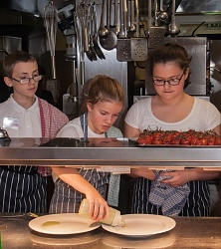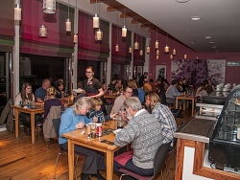
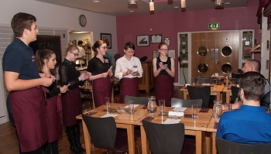

Community Café:
