Animation in the classroom

1. Introduction
Model animation or stop motion animation is a great classroom activity that engages students of all ages and abilities and can support many curriculum areas.
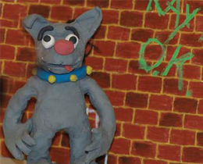

This resource has been designed for teachers to use as a planning aid for an animation project in the classroom or/and as a printable teaching PDF resource. Each section will explain simple approaches to creating a short animated film.
This introductory section focuses on the basics of animation including tips and tricks for model making. However, you may want to look at the examples section to see the kinds of projects that have been made by students and teachers.
Models can be made in one lesson lasting roughly 45 minutes. Allow students to work in groups of 4/5 and stress the importance of team work. Many of the model examples shown here were made in only 20 minutes.

Related documents
PDF file: Introduction to Animation (2.1 MB)

2. Story creation

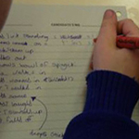
This section is designed to encourage simple stories or ideas - using bold, visual designs and small casts of characters.
Advert-length ideas are easily created in a short time and the shortest films are normally better films as they have been made with more care and attention.
Filmmaking and animation are time-based mediums. Students need to think about the length of time for units of action. Even though they will be guessing and estimating it’s better than forgetting that time is crucial.
For example, an elephant walks into a frame; how long should that last in seconds?
Three seconds = 36 frames at 12 frames per second. Then the students know that they need to take 36 frames of the elephant walking in. Conversley if they only took six frames that would last half a second and be much too quick for an elephant.
There is a blank storyboard template that can be printed out and used by the students, to help plan their story with rough drawings.

Related documents
PDF file: Tips for creating your story or idea (2.5 MB)

3. Filming

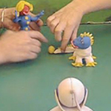
The basic principles are deceptively simple and very easy. You take photos or frames or single shots of a model, then move it a fraction and take another shot.
All the software on the market is very simple and easy to use. Practise with a few objects, such as animating a coffee cup, to get the idea of how the software you’ve got works.
Work at 12/15 FPS (Frames Per Second) as this will make it easier for the students to achieve decent results.
Start with 1 second of stillness at the beginning of the film before the action starts.
Stillness is a crucial part of animation, as is silence in music and stillness in dance. These half second pauses are similar to full stops and commas in a sentence. Break up the action with a half second pause (six shots); this will also slow the action of the film down.
Ideas for software for the PC
- I Can Animate - Kudlian Soft
- ProAnimate - Kudlian Soft
- SM Animator - Free
- Monkey Jam - Free

Ideas for software for the Mac
- iStopmotion - Boinx
- Frame by Frame - Free

Related documents

PDF file: Production and Filming (1.7 MB)

4. Post-production

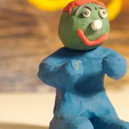
This area can be quick and simple or you can spend days perfecting the end results. But the more sound you add the better: animation is 60% sound.
Using computer programs like Movie Maker on the PC and iMovie on the Mac, you can quickly add the extra ingredients to make the animation a complete project.
Titles and transitions are easily added in both programs and it’s best to make those visual additions first. Then you can add sound effects, music and voice-overs.
Voice-overs are great for giving the finished films a sense of identity and ownership for the students involved. And because of the software this can be done over several lessons and easily corrected if it goes wrong.

Related documents
PDF file: Post production after you have filmed your animation (146 KB)

