

Case Studies:

Health and Wellbeing Responsibility of All in Secondary Schools
Kirkland High School and Community College

1. About this case study

This case study explores the successful implementation of health and wellbeing responsibility of all in Kirkland High School and Community College. This school’s approach to implementing health and wellbeing responsibility of all is particularly interesting because:

- it has a clear Curriculum Policy highlighting the importance of health and wellbeing;
- it undertakes an annual review of health and wellbeing priorities;
- each subject identifies health and wellbeing responsibility of all priorities, linking to the experiences and outcomes, and this is shared across the school; and
- it believes that the strong focus on health and wellbeing has resulted in positive changes in the school’s ethos, environment and achievements.

Kirkland High School and Community College is in Methil, Fife. It operates as an S1 to S6 school, and also as a community college. It is located in an area which falls into ‘decile one’ of the Scottish Index of Multiple Deprivation – meaning it is among the most deprived areas of Scotland. There are over 500 young people, 150 adult students, 55 teaching staff and 9 support staff at the school and college.

This case study is based on discussions with a sample of five leaders responsible for health and wellbeing within the school; nine teachers and partners (including Community Education and Active Schools); 19 young people from S1 to S6; and two parents with children at the school.

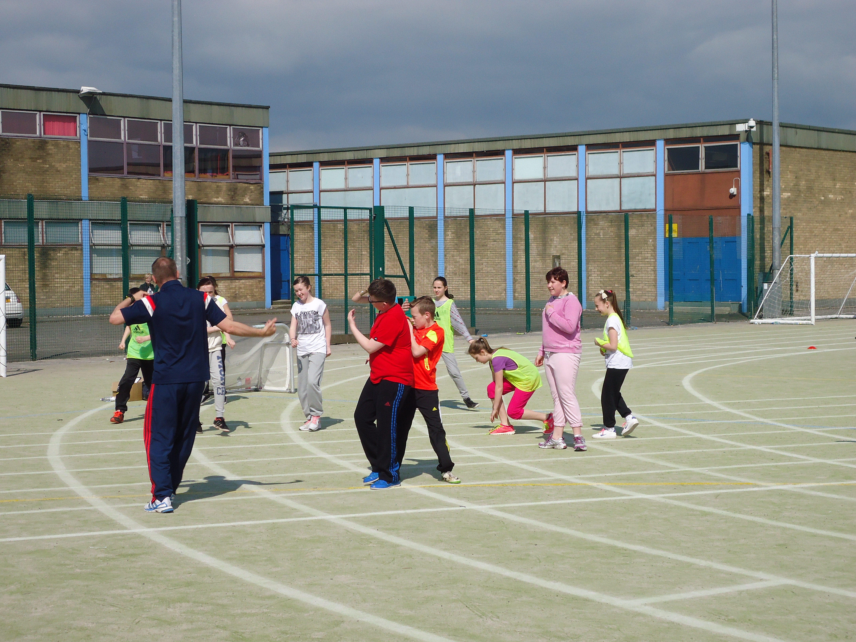 | 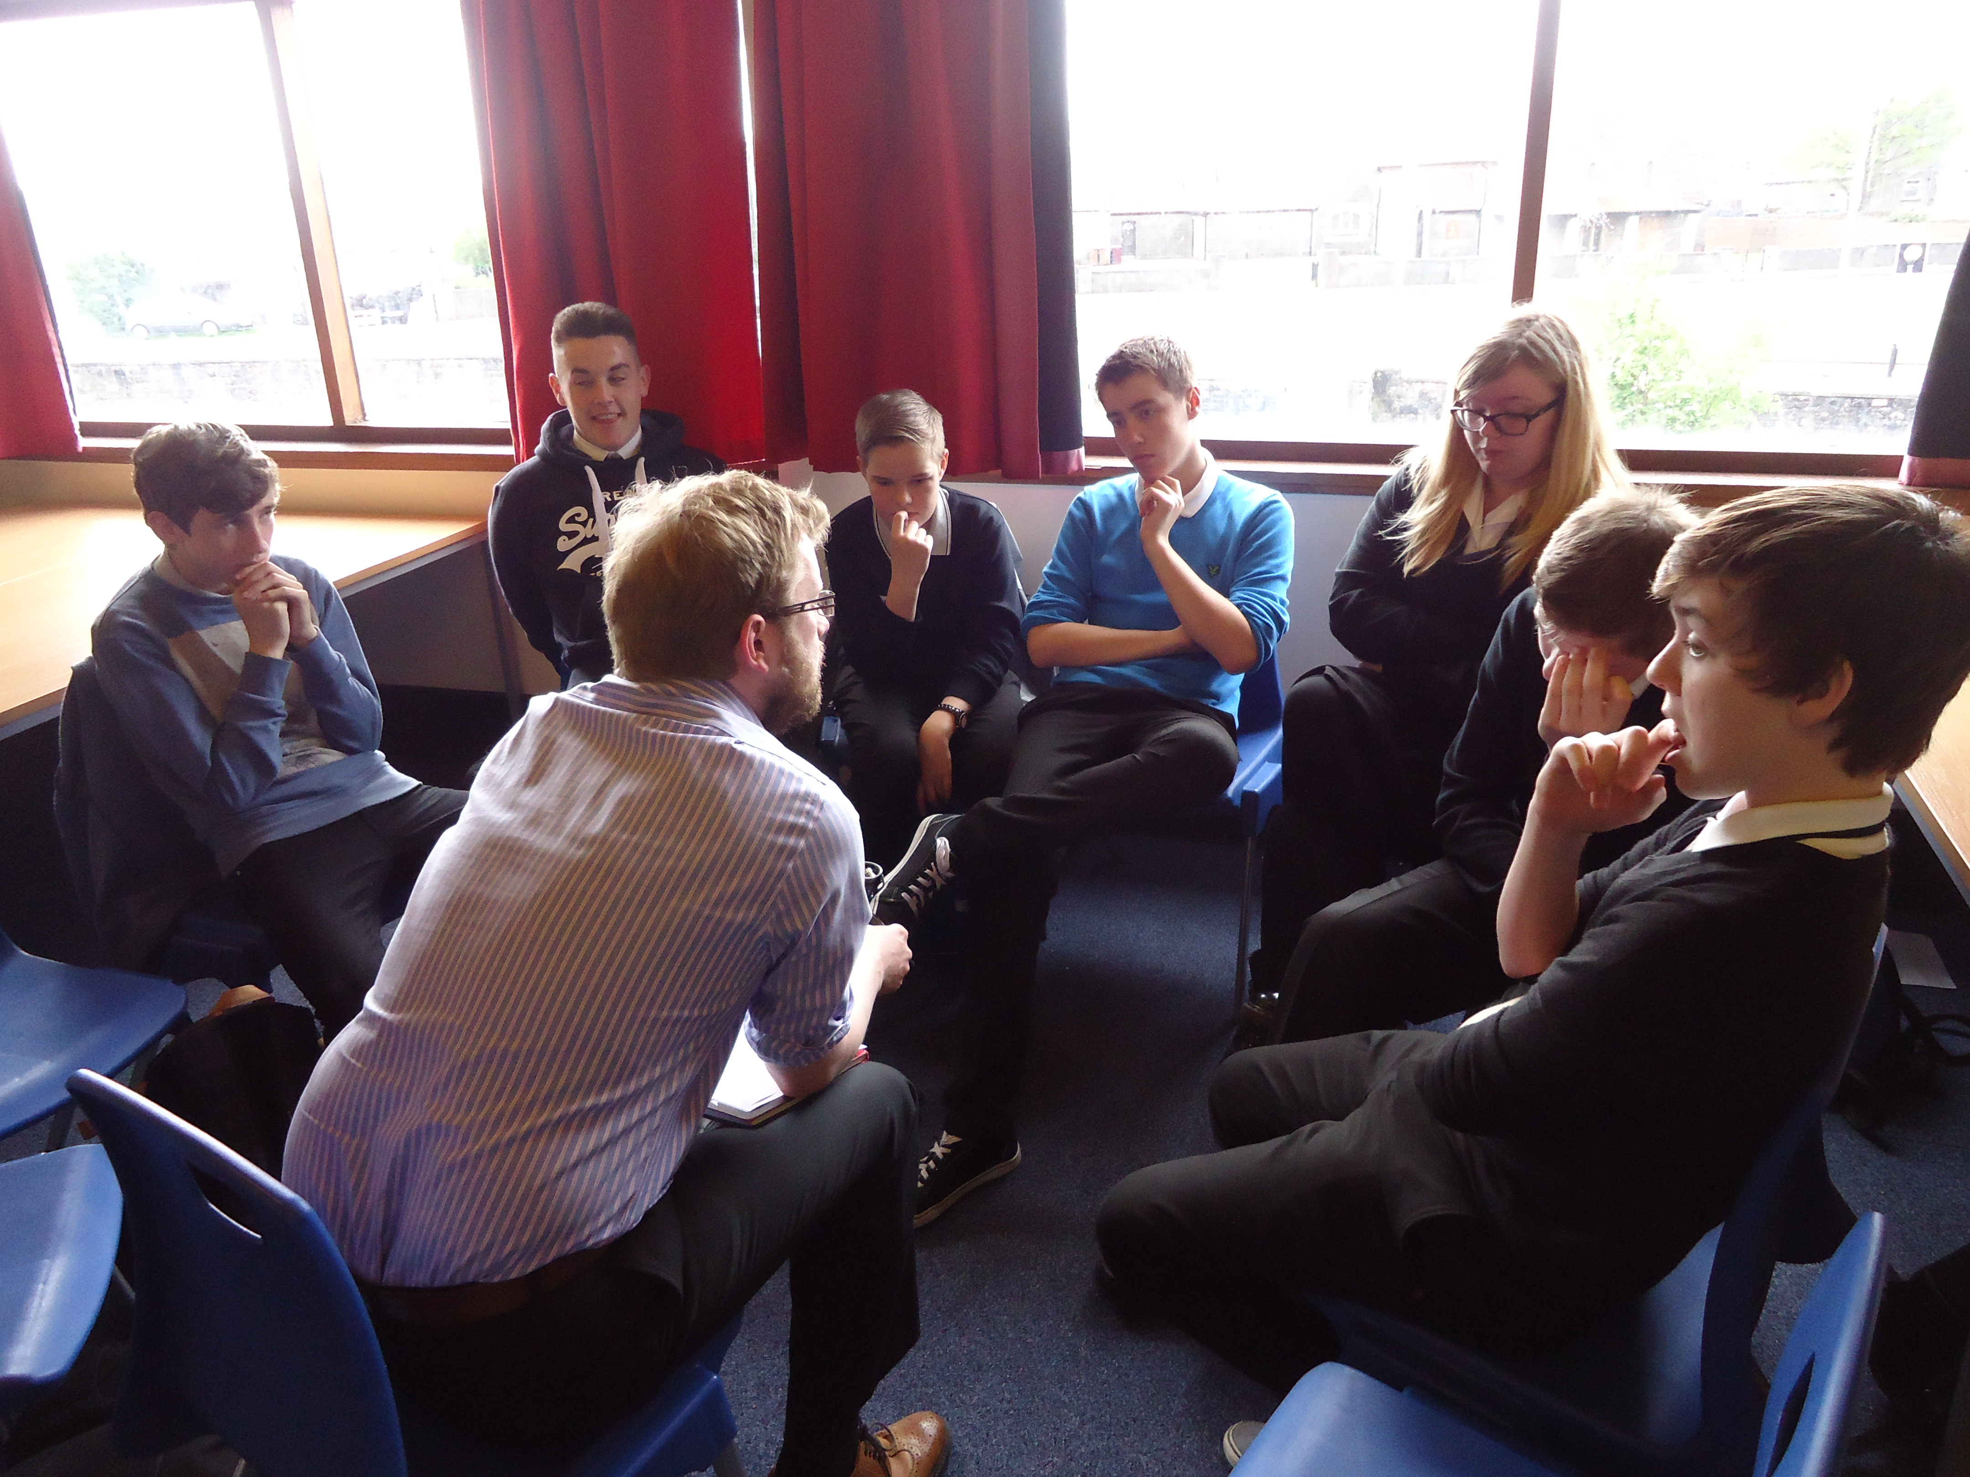
Example of peer education during the P7 Cluster Transition Event, run by teachers and pupils | Pupil discussion group about smoking, by Stirling University
2. About Health and Wellbeing Responsibility of All

The three themes that are responsibility of all for health and wellbeing at secondary school level are:

- mental, emotional, social and physical wellbeing – through fostering a safe, caring, supportive and purposeful environment that enables relationships based on mutual respect;
- planning for choices and changes – with learners experiencing opportunities which raise awareness of future choices, increase aspirations, and develop skills for making decisions and for sustaining positive destinations beyond school; and
- relationships – with learners developing an understanding of how to maintain positive relationships.

4. Leadership and Structure

Three key individuals lead on health and wellbeing responsibility of all – the Head Teacher, a Depute Head Teacher and a Principal Teacher. The Principal Teacher leads and manages delivery across the school, with support from the Depute and Head Teacher. Together, the leaders:

- highlight the importance of responsibility of all to all school staff;
- set the policy for delivery – reflecting national, authority wide and local issues;
- develop partnerships with other organisations and the community; and
- promote and encourage the approach to health and wellbeing.

There are a number of different groups to support the implementation of health and wellbeing responsibility of all.

- A Health and Wellbeing Working Group – This group is responsible for all aspects of the approach to health and wellbeing within the school. It involves staff from all departments in Kirkland High, as well as partners such as Fife Council Community Learning and Development and Environmental Health teams, the local Active Schools Co-ordinator, the school nurse and a primary teacher. The Principal Teacher chairs this group.

- A Health and Wellbeing Cluster Group – This involves the Principal Teacher, the associated primary schools within the cluster and partner organisations. It works to develop a coherent and co-ordinated approach to health and wellbeing across the cluster schools.

- A Junior Health and Wellbeing Group – This group is made up of young people. Their remit is to discuss issues raised by other young people in relation to health and wellbeing, and to act as a reference group for the wider community. For example, young people receive training on health messages – such as healthy salt intake, hand washing and global health – and then deliver the messages throughout the school.

Teachers have been involved collaboratively in the development of the approach to health and wellbeing. They are involved in the Health and Wellbeing Working Group and take part in an annual audit of health and wellbeing.

Young people involved in this case study felt that it was clear that health and wellbeing was a priority in the school, and felt that it was right that it was a high priority. They and their parents felt that health and wellbeing underpinned everything they did.

“If you feel better you normally feel happier and you’re more willing to learn.”
(Pupil)

“Health and wellbeing underpins everything. It is massively important especially mental and emotional health.”
(Parent)

4. Approach to Health and Wellbeing Responsibility of All

Kirkland High has a strong commitment to health and wellbeing. It is a Health Promoting School and a Rights Respecting School (UNICEF). Health and wellbeing has been a major focus since 2009/10, when the school explored views on school values with everyone associated with the school. This found that health was a key priority, with worrying health indicators for the area.

As Curriculum for Excellence was introduced, the school built on its existing approach as the foundation for taking forward health and wellbeing responsibility of all. In 2013, a Curriculum Policy for the whole school was developed - and health and wellbeing responsibility for all is an integral part. The Curriculum Policy clearly identifies health and wellbeing as being the responsibility of all staff.

“(The approach is) organic and evolving – growing out of an existing approach that embodied the values of the school and the way staff already worked.”
(School staff member)

Kirkland High undertakes an annual review of health and wellbeing, structured around the experiences and outcomes within Curriculum for Excellence. This influences how each school staff member works towards health and wellbeing experiences and outcomes each year. The school considers each of the outcomes and experiences, and how different subjects can contribute to achieving these.

Priorities around health and wellbeing are also influenced by the Fife Health and Wellbeing Accreditation Framework for Health Promoting Schools. This is an accreditation system set up by Fife Council, so that schools can build a structured, focused approach to health and wellbeing and gain recognition for and feedback on their achievements.

5. The Approach in Practice

Integrating Outcomes across the Curriculum

The Kirkland High School Audit for 2013/14 shows how different subjects contribute to each of the health and wellbeing responsibility of all outcomes. There is a planned approach to ensuring that outcomes are integrated across the curriculum.

Teachers involved in this case study felt that health and wellbeing was so integrated in their teaching and the way in which they approached lessons that it had become embedded in what they do. Teachers felt that health and wellbeing wasn’t an artificial focus during a subject lesson, but a holistic approach that blended with the lesson. They felt that this made the lessons more interactive and engaging.

Outcome:
“I am aware of and able to express my feelings and am developing the ability to talk about them.”

Examples of how this was addressed include:

- Art and design - All young people in S1 are asked to complete homework in which they express and record their feelings and emotions of their first week at secondary school through words, pictures, poetry or a story.
- French – Young people in S3 (and older) undertake work on personalities, family relationships and problems. Staff also have a willingness to listen to pupils, and pass on information if appropriate.
- Personal and Social Education – young people have various opportunities in PSE to express their feelings through discussion, written tasks, and group work in a range of topics in S1-S3.
- Religious and Moral Education and Social Subjects – Young people take part in class discussions about prejudice, war and peace, evil and suffering, ultimate questions, and poverty.

Planning for Choices and Changes

Choice is an important aspect of the approach at Kirkland High. Young people are supported to make informed choices about their life and learning. For example:

- Young people in S1 to S3 take part in a Curricular Enhancement Programme, for two periods a week, focusing on interdisciplinary learning opportunities around literacy, numeracy and health and wellbeing. They can choose to get involved in electives such as health and wellbeing, leadership programmes and additional sporting activities.
- Young people in the senior school take part in a Learning for Life Programme, for two lessons each week. Within this, they can study topics of their choice – choosing from topics including physical activity, dance, employability skills, business, life skills and home economics.

Planning for choices and changes is also built into a range of different subjects across the school. An example is provided below.

Outcome:
“I am investigating different careers/occupations, ways of working, and learning and training paths. I am gaining experience that helps me recognise the relevance of my learning, skills and interests to my future life.”

Examples of how this was addressed include:

- French – Young people are supported to investigate career paths within this subject area and staff are open and helpful to queries about careers.
- Personal and Social Education – Young people cover careers based topics S1-S3, including career planning and target setting. PSE also works in partnership with other agencies, such as Skills Development Scotland.
- Business education – Young people receive careers advice, and learn about business working environments.

Mental, Emotional, Social and Physical Wellbeing

The school supports young people to contribute their time, talents and views to the school and wider society. It promotes volunteering and has a wide range of leadership and coaching opportunities for young people, including the Duke of Edinburgh scheme, peer education programmes around alcohol awareness and sexual health, and sports leaders programmes. It also has a Pupil Union, which is involved in influencing the day to day life of the school. It also undertakes a wide range of work within subjects, to promote awareness and understanding of rights. An example is below.

Outcome:
“As I explore the rights to which I and others are entitled, I am able to exercise these rights appropriately and accept the responsibilities that go with them. I show respect for the rights of others.”

In 2013/14, this was addressed through:

- Business Education – Young people consider the rights and responsibilities of employers and employees, and classes design their own classroom rules.
- Drama – Through role play units. For example, young people designed and developed sketches which were used to launch Fife’s anti-bullying policy (the only school in Fife to be involved in this way).
- Modern Studies – Young people discuss and study human rights, and rights and responsibilities more generally in society.
- Social Subjects – Young people in S2 work through a Holocaust Unit, exploring the rights denied to individuals.

Relationships

Kirkland High is a ‘Rights Respecting School’. It aims to put the rights of the child at the heart of the school’s planning, policies, practice and ethos, and build strong positive relationships between young people and teachers. The school has adopted restorative approaches to support the development of positive relationships among peer groups and between staff and young people.

“(Restorative approaches) have made a huge difference in terms of behaviour and how we deal with young people and how young people deal with one another.”
(School staff member)

Practitioners suggested that there was now a common approach to behaviour issues across the school, and that stress levels in teachers have reduced as a result. They felt that young people were calmer and that there was a more transparent approach to how young people were dealt with when problems arise. Some young people also mentioned restorative approaches, and felt that relationships between themselves and teachers had improved in the time they had been at school.

Wider Health and Wellbeing

The school also undertakes a wide range of other activities, to promote health and wellbeing more generally, including:

- a programme of voluntary physical activity and sport – including gymnastics, taekwondo, athletics, football and holiday camps;
- a strong Active Schools programme, with an Active Schools Coordinator based in the school;
- healthy eating and healthy living activities – including a young chef competition and Home Economics enterprise project;
- challenge days and whole school events which promote interdisciplinary learning around a particular topic; and
- health and wellbeing themed assemblies.

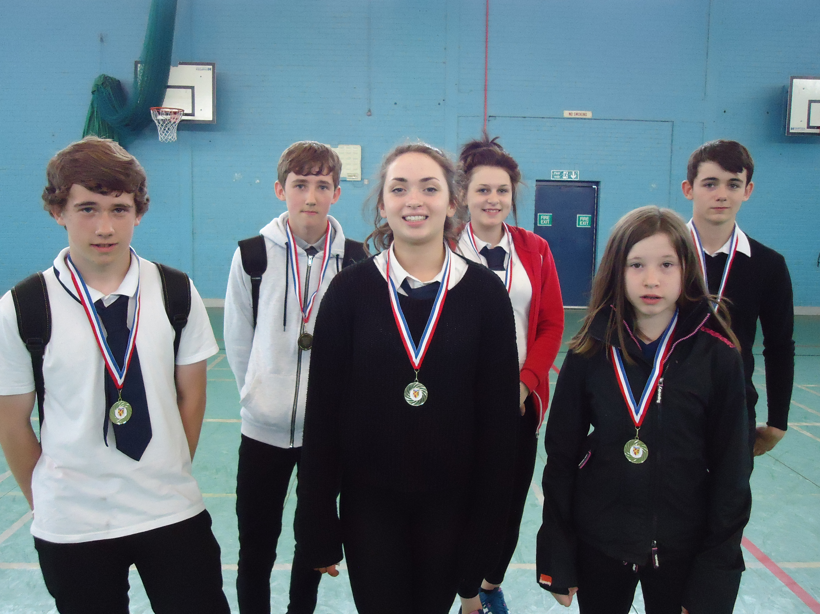 | 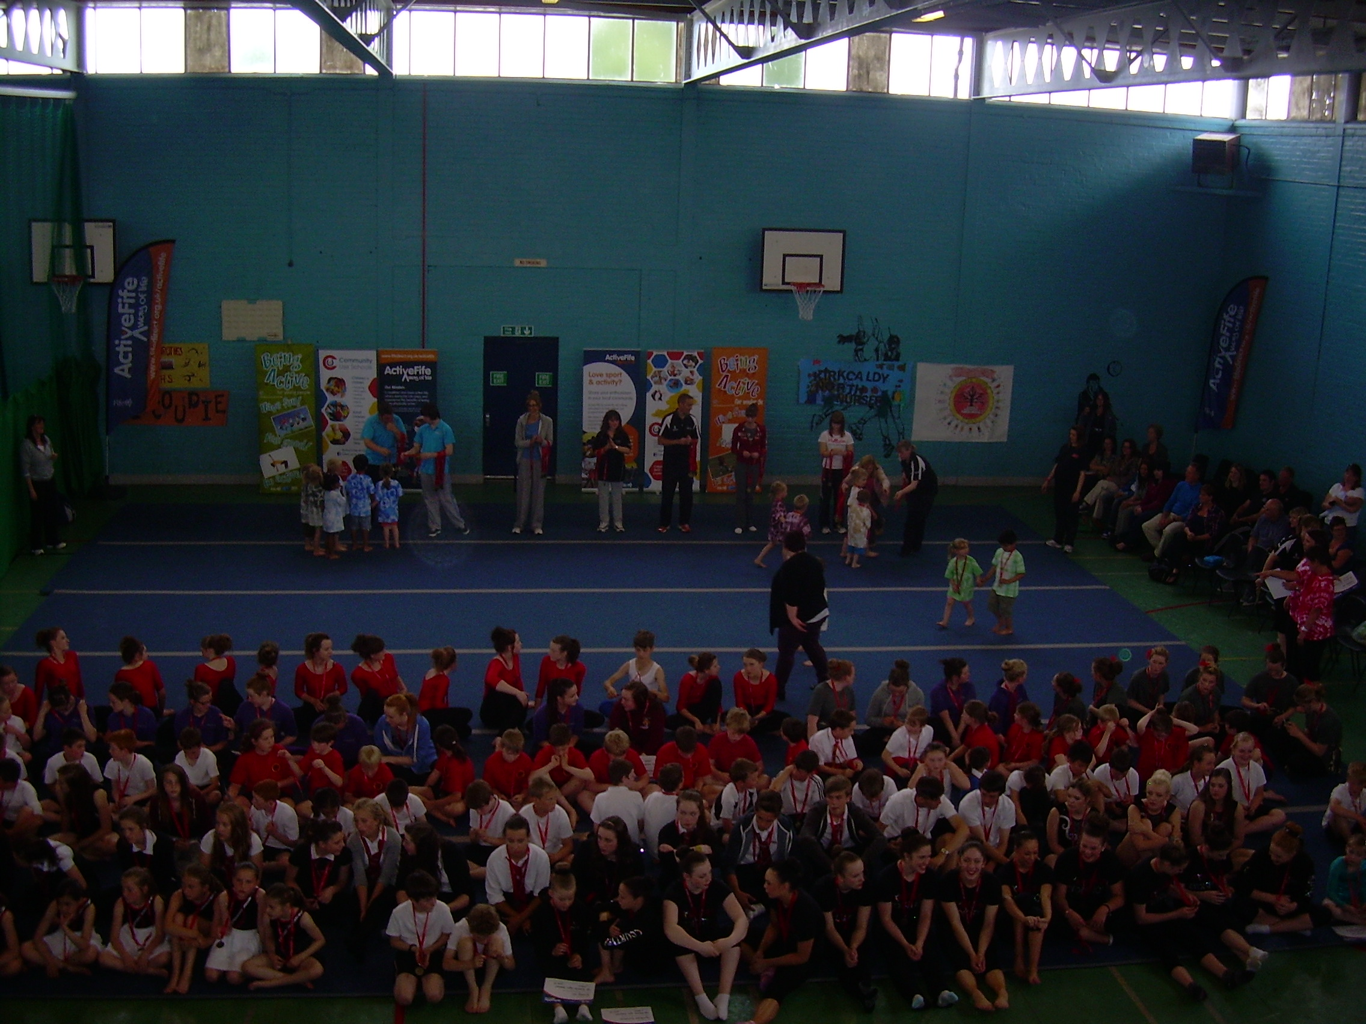
School Athletics Championships – winners from each year group | Regional gymnastics finals held at the school – and including young people from the school
6. Impact

Achieving health and wellbeing experiences and outcomes
Kirkland High is clear that its primary aim in integrating health and wellbeing within the school is to achieve the outcomes for health and wellbeing set out in Curriculum for Excellence – including those which are responsibility of all. Leaders felt that this had resulted in a clear, co-ordinated, rigorous approach with a higher priority focus on health and wellbeing.

Discussions with a small number of young people from the school highlighted that all felt that they were meeting the health and wellbeing responsibility of all experiences and outcomes. Young people felt most strongly that they:

- understand that there are people they can talk to;
- recognise that each individual has a unique blend of abilities and needs;
- are aware of the need to respect personal space and boundaries; and
- are developing the skills and attributes they need for learning, life and work.

Young people involved in this case study generally felt that health and wellbeing was a ‘taught’ subject in Social Education, Physical Education, Home Economics and Biology. They did not recognise health and wellbeing as something they learned about in every subject, but did feel that health and wellbeing was central to the ethos of the school.

Impact on school ethos

Overall, leaders, teachers and young people felt that there was a positive, inclusive and forward looking approach to health and wellbeing within Kirkland High. The young people involved in this case study described an environment that was a “good place to be”. They spoke highly of the school and personally demonstrated many attributes that the school seeks to develop in their young people.

“Everybody is offered opportunities – not everyone joins in but everyone is encouraged to get involved.”
(Pupil)

Many young people felt that the focus on health and wellbeing meant that their school experience was more conducive to learning with less disruption. The supportive environment and positive relationships between pupils and teachers were also highlighted. And staff and pupils felt there was more of a link between Personal and Social Education classes, and other areas of the curriculum.

“Teachers care like parents and encourage us.”
(Pupil)

“We are able to make changes to our lessons sometimes – I told the teacher that I thought we needed more challenging sequences in Dance and she helped us do that.”
(Pupil)
School staff also felt that the focus on health and wellbeing had resulted in:

- young people behaving better;
- young people being more aware of their health – including long term health;
- less stress – both young people and teachers – leading to a “calmer school”;
- improvement in behaviour of fans and players at inter-school matches;
- more teacher autonomy and flexibility;
- more coherent links with partners; and
- more interactive and engaging lessons due to integrating health and wellbeing.

School staff felt that the approach had strengthened partnership working with other organisations, particularly Fife Council’s Community Learning and Development (CLD) team. Now, CLD youth workers use the health and wellbeing experiences and outcomes within Curriculum for Excellence to plan the year ahead. This was beneficial for young people, teachers and CLD staff.

“Pupils we are working with are often achieving and making progress out with school during the evenings or school holidays. We are able to use the experiences and outcomes to plan their programme and show progress and impact.”
(Partner organisation)

Teachers highlighted that the opportunities available to young people through CLD helped them to develop both within and outwith school time. The CLD team support the curriculum where appropriate. For example, the team organised speakers and support to stimulate discussion about sexual orientation and gender identity.

“CLD opens up so many opportunities for us.”
(School staff member)

Indications of impact

Kirkland High uses a range of different methods to gather indications of the impact its approach to health and wellbeing is having:

- Attainment and achievement – Kirkland High monitors attainment and achievement levels, and school staff believe that the approach to health and wellbeing has contributed (alongside other work) to recent improvements in attainment and achievement. The school has also seen an increase in positive leaver destinations. However, it is very difficult to link health and wellbeing activity to improvements in attainment. The school believes it has seen clear signs that young leaders are growing in confidence through the opportunities to act as leaders, but can’t link this absolutely to attainment.

- Pupil feedback – Kirkland High gathers qualitative information about the impact its approach is having through a range of methods, including evaluations by young people; department meetings; and health and wellbeing cluster meetings.

School staff and partners felt that the approach to health and wellbeing was having an impact, including:

- more young people being involved in physical activity – this is tracked by the Active Schools Coordinator for Kirkland High, and figures show activity is increasing;
- leadership and volunteering involvement increasing;
- improvements in attainment and achievement; and
- young people being more likely to move into a positive destination.

7. Lessons Learned

This case study highlighted a number of key success factors, which have helped Kirkland High to successfully deliver health and wellbeing responsibility of all:

- An inclusive ethos and culture – It was felt that an inclusive ethos where everyone was encouraged to work towards their personal best was essential.

- A ‘Distributive Leadership Model’ – Kirkland High uses a ‘Distributive Leadership Model’ – promoting an open culture and collaborative working – which was seen as vital to its success. Leaders and teachers agreed that being open and willing to consider anything that was offered to the school (within reason and remit) meant that young people had more opportunities to be part of something positive.

- A Principal Teacher – It was felt that the appointment of a Principal Teacher to lead on health and wellbeing responsibility of all was a key success factor. This post gave direction and focus to the work and is a major resource.

- Partnership working - Partnerships that are “purposeful and mutually supportive” were seen as critical. The fact that partnership working is built into the ethos of the school was important – both with other organisations, and between staff and young people.

“Let people try out ideas, be creative and innovative.”
(Leader)

There were few barriers experienced in implementing the health and wellbeing responsibility of all approach. However, the main challenge was time. Teachers were initially quite reluctant, seeing this as “something else to add to an already very busy workload.” However, initial fears were allayed through Continued Professional Development, and an understanding that teachers would be “promoting and identifying what we are doing already”.

Kirkland High School continues to develop its approach to health and wellbeing responsibility of all, in an organic and evolving way.

Based on the Scottish Index of Multiple Deprivation 2012
The Rights Respecting Schools Award (RRSA) recognises achievement in putting the United Nations Convention on the Rights of the Child (CRC) at the heart the school.
Restorative approaches can promote harmonious relationships in schools

